Board Review: February 25, 2014

The Syndrome of Inappropriate Antidiuresis: Pathophysiology, Clinical Management and New Therapeutic Options
Pasquale Esposito Giovanni Piotti Stefania Bianzina Yehuda Malul, Antonio Dal Canton Nephron Clin Pract 2011;119:c62–c73 Review Article

Summary:
Intro:
The syndrome of inappropriate antidiuresis (SIAD) is one of the most common causes of hyponatremia
It is a disorder of sodium and water balance characterized by urinary dilution impair- ment and hypotonic hyponatremia, in the absence of renal disease or any identifiable non-osmotic stimulus able to induce antidiuretic hormone (ADH) release
** NOTE: Name change! change in the name, once the syndrome of inappropriate secretion of ADH (SIADH), today SIAD.
The homeostasis of body water balance is finely regulated by hypothalamus, neurohypophysis, kidneys and circulating hormones, the most important of which is the antidiuretic hormone (ADH), also known as arginine vasopressin (AVP)
Arginine Vasopressin: Synthesis, Function, Receptors and Mechanisms, Osmotic and Non- Osmotic Stimuli
It is synthesized in the hypothalamic supraoptic and paraventricular nuclei neurons, then transported along the axons to the posterior lobe of the hypophysis and, in response to a number of stimuli, is released into the circulation
Circulating ADH is rapidly metabolized by hepatic and renal aminopeptidase. (vasopressinase); this enzyme can also inactivate oxytocin
Receptors: Three known receptors bind ADH at the cell membrane:
- V1a
- V1b (also known as V3)
- V2
These receptors belong to the G-protein-coupled receptor superfamily.
ADH binding to V1a and V1b receptors results in phospholipase C activation and elevation of intracellular calcium that, in turn, stimulates protein kinase C.
Instead, the binding to V2 receptors activates adenylate cyclase, causing a rise in intracellular cyclic adenosine monophosphate (cAMP)
V1a receptor:
- Ubiquitous and it is found on several cells, such as vascular smooth muscle cells, hepatocytes, platelets, brain and uterus cells.
- This receptor mediates the cardiovascular effects of ADH, which exerts its hypertensive effects mainly through smooth muscle cell contraction
- Moreover, the stimulation of V1a receptors regulates glycogenolysis, platelet aggregation, myocyte hypertrophy, anxiety and stress
V1b receptors (V3):
- V1b receptors are found predominantly in the anterior pituitary gland and their stimulation results in the release of adrenocorticotropic hormone (ACTH)
V2 receptors
- Are found in endothelial cells, where their activation induces the secretion of von Willebrand factor
- They are also found on the basolateral membrane of the principal cells of the renal collecting ducts, where they mediate an antidiuretic response.
- Stimulation of V2 receptors, through intracellular cAMP, increases synthesis and insertion of aquaporin-2 (AQP2) water channels in the luminal membrane of the collecting ducts, thus making them permeable to water. Consequently, water passes passively to the hypertonic interstitium of renal pyramids, resulting in urine concentration.
ADH antidiuretic action also depends on its ability of maintaining the medullary interstitial osmotic gradients by increasing the number of epithelial [Na+] channels and urea transporters (UT-A1), thus enhancing sodium and urea permeability in the collecting duct
ADH secretion is influenced by many different stimuli, which can be classified as osmotic and non-osmotic.
Under physiological conditions, the most important stimulus is the effective osmotic pressure of plasma.
- Osmoreceptors are located in the anterior hypothalamus, outside the hematoencephalic barrier, mostly on the vascular side of the terminal lamina around the ventricles, exposed to the osmotic variations of the systemic circulation.
- The threshold for ADH release cessation corresponds to a plasmatic osmolality <275 mosm/kg, while for plasmatic osmolality of 284 mosm/kg or higher
Hypovolemia is a potent non-osmotic stimulus for ADH secretion.
- Baroreceptors are classified in low- and high-pressure receptors and the activation of both of them results in ADH increase.
- The low-pressure receptors are located in larger veins, right and left atrium and lungs. The high-pressure ones in the carotid sinuses and aortic arch.
- ECF depletion initially induces secretion of vasopressin through low-pressure receptors pathways, thus working even with normal arterial pressure
Angiotensin II and norepinephrine, which reinforce the response to hypovolemia, further stimulate ADH secretion
Among the other non-osmotic stimuli, like stress, nausea, vomiting, drugs and hypoglycemia, nociceptive stimuli, mainly post-surgery pain, have been clearly associated with an increase in ADH levels, but the underlying mechanism has not been characterized so far

Osmotic stimuli of ADH release | Non-osmotic stimuli of ADH release | Inhibitors of ADH release
Plasma osmotic pressure (most important stimulus) | Hypovolemia/ECF depletion
 | Angiotensin II
 | Norepinephrine
 | Nausea/vomiting
 | Hypoglycemia
 | Nociceptive stimuli
 | Drugs

Definition of SIAD
SIAD is a disorder of sodium and water balance characterized by hypotonic hyponatremia and impaired urinary dilution in the absence of renal disease or any identifiable non-osmotic stimulus known to release ADH. It is a diagnosis of exclusion.
Pathophysiology of SIAD
The pathophysiological basis of SIAD is an absolute increase in body water. This increase depends on an excessive water intake that overwhelms the restricted renal ability of diluting urine and mounting compensatory diuresis due to ADH dysregulation.
- Excessive water intake, mainly due to iatrogenic water administration or inappropriate thirst, and ADH dysregulation, are both necessary for the full development of this syndrome
- This accounts for the body water expansion that in turn, through plasmatic sodium dilution, causes hypotonic hyponatremia.
- To compensate for ECF expansion, aldosterone secretion is inhibited while atrial natriuretic peptide (ANP) increases. These compensative responses serve to maintain euvolemia, but at the same time, determining natriuresis and body exchangeable sodium loss, further worsen hyponatremia
Causes of SIAD :

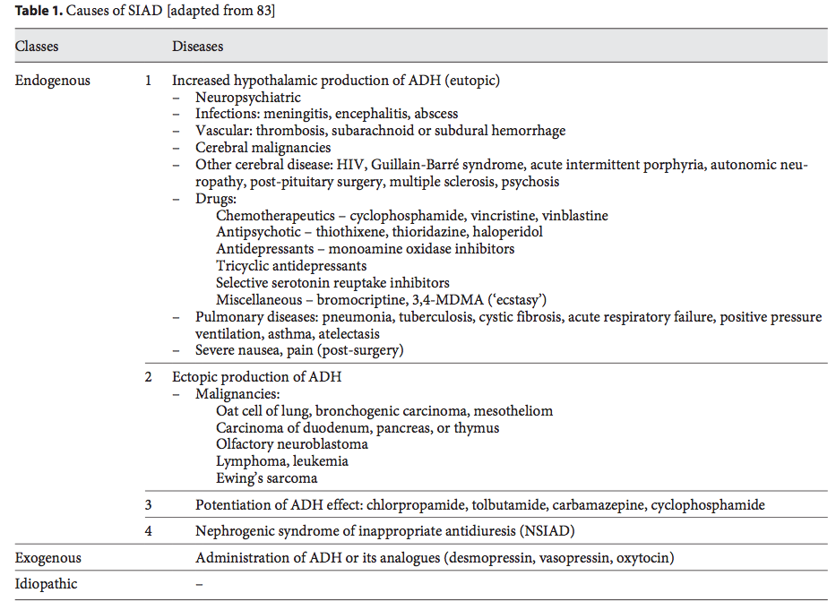
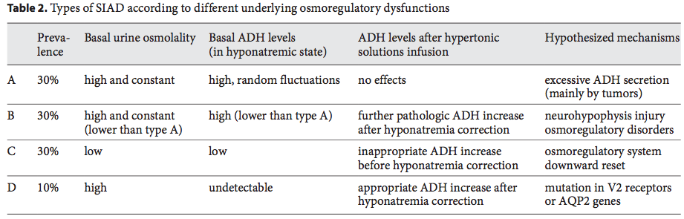

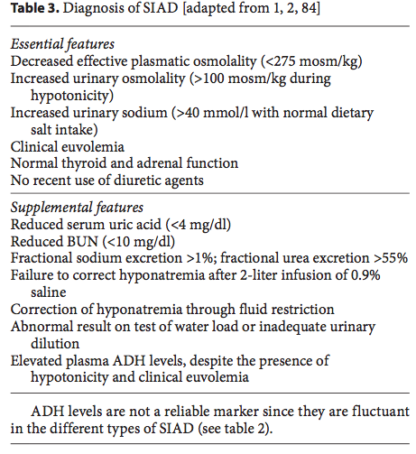

Diagnosis:
- The laboratory evaluation of hyponatremia should start measuring serum osmolality to confirm true hyponatremia, excluding two different situations: pseudo-hyponatremia, a laboratory artifact due to very high lipid or protein levels, and hypertonic translocational hyponatremia, due to the presence of osmotically active solutes, such as glucose or mannitol, which drive free water out- side the cells.
- Urine osmolality and sodium concentration must be regarded to verify the presence of high osmolality (1100 mosm/kg, except for type C SIAD; table 2) and high sodium concentration (usually 140 mmol/l).
- Cerebral and renal salt wasting syndromes (SWS) require special attention for diagnosis. They are characterized by hyponatremia and ECF depletion, caused by an abnormal renal excretion of sodium mainly in patients with insults to the central nervous system. Both SWS and SIAD present hyponatremia, concentrated urine and natriuresis, but SWS is defined by a hard-to-recognize ECF depletion.
- In case of diagnostic uncertainty, correction of hyponatremia with the infusion of 2 liters of 0.9% saline over a period of 24–48h (a safe procedure even in SIAD when baseline urinary osmolality is <500 mosm/ kg) suggests a diagnosis of hypovolemic hyponatremia.
- Euvolemic hyponatremia, that is the clinical feature of SIAD, occurs also in the course of endocrine diseases, such as hypothyroidism and ACTH deficiency, primary polydipsia and excessive iatrogenic fluid replacement, mainly after the surgical procedure. Differential diagno- sis may be guided by laboratory findings, such as hor- mone level and urinary osmolality, that results in being reduced (!100 mosm/kg) over the course of polydipsia. ACTH deficiency should be ruled out before making a diagnosis of SIAD.

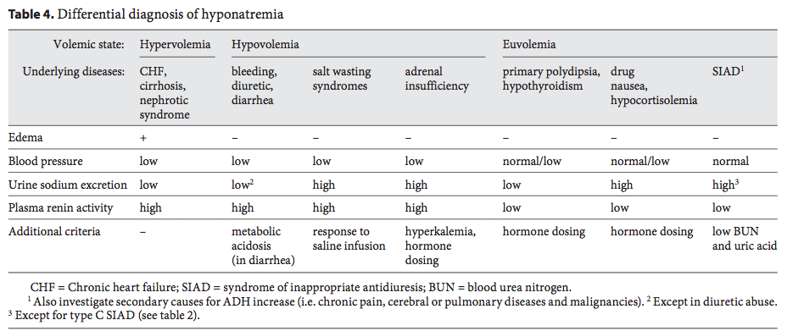

Clinical presentation and management:

Neurological manifestations dominate the clinical presentation; secondary to cerebral edema
Medical care and management mainly depend on the clinical picture and timing of the development of hyponatremia, i.e. acute vs. chronic forms.
Traditional treatment options for SIAD include fluid restriction, saline infusion, furosemide, demeclocycline ( causes neprhogenic DI; banned) and urea (increases free water clearance), but all have their limitations and no guidelines are available.
saline infusion has arisen as the cornerstone of the treatment. Isotonic saline solution (0.9%) should be reserved for mild symptomatic patients and those cases of difficult differentiation between hypovolemic and euvolemic status.
Note: the infusion of isotonic solution to a patient with SIAD who presents a fixed elevated urine osmolality can result in further dilution and decrease of serum sodium levels. This phenomenon, also known as desalination, depends on the retention of electrolyte-free water that occurs when the osmolality of an infused solution is lower than the patient’s urinary osmolality
Acute and more severe conditions re- quire administration of hypertonic saline solution (3 or 5%); the correction speed must be adequate and slower than 12 mmol/l/day because of the risk of osmotic demyelination syndrome. Osmotic demyelination entails both central pontine and extrapontine irreversible myelinolysis.
The infusion of DDAVP has been described as an effective and safe strategy to prevent or eventually reverse an inadvertent overcorrection of hyponatremia, even if the increased sodium levels had already exceeded the intended limit
Furosemide may be effective only in early SAID
Recently, new therapeutic options have been evaluated, in particular vasopressin receptor antagonists, the so- called vaptans
These molecules, known as vaptans or aquaretics, block ADH V2 receptors and decrease AQP2 at renal collecting ducts, which result in being insensitive to ADH and become less permeable to water, thus leading to an increased urinary excretion of free water
Conivaptan hydrochloride (Vaprisol) is a non-peptide benzazepine derivate that acts as a non-selective vasopressin V1a/V2 receptor antagonist.
tolvaptan (Samsca) is a selective vasopressin V2-receptor antagonist, approved by the FDA (USA) for treatment of hypervolemic and euvolemic hyponatremia, including patients with heart failure, cirrhosis and SIAD, while by EMEA (EU) only for SIAD

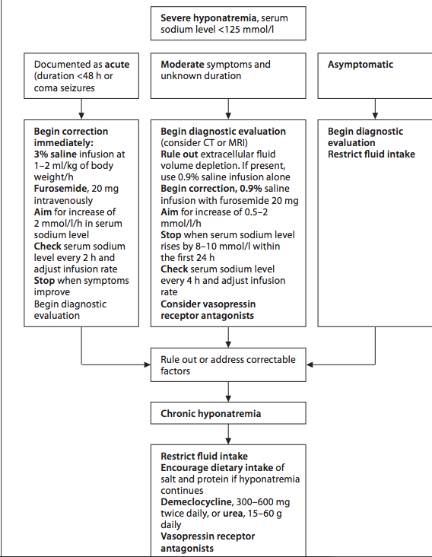

Questions:

- The V1a receptor mediates the __________________________ effects of ADH. Other effects include, glycogenolysis, platelet aggregation, myocyte hypertrophy.
Answer: cardiovascular effects. It exerts its hypertensive effects mainly though
smooth muscle contraction

- V1b receptors are found predominantly in the _____________________________and their stimulation results in the release of _________________.
Answer: anterior pituitary gland, ACTH
- V2 receptors are found in _____________________________, where their activation induces the secretion of von Willebrand factor, and on the basolateral membrane of the ____________________cells of the renal collecting ducts, where they mediate an antidiuretic response.
Answer: Endothelial cells, Principle cells
- SIAD is a disorder of sodium and water balance characterized by urinary dilution impairment and hypotonic hyponatremia, in the absence of renal disease or any identifiable non-osmotic stimulus able to induce antidiuretic hormone (ADH) release. T or F?

- List at least 4 essential clinical features of SAID
- Hyponatremia (decreased plasma osmolality)
- Concentrated urine (increased urinary osmolality)
- Natriuresis
- Euvolemia
6. List at least 3 treatment options that have been used in the management od SAID
- Saline infusion (0.9%, hypertonic)
- Furosemide
- Demeclocycline (banded)
- Oral urea
- Aldosterone anatgonists

Hyperadrenocorticism: Treating Dogs
Cassandra G. Brown, DVM
Thomas K. Graves, DVM, PhD, DACVIM University of Illinois at Urbana-Champaign
CEArticle #1 Compenduim March 2007
ABSTRACT: This article is a complete review of all reported therapies for hyperadrenocorticismin dogs. Both medical and surgical options for treating pituitary-dependent hyperadrenocorticism and adrenal tumor-related disease are discussed, and the efficacy, safety, and use of these treatments are compared.
Summary:
Two forms exist. Excessive adrenocorticotropic hormone (ACTH) secretion is the result of pituitary-dependent hyperadrenocorticism (PDH) and is responsible for approximately 80% to 85% of naturally occurring cases in dogs. An autonomously functioning adrenocortical tumor (AT) is reported in the vast majority of the other naturally occurring cases.
Treatment options:
- Mitotane
- Trilostane
- Selegiline
- Ketoconazole
- Adrenalectomy (for ATs)
- Hypophysectomy
- Radiation therapy
- Metyrapone
- Aminoglutethimide
- Cyproheptadine
- Bromocriptine
- RU-486.

Mitotane:
- Mitotane (Lysodren [Bristol-Myers Squibb], o,p-DDD) is the most common medical therapy for hyperadrenocorticism in dogs
- A potent adrenocorticolytic agent: results in progressive adrenocortical necrosis of the zona fasciculata and zona reticularis.
- Mitotane is activated within adrenocortical tissue to a reactive acyl chloride intermediate and subsequently is covalently bound to adrenal proteins, resulting in progressive cortical necrosis
- Two phases of classic mitotane administration for treatment of PDH exist
1. Induction: 50mg/kg SID for 5-14days. Completion of induction is based on ACTH stimulation test documentation of a subnormal post- stimulation serum concentration of cortisol (normal: 1 to 5 μg/dl). Daily mitotane should be discontinued when clear decreases in appetite or water consumption are noted or when listlessness, vomiting, or diarrhea is doc- umented. An ACTH stimulation test should be conducted within 24 hours to evaluate adrenal function and determine whether induction therapy is complete. Because mitotane reliably reduces cortisol production, the dog should be examined by a veterinarian on day 8 or 9 of induction, and an ACTH stimulation test should be conducted even if no clinical signs of completion of induction are noted. Induction should be continued for an additional 3 to 7 days if post-ACTH stimulation cortisol levels remain elevated above the goal of 1 to 5ug/dL. Because the urine cortisol:creatinine ratio is unreliable for monitoring mitotane therapy, it should not be used.
2. Maintenance: see recommended doses; maintenance therapy involves administration two or three times per week

- Note: you can preform a medical adrenalectomy by giving high doses (75mg/kg/day for 25days) and completely destroy the entire adrenal gland. These patient will require mineralocorticoid and glucocorticoid supplementation.

- Adverse effects of mitotane include GI upset, idiosyncratic hepatotoxicity, central nervous system (CNS) toxicity, and development of transient or permanent hypocortisolism. Bone marrow necrosis has been reported.
Trilostane:
- Action: is a competitive inhibitor of the 3β-hydroxysteroid dehydrogenase enzyme system and blocks the production of both aldosterone and cortisol.
- Trilostane competes with pregnenolone as a substrate for 3β- hydroxysteroid dehydrogenase and results in decreased production of progesterone, the progenitor of almost all steroid hormone production in not only the adrenal gland but also gonadal and placental tissue
- Excessive ACTH production continues in cases of PDH treated with trilostane, and adrenal gland size increases during treatment.
- The treatment protocol for trilostane differs from that for mitotane in that no distinct induction and maintenance periods exist for trilostane.
- ACTH stimulation testing is the recommended monitoring method and should be conducted 10 to 14 days following initiation of therapy and again 2 weeks later, followed by repeated testing every 3 months.
- Current recommendations include stimulation testing 4 to 6 hours after trilostane administration.
The use of the urine cortisol:creatinine ratio has not proven adequate in monitoring treatment.
In the largest retrospective study comparing survival times of dogs treated with trilostane or mitotane, no significant difference was found. The median survival time of 123 dogs that received trilostane was 662 days (range: 8 to 1,971 days), whereas the median survival time of 25 dogs treated with mitotane was 708 days (range: 33 to 1,399 days)
*** NOTE: There are reports of sudden death with the use of this medication

Ketoconazole:
- Ketoconazole is an antifungal that inhibits ergosterol synthesis and fungal cell membrane growth.
- It also inhibits mammalian steroidogenesis by inhibiting the cytochrome P-450 enzyme system responsible for both androgen and cortisol production.
- Ketoconazole inhibits both the first and last steps in cortisol synthesis (11- deoxy to cortisol).
- Ketoconazole also inhibits ACTH secretion from pituitary corticotrophs
- Twenty-one days after initiation of treatment, an ACTH stimulation test should be conducted several hours after drug administration. The dose should be increased—based on incomplete clinical sign response and ACTH stimulation testing
- In a study of 60 dogs with hyperadrenocorticism (i.e., both PDH and AT), 75% to 80% of the dogs reportedly had a good clinical response to ketoconazole. The plasma cortisol response to ketoconazole was not significantly different in dogs with PDH versus those with AT.
- Twenty percent to 25% of dogs fail to respond to ketoconazole, which is likely the result of poor intestinal absorption.
- Rarely reported side effects include transient hypocortisolism, GI upset, and hepatotoxicity.
Hypophysectomy:
- PDH is the result of excess ACTH secretion from adenomatous pituitary corticotrophs that vary in size from microscopic to space-occupying, large pituitary masses
- In approximately 10% of patients with PDH, signs of a space-occupying intracranial mass develop because of macroadenomas.
- Therapy with both trilostane and mitotane, as already described, actually results in increased ACTH secretion partly due to the removal of negative feedback mechanisms still in effect. This may at least be theorized to promote pituitary tumor growth.
- Hypophysectomy methods have been described in dogs
- The pituitary is located within the bony sella turcica and varies in position among dogs.
- With the use of advanced imaging, the sphenoid bone can be removed ventral to the location of the pituitary via a transoral or ventral cervical approach
- Ideally, the adenoma would be removed while leaving the remaining normal pituitary tissue intact, but the limited field of view and relatively small size of macroadenomas make this impossible.
- Therefore, following hypophysectomy, secondary hypothyroidism and hypoadrenocorticism are anticipated; thyroid and glucocorticoid hormone supplementation must be continued lifelong.
- Central diabetes insipidus may occur post hypophysecomty; this is often transient because hypothalamic production of arginine vasopressin can result in antidiuresis. Desmopressin (synthetic antidiuretic hormone) is routinely administered for 2 weeks following surgery and then continued if signs of polyuria persist, indicating persistent central diabetes insipidus.
- Keratoconjunctivitis sicca developed in 47 of 150 dogs after surgery and is theorized to be the result of traumatic or ischemic injury to the innervation of the lacrimal glands. Schirmer’s tear test values should be monitored and ocular lubrication instituted if the values decrease.
Pituitary radiation:
- Pituitary radiation should be considered in dogs with PDH and a macroadenoma resulting in CNS signs.
- May be effective in resolving CNS signs, but not always signs secondary to hypersecretion of ACTH
Adrenalectomy:
- This is the preferred treatment in patients with an adrenal tumor as it offers and opportunity for a cure.
- Mitotane therapy has been used in nonsurgical cases of AT, but higher doses and the risk for metastatic disease with malignant tumors make it a less than ideal choice.
- Although bilateral adrenalectomy has been performed in dogs with PDH that cannot tolerate medications or in which hypophysectomy is not pursued, it is used mainly in treating AT.
- Before surgery, medical management may be indicated to control clinical signs of hyperadrenocorticism, improve healing, and reduce thromboembolic complications.
- Immediately before and after surgery, glucocorticoids and mineralocorticoids should be administered because removal of autonomously functional ATs results in transient hypoadrenocorticism until the atrophied contralateral adrenal gland regains the ability to respond appropriately to ACTH.
- The median survival time of dogs with carcinomas was 778 days, and the median survival time of dogs with adenomas was not obtained because none of these dogs died from adrenal disease or related complications.

Other:
Metyrapone is an 11βhydroxylase inhibitor that inhibits the final step in adrenal steroidogenesis. The efficacy of steroidogenesis inhibitors is limited by the fact that progressive increases in ACTH secretion can eventually overwhelm the ability of the drugs to inhibit adrenal cortisol production.
Aminoglutethimide, a cytochrome P-450 enzyme inhibitor that blocks the conversion of cholesterol to pregnenolone, has been demonstrated to reduce cortisol secretion in normal dogs.
Mifepristone (RU-486) is a steroid analogue that is a competitive inhibitor of progesterone and glucocorticoids at receptor sites. Administration of the drug results in increases in measured serum levels of both cortisol and ACTH but reduces cellular effects of cortisol and thus the clinical signs of hyperadrenocorticism. Side effects reported in people are generally attributable to hypocor- tisolism and resolve when the drug is removed. The drug has been shown to be effective in treating people with AT and syndromes of ectopic ACTH secretion, but not in cases of PDH because increased ACTH secretion and subsequent hypercortisolemia overwhelm the drug’s competitive receptor blockade.
Selegiline (i.e., L-deprenyl) is a monoamine oxidase inhibitor that enhances CNS dopamine concentrations. Dopamine inhibits pituitary pars intermedia ACTH secretion and thus has been proposed as a centrally acting therapy for PDH. However, approximately 70% of canine PDH cases are caused by adenomatous changes of a pituitary pars distalis cell type that secretes ACTH independent of dopaminergic control. There is no indication for the use of L-deprenyl in treating AT.
Cyproheptadine is not recommended for the treatment of hyperadrenocorticism in dogs. It was thought that serotonin supports increased ACTH secretion, however this drug has not proven to be effective.
Bromocriptine, a dopamine agonist, has been evaluated in treating canine PDH. Mehanism of action of the drug (i.e., increasing CNS dopamine concentrations and inhibiting ACTH secretion) is ultimately similar to that of selegiline. Just like selegiline, bromocriptine has not been shown to be effective in cases of PDH in dogs and is not recommended

Questions:
- How does Mitotane work?
Answer: A potent adrenocorticolytic agent: results in progressive adrenocortical necrosis of the zona fasciculata and zona reticularis.
(activated within adrenocortical tissue to a reactive acyl chloride intermediate and subsequently is covalently bound to adrenal proteins, resulting in progressive cortical necrosis)
- How does Trilostane work?
Answer: Competitively inhibits the 3β-hydroxysteroid dehydrogenase enzyme system and blocks the production of both aldosterone and cortisol.
(Trilostane competes with pregnenolone as a substrate for 3β- hydroxysteroid dehydrogenase and results in decreased production of progesterone, the progenitor of almost all steroid hormone production)
- In approximately ____% of patients with PDH, signs of a space-occupying intracranial mass develop because of macroadenomas.
- 2%
- 5%
- 7%
- 10%
Answer: D.10%

- List at least 2 common endocrine disorders that are likely to occur following a hypohysectomy:
Answer: Hypothyroidism, Hypoadrenocorticism, central DI

Testing for Hyperthyroidism in cats
Vet Clin Small Animal 37 (2007) 671-691
Summary: (review article)
The clinical syndrome results from excessive circulating concentrations of the active thyroid hormones thyroxine (T4), and triiodothyronine (T3) produced by an abnormally functioning thyroid lobe.
The underlying pathologic finding in more than 98% of cases is benign adenomatous hyperplasia (adenoma); as such, the disease carries a favorable prognosis with effective therapy. Thyroid carcinoma is a rare cause of hyperthyroidism in cats.
Diagnostics:
CBC:
- mild to moderate erythrocytosis and macrocytosis
- Such changes may reflect increased erythropoietin production resulting from increased oxygen consumption or direct thyroid hormone–mediated b-adrenergic stimulation of erythroid marrow.
- Anemia seems to be rare and usually associated with severe hyperthyroidism, and it may result from bone marrow exhaustion or iron or other micronutrient deficiency
- A significantly higher incidence of Heinz body formation has been reported in cats with hyperthyroidism
- Stress leukogram
Serum biochemistry profile:
- The most striking biochemical abnormalities are elevations in the liver enzymes, alanine aminotransferase (ALT), alkaline phosphatase (ALKP), lactate dehydrogenase (LDH), and aspartate aminotransferase (AST). At least one of these enzymes is elevated in more than 90% of hyperthyroid cats
- Liver histopathology: In more severe cases, centrilobular fatty infiltration may occur together with patchy portal fibrosis, lymphocytic infiltration, and proliferation of bile ducts
- Suggested explanations for such abnormalities have included mal- nutrition, congestive cardiac failure, infections, hepatic anoxia, and direct toxic effects of thyroid hormones on the liver. Several reports have examined the possibility of other sources of these enzymes, however, and have shown that the liver and bone contribute to increased ALKP activity in hyperthyroid cats
- Hyperphosphatemia (in the absence of azotemia) has been reported to occur more commonly in hyperthyroid cats. This, together with the elevation in the bone isoenzyme of ALKP, is consistent with altered bone metabolism in hyperthyroidism.
- In addition, hyperparathyroidism seems to be common in hyperthyroid cats
- The etiology of hyperparathyroidism, hyperphosphatemia, ionized hypocalcemia, and elevated bone marker concentrations in cats remains unclear and warrants further study.
- Current figures suggest that just more than 10% of hyperthyroid cats are azotemic. Although azotemia is not unexpected in a group of aged cats, it could be exacerbated by the increased protein catabolism and prerenal uremia of thyrotoxicosis
- Most studies have shown relatively lower pretreatment urea concentrations in hyperthyroid cats when compared with posttreatment values, however. This is presumably related to the elevated glomerular filtration rate (GFR) associated with hyperthyroidism, resulting from increased cardiac output and renal afferent arteriolar vasodilation
- Hypokalemia has been reported in up to 17% of hyperthyroid cats
- Blood glucose concentrations may be elevated in hyperthyroid cats, presumably reflecting a stress response
- Hyperthyroidism is also associated with glucose intolerance characterized by delayed clearance of administered glucose from the plasma despite increased secretion of insulin
- Almost 50% of hyperthyroid cats have detectable serum troponin I concentrations, with a marked reduction in this percentage after therapy, consistent with hyperthyroid-induced myocyte damage
Urinalysis:
- Routine urinalysis in thyrotoxic cats seems to be noncontributory. Urine specific gravity values are extremely variable and ranged from 1.009 to 1.050 (mean =1.031) in 57 hyperthyroid cats, with only two values (4%) less than 1.015
- Proteinuria is common in hyperthyroid cats.
- Severity of the proteinuria decreased in most cats after treatment. Neither an elevated UPC nor an elevated UAC was predictive of the development of renal failure, and their pathogenic significance remains unclear
- Urinary corticoid/creatinine ratios are significantly higher in untreated hyperthyroid cats; this presumably reflect increased metabolic clearance of cortisol and activation of the hypothalamic-pituitary-adrenal axis by the disease.
Definitive diagnostic tests:
The diagnosis of hyperthyroidism is confirmed by the demonstration of increased thyroidal radioisotope uptake or circulating concentrations of the thyroid hormones.
Radioactive iodine isotopes:
- Uptake of radioactive iodine isotopes (131I or 123I) and technetium Tc 99m as pertechnetate (99mTc04-) is increased in hyperthyroid cats
- The radioactive iodine isotopes and pertechnetate are trapped and concentrated within the thyroid gland
- Percentage thyroid uptake of pertechnetate is routinely measured between 20 and 60 minutes after intravenous injection
- Values are significantly higher in hyperthyroid cats compared with healthy cats and correlate well with circulating thyroid hormone concentrations
- Calculation of the percentage uptake of pertechnetate is not routinely performed, however, because it re- quires accurate assessment of the injected dose together with correction for background radioactivity. Similar if not more diagnostically efficient results are obtained if the thyroid/salivary (T/S) ratio is calculated, and this provides the best correlation with serum total T4 concentrations. It is generally ac- cepted that the T/S ratio in healthy cats is <1. For assessment of the T/S ratio, pertechnetate may be administered subcutaneously or intravenously.
- Nonthyroidal illness likely exerts less effect on the results of scintigraphy than basal total T4 concentration and could potentially exclude hyperthyroidism in those few euthyroid cats with an elevated free T4 concentration. In addition, results of scintigraphy may be abnormal in cats with early hyperthyroidism and reference range circulating thyroid hormone concentrations. Pertechnetate scans (sintigraphy) are performed uncommonly in veterinary medicine.
- Methimazole may affect radioactive iodine uptake.
Circulating thyroid hormone concentrations:
The elevated circulating thyroid hormone concentration remains the biochemical hallmark of hyperthyroidism.

Basal thyroid hormone levels:
- The basal total T4 concentration is greater than the reference range in most hyperthyroid cats
- It is becoming increasingly recognized that the serum total T4 concentration may also be within the middle to high end of the reference range (>30 nmol/L) in a significant percentage (up to and exceeding 10%) of hyperthyroid cats
- Serum total T3 values are often concurrently elevated; however serum total T3 values are within the reference range in a significant proportion of hyperthyroid cats.
- Severe concurrent nonthyroidal illness may play a role in suppressing the T3 concentration by inhibiting peripheral conversion of T4 to T3
- Nonspecific fluctuation of thyroid hormones may account for the reference range total T4 and T3 values found in hyperthyroid cats
- The presence of concurrent nonthyroidal illness can also affect the circulating total T4 concentration in hyperthyroid cats
- Despite the possibility of encountering middle to high reference range values in mildly hyperthyroid cats with concurrent dis- ease, they usually do not pose a diagnostic dilemma, because serum total T4 concentrations also decline in euthyroid individuals with similar illnesses. In euthyroid cats, the degree of suppression is correlated with the severity rather than with the type of illness and can be used as a prognostic indicator. Low total T4 values are only expected in hyperthyroid cats with the most severe concurrent disorders, and in these cases, other criteria, particularly detection of a palpable thyroid nodule, may indicate the need to investigate hyperthyroidism further.
Free T4:
- Serum free T4 concentration remains elevated in hyperthyroid patients with nonthyroidal illnesses when the total T4 concentration is suppressed into the reference range. Measurement of the free T4 concentration has recently been evaluated in hyperthyroid cats and seems to be a useful diagnostic test, particularly in cats with a reference range serum total T4 concentration
- The serum free T4 concentration was elevated in 903 (98.5%) of 917 hyperthyroid cats, whereas the corresponding serum total T4 concentration was elevated in 837 (91.3%) cases.
- In all cats with a markedly elevated serum total T4 concentration, the free T4 concentration was concurrently elevated, adding little diagnostic information to that already obtained.
- The increased diagnostic sensitivity of free T4 measurement is complicated by a loss of specificity, because 6% to 12% of sick euthyroid cats have elevated concentrations.
- The specificity of free T4 measurement may be substantially lower in certain disease states
- More reliable information is obtained when it is interpreted together with the serum total T4 concentration. A middle to high reference range total T4 concentration and an elevated free T4 concentration are consistent with hyperthyroidism
- By contrast, a low total T4 value and elevated free T4 value are usually associated with nonthyroidal illness

Thyroid stimulating hormone (TSH):
- In human beings, measurement of the circulating TSH concentration is generally used as a first-line discriminatory test of thyroid function.
- There is a log-linear negative feedback relation between free T4 and TSH, such that marked changes in TSH concentration can be induced by relatively small changes in free T4.
- To date, a feline-specific TSH assay has not been developed commercially, and most studies have focused on using assays de- signed for canine or human use.
- A canine TSH assay has been evaluated in cats; its only value may be in eliminating hyperthyroidism in cats with readily detectable concentrations.

Dynamic thyroid function testing:
Such tests may be required in some cats with clinical signs suggestive of hyperthyroidism, however, when a repeated serum total T4 concentration remains equivocal and a serum free T4 measurement is unavailable or unhelpful
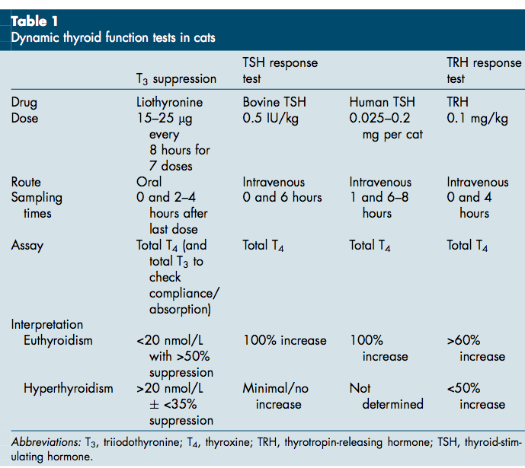

TSH response test:
May not be different between hyper and euthyroid cats, suggesting the thyroid is secreting T4 at maximal capacity or is independent of TSH
If there is a difference it may be due stimulation of normal thyroid tissue
TRH response test:
There is a limited total T4 response to TRH stimulation in hyperthyroid cats.
T3 suppression test:
- The T3 suppression test relies on the ability of administered liothyronine, through negative feedback, to decrease T4 production by the thyroid gland.
- In hyperthyroidism, because excess circulating thyroid hormone concentrations have already suppressed TSH production and secretion, additional T3 has minimal effect on T4 production. Therefore, the serum total T4 concentration re- mains significantly higher after liothyronine administration in hyperthyroid compared with euthyroid (healthy and sick) cats, and the percentage decrease is consequently significantly lower
- Although individual laboratories vary, as a general guideline, the postliothyronine serum total T4 concentration tends to be greater than 20 nmol/L in hyperthyroid cats and less than 20 nmol/L in euthyroid cats.
- Suppression of 50% or more is consistent with euthyroidism, whereas hyperthyroid cats rarely have values exceeding 35%.
- Although the T3 suppression test is capable of diagnosing hyperthyroidism, some authors suggest that it is most useful in confirming euthyroidism and ruling out hyperthyroidism

Questions:
1. According to this review, hyperparathyroidism is more common in hyperthyroid cats. T or F?
Answer: True
2. According to this review almost _______________% of hyperthyroid cats have detectable serum troponin I concentrations, with a marked reduction in this percentage after therapy, consistent with hyperthyroid-induced myocyte damage
  - 15%
  - 25%
  - 50%
  - 75%
Answer: C. 50%
3. What is the most common biochemical abnormality documented on hyperthyroid cats?
Answer: elevated liver enzymes
4. List 2 definitive tests for hyperthyroidism in cats
Answer: Demonstration of increased thyroidal radioisotope uptake or circulating concentrations of the thyroid hormones
5. You have a feline patient you suspect of having hyperthyroidism. You measure a Total T4 and a Free T4 and obtain the following results: low total T4 value and elevated free T4
Your patient most likely has…
  - hyperthyroidism
  - Non-thyroidal illness
Answer: B
The increased diagnostic sensitivity of free T4 measurement is complicated by a loss of specificity, because 6% to 12% of sick euthyroid cats have elevated concentrations

