Questions: Rounds 6/17/14

- Identify the following:
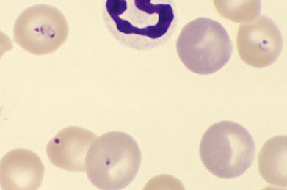

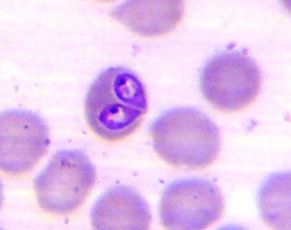

- What are the definitive hosts for Toxoplasma gondii:__________________________
- T or F: Although placental transmission can occur, ingestion of infected tissue, food, or water is the most common cause of Toxoplasma infection in cats.
- Following tachyzoite infection of a cell with Toxoplasma what are the two possible outcomes:

- T or F: Oocysts are realtively easy to find the feces of clinically affected cats.

- T or F: While toxoplasma will frequently cause uveitis in clinically affected cats, it is uncommon in clinically affected dogs.

- T or F: Oocyts shed in feces are immediately infective.

- T or F: Drug therapy can eliminate toxoplasma infection

- Which of the following is the drug of choice for treating clinical toxoplasmosis:

  - TMS
  - Clindamycin
  - Azithromycin
  - Monensin
- Describe the most common clinical form of Neosporia seen in puppies:

- In older dogs with clinical neospira infection, it is usually due to (reactivation of a chronic infection / acute infection).

- Describe the most common clinical form of Neosporia seen in older dogs:

- What are the definitive hosts for Neospira_____________________________

- T or F: Naturally infected cats showing clinical Neopsira infection has been documented.

- T or F: Treatment of young dogs with paralysis due to Neospira is often rewarding.
- T or F: Dog bites are an important route of transmission for Babesia, especially B gibsoni.
- T or F: Ticks must feed on an infected dog for 2-3 days to become infected with Babesia.
- T or F: Splenectomy is indicated for dogs with Babesia.
- T or F: thrombocytopenia is common with acute Babesia.
- Although not always successful, what drug(s) are more likely to clear Babesia infection:
  - Imidocarb
  - Clindamycin/diminazene
  - Azithromycin/atovaquone
  - Doxycycline
- Greyhounds in the US have a high prevalence of subclinical infection with:
  - Babesia canis vogeli
  - Babseia gibsoni
  - Neospira caninum
  - Toxoplama gondii
- Why is this a potentially important consideration in ECC?

