Dibartola Chp 13: Strong ion approach to acid-base disorders
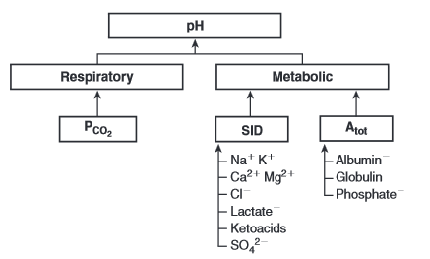
- Independent variables: [Atot], PCO2, SID
- Dependent variables: pH, HCO3
- PCO2 – interpreted as with traditional acid-base
  - Respiratory acidosis = hypoventilation
  - Respiratory alkalosis = hyperventilation
- Strong ion difference (SID)
  - Strong ions are fully dissociated at physiologic pH
  - This results in them NOT having a buffering effect
  - Do have electrical effect b/c there are more strong cations than anions
  - Act as a collective unit of positive charge
  - Most important quantitatively: Na, K, Ca, Mg, Cl, lactate, β-hydroxybutyrate, acetoacetate, and SO4
  - Not all can change in a magnitude great enough to impact SID significantly
    - Increasing Na, Cl, SO4, or organic anions
    - Decreasing Na or Cl
  - Decrease in SID = acidosis
    - Decreased Na
    - Increased Cl, SO4, organic anions
- [A_{tot}]
  - Buffer ions are derived from weak acids and are NOT fully dissociated at physiologic pH
  - pKa within 1.5 of physiologic pH can act as buffer (pKa between 5.98.9)
  - Most plasma buffers act as weak acids at physiologic pH
    - HA H+ + A-
    - Phosphate, imidazole (histidine) groups on plasma proteins
  - It is assumed that HA and A- do not take part in reactions that destroy or create HA or A-
    - [Atot] is the sum of A dissociated [A-] and undissociated [HA]
    - Should remain constant due to the law of conservation of mass
  - Increased [Atot] = acidosis
  - Decreased [Atot] = alkalosis
  - Major contributors are albumin, globulins, and phosphate
    - Can change Atot if one of these change in absolute amount (numerator effect)
    - Can change A tot if the distribution volume changes (denominator effect)
      - Changes in plasma free water for albumin and globulins
      - Changes in ECF volume for phosphate
  - Canine/feline plasma proteins have a greater net negative charge than human plasma protein
    - Canine – 1 g/dL increase in total protein decreases pH by 0.047
    - Feline – 1 g/dL increase in total protein decreases pH by 0.093
  - Phosphate concentration - divide mg/dL by 3.1 = mmol/L x valence charge (1.8) = mEq/L
- Nonvoalatile buffer alkalosis
  - Decreased albumin increases pH -> metabolic alkalosis (only cause)
    - Phosphorous cannot drop enough to cause significant alkalosis
    - Globulins usually do not decrease without concurrent decrease in albumin
  - Hypoalbuminemia complicates identification of increased unmeasured anions b/c it increases pH and decreases AG
    - Preferable to calculate SIG in these patients
- Nonvolatile buffer acidosis
  - Hyperphosphatemia can increase Atot significantly -> metabolic acidosis
    - Usually caused by kidney disease
    - Patients with kidney disease also have acidosis b/c of increase in unmeasured strong anions such as sulfate
  - Sodium bicarbonate may be used as therapy
    - Increases Na levels increases plasma SID (SI alkalosis)
    - Expands volume of ECF – which increases distribution space for phosphorous
    - Increases urine production
- SID disorders
  - Henderson-Hasselbach and SID approach are equivalent when albumin, phosphate and globulins are within normal range
  - How to change SID
    - Increase in strong anions relative to strong cations
    - Decrease strong anions relative to strong cations
    - Change in free water content of plasma with no change in strong anions/cations
- SID alkalosis = increase in SID
  - Increase in Na, decrease in Cl, decrease in free water
  - Strong cations other than sodium cannot change enough to affect SID clinically
    - Loss of free water or gain of sodium
  - Concentration alkalosis occurs when there is a free water deficit
    - All cation and anion concentrations are increased equally – thus SID increases
    - Atot is also increased (acidosis) but the SID has a greater effect on pH
    - Isotonic fluid loss (elytes do not change) does not alter SID
  - Gain of sodium – NaBicarb administration, Cushings, toxicity
  - Chloride is the only anion present in great enough quantity that a decrease can affect SID
    - If Na remains stable decreases in Cl can increase SID (hypochloremic alkalosis)
    - Occurs with Cl wasting diuretics, vomiting stomach contents
  - Chloride-resistant metabolic alkalosis
    - Hyperadernocorticism or hyperaldosteronism
    - Sodium retention occurs by activation of type I renal mineralocorticoid receptors, chloride wasting occurs and SID cannot be corrected by chloride administration
- SID acidosis = decrease in SID
  - Decrease in sodium
    - Excess of free water results in dilutional acidosis
    - All strong anions are decreased proportionally and thus SID
    - Atot also decreases (alkalosis) but the change in SID alters pH more
    - CHF, Addison’s, third spacing of sodium, hypotonic IVF, GI loss of sodium
  - Increase in chloride
    - Dramatically decreases SID
    - Chloride retention – CKD, RTA, excess loss of sodium relative to chloride, 0.9% NaCl (administration of fluid with more Cl than Na compared to normal ECF composition)
    - Can Tx with NaBicarb
  - Increase in concentration of other strong anions
    - Organic anions or exogenous anions (salicylates, ethylene glycol, methanol)

- Strong anion gap (SIG)
  - Difference in charge between all unmeasured strong anions and all unmeasured strong cations
    - There are more cations than anions so it should be positive
    - SIG estimates difference btwn unmeasured strong cations and anions

    - AG estimtes difference between all unmeasured cations and anions
  - Dog SIG_{simplified} = ([alb] x 4.9) – AG
  - Cat SIG_{simplified} = ([alb] x 7.4) – AG
  - Suspect increase in unmeasured strong anions is suspected whenever SIG is less than 5
  - AG should be adjusted when hyperphosphatemia is present
    - AG _{phosphate-adjusted} = AG + (2.5 – 0.58x[Phosphate])

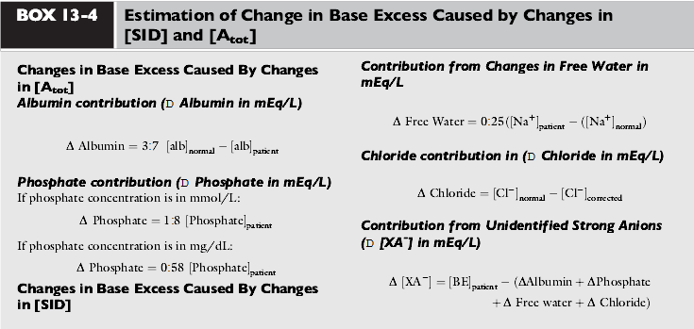

- List the independent variables based on Stewart’s approach:

- List the contributors to Atot:

- Explain how contraction alkalosis increases the SID:

- T or F: Hyponatermia will result in a metabolic acidosis due to a decrease in SID.
- T or F: Hypoalbuminemia will result in a metabolic acidosis due to a decrease in Atot.

- T or F: Hypochloremia will result in metabolic alkalosis due to a decrease in SID.

- Hyperphosphatemia increases/decreases Atot.

- T or F: There are more strong anions than cations.

