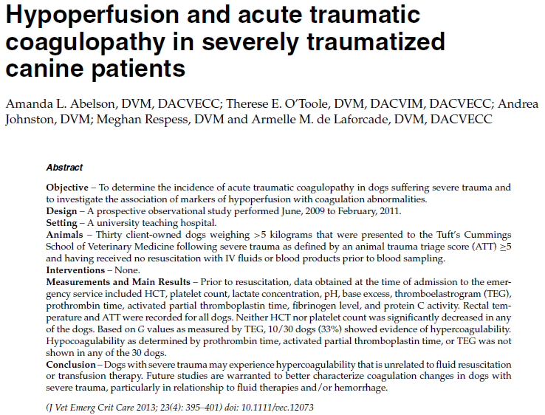

- 21/30 dogs had at least one TEG value that was in the hypercoagulable range
- 33% were considered hypercoagulable based on G value
- No association btwn G value and trauma score, pH, lactate, BE
- May be inconsistent with other studies b/c samples for this study were collected before any therapy

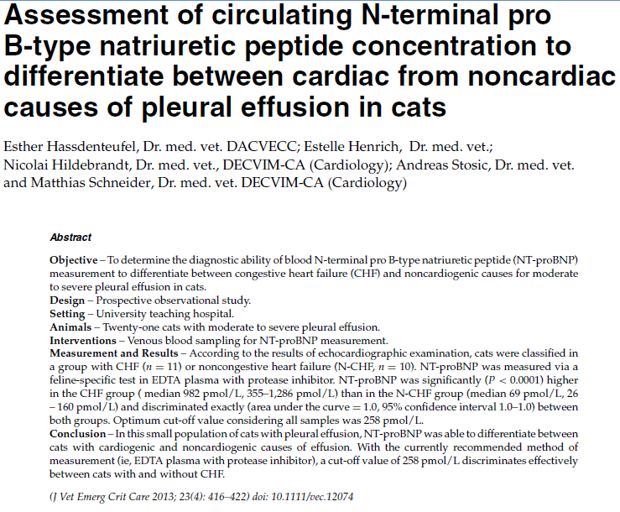
- All cats admitted to ICU w/ moderate or severe pleural effusion and had an echo performed at the request of the clinician
  - Mainly used LA & RA size on echo to determine CHF vs other cause of effusion
- EDTA plasma stored frozen in protease inhibitor tubes – sent to IDEXX lab (NOT point of care)
- Some patients had received furosemide before blood sampling/echo
- NT-proBNP significantly higher in cats with pleural effusion due to CHF, recommended cut off of 258 to distinguish

