1. A 5 year old MC Schnauzer presented with a history of depression, abnormal mentation, and vomiting. Blood work reveals a mild anemia, while on a blood smear you note nucleated RBC’s and the following:
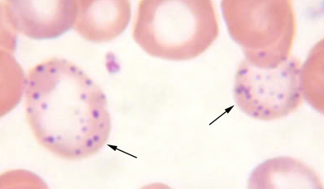
An abdominal radiograph reveals 4 small pieces of metal opacity in the small intestine, however, the owner is unwilling to consent to surgery. Which of the following drugs would be appropriate to treat the dog with?
- Calcium EDTA
- Penicillamine
- Desferoximine
- Succimer

2. Matching:
- Metronidazole Dribbling urine
- Ochratoxin A Potent vasodilator via K channels
- Minoxydil Feed refusal and vomiting
- Marijuana Central vestibular disease
- MAOI’s Cyproheptadine may reduce clinical signs
- Metaldehyde Acute kidney injury
- Deoxynivalenol Tremoring and seizures are a common sign, even at low doses

3. What is the last phase of severe iron toxicosis?
a. Severe hemolytic anemia
b. Severe GI signs including GI hemorrhage, and resultant shock
c. GI fibrosis with possible secondary obstruction
d. Death due to organ necrosis

4. IV lipid emulsion therapy may be helpful in treating which of the following:
a. MDMA
b. Ivermectin
c. Metaldehyde
d. Metronidazole
5. True or False – Aggressive supportive care and a poor prognosis is warranted with macadamia nut ingestion in dogs.
6. A 7 year old Samoyed with a history of chronic diarrhea presents for an acute onset of neurologic signs. The dog is on a medication, but the owners are unsure of the name or dose – they give one pill twice daily. Neurologic exam reveals falling and circling to the left with left proprioceptive deficits. Which of the following drugs may help shorten the duration of this dogs clinical signs?
a. Phenobarbital
b. IV lipid emulsion therapy
c. Leviteracetam
d. Diazepam

