Respiratory acid base questions:

- What is Fick’s Law?
Answer: Diffusion of gases is directly proportional to the surface area of the interface and inversely proportional to the thickness of the membrane

- Where are the most significant oxygen-sensitive chemoreceptors located?
Answer: The most significant oxygen-sensitive chemoreceptors are primarily found within the carotid body at the bifurcation of the internal and external carotid arteries. Although carotid body chemoreceptors sense changes in CO2 and pH as well, these chemoreceptors dominate the hypoxic ventilatory response and are responsible for approximately 90% of the increase in minute ventilation seen with hypoxemia. Oxygen-sensitive receptors are also found in the aortic bodies within the aortic arch. However, they appear to play a minimal role during normal ventilation. In addition to the periphery, O2-sensitive chemoreceptors are also present in the CNS, but their contribution to ventilatory control remains unclear.

- Where are the CO2/pH – sensitive receptors located
Answer: In contrast to O2-sensitive receptors, the primary CO2/pH-sensitive receptors are located in the CNS throughout the brainstem (i.e., retrotrapezoid nucleus [RTN], serotonergic and GABAergic neurons in the raphe nuclei, noradrenergic neurons in the locus coeruleus, nucleus of the solitary tract [NTS], pre- Bo ̈tzinger complex, and cerebellar fastigial nucleus). Peripheral ones are located in the carotid boides.

- Although both peripheral and central chemoreceptors contribute to CO2-induced ventilatory responses, the _________________ receptors appear to be quantitatively more significant for producing changes in ventilation mediated by CO2
Answer: Central

- The lungs are the only avenue for CO2 elimination. Carbon dioxide efficiently diffuses across the alveolar capillary wall. Thus, under most circumstances, the CO2 partial pressure is essentially the same in the alveoli (PaCO2) and arteries (PaCO2). T or F?
Answer: True

- Dissolved carbon dioxide is approximately _______________times more soluble than oxygen.
Answer: 20-24
- What is the “Chloride shift?”

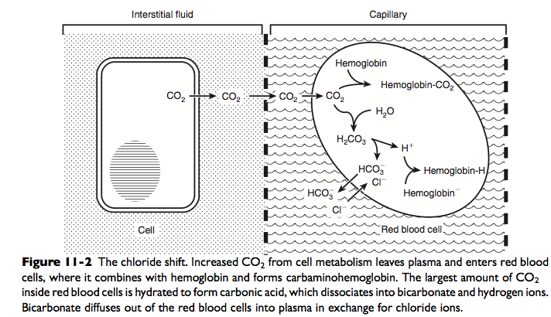

- Most of the CO2 generated from cellular metabolism is transported to the lung as bicarbonate? T or F?
Answer: True. Most of the carbon dioxide (approximately 81%) is subsequently transported to the lung as bicarbonate. A small amount is transported still dissolved in plasma (approximately 8%), and some is combined with terminal amino groups of blood proteins (approximately 11%), the most important of which is carbaminohemoglobin.

- Diffusion impairment occurs whenever there is incomplete equilibration of alveolar gas and pulmonary end- capillary blood. T or F?
Answer: True

- Please list at least 3 circumstances in which diffusion impairment may lead to the development of hypoxemia.
Answer:
- Thickening of the alveolar capillary membrane (pulmonary interstitial disease)
- Loss of alveolar capillary surface area (emphysema, vasculitis)
- High cardiac output states (exercise)

Equilibration of oxygen between the alveolus and the erythrocyte is extremely rapid under normal conditions, and this type of hypoxemia infrequently is observed in small animal medicine.
However, a diffusion impairment leading to hypoxemia may be seen with thickening of the alveolar-capillary membrane (e.g., “alveolar-capillary block” seen in diffuse pulmonary interstitial disease), or loss of alveolar or capillary surface area (e.g., emphysema or vasculitis). Although hypox- emia from a diffusion impairment may occur as a consequence of the aforementioned disease states, it also may be detected under certain circumstances of high cardiac output that markedly decrease transit time of red cells (e.g., exercise). In any case, its contribution to hypoxemia is usually negligible and a diffusion impairment seldom is the limiting factor in oxygen transfer to arterial blood

- List examples of conditions which result in a low V/Q ratio
Answer:
Conditions in which there is increased airway resistance
- Asthma
- Bronchitis
- chronic obstructive pulmonary disease
Low V-Q units (poorly ventilated, adequately perfused) can be found in patients with increased airway resistance (e.g., asthma, bronchitis, chronic obstructive pulmonary disease).
Low V-Q units have a low PaO2 and high alveolar PCO2, resulting in hypercapnic and hypoxemic blood.

- List examples of conditions which result in a high V/Q ratio
Answer:
- High V-Q ratios are found in diseases with increased compliance (e.g., emphysema) or low output states (e.g., pulmonary embolism)

High V-Q units (poorly perfused, adequately ventilated) have a high PaO2 and a low PaCO2.
In lung areas with V-Q ratios greater than 1, additional increases in ventilation do not improve oxygenation.
- In lung areas with V-Q ratios greater than 1, additional increases in ventilation do not improve oxygenation. T or F?
Answer: True.

- Patients with V-Q mismatch usually are hypoxemic but have normal or decreased PaCO2 because chemoreceptors respond to, and minute ventilation is altered by, changes in carbon dioxide levels.
Answer: True

- Hypoxemia resulting from V-Q mismatch can be corrected by increasing the fraction of inspired oxygen (FIO2) by use of 100% O2.
Answer: True

- What is a right to left shunt?
Answer: Right-to-left shunting is a severe form of V-Q mismatch and results when mixed venous blood completely bypasses ventilated pulmonary alveoli and returns to the arterial circulation.
A small amount (2% to 3%) of shunting is present in normal animals through the bronchial and thesbian circulations.
In pathologic states, shunt results from perfusion of lung areas that receive no ventilation because of atelectasis or consolidation (V-Q 1⁄4 0) or from deoxygenated blood flow through anatomic right- to-left channels. Thus shunting is the main cause for hypoxemia in pulmonary edema, atelectasis, pneumonia, and in congenital abnormal cardiac communications between the systemic and pulmonary circulations (e.g., patent ductus arteriosus, ventricular or atrial septal defect, tetralogy of Fallot) with right-to-left blood flow bypassing the lungs.
Even small amounts of shunt result in clinically relevant hypoxemia because venous blood oxygen content is extremely low and mixed venous blood is being added directly to arterial blood without alveolar gas exchange.
However, one major difference is that the PaO2 levels in animals with increased shunting fail to return to normal even with 100% O2 supplementation. In contrast, animals with V-Q mismatch, hypoventilation, or diffusion impairment exhibit pronounced increases in PaO2 with oxygen enrichment
