Small intestinal diameter in small intestinal obstruction. Vet Radiol Ultrasound 2013

Radiographic diagnosis of foreign body can be made by: gastric and intestinal dilatation by gas and/or fluid, abnormal shape of intestinal loops (hairpin curves, stacked, plication, pleating), presence of foreign material, and the gravel sign. Dilitation of obstruction of intestinal loops is the key radiographic sign.

Quantitiative radiographic criteria used:
- Diameter of a segment of the small intestine should be less than 50% of the average diameter of the small intestine.
- Ratio between maximal SI diameter and height of L5 lumbar veterbra should be less than 1.6.
  - A value of 1.97 = 80% probability of obstruction
  - A value of 2.07 = 90% probability of obstruction

Aim: Determine if the use of the SI/L5 ratio increased the accuracy of the radiographic diagnosis of intestinal obstruction in dogs.

Materials/methods: Power study indicated >78 dogs with abdominal radiographs needed to be enrolled. Cases were reviewed by students, residents and faculty, first without use of measurements, and >3 days later using measurements.

Results: 85 dogs included, 37 were obstructed, 48 non-obstructed. Causes for obstruction included FB, neopleasia, intussusception. Using SI/L5 ratio of 1.7 – specificity and sensitivity of 66%. Probability of obstruction increased with increasing SI/L5 ratio. Significantly different likelihood of obstruction at the second sitting (with measurements).

Discussion: SI/L5 ratio of 1.95 represented a 77% probability of obstruction, and 2.07 represents an 86% probability of obstruction.
Many dogs found to be obstructed at sx had no radiographically apparent intestinal dilatation (did not provide %).
Questions for SI diameter in SI obstruction

- The small intestinal to 5th lumbar vertebra (SI/L5) ratio has been found to be associated with the likelihood of an intestinal obstruction. Regarding the SI/L5 ratio, which of the following is true?
  - The probability of an intestinal obstruction did not increase with increasing SI/L5 diameter.
  - An SI/L5 ratio of 2.07 represented an 88% probability of obstruction.
  - The use of SI/L5 ratio was associated with increased accuracy for diagnosing small intestinal obstruction.
  - More experienced observers had more accurate interpretation of radiographs.
  - An SI/L5 ratio of 1.7 (for diagnosis of intestinal obstruction) was associated with a sensitivity and specificity of 78%.
- True or false: Observers performed equally well whether or not they determine the SI/L5 ratio.
- Potential causes of intestinal dilatation besides mechanical obstruction include…?

- Determine the approximate SI/L5 ratio in the following image and indicate if this is consistent with a mechanical obstruction or not.
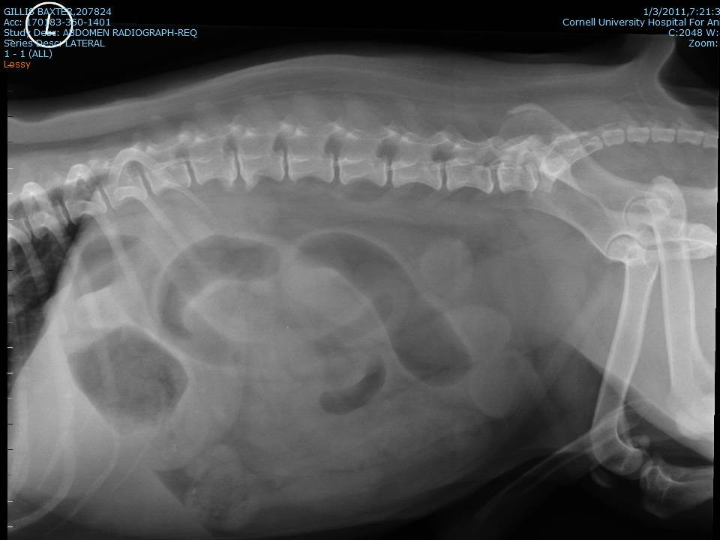

Questions for SI diameter in SI obstruction

- The small intestinal to 5th lumbar vertebra (SI/L5) ratio has been found to be associated with the likelihood of an intestinal obstruction. Regarding the SI/L5 ratio, which of the following is true?
  - The probability of an intestinal obstruction did not increase with increasing SI/L5 diameter.
  - An SI/L5 ratio of 2.07 represented an 88% probability of obstruction.
  - The use of SI/L5 ratio was associated with increased accuracy for diagnosing small intestinal obstruction.
  - More experienced observers had more accurate interpretation of radiographs.
  - An SI/L5 ratio of 1.7 (for diagnosis of intestinal obstruction) was associated with a sensitivity and specificity of 78%.
- True or false: Observers performed equally well whether or not they determine the SI/L5 ratio.
- Potential causes of intestinal dilatation besides mechanical obstruction include…?
Acute enteritis
Dysautonomia
Ileus
- Determine the approximate SI/L5 ratio in the following image and indicate if this is consistent with a mechanical obstruction or not. (1.8-2.3, yes)

Evaluation of ultrasound-guided vascular access JVECC 2013

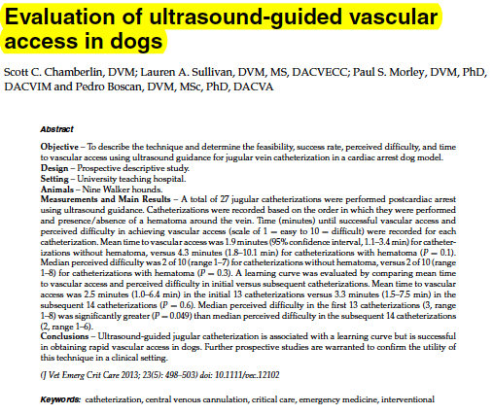
Cardiac arrest model of canines from terminal labs
Hair clipped, 18g catheters placed, confirmed as positive when >3mls blood could be aspirated
Hematoma simulated by infusion of saline around the vessel

100% ability to place catheters, with or without hematoma. NSD in time to placement
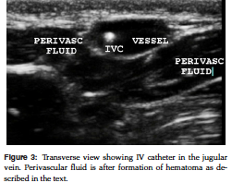
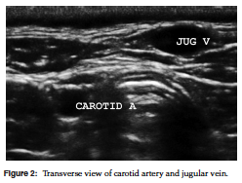

Questions for US guided vascular access

- In the study by Chamberlin et al (JVECCS 2013 Use of ultrasound-guided vascular access in dogs), the presence of a preexisting hematoma at the catheter site…
  - Decreased successful placement of catheters by 25%
  - Significantly increased time to catheter placement vs those without hematomas
  - Increased the perceived difficulty of the catheter placement
  - Had no significant impact on the placement of catheters
- True or False: This study evaluating ultrasound guided vascular access found 100% success in catheter placement, despite the presence of a simulated hematoma.
- Which of the following was found to aid the clinician in placing a catheter via ultrasound guidance in a patient suffering cardiac arrest?
  - Compression of the jugular vein distal to the venipuncture site in order to distend it and improve visualization.
  - Application of pressure via the ultrasound probe to visualize compression of the vessel.
  - Use of Doppler imaging to detect pulsatile flow of the vessel.
  - Extensive clipping of the site and use of ultrasound gel to improve contact/image quality.
  - Transverse vs longitudinal orientation of the ultrasound probe.
- Name three advantages of ultrasound guided vascular access technique as discussed in this paper.
Answers to Questions for US guided vascular access

- In the study by Chamberlin et al (JVECCS 2013 Use of ultrasound-guided vascular access in dogs), the presence of a preexisting hematoma at the catheter site…
        - Decreased successful placement of catheters by 25%
        - Significantly increased time to catheter placement vs those without hematomas
        - Increased the perceived difficulty of the catheter placement
        - Had no significant impact on the placement of catheters
- True or False: This study evaluating ultrasound guided vascular access found 100% success in catheter placement, despite the presence of a simulated hematoma.
- Which of the following was found to aid the clinician in placing a catheter via ultrasound guidance in a patient suffering cardiac arrest?
        - Compression of the jugular vein distal to the venipuncture site in order to distend it and improve visualization.
        - Application of pressure via the ultrasound probe to visualize compression of the vessel.
        - Use of Doppler imaging to detect pulsatile flow of the vessel.
        - Extensive clipping of the site and use of ultrasound gel to improve contact/image quality.
        - Transverse vs longitudinal orientation of the ultrasound probe.
- Name three advantages of ultrasound guided vascular access technique as discussed in this paper.
      - Easy, fast
      - Allowed rapid id of the vessel
      - Confirmation of catheter placement
      - Increased operator comfort with accessing larger vessels
      - Ability to place large bore catheter allowing rapid fluid and drug delivery to the central circulation

