Quantitative acid base April 22 2014

The expanded anion gap accounts for many of the usually unmeasured anions
Normal values for the expanded anion gap range between 0 and 4mEq/L
This residual anion gap is composed of the remaining unmeasured anions such as sulfates, ketones, and various amino acids.
The expanded anion gap formula moves many of the relevant players in the anion gap calculation from an unknown to a known category, which allows for a more comprehensive evaluation of the acid-base status

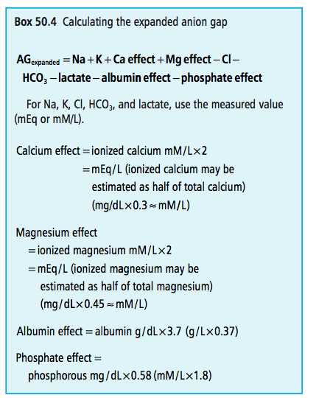

Strong Ion difference:

SID is the difference between the strongly dissociated cations and the strongly dissociated anions; however the usual formula is much abbreviated:
Na+K−Cl
The only difference between this SID formula and the traditional anion gap formula is the absence of HCO3
Decrease in SID can be used as a marker of metabolic acidosis
Increase in SID as a marker of metabolic alkalosis
Atot:

This gap is composed of the anions of weakly dissociated acids: albumin and phosphate (ATOT)
ATOT (the albumin effect and the phosphate effect), as calculated for the expanded anion gap formula (Box 50.4)
An increase in ATOT caused by hyperphosphatemia or hyperalbuminemia would be associated with a metabolic acidosis, and vice versa.
The remaining important weakly dissociated acid is
carbonic acid; the conjugate anion is bicarbonate. ATOT
and HCO3 comprise SIDeffective. SIDapparent and SIDeffective generally have a similar value because the former is an assessment of the stuff around the gap and the latter is an assessment of the stuff of the gap itself
Stewart Approach:

According to the Stewart approach, the three causes of acid-base disturbances are changes in PCO2, changes in SIDapparent, and changes in ATOT.
Bicarbonate has been relegated to “dependent” ion status, and as such it cannot primarily affect acid-base balance; it can only be affected by changes in the other parameters.
The Fencl-Leith quantitative expansion of the Stewart approach might be useful to help define individual contributions to the overall base deficit/excess

Markers of specific contributors to the metabolic component
Lactate
In lactic acidosis, lactate accumulates in the plasma as the hydrogen ion is buffered by bicarbonate; the magnitude of the lactate increase is similar to the decrease in bicarbonate (if there were no other influences on the bicarbonate concentration).
The lactate concentration can be used as a marker of the quantity of lactic acid that has been added to the extracellular fluid (ECF).
Each 1mEq or mM/L increase in lactate would have a 1mEq/L base deficit effect.
It is not the lactate anion that causes the acidosis; it is the hydrogen that came with it.
Sodium lactate (such as in lactated Ringer or Hartmann solution) is a salt, not an acid, and will have no impact, per se, on acid-base balance
If a blood sample is contaminated with sodium lactate, the measured lactate may be very high but will not be associated with an acidifying effect.

Ketones
Acetoacetate can be measured in the urine by nitroprusside reaction on most urine reagent strips.
Acetoacetate represents a much lower proportion of the ketoacids compared with β-hydroxybutyrate in ketoacidosis.
Plasma β-hydroxybutyric acid can be measured in the laboratory or with handheld instrumentation by measuring the NAD+:NADH ratio, a reduction/oxidation reaction.
The units of measure are mM/L that have a 1:1 relationship with the mEq/L contribution to the acid base balance. Plasma ketones are normally zero.

Phosphate
Plasma inorganic phosphate is commonly measured and reported as elemental phosphorous in mg/dL or mM/L in serum chemistry testing profiles.
Plasma phosphate anion is also associated with other plasma cations such as sodium, potassium, calcium, magnesium, and, of importance to the present discussion, with hydrogen as phosphoric acid.
Phosphoric acid (H3PO4) could potentially exist as:
H3PO4, H2PO41−, HPO42−,or PO43−,depending on the pH of the fluid.
At a pH of 7.4, approximately 90% of phosphoric acid exists as HPO42− and 10% exists as H2PO41−.
The hyperphosphatemia of renal disease is associated with a phosphoric acidosis. A coexistent sulfuric acidosis (another end product of protein metabolism) would be expected but is not measured.
The magnitude of the phosphoric acidosis contribution to the metabolic component can be calculated:
Change in phosphorous (in milligrams per deciliter) from normal (4 mg/ dL) × 0.58 = phosphorous effect (mEq / L)
Change in phosphorous (in mM/L) from normal (1.3 mM / L) × 1.8 = phosphorous effect (mEq / L)

Albumin:
Albumin is a multivalent anion associated with many plasma cations: sodium, potassium, calcium, magnesium, and, of concern to this discussion, hydrogen.
Hypoalbuminemia is associated with a decrease in the “H-Alb acid,” resulting in a metabolic alkalosis, whereas hyperalbuminemia is associated with an acidosis.
The impact of changes in albumin concentration on acid-base balance can be calculated:
1 g / dL (10 g / L) change in albumin concentration ×3.7 mEq/L of BD/E effect

An increase in albumin has an acidifying effect; a decrease has an alkalinizing effect

Water
Water dissociates to a small extent, in a temperature- dependent manner, into H+ and OH−.
Water has a pK of 7.00 at room temperature and a pK of 6.80 at body temperature.
Compared with the body at a pH near 7.40, water is acidic.
This acidic effect is magnified in vivo because once the water is equilibrated with existing levels of carbon dioxide it has considerable titratable acidity.
The concentration of free water is not measured, but the consequence of changes in the concentration of free water (i.e., the sodium concentration) is commonly measured.
Changes in sodium concentration are used to calculate the free water effect.
Changes in sodium, per se, do not have an impact on acid-base balance; it is not the sodium, it is the water, even though it is sometimes referred to as the “sodium effect.”
The acid-base effect of changes in water concentration is calculated as follows:
(Nameasured −Nanormal) x 0.25
An increase in free water (marked by a decrease in sodium concentration) has an acidifying effect; a decrease has an alkalinizing effect.

Chloride-bicarbonate effect
This category is sometimes referred to as the “chloride effect,” suggesting it is the chloride that has the effect. But changes in chloride concentration, per se, do not have an impact on acid-base balance.
As noted earlier, bicarbonate is a rather complex anion that is influenced by several buffer systems and respiratory handling of carbon dioxide; bicarbonate concentration is difficult to predict. Many processes in the body, however, involve the reciprocal handling of chloride and bicarbonate (i.e., when one is lost, the other is retained, and vice versa). In this manner, changes in chloride concentration can be used as a marker for the change in bicarbonate concentration that would have occurred (equal and opposite) had there been no other influences operating on the bicarbonate concentration.
Like sodium, chloride is affected by changes in water concentration. Because the effect of changes in water concentration have already been considered, effect on chloride concentration must now be eliminated from consideration. This is done by calculating an “adjusted chloride concentration” reference value:
Normal chloride concentration(110mEq/L[mM/L] in dog; 120 in cat) ± (change in sodium concentration × 0.75*)
A higher than anticipated measured chloride concentration marks a proportional base deficit effect (a metabolic acidosis); a lower than anticipated measured chloride concentration marks a base excess effect

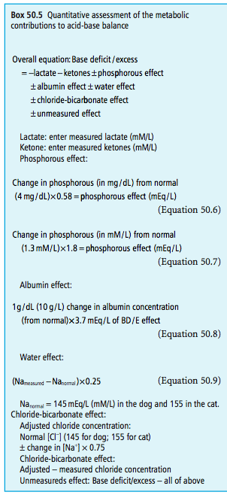
Metabolic acidosis:
Treat underlying cause
If, however, the metabolic acidosis is severe (base deficit >10mEq/L; bicarbonate concentration <14mEq/L; pH <7.2) and the underlying disease is difficult to treat, symptomatic alkalinization therapy may be indicated.
Metabolic alkalosis:
Usually mild and do not require specific therapies
On the rare occasion that acidifying therapy is warranted, a dilute solution of hydrochloric acid, lactic acid, or acetic acid could be administered.
Saline, acetazolamide, potassium-sparing diuretics (spironolactone, amiloride, and triamterene) and ammonium chloride are also acidifying therapies.
Coexistent electrolyte abnormalities such as hypochloremia and hypokalemia potentiate metabolic alkalosis and should be treated.

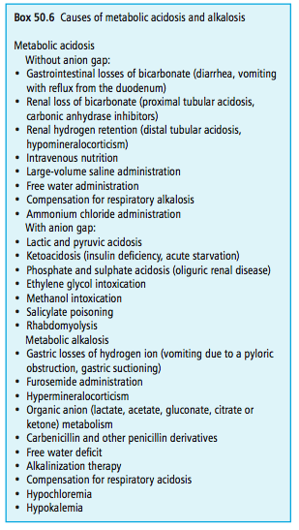
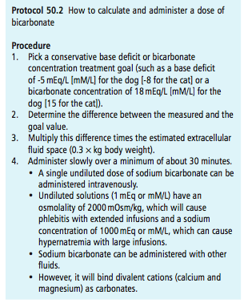
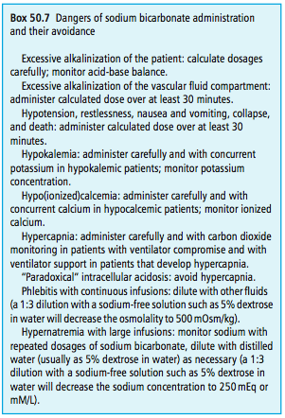

Compensation:

The general concept is that compensatory mechanisms do not over- compensate.
Therefore, the component that varies in the same direction as the pH is probably the primary abnormality, whereas the component that varies in a direction opposite to that of pH is probably the secondary, compensatory abnormality.

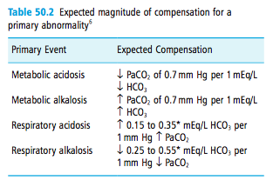

Buffers:

Buffers are acid-base pairs with pK values near 7.4.
The pK is the pH at which an acid or base is 50% undissociated and 50% dissociated.
Buffers combine with acids and bases so as to eliminate much of their influence on pH.
The primary buffer systems are:
carbonic acid–bicarbonate (pK 6.1)
phosphoric acid–phosphate ( H2PO4− − HPO42− ) (pK 6.8),
Various proteins (hemoglobin, albumin, intracellular) (HPr – Pr−) (pK 5.5–8.5).

Acid base impact of crystalloid solutions:

Granular sodium chloride, sodium lactate, sodium acetate, sodium gluconate, and sodium citrate have no acid-base impact when added to whole blood in vitro.
Sodium and the respective anion increase in proportion to the amount added and SID changes (decreases with sodium chloride; increases with sodium lactate, acetate, gluconate, and citrate), but pH does not change. The same would be true in vivo if the organic anions (lactate, acetate, gluconate, and citrate) were not metabolized.
The addition of distilled water to whole blood has an acidifying effect by two mechanisms. First, distilled water at body temperature has a pH of about 6.8 and is therefore acid when compared with plasma at a pH of 7.4.
Water itself has very little titratable acidity (0.2 mM/L), which means that its addition would have little quantitative effect on acid-base balance. But when water is equilibrated to a PCO2 of 40mm Hg, the carbonic acid–bicarbonate buffer system is “activated,” the pH decreases to between 4.9 and 5.6, and the titratable acidity increases to 24mM/L.
Second, the water dilutes the bicarbonate concentration (to a proportionately greater extent than it does the hydrogen concentration) causing carbonic acid to dissociate, which adds more hydrogen ions to the milieu.
When sodium chloride, sodium lactate, sodium acetate, sodium gluconate, and sodium citrate solutions are added to whole blood in vitro, they will have a mild acidifying effect similar to that of adding the same amount of distilled water.
It is the water, not the electrolytes, that causes the initial acidifying effect. The same thing occurs when these solutions are initially administered to patients (before the anions are not metabolized). With saline, the chloride is not metabolized, but the bicarbonate is diluted and a mild metabolic acidosis would occur until the animal compensated.
The organic anions of the remaining sodium solutions are metabolized. As they are metabolized, an equal number of hydrogen ions are also removed. As the hydrogen ions are removed from the plasma, additional carbonic acid dissociates and bicarbonate is generated. These organic anions are not metabolized to bicarbonate; they are replaced by bicarbonate (via new carbonic acid dissociation). So the metabolism of these organic anions has an alkalinizing effect and the magnitude of the alkalinization depends on their relative concentration in the crystalloid compared with that of bicarbonate in plasma.
In lactated Ringer and Hartmann solutions, where the lactate concentration is about the same as plasma, there will be minimal net effect on acid-base. In Normosol R and Plasmalyte 148, where the acetate plus gluconate concentrations far exceed plasma bicarbonate, there will be a net alkalinizing effect.
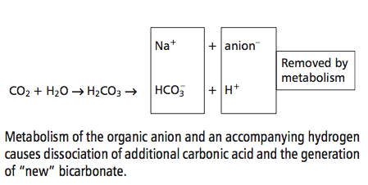

Questions:

- Your patient has a plasma HCO3- of 10meq/L and a body weight of 20kg. calculate the bicarbonate deficit.
Answer: Bicarb deficit x 0.3 x BW(kg)
(20- 10) x 0.3 x 20 = 60

- What is the equation of the expanded anion gap?
Answer:
AG = Na⁺ + K⁺ + Ca effect + Mg effect – Cl⁻ - HCO3⁻ - albumin effect – phosphate effect

- List 3 primary buffer systems as outlined in this text
Answer:
- carbonic acid–bicarbonate (pK 6.1)
- phosphoric acid–phosphate ( H2PO4− − HPO42− ) (pK 6.8),
- Various proteins (hemoglobin, albumin, intracellular) (HPr – Pr−) (pK 5.5–8.5)

- Write the overall equation for the quantitative assessments of the metabolic contributions to acid base balance on the overall base excess
Answer:

BE/BD = - lactate – ketones +/- phosphorous effect +/- albumin effect +/- water effect +/- chloride-bicarbonate effect +/- unmeasured effect

