The use of Na-Cl difference and Cl/Na ratio as SID surrogates in the evaluation of metabolic acidosis in critically ill patients
Nagaoka et al Journal of Critical Care 2010
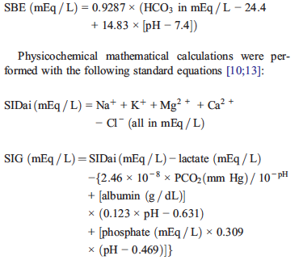

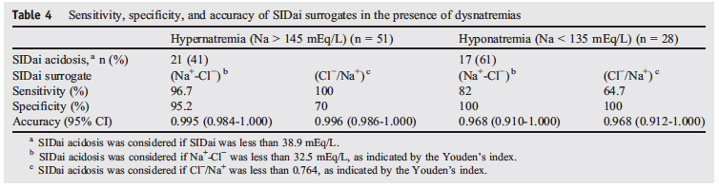
Both Na-Cl and Cl/Na are good tools for identifying SIDai acidosis. In patients with dysnatremias, Na-Cl is an easy and accurate tool for SIDai acidosis diagnosis.

Questions –

- True or False: The Na-Cl difference has been shown to be an accurate surrogate of the strong ion difference in the presence of dysnatremias.
- True or False: The normal Na-Cl difference is 35 mEq/L.
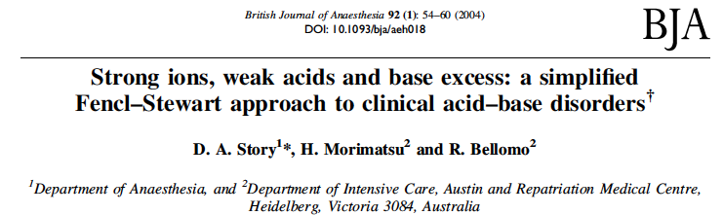

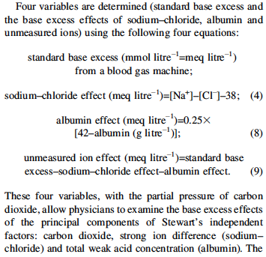

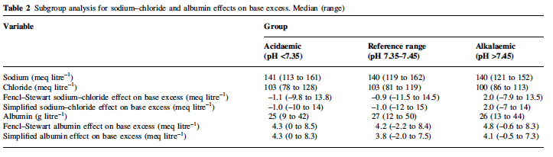
This study indicated that the four simplified equations above had good agreement with the more complex equations, and made for easier direct application of Stewart’s acid base approach.

