Experimental Determination of Net Protein Charge and Atot and Ka of Nonvolatile Buffers in Canine Plasma
Peter D. Constable and Henry R. Stampfli

- Total concentration of plasma nonvolatile buffers (albumin, globulin and phos) = Atot
- Effective dissociation constant for plasma weak acids = Ka
- Calculated SID for normal canine plasma (using Na, K, Ca, Mg, Cl and L-lactate) and a total protein of 64 g/L was 27 mEq/L
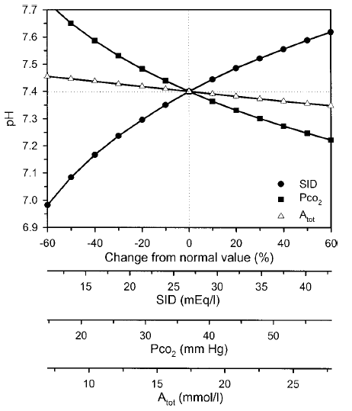
- Net protein charge for normal canine plasma was 0.25 mEq/g/L of total protein or 0.42 mEq/g/L of albumin
- All of the studies that have applied the strong ion approach to acid-base disturbances in dogs assumed that values for Atot and the net protein charge were similar in canine plasma to human plasma
- SID - [HCO3- ] - [Atot] = 0 There for SBE should ~0
- Albumin adjusted AG =
  - AG + 0.42 X (37.7 – Albumin) in g/L
  - AG + 4.2 X (3.8 – Albumin) in g/dL
- Total protein adjusted AG =
  - AG + 0.25 X (63.7 -TP) in g/L
  - AG + 2.5 X (6.4 – TP) in g/dL

- If pH is assumed to be 7.40 we can simplify strong ion gap equation to:
  - SIG = ([Albumin] X 0.49 – AG) in g/L or = ([Albumin] X 4.9 – AG) in g/dL
  - SIG = ([Total Protein] X 0.29 – AG) in g/L or = ([Total Protein] X 2.9 – AG) in g/dL
- SIG is approximately 0 mEq/L with either the albumin or total protein concentration
- 95% confidence interval for SIG being -5.0 to +5.4 mEq/L for albumin and -6.0 to +6.3 mEq/L for total protein
- A SIG >5 mEq/L therefore indicates an increase in unidentified strong cations (a rare event)
- A SIG <-5 mEq/L indicates an increase in unidentified strong anions, such as L-lactate

Effects of fluid therapy on total protein and its influence on calculated unmeasured anions in the anesthetized dog
Alexander Valverde, DVM, DVSc, Dip. ACVA; M. Erin Hatcher, DVM and Henry R. Sta¨mpfli, DVM,
Dr. Med. Vet., Dip. DACVA, DACVIM
- Determine the effects of IV lactated Ringer’s solution at a rate of 10 mL/kg/h in anesthetized dogs on total protein (TP) measurement and calculation of unmeasured anions (UAs) using 2 quantitative methods of acid-base status determination, strong ion gap, and modified base deficit
- Forty-three dogs undergoing surgery under general anesthesia were given approximately 10 mL/kg of lactated Ringer’s solution over 1 hour.
- Arterial blood analyses, electrolytes, lactate, Hgb, PCV, and TP were performed immediately after induction and again after fluids
- UAs were determined using strong ion gap and modified base deficit methods
- Fluid replacement for 1 hour decreased TP, Hgb, and PCV by 8%, 7.8%, and 8.6%, respectively
- Degree of decrease in TP did not impact the calculation of UAs by quantitative methods when the prefluid administration TP value was used instead of the post fluid TP value in the calculation
- The two methods showed a low correlation and marked differences in the precision
- MBD = base deficit/excess – (Water effect + Cl effect + TP effect + lactate)
- Water/Na effect = 0.25( Na measured – Na normal)
- Cl effect = Normal Cl X (Normal Na/measured Na)
- TP effect used = 0.3 X (61-measured TP in g/L) or 3X (6.1 – TP in g/dL)
- SIG = AG – ([0.25 X TP measured] + lactate)
- SIG may be more specific in detecting the presence of unmeasured strong ions (such as lactate) in plasma than AG because it quantifies the effects of anions such as albumin, globulins, and phosphate in its estimations

