Humoral Hypercalcemia of Malignancy: Diagnosis and Treatment

Compenduim 2003

ABSTRACT: The diagnosis of humoral hypercalcemia of malignancy begins with a thorough history and physical examination. After confirming the presence of true hypercalcemia, the diagnostic plan should be developed to include testing such as radiography of the thorax and abdomen; ultrasonography of the abdomen; aspiration cytology of lymph nodes and bone marrow; and, potentially, specialized blood tests to determine parathyroid hormone, parathyroid hormone–related protein, ionized calcium, and calcidiol levels. Supportive therapy with diuresis and additional drug therapy (e.g., diuretics and glucocorticoids as needed) helps protect the body from the detrimental effects of hypercalcemia until an etiologic diagnosis is made and more specific therapy initiated. In refractory cases, other therapies, including salmon calcitonin, bisphosphonates, and sodium bicarbonate, may be indicated. Most patients have a good quality of life while the underlying cancer is in remission.
Summary:
The first diagnostic step when hypercalcemia is detected on a routine serum biochemistry panel should be to confirm that it is real.
Ideally, a fasting sample should be submitted because sample conditions (lipemia or hemolysis) can artifactually increase the total serum Ca++ values reported by colorimetric analyzers.
After confirming the presence of elevated Ca on a fasted sample, an ionized Ca value should be determined because it is a better reflection of the biologically active form of Ca
Samples used for ionized Ca determination should be handled anaerobically (similarly to a blood gas sample) and according to reference laboratory guidelines because pH, temperature, and carbon dioxide content can alter reported ionized Ca values
In healthy dogs, ionized Ca values can be estimated from the total serum values: Ionized Ca is approximately 55% of the total serum Ca. n adult dogs (older than 12 months of age), accuracy can be further improved by first correcting the total serum Ca for the serum albumin concentrations as follows

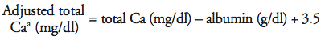
Unfortunately, the concentration of ionized Ca can not be accurately estimated in cats or sick dogs based on a percentage of total serum Ca because it is affected by many factors, including pH, serum protein concentrations and affinity, and complexed Ca concentrations.
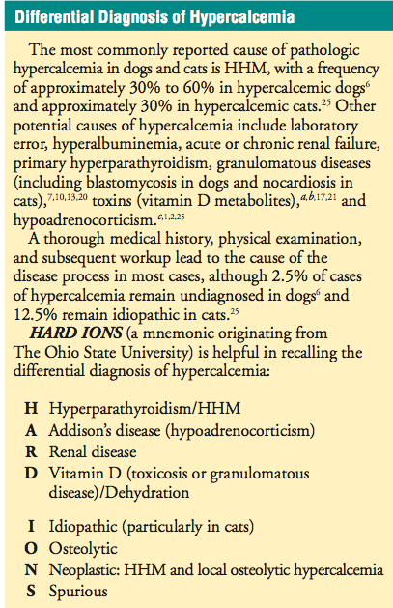

Because the most commonly reported cause of HHM is lymphosarcoma, evaluation of peripheral lymph nodes with aspiration cytology (even if they are normal on palpation) is warranted in patients with unexplained hypercalcemia
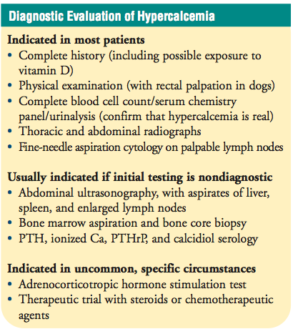
Differentiating humoral hypercalcemia of malignancy with secondary renal dysfunction from renal disease with secondary hypercalcemia can be difficult. This is especially difficult in patients with marked azotemia and marked hypercalcemia.
With HHM, the serum phosphorus (P) value should be low to normal because parathyroid hormone (PTH)–related protein (PTHrP) causes renal Ca reabsorption with phosphorus (P) excretion, whereas, with renal failure, the serum P level is often elevated.
The ionized Ca level, when available, is valuable for differentiating the two conditions: With renal failure, the ionized Ca level is usually normal to low, whereas with HHM, the ionized Ca level is increased. Additionally, with appropriate therapy and diuresis, azotemia usually normalizes more rapidly with HHM than with chronic renal failure.
Deterioration of the patient secondary to resistant or profound hypercalcemia may dictate the need for diagnosis based on response to therapy while awaiting a serologic diagnosis. n these cases, a trial of glucocorticoids or other chemotherapeutic drugs (e.g., L-asparaginase) may help diagnose HHM. A positive response (decreased total and/or ionized Ca values) to L-asparaginase is more specific than a similar response to glucocorticoids because glucocorticoids can improve abnormal Ca homeostasis of numerous causes, including vitamin D toxicosis, hypoadrenocorticism, granulomatous disease, lymphosarcoma, and multiple myeloma.
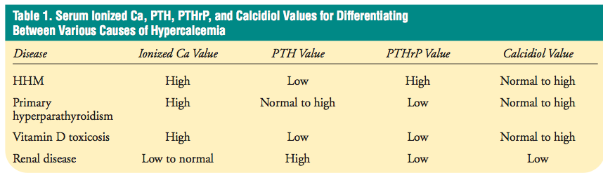

Treatment:
Physiologic saline (0.9% sodium chloride) is the fluid of choice because it is devoid of Ca, has a higher concentration of sodium (Na) to promote diuresis, and lacks the lactate in lactated Ringer’s solution.
Patient status—Cardiovascular and neurologic impairment may require more aggressive therapy.
Magnitude of hypercalcemia—A total serum Ca value greater than 16 mg/dl may call for aggressive emergency management in contrast to values of 12 to 13 mg/dl in a well-hydrated patient, which may call for minimal or no supportive care.
Ca × P product—A product of over 60 increases concerns of soft tissue mineralization.
Rate of change in the Ca value—Rapid increases of 2 to 3 mg/dl may require more aggressive therapy
Duration of hypercalcemia—Acute, significant elevations in the total serum Ca level, especially to values in excess of 16 mg/dl, may also require more aggressive therapy.

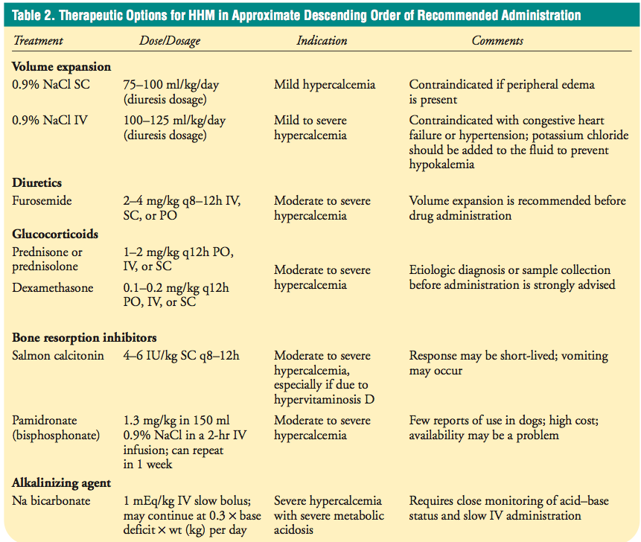

Furosemide (2 to 4 mg/kg IV q12h) promotes calciuresis by inhibiting active reabsorption of chloride in the thick ascending loop of Henle, which leads to decreased renal tubular reabsorption of Ca ions
Thiazide diuretics are contraindicated because they enhance renal tubular reabsorption of Ca2+
Glucocorticoids:
In addition to being cytotoxic to malignant lymphocytes, glucocorticoids are useful in treating hypercalcemia because they decrease the absorption of Ca from the intestines, reduce bone resorption of Ca, and enhance Ca excretion from the kidneys. Therefore, a favorable response to glucocorticoid administration is not pathognomonic for HHM.
Salmon Calictonin:
Salmon calcitonin decreases bone resorption of Ca and potentially promotes calciuresis. The disadvantages associated with the use of salmon calcitonin include high cost, high frequency of administration, and variable response rates
Bisphosphonates:
Bisphosphonates exert their effect by binding to the hydroxyap- atite of bones and decreasing osteoclastic activity and function. Pamidronate is the most commonly used bisphosphonate in veterinary medicine
Na bicarbonate:
can also be administered for hypercalcemia to help correct metabolic acidosis or to create a mild metabolic alkalosis because pH increases shift some of the ionized Ca into the protein-bound fraction. Additionally, the bicarbonate portion of Na bicarbonate can bind to ionized Ca to form Ca bicarbonate, thereby decreasing the concentration of ionized Ca.
The use of Na bicarbonate for significant hypercalcemia may precipitate soft tissue calcification, which may increase morbidity or mortality. Therefore, the risks of Na bicarbonate administration should be weighed against the potential serious complications.
Other:
Other therapies that have been mentioned in the literature but that are rarely indicated include mithramycin, Na EDTA, and peritoneal dialysis.
- Mithramycin is an antineoplastic antibiotic that has hypocalcemic effects. Unfortunately, its use as a hypocalcemic agent is limited by nephrotoxicity, hepatotoxicity, and thrombocytopenia.
- Na EDTA has also been used to treat hypercalcemia. EDTA chelates ionized Ca to form soluble complexes that are excreted via the kidneys. The usefulness of Na EDTA is limited, however, because it can be nephrotoxic.
- Peritoneal dialysis with a low Ca dialysate can be effective in treating hypercalcemia, but its use has not been reported in veterinary medicine.
Newer therapeutic approaches:
- include Ca channel blockers, somatostatin congers, nonhypercalcemic analogs of calcitriol, and Ca receptor agonists.
- Ca channel blockers, such as verapamil can be used to temporarily control hypercalcemic effects on the heart
- Somatostatin congers, nonhypercalcemic analogs of calcitriol, and Ca receptor agonists inhibit PTHrP production and are being investigated

Questions:

- Please write the equation for correction of total serum calcium for the serum albumin concentration.

- Hemolysis and lipemia may artifactually raise the total serum calcium levels on a standard serum biochemistry profile? T or F?
Answer: True

- When measuring an ionized calcium level the sample must be handled anerobically, as several factors may alter the reported iCal values. Please list 3 factors that may affect measured calcium levels, secondary to inappropriate sample handling:
Answer:
- CO2
- pH
- Temperature

- How does Furosemide promote calciuresis?
Answer: promotes calciuresis by inhibiting active reabsorption of chloride in the thick ascending loop of Henle, which leads to decreased renal tubular reabsorption of Ca ions

- Thiazide diuretics are contraindicated with hypercacemia because they enhance renal tubular reabsorption of Ca T or F?
Answer: True

- With respect to the mechanism of glucocorticoids in the treatment of hytpercalcemia, which of the statements below is correct?

A. Glucocorticoids are cytotoxic to malignant lymphocytes
B. Glucocorticoids decrease the absorption of Ca from the intestines
C. Glucocorticoids reduce bone resorption of Ca
D. Glucocorticoids enhance Ca excretion from the kidneys
E. All of the above

Answer: E

- For the following therapies/medications used in the treatment of hyperacalcemia , please list the mechanism(s) of action for reducing serum calcium levels:

Glucocorticoids:
A. Glucocorticoids are cytotoxic to malignant lymphocytes
B. Glucocorticoids decrease the absorption of Ca from the intestines
C. Glucocorticoids reduce bone resorption of Ca
D. Glucocorticoids enhance Ca excretion from the kidneys

0.9% NaCl:
Administering IV fluids to correct dehydration and promote diuresis helps decrease hypercalcemia secondary to hemoconcentration and promotes calciuresis.
Physiologic saline (0.9% sodium chloride) is the fluid of choice because it is devoid of Ca, has a higher concentration of sodium (Na) to promote diuresis, and lacks the lactate in lactated Ringer’s solution

Salmon Calcitonin:
Salmon calcitonin decreases bone resorption of Ca and potentially promotes calciuresis.

Bisphosphonates:
Bisphosphonates exert their effect by binding to the hydroxyap- atite of bones and decreasing osteoclastic activity and function.

Na Bicarbonate:
Na bicarbonate can also be administered for hypercalcemia to help correct metabolic acidosis or to create a mild metabolic alkalosis because pH increases shift some of the ionized Ca into the protein-bound fraction. Additionally, the bicarbonate portion of Na bicarbonate can bind to ionized Ca to form Ca bicarbonate, thereby decreasing the concentration of ionized Ca.

Case-control study to evaluate risk factors for the development of sepsis (neutropenia and fever) in dogs receiving chemotherapy
Karin U. Sorenmo, dvm, dacvim; Lisa P. Harwood, vmd; Lesley G. King, mvb, dacvecc, dacvim; Kenneth J. Drobatz, dvm, msce, dacvim, dacvecc
JAVMA, Vol 236, No. 6, March 15, 2010
Abstract:
Objective—To identify risk factors for development of sepsis in dogs treated with chemo- therapeutics and to evaluate the impact of sepsis on outcome.
Design—Case-control study. Animals—Client-owned dogs with various cancers undergoing standard chemotherapeutic
treatment at the University of Pennsylvania veterinary hospital.
Procedures—39 dogs with sepsis (cases) were identified through a search of the medical record database. Controls (n = 77) were randomly selected from dogs admitted during the same time period. Variables analyzed included patient demographics, tumor type, stage, remission status, treatment phase, chemotherapeutics used, and outcome.
Results—Dogs that weighed less and dogs with lymphoma were significantly more likely to become septic, compared with larger dogs or dogs with solid tumors. Septic dogs were also significantly more likely to have received doxorubicin (odds ratio [OR], 12.5; 95% con- fidence interval [CI], 2.4 to 66.0) or vincristine (OR, 9.0; 95% CI, 1.6 to 52.0) than controls. Of the 39 cases, 28 (71.8%) were in the induction phase of their protocol, and 19 of 39 (48.7%) became septic after receiving the chemotherapeutic drug for the first time. Median survival time of the cases (253 days) was not significantly different from that of the controls (371 days).
Conclusions and Clinical Relevance—Dogs that weighed less were at increased risk for chemotherapy-induced sepsis. Tumor type and chemotherapeutic drug used were also im- portant risk factors. These results may lead to the implementation of prophylactic mea- sures, especially when doxorubicin or vincristine is used in the induction phase in small dogs with lymphoma.

Key points:
Neutropenia was defined as a neutrophil count < 2,500 cells/L, and fever was defined as a rectal temperature of > 39.2oC (102.5oF). The combination of neutropenia and fever was assumed to be associated with sepsis
Risk factors for sepsis that were evaluated in the study included age, sex, breed, body weight, body condition, tumor type, tumor stage, remission status, treatment phase (for lymphomas and leukemias, induction, maintenance, and res- cue; for solid tumors, adjuvant or primary [measurable tumor]), chemotherapeutic drug or protocol for use (eg, dosage), use of corticosteroids, and single chemotherapeutic agent versus a combination of chemotherapeutic agents. Outcome and survival time were evaluated for case and control dogs.
Rottweilers were significantly (P = 0.036) less likely to be septic than were dogs of any of other breed.
There was a significant (P = 0.014) association between being a case dog (ie, developing sepsis) and having lymphoma. However, when the effect of body weight and tumor type was analyzed in a logistic regression model, tumor type was not significantly (P = 0.071) associated, but body weight was significantly associated (OR = 0.96; 95% CI, 0.93 to 0.99; P = 0.013).
Dogs that weighed less and dogs with lymphoma were significantly more likely to become septic, compared with larger dogs or dogs with solid tumors
There was no difference between the groups when evaluating body condition.
Logistic regression analysis (including the effect of chemotherapeutic drug and tumor type) revealed that both doxorubicin (OR = 12.5) and vincristine (OR = 9.0) were associated with a significantly higher risk for development of sepsis, independent of tumor type
There were no significant differences between case and control dogs regarding stage of disease (stage V vs stages I to IV for lymphoma or leukemia), metastasis (solid tumors), or remission status (lymphoma or leukemia)
There were no significant differences between case and control dogs with regard to the use of a single chemotherapeutic agent versus a combination of chemotherapeutic agents or for the frequency of dose reductions
Overall median survival time did not differ significantly between case (septic) dogs (median, 253 days; 95% CI, 132 to 411 days) and control dogs (median, 371 days; 95% CI, 263 to 487 days).
The majority (21/29 [72.4%]) of the case dogs with lymphoma or leukemia were in the induction phase of chemotherapy when they became septic, compared with 18 of 39 (46.2%) of the control dogs that were in the induction phase at the time they became septic; however, these proportions did not differ significantly
This study suggests: The results of this study are similar to those of other studies and confirm that the current practice of administration of chemotherapeutic drugs on the basis of BSA is imperfect and may lead to relative overdosing of small animals or underdosing of large animals.

Key Take Home Message: !!!!
Septic (case) dogs weighed less than did control dogs, were more likely to have lymphoma than were control dogs, and were more likely to have received doxorubicin and vincristine. In addition, most of the septic events happened early during treatment (induction phase) but did not appear to have an adverse effect on survival.
Questions:
- Median survival times were different among dogs who developed sepsis secondary to chemotherapy vs those that did not become septic. T or F?
Answer: False. MST was NOT different between the two groups

- With respect to the current study, which of the following statements is incorrect?
- Dogs that received vincristine were more likely to become septic
- A lower body weight was found to be a significant risk factor for the development of sepsis
- There was a significant association between lymphoma and developing sepsis
- Patients receiving a combination of chemotherapeutic drugs as part of their treatment protocol were more likely to become septic

No difference identified between patients receiving a single agent vs a combination

- List the 2 chemotherapeutic agents that this study identified to be associated with an increased risk for the development of sepsis.

- Doxorubricin (OR 12.5)
- Vincrtistine (OR 9)

- When evaluating the effect of body weight and tumor type in a multiple regression analysis, this study determined that tumor type was not a significant independent risk factor for the development of sepsis but was associated with body weight. T or F?
Answer: True

Principles of Cytology and Pathology – Chapter 4
Summary:
It is important to remember that certain tumour cells generally exfoliate better than others, i.e. round cells  epithelial  mesenchymal.
Impression smears taken from biopsy samples are also useful intra-operatively, especially if the type of lesion may affect the procedure and the ability to examine frozen sections is not available.
The major characteristic of active inflammation is the presence of the segmented neutrophil. Progression of inflammation to the chronic phase is characterized by the presence of macrophages in addition to neutrophils
Cytological preparations that would be non-neoplastic include ‘cystic’ structures, normal structures (e.g. fat, salivary glands) and hyperplastic tissue (reactive fibroblasts in recent scar tissue
Neoplastic tissue, by definition, means ‘new growth’ so the criteria for defining potential neoplasia on cytology are cell type and the characteristics of malignancy. Caution must be applied when using the latter criterion on cytological specimens as hyperplasia (reactive features) and neoplasia can appear cytologically very similar
If you are sure that the sample you are examining is from a tumour, the next question to resolve is whether or not it is benign or malignant.
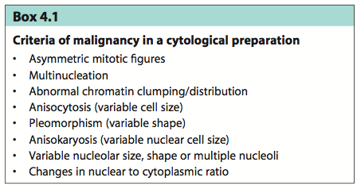

Tumours are classified into four broad categories:
- • ‘round cell’ tumours
- • epithelial cell tumours
- • mesenchymal cell tumours
- • neuroendocrine tumours.

Round cell tumors:
Exfoliate well
Common round cell tumours that can be identified on cytology include:
- lymphoma, plasma cell tumour, histiocytoma, mast cell tumour, melanoma, transmissible venereal tumour (TVT), hepatoid tumour (also may appear epithelial) and anaplastic tumors of any type
Epithelial cell tumors:
Epithelial cells exfoliate well and are typified by forming ‘rafts’ of cells with definite borders between cells because of the presence of tight junctions giving the appearance of a cobble- stone pattern
Mesenchymal cell tumors:
Cells of mesenchymal origin do not, as a rule, exfoliate well. Often a low yield of cells on an aspirate can be suggestive of mesenchymal origin (e.g. a sarcoma)
On cytology these cells often have indistinct cell borders so it is difficult to delineate the end of the cytoplasmic border of one cell and the beginning of the next cell.
The individual cells are elongated with central or eccentric nuclei
Neuroendocrine tumors:
These relatively rare tumors are characterized by possessing round to oval nuclei, often located within a ‘sea’ of cytoplasm. Some discrete cells may have granular or finely vacuolated cytoplasm and features of malignancy may be very subtle

Cytologic evaluation of lymph nodes:
Evaluation of regional lymph nodes is an essential part of staging and, depending on the tumour type (mast cell tumours, epithelial tumours, melanomas), the lymph nodes can be the first site of dissemination.
Sarcomas more typically spread haematogenously, but aggressive sarcomas can also involve the regional lymph nodes.
Whenever possible the sentinel node should be removed at the time of surgery, irrespective of the results of cytology.
Cytologic evaluation of effusions:
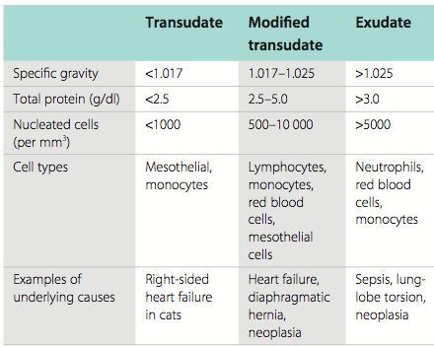
Chylous effusions:
- Chylous effusions can result from neoplastic and non- neoplastic conditions and are a consequence of leakage from the thoracic duct or other lymphatics.
- They are characterized by sudanophilic droplets (chylomicra) with triglyceride levels greater than in serum, the latter being the most diagnostic test
- The fluid clears on alkalinization and ether extraction
- the predominant cell population is small lymphocytes.
- Differentials include feline cardiac disease, thoracic duct rupture and lymphatic obstruction (neoplastic or non-neoplastic).
Pseudochylous effusion:
- A pseudochylous effusion must be differentiated from a true chylous effusion and is characterized by the absence of Sudan staining, failure to clear with ether (although some clear with alkalinization) and triglyceride levels lower than in serum; small lymphocytes are the predominant population.
- Differentials include feline cardiac disease.
Hemorrhagic effusion:
- Haemorrhagic effusions are characterized by the packed cell volume (PCV) of the effusion being close to that of the peripheral blood PCV. An effusion may look bloody but the PCV of the fluid must always be checked against the circulatory PCV.

Malignant effusions:
Pericardial effusion:
A number of studies have looked at cytology, pH and other biochemical variables, but all studies had significant overlap between the two groups (Laforcade et al 2005) or contradictory values were obtained (Edwards 1996, Fine et al 2003), meaning that although cytological evaluation of the fluid is helpful, ultimately it is the visualiza- tion of tumour that distinguishes neoplastic effusion from idiopathic.
Histopathology:
In addition to the diagnosis, biopsy material also allows the malignant poten- tial of the tumour to be characterized based on the degree of differentiation, invasion, necrosis, destruction of surrounding normal tissue and the presence of micrometastases within small blood vessels and lymphatics.
Tissue should be placed in neutral buffered formalin at a volume of 1 part tissue to 10 parts formalin (10%) to allow for adequate fixation. Tissue pieces greater than 1–2 cm may require incisions to be made into the tissue to allow penetration of the fixative: this can be done in a ‘bread loaf’ pattern allowing multiple cuts into one surface but leaving the other surface intact to preserve orientation.
Special stains:
The most common application of immunohistochemistry is in lympho- mas to differentiate between T and B cells, as this is of prog- nostic significance. With the apparent increase in the diagnosis of histiocytic disease, it is advisable for any tumour that might possibly be histiocytic in origin to have definitive immunohis- tochemistry performed
Flow cytometry makes it possible to distinguish myeloid from lymphoid leukaemias and to classify lymphoid leukaemias and lymphomas accurately by immunophenotype
