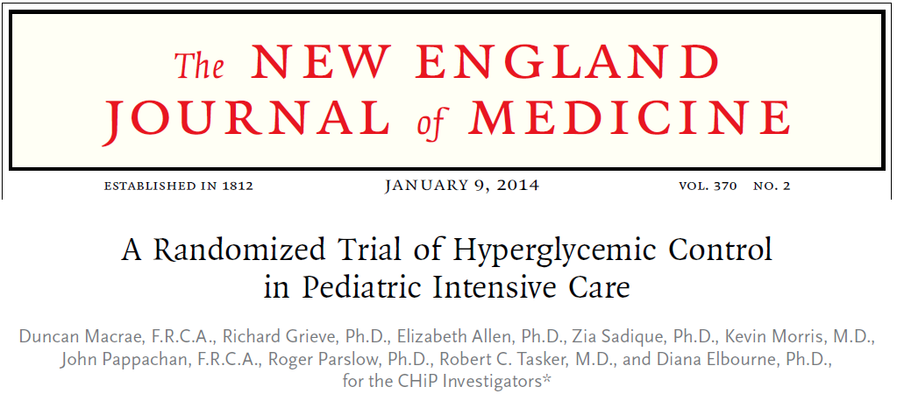
Objective: Whether an insulin infusion should be used for tight control of hyperglycemia in critically ill children.
Methods: Randomly assigned children (≤16 years of age) who were admitted to the pediatric intensive care unit (ICU) and were expected to require mechanical ventilation and vasoactive drugs for at least 12 hours to either tight glycemic control, with a target blood glucose range of 72 to 126 mg per deciliter (4.0 to 7.0 mmol per liter), or conventional glycemic control, with a target level below 216 mg per deciliter (12.0 mmol per liter). The primary outcome was the number of days alive and free from mechanical ventilation at 30 days after randomization. The main prespecified subgroup analysis compared children who had undergone cardiac surgery with those who had not. We also assessed costs of hospital and community health services.
Results: A total of 1369 patients at 13 centers in England underwent randomization: 694 to tight glycemic control and 675 to conventional glycemic control; 60% had undergone cardiac surgery. The mean between-group difference in the number of days alive and free from mechanical ventilation at 30 days was 0.36 days (95% confidence interval [CI], −0.42 to 1.14); the effects did not differ according to subgroup. Severe hypoglycemia (blood glucose, <36 mg per deciliter [2.0 mmol per liter]) occurred in a higher proportion of children in the tight-glycemic-control group than in the conventional glycemic-control group (7.3% vs. 1.5%, P<0.001). Overall, the mean 12-month costs were lower in the tight-glycemic-control group than in the conventional-glycemic control group. The mean 12-month costs were similar in the two groups in the cardiac-surgery subgroup, but in the subgroup that had not undergone cardiac surgery, the mean cost was significantly lower in the tight-glycemic-control group than in the conventional-glycemic-control group: −$13,120 (95% CI, −$24,682 to −$1,559).
Conclusions: This multicenter, randomized trial showed that tight glycemic control in critically ill children had no significant effect on major clinical outcomes, although the incidence of hypoglycemia was higher with tight glucose control than with conventional glucose control.
Other Key Points:
- 1369 critically ill children, at 13 pediatric ICUs in England, who were undergoing mechanical ventilation and receiving vasoactive medications
- Primary outcome was the number of days alive and free from mechanical ventilation at 30 days
  - Also assessed other critical care outcomes, as well as the number of days in the hospital and health care costs over a 12-month period
- In the subgroup of patients who had not undergone cardiac surgery, the average length of stay in the hospital up to 1 year follow up was 13.5 days shorter with tight glycemic control than with conventional glycemic control
- Per-patient health care costs were $13,000 less in the tight-glycemic-control group and were not due to early mortality
- Use of renal-replacement therapies was significantly lower in the tight-glycemic-control group than in the conventional-glycemic control group, although renal function was not reported

