- Increased secretion of epinephrine is most likely to cause increased…
  - Triglyceride storage
  - Glycogen synthesis
  - Muscle protein synthesis
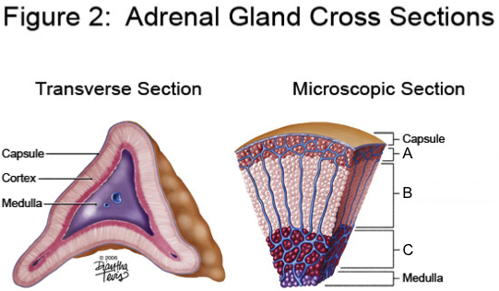
  - Gluconeogenesis
  - Physiology Text, Constanza

- Selective destruction of the section labeled “A” in Figure 2, would produce a deficiency of which hormone?
  - Aldosterone
  - Androstenedione
  - Cortisol
  - Dehydroepiandrosterone
  - Physiology Text, Constanza

- Which of the following decreases the conversion of 25-hydroxycholecalciferol to 1,25-dihydroxycholecalciferol?
  - A diet low in calcium
  - Hypocalcemia
  - Hypophosphatemia
  - Chronic renal failure
  - Physiology Text, Constanza

- Which of the following is a direct effect of parathyroid hormone?
  - Increased osteoclast activity
  - Reduced 1 α-hydroxylase activity
  - Increased intestinal synthesis of calcium-binding protein
  - Increased renal tubular phosphate reabsorption
  - Physiology Text, Constanza

- A decrease in plasma ionized calcium together with an increase in parathyroid hormone level is most likely to be found in a patient with…
  - Hypoparathyroidism
  - Primary hyperparathyroidism
  - Vitamin D deficiency
  - Calcitonin deficiency
  - Physiology Text, Constanza

- After secretion by the beta cell, insulin reaches the _________________ first before being carried in the circulation to other insulin target organs.
  - Muscle
  - Adipose tissue
  - Liver
  - Kidney
  - Physiology Text, Constanza

- Which of the following is most likely to decrease secretion of adrenocorticotropic hormone?
  - Administration of dexamethasone
  - Hypoglycemia
  - Surgical removal of one adrenal gland
  - Physical trauma
  - Physiology Text, Constanza

- A patient with untreated diabetes mellitus is most likely to have increased…
  - Muscle glucose uptake
  - Lipolysis
  - Hepatic glycogen synthesis
  - Muscle protein synthesis
  - Physiology Text, Constanza

- Which of the following hormones is least likely to increase during stress?
  - Calcitonin
  - Glucagon
  - Growth hormone
  - Cortisol
  - Physiology Text, Constanza

- Which of the hormones listed below modulates the glomerular filtration rate by acting on smooth muscle cells that control blood flow through the afferent arteriole?
  - 1,25-dihydroxycholecalciferol
  - Aldosterone
  - Angiotensin II
  - Parathyroid
  - Vasopressin
  - Physiology Text, Constanza

- Which of the hormones listed below increases active transport of calcium via transcellular pathways in the distal convoluted tubule?
  - 1,25-dihydroxycholecalciferol
  - Aldosterone
  - Angiotensin II
  - Parathyroid
  - Vasopressin
  - Physiology Text, Constanza

- Which of the hormones listed below increases sodium reabsorption in the distal convoluted tubule?
  - 1,25-dihydroxycholecalciferol
  - Aldosterone
  - Angiotensin II
  - Parathyroid
  - Vasopressin
  - Physiology Text, Constanza

- Which of the hormones listed below decreases phosphate reabsorption in the proximal convoluted tubule?
  - 1,25-dihydroxycholecalciferol
  - Aldosterone
  - Angiotensin II
  - Parathyroid
  - Vasopressin
  - Physiology Text, Constanza

- Which of the hormones listed below is the primary effector in the collecting ducts where it increases the permeability of the apical membrane to water?
  - 1,25-dihydroxycholecalciferol
  - Aldosterone
  - Angiotensin II
  - Parathyroid
  - Vasopressin
  - Physiology Text, Constanza

- True or False: Mitotane is considered an adrenocorticostatic drug, whereas trilostane is adrenocorticolytic.
  - A Comparison of Factors that Influence Survival in Dogs with Adrenal-Dependent Hyperadrenocorticism Treated with Mitotane or Trilostane. JVIM 2011;25:251–260

- Given the following thyroid panel results in a 9-year-old MC Lab, hat is the most likely diagnosis?
TSH: normal Total T4: ↓ Free T4: normal TGAA: positive
  - Primary hypothyroidism
  - Sick euthyroid syndrome
  - Lymphocytic thyroiditis
  - Congenital hypothyroidism
  - Mooney CT. Canine Hypothyroidism: A Review Of Aetiology And Diagnosis. New Zealand Veterinary Journal. 2011;59:105-114

- Adrenocortical tumors and pituitary dependent hyperadrenocorticism but not pheochromocytomas are associated with increased serum inhibin concentration.
  - Serum Inhibin Concentration in Dogs with Adrenal Gland Disease and in Healthy Dogs. JVIM 2013;27:76–82.

- True or False: Octreotide is a long acting glucagon analogue.
  - Insulinoma in Dogs: A Review JAAHA 2012; 48:151–163.

- Monoiodotyrosine (MIT) + diiodotyrosine (DIT) forms 3,5,3’-Triiodothyronine (T3), while diiodotyrosine (DIT) + diiodotyrosine (DIT) forms 3,5,3’5’-Tetraiodothyronine (thyroxine, or T4).
  - Finora K, Greco D. Hypothyroidism And Myxedema Coma. Compendium on Continuing Education for the Practicing Veterinarian. 2007;29:19-31.

- A golden retriever who is undergoing treatment for stage V lymphoma received doxorubicin at an appropriate dose one week ago. It presents to your clinic for lethargy and anorexia with a fever of 103.5F. CBC revealed 0.5K/ul neutrophils. You elect to hospitalize the patient. Which of the following is true regarding chemotherapy drug reaction?
  - Doxorubicin can be used in this patient with dose reduction because this is a Type B adverse drug event.
  - Anemia is expected in 2-3 weeks due to the effect of doxorubicin on the bone marrow.
  - This is an example of a dose dependent adverse drug reaction, due to the high potential for myelotoxicity of doxorubicin.
  - Neutropenia occurs in 5-7 days, as that is the half-life of neutrophils.
  - Compendium 2012 – Drug Associated Blood Cell Dyscrasias.

- Which of the following are examples of Type A adverse drug reactions?
  - Bone marrow suppression due to use of azathioprine in treatment of canine IMHA
  - Polyarthropathies due to use of sulfonamides in a dog
  - Development of methemoglobinemia due to acetaminophen ingestion in a dog
  - Aplastic anemia due in a dog undergoing therapy for prostatic hyperplasia
  - Compendium 2012 – Drug Associated Blood Cell Dyscrasias.

- In the treatment of a dog with immune-mediated hemolytic anemia that is not responding to glucocorticoid therapy as expected, you elect to begin a second immunomodulatory drug. Which of the following would be an appropriate option and why?
  - Cyclophosphamide – Cyclophosphamide has been used to suppress cell mediated immunity and humoral immunity, and has little toxicity.
  - Cyclosporine (aka ciclosporin for the Canadians and the Brit) – cyclosporine can be used for its effect on blocking transcription genes required for T cell activation, especially IL6.
  - Danazol – because we want to pump-you-up! It is a synthetic androgen reported to down regulate macrophage Fc receptor expression.
  - Mycophenolate mofetil – MMF is a reversible inhibitor of a key enzyme in the de novo purine synthesis, required for T and B cell maturation. It has been shown to begin inhibiting the enzyme within 4 hours.
  - JSAP 2011 – Whitley and Day – Immunomodulatory Drugs and Their Application to the Mgt of Canine Immune-Mediated Disease.

- In completing your resident research project and bribing the statistician to provide you the numbers that you want to see to reject your null hypothesis when in reality your study failed to reject the null hypothesis, you have committed
  - A type 1 error
  - A type 2 error
  - A false negative
  - A false positive
  - That thing Dan sent out on Type 1 and Type 2 errors…

- A dog with an adrenal tumor is admitted for surgery. Based on the findings of Barrera et al (JAVMA 2013), what is the likely outcome of this case?
  - The tumor is most likely a pheochromocytoma, and the patient should be on alpha-adrenergic blocking drugs prior to anesthesia as this was associated with improved outcomes.
  - Since the tumor is already invading the caudal vena cava, it is not surgically resectable.
  - The presence of tumor invasion is associated with higher post-op mortality rate.
  - A pheochromocytoma was associated with better survival times in contrast to carcinomas.
  - Barrera JAVMA 2013 Evaluation of Risk Factors for Outcome Assoc with Adrenal Gland Tumors.

- What is the principal site of the immunomodulatory effects of opioids?
  - Adrenal glad zona glomerulosa
  - Posterior pituitary gland
  - Anterior pineal gland
  - Periaqueductal grey matter
  - Odunayo A. Dodam JR, Kerl ME, Declue AE. Immunomodulatory Effects Of Opioids. JVECC 2010; 20(4): 276-385

- You are managing a mechanically ventilated dog with ARDS. The dog has been stable on its current settings until now. You are called to investigate after the dog’s oxygen saturation falls from 92 to 87%. The dog has recently been turned from left to right lateral recumbency. You see the following volume-time scalar:
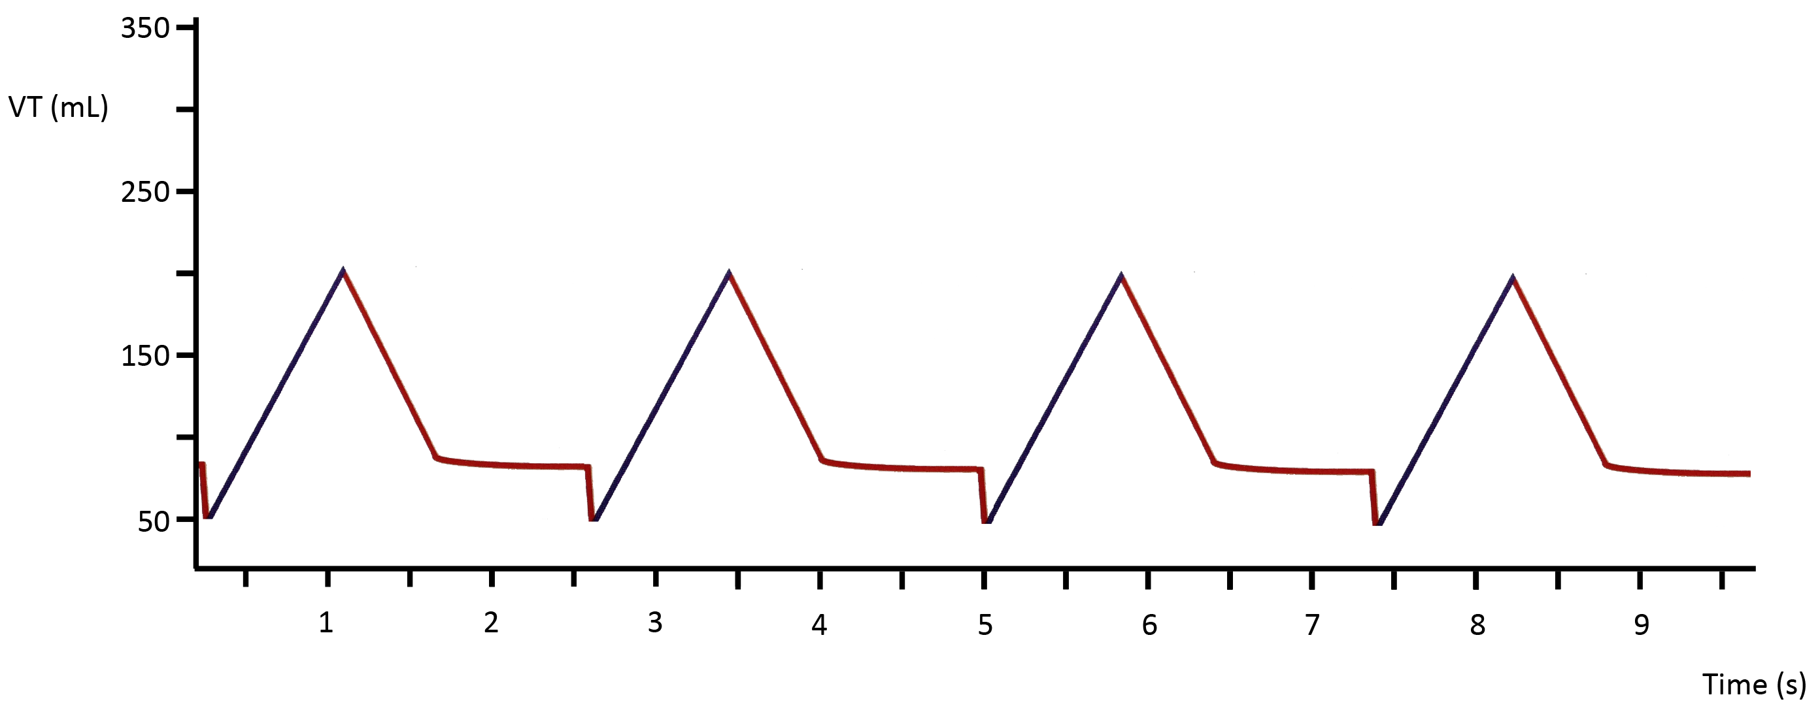
  - Displaced ET tube
  - Bronchoconstriction
  - Atelectasis in left lung
  - Airway secretions
  - Pierce LNB. Management Of The Mechanically Ventilated Patient. 2007. 2nd Edition. Saunders. St Louis.

- What is the single best assay for the diagnosis of pheochromocytoma in the dog?
  - Plasma vanillylmandelic acid
  - Urine epinephrine:cortisol ratio
  - Plasma free normetanephrine
  - Urine inhibin
  - Cameron KN, Monroe WE, Panciera DL, Magnin-Bissel GC. The Effects Of Illness On Urinary Catecholamines And Their Metabolites In Dogs. JVIM 2010; 24:1329-1336.
  - Bromel C, Nelson RW, Feldman EC et al. Serum Inhibin Concentration In Dogs With Adrenal Gland Disease And In Healthy Dogs. JVIM 2013;27:76–82.
  - Gostelow R, Bridger N, Syme HM. Plasma-Free Metanephrine And Free Normetanephrine Measurement For The Diagnosis Of Pheochromocytoma In Dogs. JVIM 2013;27:83–90.

- You are analyzing data from a retrospective study of dogs with congestive heart failure. Your hypothesis is that treatment of dogs in CHF with furosemide reduces the size of the left atrium. For all of the dogs treated with furosemide (but no other drug therapy) you have pre- and post-treatment LA:Ao ratio data. This data is not normally distributed. What is the best test to use to analyze these data?
  - Paired Student’s t-test
  - Wilcoxon signed-rank test
  - Fisher’s exact test
  - Kruskal-Wallis test
  - Lamb CR. Statistical Briefing: Which Test? Vet Radiol Ultrasound. 2009; 50(4):447.

- You are evaluating a new test for diagnosis of parvovirus. In dogs presenting to your hospital with diarrhea, the prevalence of parvovirus in this population is 20%. Your new test has a sensitivity of 98% and a specificity of 88%. What is the overall probability that a dog presenting to your hospital with diarrhea, which tests positive for parvovirus actually has the disease?
  - 65%
  - 67%
  - 88%
  - 92%
  - Shin JJ, Stinnett S, Page J, Randolph GW. Evidence-Based Medicine In Otolaryngology, Part 3: Everyday Probabilities: Diagnostic Tests With Binary Results. Otolaryngol Head Neck Surg. 2012; 147(2):185-92.
- You have a patient you initiated trilostane therapy in for the management of canine hyperadrenocorticism 10 days ago. How will you monitor therapy?
  - ACTH stimulation testing
  - Low dose dexamethasone suppression test
  - High dose dexamethasone suppression test
  - Urine cortisol:creatinine ratio
  - Brown, C.G., Graves, T.K. 2007. Hyperadrenocorticism: Treating dogs. Compendium.132-144.

- You have a canine patient with pituitary dependent hyperadrenocorticism, whom you have treated with a hypophysectomy due to the occurrence of a space-occupying lesion associated with this condition. Post operatively your patient appears polydipsic, polyuric and has developed significant hypernatremia. Of the following options, you elect to treat him with:
  - Trilostane
  - DDAVP
  - Ketoconazole
  - Selegiline
  - Brown, C.G., Graves, T.K. 2007. Hyperadrenocorticism: Treating dogs. Compendium. Pp 132-144.

- You have a feline patient referred to you for dermatologic signs and diabetes mellitus. Hyperthyroidism has been ruled out by the RDVM. As part of further investigation of this patient, which of the following test would you elect to perform next:
  - ACTH stimulation test
  - Low dose dexamethasone suppression test
  - Endogenous ACTH levels
  - Urine cortisol:creatinine ratio
  - Shiel, R.E., Mooney, C.T. 2007. Testing for Hyperthyroidism in Cats. Vet Clin Small Anim. (37). 671-691.

- You have diagnosed a feline patient with primary hyperaldosteronism based on refractory hypokalemia, systemic hypertension and elevated plasma aldosterone levels. Ultrasound revealed the presence of an adrenal mass. The owner declined surgical management, of this condition and has elected to pursue medical management. As such, you being the patient on the following treatments:
  - Spironolactone, Eplerenone
  - Eplerenone, amlodipine
  - Tumil K, sotalol
  - Spironolactone, Tumil K, amlodipine
  - Sylvia Djajadiningrat-Laanen, Sara Galac and Hans Kooistra. Primary Hyperaldosteronism: Expanding The Diagnostic Net. Journal of Feline Medicine and Surgery (2011) 13, 641–650.

- True or False: Rejecting the null hypothesis when it is true is known as a Type 1 error.
  - Lamb, C. Statistical Briefing: Type 1 And Type 2 Errors.

- A 10-year-old female spayed Rottweiler was presented to your clinic for acute onset of lethargy and inappetence. The patient is obtunded on initial assessment. Point of care blood work reveals ph=7.1 (7.32-7.38), HCO3=12mmol/L (20-25mmol/L), blood glucose=840mg/dl (60-120mg/dl) and Na=135mmol/L (145-151). Based on these findings what is the most appropriate fluid choice for initial volume resuscitation in this patient?
  - 0.9% nacl
  - Plasmalyte-A
  - Lactated Ringers Solution
  - 3% nacl
  - Dibartola

- A 2-year-old male castrated Labrador diagnosed with septic peritonitis has refractory hypotension despite adequate volume resuscitation and vasopressor support. An ACTH stimulation test is performed with 0.5ug/kg cosyntropin and reveals the following:
Baseline cortisol 4.1ug/dl (0-6) Stim cortisol 6.2ug/dl (6-15)
Based on these findings which of the following is the most appropriate next step:
  - Do not initiate treatment; the dose of ACTH is too low to elicit an appropriate stimulation response
  - Perform a high dose dexamethasone suppression test to differentiate between pituitary and adrenal dependent disease
  - Perform an abdominal ultrasound prior to treatment to evaluate for adrenal infarction
  - Initiate treatment with hydrocortisone.
  - Martin review on circi

- True or False: Gastrin levels in gastrinomas are impacted by the use of proton pump inhibitors.
  - Hughes gastrinoma review

- SIAD is a syndrome of...
  - Hypotonic hyponatremia and impaired urine concentrating ability
  - Hypertonic hypernatremia and impaired urine concentrating ability
  - Hypotonic hyponatremia and impaired urine dilution
  - Hypertonic hypernatremia and impaired urine dilution
  - Esposito review on SIAD

- A 5-year-old female spayed Rottweiler was presented to your clinic after being hit by a car. The patient is stuporous on presentation, hypothermic, bradycardic, and hypotensive. Other than persistent recumbency neurologic evaluation is normal. The patient continues to demonstrate these abnormalities despite adequate resuscitation. A thyroid panel is performed. Which of the following panels would best support a diagnosis of myxedema coma in this patient?
  - Low total T4 and high TSH
  - Low total T4 and low TSH
  - Low total T4 and high free T4
  - Normal free T4 and high TSH
  - Finora review on hypothyroidism and myxedema coma

- What is the ligand that toll-like receptors recognize?
  - Pathogen-associated molecular patterns
  - Nuclear factor – κb
  - Activated protein-C
  - Schulte W, Cytokines In Sepsis: Potent Immunoregulators And Potential Therapeutic Targets – An Updated Review. Mediators Of Inflammation, 2013

- Which organs are most often affected in dogs experiencing anaphylaxis?
  - Lungs & heart
  - Kidney & liver
  - Lungs & liver
  - Liver & gastrointestinal tract
  - Shmuel DL, Anaphylaxis In Dogs And Cats, JVECC 2013

- A dog is evaluated for lethargy and weakness, and a thyroid panel is performed. How would you evaluate this dogs thyroid function based on the blood work provided:
Total T4 = 1.0 ug/dl (normal 1.5-3)
Total T3 = 0.9 ng/ml (normal 0.6-1.4)
TSH = 0.65 ng/ml (normal 0-0.5)
  - Secondary hypothyroid (euthyroid sick)
  - Primary hypothyroid
  - Euthyroid
  - Cannot be determined from this information
  - Finora K, Hypothyroidism And Myxedema Coma, Compendium, 2007

- The curves drawn below depict standard bell curves that represent populations A and B. The points represent individuals within the population that you have sampled.
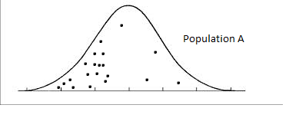
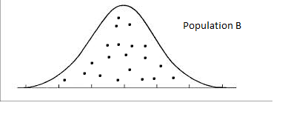
True or False – You can compare your data sets using the student’s t-test.
  - Dr. Fletchers lecture

- This form of vitamin D directly stimulates enterocytes to increase calcium and phosphorous absorption.
  - Cholecalciferol
  - Calcidiol
  - Calciferol
  - Calcitriol
  - Stillion JR, Renal Secondary Hyperparathyroidism In Dogs. Compendium 2009

- True or False: a 9-year-old male castrated Golden Retriever presents to your hospital for evaluation of a 5 day history of progressively altered mentation, circling to the left, and right thoracic and pelvic limb proprioceptive deficits. General physical exam is unremarkable with the exception jugular venous distention and mild peripheral edema. Initial blood gas analysis shows hyponatremia (Na = 129 mEq/L), hypochloridemia (Cl = 99 mEq/L), and hypokalemia (K=3.09 mEq/L). The most likely diagnosis in this patient is SIADH secondary to intracranial neoplasia.
  - Esposito et al., Nephron Clin Pract 2011; 119:c62-c73.

- True or False: a 4-year-old female spayed standard poodle presents to your clinic for acute hemorrhagic diarrhea and collapse. The owner reports a history of repeated, similar episodes over the last 6 months, but previous episodes were much less severe and were self-limiting. Blood gas analysis showed a moderate metabolic acidosis, hyponatremia, and severe hyperkalemia (K = 10.7 mEq/L). You presumptively diagnose Addison’s disease. Due to the severity of the hyperkalemia, you elect to use hydrocortisone as part of your initial management plan. A reasonable initial plan is to place an IV catheter, pull a pre-ACTH sample for cortisol assay, administer the ACTH and a dose of hydrocortisone, and then pull a post-ACTH sample for cortisol assay in 1 hour.
  - Klein and Peterson, Can Vet J; 51: 179-184, 2010.

- You are doing a study comparing cortisol concentrations in patients with sepsis to those with septic shock. You hypothesize that patients with septic shock will have higher basal cortisol levels than those with septic shock. At the completion of your study, you generate the data below. Which of the following statistical tests would be the most reasonable to compare these two groups?
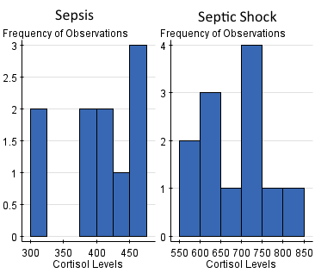
  - T-test
  - Mann-Whitney U test
  - Chi-square test
  - Analysis of variance
  - Fletcher’s brain

