Clare: Cytoprotective agents + transcranial doppler + long-term prognosis

Therapeutic use if cytoprotective agents in canine and feline hepatobiliary disease

Mechanisms of hepatocyte cell death
Necrosis – non energy dependent, generally due to overwhelming cellular damage especially mitochondrial damage. Mitochondroal damage leads to ATP depletion, loss of membrane integrity, osmotic imbalances, cell swelling, and ultimately cell rupture. All leads to inflammatory response
Apoptosis – controlled cell death. Results in apoptotic bodies that are cleared by the phagocytic system without an inflammatory response. Uses caspases.
Initiator caspases (8,9,10) - requires activation via extrinsic death receptor (FAS or TNF-a) or intrinsic mitochondrial mediated pthwy (Bax, Bak, cytochrome C).
Effector caspases (3) – demo phase

Oxidative stress – imbalance betn oxidative and antioxidant systems
In health – most ROS are generated via oxidative phosphorylation in the mitochondria.
In hepatobiliary disease – inflammatory cells, cytochrome P450 enzymes, and damaged mitochondria

Enzymatic antioxidant pathways
Superoxide dismutase (SOD) – catalyzes the dismutation of superoxide anion into H2O2
Catalase – Catalyzes H2O2 to water
Gluthathione (GSH) peroxidases – lipid and H2O2 to water and stable alcholos by oxidizing reduced GSH to its disulfide form (GSSG) (see figure below)

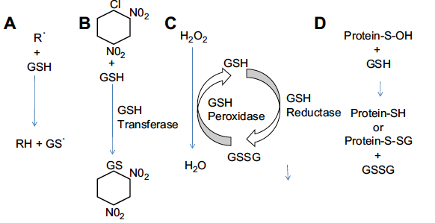
Nonenzymatic antioxidant pathways
GSH – tripeptide of cysteine, glycine and glutamine. Limiting factors are the availability of cysteine and gamma-glutamylcysteine synthase (GCS). GSH levels highly dependent on nutritional conditions.GSH is synthesized in the cytosol and transported into intracellular organelles. Transport across the mitochondrial membrane is essential in maintaining defense against mito injury,
Exists as GSH (reduced) and GSSG (oxidized) (95:1).
GSSG GSH via GSH reductase – facilitates removal of hydrogen and organic peroxidases.
Conjugation and removal of endogenous and exogenous toxins from the cell thru glutathione S-transferases (via mercapturic acid pthwy)
Reduced GSH can also nonenzymatically react with free radicals including superoxide, hydroxyl, and nitric oxide.
Can aid in the reduction of other antioxidants such as ocopherol and ascorbate
Vitamin E (alpha-tocopherol) – predominant lipid soluble antioxidant protecting membrane phospholipids from lipid peroxidation. Essential nutrient.
Vitamin C (Ascorbate) – water-soluble reducing agent that protects against ROS such as H2O2. Also reduces oxidized vitamin E back into non harmful state.

Cytprotective agents

S-adenosylmethionine (SAMe) – generated from L-methionine and ATP catalyzed by methionine adenosyltransferase.
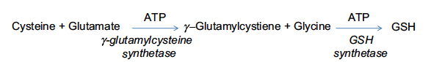
Metabolized in the liver via three pathways
- Transmethylation - 85% - SAMe donates its methyl group by methyltransferases. The byproduct S-adenosylhomocysteine (SAH) is hydrolyzed to homocysteine and adenosine by SAH hydrolase. Homocysteine is then remethylated to methionine (methionine synthase and betaine methyltransferase), requires folate and B12) or undergoes transulferation.
- Transsulferation - homocysteine cysteine in a series of enzymatic steps in the presence of B6.
- Aminopropylation - results in the decarboxylation of SAMe, with transfer of its aminopropyl group to form polyamines. Methyladenosine is intermediate. Exogenous SAMe can spontaneously convert to MTA.
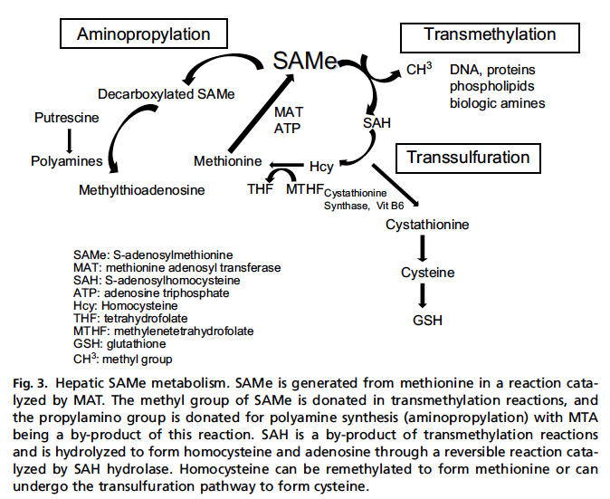

Cytoprotective benefits of SAM-e
- augmentation of hepatocyte GSH levels
- improvement in membrane fluidity – via methylation of mito membrane phospholipids, reestablishing mito GSH transport
- modification of cytokine expression – inhibits LPS stimulated release of TNF-alpha from macs. Increases production of anti-inflamm ytokines such as IL-10
- alterations in DNA/histone methylation
- modulation of apoptosis – pro apoptotic by JNK pathway in cancerous liver cells, protects normal hepatocytes against okadaic acid and bile acid induced apoptosis.
- Reverse signs of mitochondrial damage

In the literature….
-improves survival in animal models of alcoholism, acetaminophen, galactosamine and thioacetarsamide induced hepatotoxicity and ischelia-reperfusion induced liver injury.
-decreases fibrosis in rats treated with cardon tetrachloride
-efficacy in amerlioating hepatic steatosis
-decreased serum bilirubin levels and ameliorated histologic evidence of hepatocellular necrosis
-cats – increased resilience to osmotic challenge in RBC’s – membrane stabilizing effects?
-decreased acetaminophen induced RBC and hepatic damage in cats

Dose and pharmacokinetics
Denosyl or Zentonil
Give on empty stomach – food reduces absorption
Do not crush or split tablets
20mg/kg/day
~3% bioavailable
rapidly metabolized intracellularly
ASE: nausea, food refusal, anxiety, emesis (mostly cats)

Use in canine and feline hepatobiliary diease
No studies
Potentially beneficial in numerous diseases

N-acetylcysteine (NAC)

Stable formulation of L-cysteine
Beneficial in hepatotoxins, ALF.
In ALF – improves vasomotor tone in peripheral, cerebral and sinusoidal vascular beds. Increased MAP, oxygen extraction, decreases CPP. In ischemia-reperfusion, improvements in hepatic microcirculation and decreased hepatic damage in rabbit and rodent.

Acetaminophen – antidote of choice – restores intracellular GSH levels, aids in detoxification of the reactive intermediate generated by CP-450 metabolism of acetaminohoen.
Acetaminophen toxicity – 140mg/kg loading dose then 70mg/kg q6h for 7 treatments. Most effective when given within 8-16 hours of ingestion.

ASE – GI upset, allergic reactions, hemodynamic changes (orally). Parenteral use well tolerated.

Uses: acetaminophen toxicity, Heinz body anemia, suspect toxin related liver injury, ALF. Should be considered in any patient fitting the criteria for ALF

Ursodeoxycholic acid (Ursodiol)

Cholesterolchenodeoxycholate, cholate conjugated in the liver to either glycine or taurine (dog) or taurine (cat). Major circulating BA is taurocholate.
Some BA’s are hepatotpsic. – seems to correlate to some degree with hydrophobicity (more hydrophobic BA’s damage hepatocytes primarily by disrupting mito membranes and activating apoptosis
Ursodiol is cytoprotective hydrophobic BA
Replacement of more toxic BA’s in the BA pool, stimulation of choleresis, anti-apoptotic effects, stabilization of mito function, and immunomodulatory effects.

Mechanisms of action:
- Replacement of the more toxic BA’s – hard to demonstrate
- Increased choleresis – increases the elimination of endogenous toxins normally excreted by the bile such as copper, leukotrienes, bilirubin. It is the result of a increase in the expression of membrane transporters necessary to generate bile flow and direct stimulation of a bicarbonate-rich bile flow in the bile ducts.
- Apoptosis inhibition – preserves mito ingetrity, increases expression of BCL-2, decreasing Bax evels
- Immunomodulatory properties – down regulates abherrant MHC expression on hepatibiliary cells induced by cholestasis (expression of abhorrent MHC makes the hepatocytes more vulnerable to lymphocyte targeting leading to cell damage).. Supresses IL-2 and 4 production. Can activate glucocorticoid receptor and bind it leading to suppression of activation of NF-kb.

Literature…
Extensive studies proving benefit in humans, little in veterinary medicine

Dose and pharmacokinetics
Absorption enhanced in the presence of food
>60% is taken up into the liver where it is conjugated to taurine/glycine
15mg/kg/d
Bioavailability decreases with advanced cholestasis die to decreased absorption, decreased hepatic extraction and increased renal absorption
Twice daily dosing may be needed in severe cholestasis

ASE –
Diarrhea, vomiting are rare
May increase the bioavailability of vitamin E and cyclosporine
Absorption may be decreased with concurrent use of aluminum containing antacids

Use in veterinary medicine
Ancillary therapy
Reduce intra-and extrahepatic cholestasis in the absence of a complete bile duct obstruction
Lots of sludge
GB mucocoeles – non obstructed

Silymarin (milk thistle)

Flavonoids – silybin, isosilybin, silydianin, silychristin
Functions
- Antioxidant – reducing free radical production and lipid peroxidation, scavenges ROS and protects against GSH depletion
- Anti-inflammatory – suppression of NF-kb activation, inhibition of TNF-a induced cytotoxicity, increased expression of IL-10. Inhibitory effect on 5-LOX pathway inhibition of leukotriene synthesis. Protects hepatocytes against T cell-induced injury and inhibit hepC viral replication
- Antifibrotic – inhibits TGF-b secretion and stellate cell activation.
- Modulate hepatocyte transport – promotes choleresis by increasing insertion of transporters into apical membrane of hepatocytes. Inhibits uptake of phalloidin (Amanita mushroom toxin)
- Increase hepatic protein synthesis – accelerates hepatocellular regeneration as result of increased gene transcription/translation and enhanced DNA biosynthesis

Literature ….
Toxins – acetaminophen, ethanol, carbon tetrachloride, aflatoxin, Amanita
Ischemic, viral, radiation induced injury protection
Vet literature:
Carbon tetrachloride
Phalloidin - completely protective in beagles 50-150mg/kg when given 5-24 hours after ingesting a LD50 dose. Another indicated protection from severe hepatopathy when given up to 48 hours after ingestion

Dose and pharmacokinetics
Low bioavailavility – short plasma half life, preferentially accumulated in the liver, excreted as gluconoride and sulfoglucoronide conjugate, some enterohepatic recirculation. Bile concentrations 100x that of serum.
Unknown dose required to achieve therapeutic range
Suggested doses of 20-50mg/kg/d
Siliphos – silibin + phosphatidylcholine – 5-10x more bioavailable than silymarin – 3-6mg/kg/d
Marin (with Vitamin E and zinc), or Denamarin (with SAMe)

ASE
Low toxicity

Vitamin E

Essential nutrient derived from food and nutritional supplements.
Eight highly lipophilic antioxidant compounds – alpha-tocopherol is the most bioavailable and active form
What it does:
- protects membranes from oxidative damage
  - defends against peroxidative damage by terminating free radical induced chain reactions – it is then transformed back into reduced form by vitC
- antiproliferative effect on vascular smooth muscle
- inhibitory effect on platelet aggregation and adhesion
- modulate signal transduction by altering activity of lipoxygenases, cyclooxygenases, protein kinase C, and altering gene expression via NF-kb.
- Suppresses activation of inflammatory cells and protects against Kupffer and stellate cell activation

Dose:
Acetate form of alpha-tocopherol (avail as d-alpha-tocopherol) synthetic form of vitamin E.
10-15 IU/kg/d
available parenterally

ASE: low toxicity

Should be considered in management of hepatobiliary disorders likely to involve oxidative membrane injury.
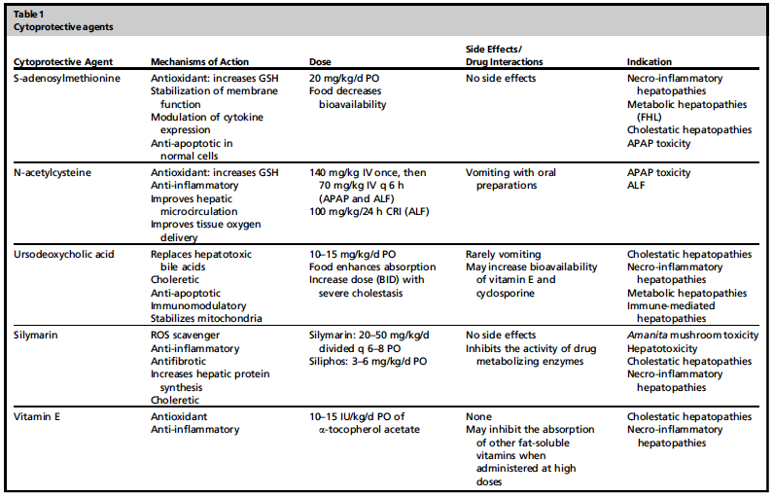

Questions and Answers for cytoprotective agents

- Name the three pathways of SAM-e metabolism, and indicate which one is the most commonly used.
Transmethylation – most common
Transsulferation
Aminopropylation

- Name three cytoprotective effects of SAMe.
  - augmentation of hepatocyte GSH levels
  - improvement in membrane fluidity
  - modification of cytokine expression
  - alterations in DNA/histone methylation
  - modulation of apoptosis
  - Reverse signs of mitochondrial damage

- Name the amino acid(s) to which bile acids are conjugated to in the dog vs cat:
Dog – taurine or glycine
Cat – taurine

- Name 3 functions of silymarin:
  - Antioxidant
  - Anti-inflammatory
  - Antifibrotic
  - Modulate hepatocyte transport
  - Increase hepatic protein synthesis

- Which cytoprotective agent has been shown to be protective against ingestion of phalloidin?
Silymarin

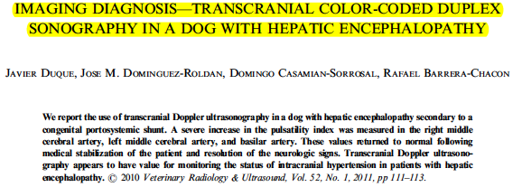
1 year old Dachshund

Transcranial Doppler ultrasound – 2.4mHz sectorial phased array scan – temporal and occipital windows used for evaluation of the middle cerebral artery and basilar artery. Compression of the ipsilateral carotid was used when attempting to ID the middle cerebral artery.

Pulsatility index (PI) measured. After clinical signs improved, transcranial Doppler was repeated and the PI had decreased in all three locations.

Humans – PI most frequently used parameter for assessing intracranial pressure in patients with hepatic failure. Adv: easy to obtain, not affected by minor changes in the angle of insonation and reflects combo of physiologic factors

Hyper-ammonemia induces accumulation of glutamine inside astrocytes cellular swelling
Cerebral hyperemia (mvt of water in the the brain facilitated by diffusion forces as wel as increased expression of water transporters (Glut-1 and aquaporin-4).
An exponettial increase in the PI has been found with intracranial hypertension in dogs and cats. Also the flow patterna and PI may be useful indices of cerebral blood flow under conditions of intracranial hypertension.

Questions and answers

- Fill in the blank: An _____increase____ (increase/decrease) in the pulsatality index has been found with intracranial hypertension. Potential causes of increased intracranial hypertension in patients with hepatic disease include ___hyper-ammonemia_____, which induces accumulation of glutamine inside astrocytes leading to intracellular swelling. Transporters such as ____Glut-1___ and ______aquaporin-4___ have been shown to facilitate diffusion of water into the brain causing cerebral edema.

- The three arteries that measurements were taken from in this study:
Right middle cerebral artery
Left middle cerebral artery
Basilar artery
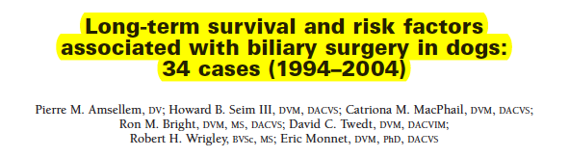

Indications – neoplasia, obstructive choleliths, inflammatory biliary tract diseases, rupture, gall bladder infarction, mucocoele, extrahepatic neoplasia, pancreatitis.
Objective – Evaluate long term outcome and factors that affected survival following biliary surgery in dogs.

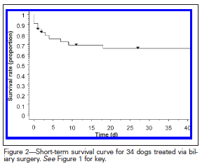
Post-op risk factors for death included: age, preasnesthetic HR, BUN, GGT, phosphorous, bilirubin values. Intraoperatively: biliary diversion surgery was risk factor for survival

Poor long term prognosis was associated with pancreatitis. Bile peritonitis not risk factor

Bacteriologic cultures – positive in 8 of 24 dogs.
Single – 8 dogs, >1 5 dogs: E. coli, staph, strep, pasteurella, clostridium., propionibacterium

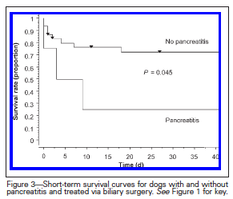
Positive culture not a risk factor

Hazard ratio – for biliary diversion was increased by increase in age, GGT, phosphorous and by pre-op hypoglycemia

66% survival
-less favorable in dogs with liver dysfunction, hypotension, certain diseases req sx.

- Which of the following factors were associated with poor survival in dogs undergoing biliary surgery?
  - Biliary diversion surgery
  - Pancreatitis
  - Bile peritonitis
  - Cholesterol levels
  - Band neutrophils
  - A and B
  - A and C

