Literature review CCM/Compendium March 2014
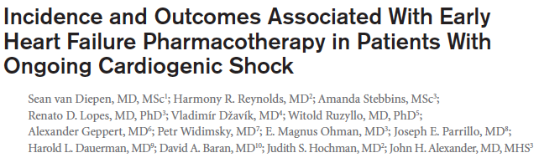

Current recommendations for patients includes initiation of beta-blockers and ACEi in low doses only after resolution of cardiogenic shock
Part of theTRIUMPH trial – Tilarginine acetate injection in a randomized international study in unstable MI patients with cardiogenic shock
Describe the prevalence and outcomes associated with early beta-blocker or ACEi initiation in patients with ongoing clinical signs.
International multicenter double blinded randomized placebo controlled study evaluating the effect of tilarginine acetate (nitric oxide synthase inhibitor) in patients with MI complicated by cardiogenic shock that persisted despite infarct artery revascularization.
n=389
compared patients with CS lasting >24 hours who DID or DID NOT receive beta-blockers or RAAS blockers
Results: 240 patients were included in analysis.
30 day mortality was higher in the patients receiving beta-blockers or RAAS inhibitors prior to CS resolution
Administration of a beta-blocker was significantly assoc with increased 30d mortality.
Among patients treated with ACEI or ARBs only no difference in mortality was observed (prob limited power to detect changes)
NSD in secondary outcome of shock duration.
Beta blockers alone assoc with longer median shock duration among all patients
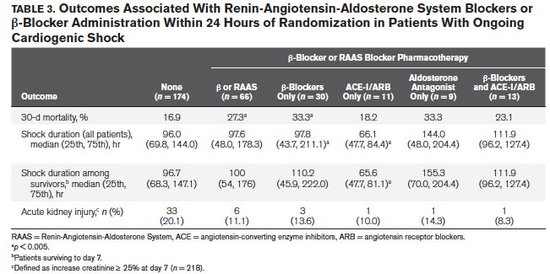

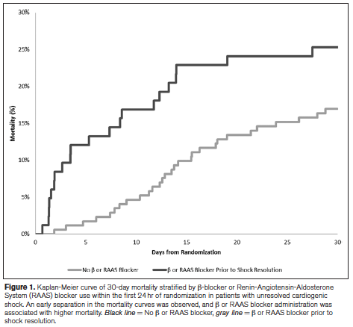
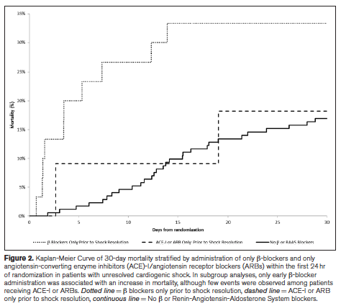
Conclusion – 30% of all patients with ongoing CS received beta blockers or RAAS blockers and this practice was associated with higher 30 day mortality in this observational study.
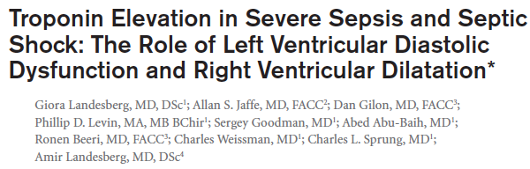
Cardiac troponin elevation in sepsis is thought to be due to direct toxicity of circulating substances, increased myocardial wall stress by pressure or volume overload, and renal dysfunction
N=225 echos, n=106 hs-cTnT measurements

Results:
History of ischemic heart disease, eGFR, and APACHE-II score independently correlated with log10(hs-cTnT) concentrations by multivariate analysis.
Echocardiographic variables: increased RVESVi and increased E/SRe wave ratio independently correlated with log10 (hs-cTnT).
ROC curves using four different hs-cTnT) cutoffs – showed APACHE-II score and eGFR predicted elevation at all cutoff levels, whereas RVESVi SRe-wave and TDIe wave predicted troponin elevations only at the higher cutoff values.
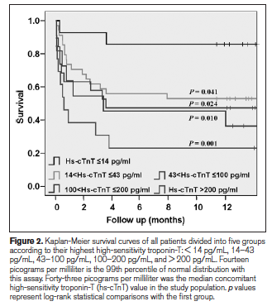
Mortality: APACHE-II score and reduced systolic blood pressure predicted in-hospitality mortality my multivariate analysis

Conclusions:
- LV diastolic dysfunction and RV dilation are the echo features best correlating with concurrent hs-cTnT concentration in patients with severe sepsis and septic shock independent of APACHE-II score and independent of eGFR the strongest clinical variables correlating with his hs-cTnT
- Both LV diastolic dysfunction and RV dilation predict in hospitality better than hs-cTnT suggesting a potential contribution of these cardiac mechanical properties to the hs-cTnT elevations and to its associated iwht nortality in severe sepsis an septic shock.

