Prospective multicenter evaluation of coagulation abnormalities in dogs following severe acute trauma
Marie K. Holowaychuk, DVM, DACVECC; Rita M. Hanel, DVM, DACVIM, DACVECC; R. Darren Wood, DVM, DVSc, DACVP; Lindsey Rogers, DVM; Karen O’Keefe, DVM and Gabrielle Monteith, BSc (Hons)
Journal of Veterinary Emergency and Critical Care 24(1) 2014, pp 93–104
Abstract
Objectives – To describe coagulation abnormalities in dogs following severe acute trauma and to evaluate the relationship between coagulation, clinical, and laboratory variables, and disease and injury severity, as well as the ability of coagulation variables to predict the presence of body cavity hemorrhage (BCH), necessity of blood product administration, and outcome.
Design – Prospective, multicenter, observational study. Setting – Two university teaching hospitals.
Animals – Forty client-owned dogs sustaining severe blunt or penetrating trauma.
Interventions – Blood samples were collected within 12 hours of the traumatic incident for measurement of blood gases, lactate concentration, platelet count, activated clotting time, prothrombin time, activated partial thromboplastin time (aPTT), fibrinogen concentration, antithrombin activity, D-dimer concentration, protein C activity, plasmin inhibition, plasminogen activity, and kaolin-activated thomboelastography.
Results – Decreased platelet count was a risk factor for the presence of BCH (P = 0.006) and decreased platelet count (P < 0.001), protein C activity (P = 0.001), angle (α) (P = 0.001), maximum amplitude (MA) (P < 0.001), and clot strength (G) (P = 0.002) were risk factors for blood product administration. Nonsurviving dogs were hypocoagulable with prolonged aPTT (P = 0.008), decreased plasmin inhibition (P = 0.033), decreased α (P = 0.021), and decreased MA (P = 0.038) compared to surviving dogs. Multivariate analysis accounting for disease severity showed that prolonged aPTT (P = 0.004, OR = 1.74) was the strongest predictor of nonsurvival. Prolonged aPTT was positively correlated with APPLE-fast score (P < 0.001, r2 = 0.35), lactate concentration (P < 0.001, r2 = 0.35), and negative base excess (P = 0.001, r2 = 0.27). Acute traumatic coagulopathy, as defined by 2 or more abnormal coagulation tests, was diagnosed in 15% of dogs at hospital admission and was more common in dogs with increased disease severity (P = 0.002), decreased systolic blood pressure (P = 0.002), and increased lactate concentration (P = 0.011).
Conclusions – In dogs with severe traumatic injuries and hypoperfusion, measurement of thromboelastography and aPTT should be considered to support clinical assessments in predicting the need for blood product administration and nonsurvival.

Background:
A formal definition does not exist for ATC (acute traumatic coagulopathy); however, most studies use a 50% prolongation in prothrombin time (PT) or ac- tivated partial thromboplastin time (aPTT), measured upon hospital admission, as a diagnostic criterion.
Numerous factors contribute to ATC including severe tissue injury, shock, hemodilution during fluid resuscitation, hypothermia, acidosis, and inflammation.
For the purpose of this study, ATC was defined as 1 or more of the following variables on hospital admission: ACT > 105 seconds, platelet count < the lower limit of the reference interval, PT or aPTT > 1.5 times the upper limit of the reference interval, and MA or α < the lower limit of the reference interval.
The objective of the present study was to describe coagulation abnormalities in dogs following severe acute trauma and to evaluate the association of coagulation and thromboelastography (TEG) variables with clinical and laboratory variables, as well as disease and injury severity, and to assess the ability of coagulation and TEG variables to predict the presence of body cavity hemorrhage (BCH), necessity of blood product administration, and outcome.
Inclusion criteria: Dogs were considered for inclusion if they were admitted to the hospital within 12 hours of a blunt or penetrating (eg, animal altercation) traumatic incident with injuries involving > 1 organ system and an anticipated requirement for hospitalization for at least 3 days.
Exclusion criteria: Dogs < 1 year old, weighing < 10 kg, diagnosed with a congenital coagulopathy, previously treated with hypertonic saline, synthetic colloids, blood products, or anticoagulant medications, with injuries localized to an extremity (eg, limb fracture), or hospitalized only for IV fluid therapy or analgesia were excluded.
Outcome was recorded as survival (to hospital discharge) or nonsurvival (died or euthanized due to a perceived grave prognosis). Dogs euthanized for financial reasons were excluded from analyses.
Key Points:

Thirty one dogs survived (31/40, 77.5%); of the 9 (22.5%) non- survivors, 8 dogs (8/9, 89%) were euthanized due to a perceived grave prognosis and 1 dog (1/9, 11%) experienced cardiopulmonary arrest and died.
Evidence of BCH was present in 25% of dogs and was evenly distributed between hemothorax (5/10, 50%) and hemoabdomen (5/10, 50%)
Decreased platelet count was a risk factor for the presence of BCH
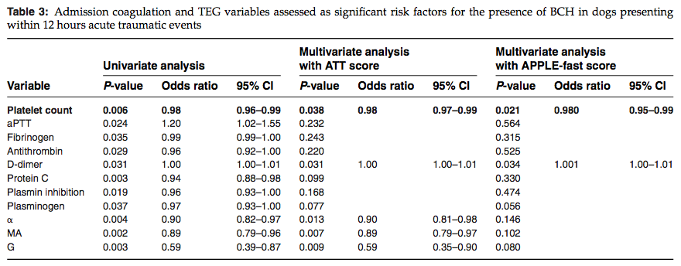

At hospital admission, prolonged aPTT (OR = 1.26), decreased plasmin inhibition (OR = 0.97, 95%), decreased α (OR = 0.93, 95% ), and decreased MA (OR = 0.93) were predictive of nonsurvival.
Using multivariate analysis with APPLE-fast score to account for disease severity, only prolonged aPTT (OR = 1.74) and decreased α (OR = 0.84) remained predictive of non-survival.
ROC curve analysis revealed that an aPTT ≥ 16.6 seconds (reference interval: 10 17 seconds) was 67% sensitive and 83% specific for predicting non- survival
Using multivariate analysis with ATT score to account for injury severity, none of the coagulation or TEG variables were predictive of nonsurvival.
At hospital admission, aPTT was positively correlated with APPLE-fast score lactate concentration, and negative base excess; AT activity was negatively correlated with APPLE-fast score; fibrinogen concentration was negatively correlated with ATT score; and platelet count was positively correlated with MAP
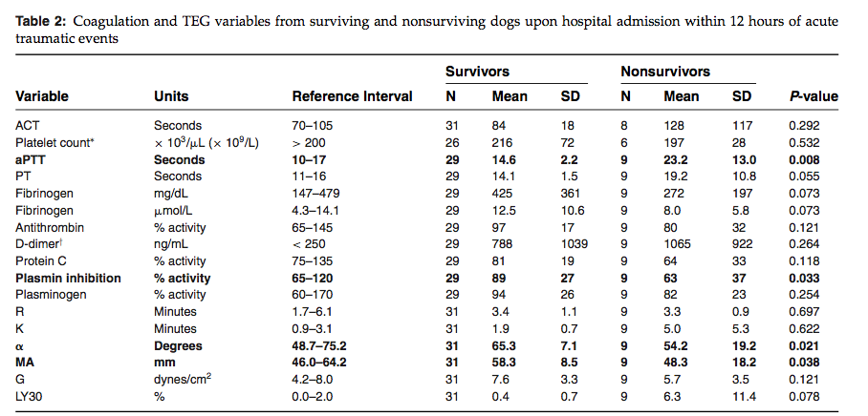
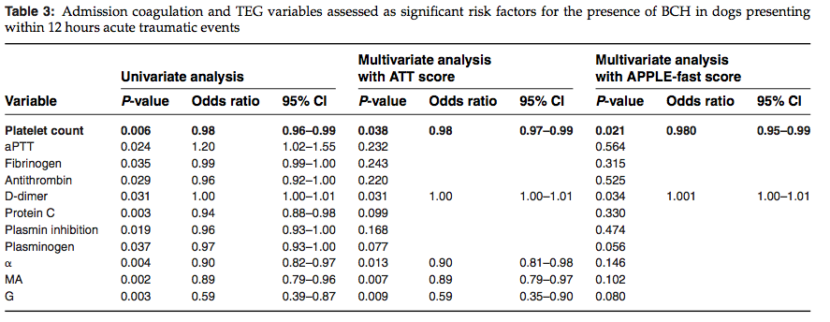
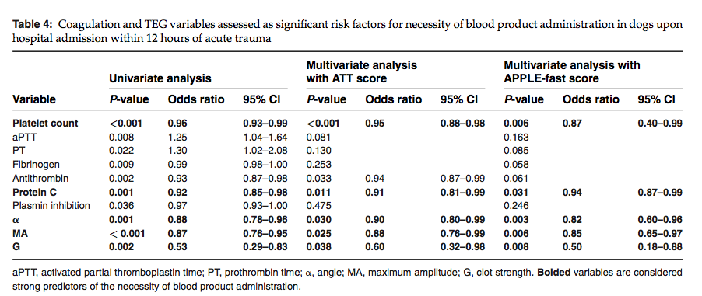

- Decreased platelet count, protein C activity , angle (α), maximum amplitude (MA), and clot strength (G) were risk factors for blood product administration

Questions:

- Following the multivariate analysis accounting for disease severity, which factor was determined to be the strongest predictor of non-survival?
Answer: Prolonged aPTT (OR 1.74)

- Using multivariate analysis with ATT score to account for injury severity, none of the coagulation or TEG variables were predictive of nonsurvival.
T or F?
Answer: True

- What was determined to be a risk factor for body cavity hemorrhage?
Answer: decreased platelet count

- At hospital admission which coagulation and/or TEG variables were predictive of nonsurvival?
Answer:
  - prolonged aPTT
  - decreased plasmin inhibition
  - decreased α
  - decreased MA

- Which coagulation and/or TEG variables were risk factors for necessity of blood product administration?
Answer: Decreased platelet count, protein C activity , angle (α), maximum amplitude (MA), and clot strength (G)

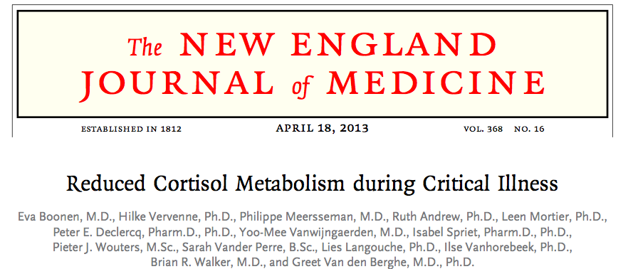
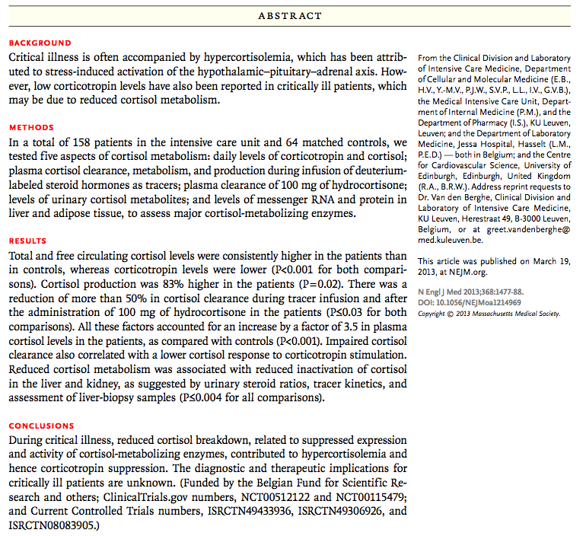

Key points:

- Total and free circulating cortisol levels were consistently higher in the patients than in controls, whereas corticotropin levels were lower
- Cortisol production was 83% higher in the patients.
- There was a reduction of more than 50% in cortisol clearance during tracer infusion and after the administration of 100 mg of hydrocortisone in the patients
- All these factors accounted for an increase by a factor of 3.5 in plasma cortisol levels in the patients, as compared with controls
- Urinary excretion of cortisol was elevated in the critically ill patients, but cortisol metabolite levels were normal or low, despite increased cortisol production
- Impaired cortisol clearance also correlated with a lower cortisol response to corticotropin stimulation.
- The ratios of urinary cortisol metabolites suggested reduced activity of the A-ring reductases in the critically ill patients and a net suppression of cortisol-to-cortisone conversion. This interpretation was corroborated by low mRNA and protein levels and low activity of the A-ring reductases in liver-biopsy samples.
- The negative correlation between the expression and activity of the A-ring reductases and circulating bile acid levels suggests that elevated levels of bile acids may reduce cortisol metabolism in critically ill patients
- Reduced cortisol metabolism was associated with reduced inactivation of cortisol in the liver and kidney, as suggested by urinary steroid ratios, tracer kinetics, and assessment of liver-biopsy samples

Questions:

- Total and free circulating cortisol levels were consistently higher in the patients than in controls, whereas corticotropin levels were lower. T or F?
Answer: True

- Impaired cortisol clearance also correlated with a lower cortisol response to corticotropin stimulation. T or F?
Answer: True

- Reduced cortisol metabolism was associated with reduced inactivation of cortisol in the liver and kidney, as suggested by urinary steroid ratios, tracer kinetics, and assessment of liver-biopsy samples. T or F?
Answer: True

Partnership on Rotational ViscoElastic Test Standardization (PROVETS): Evidence-based guidelines on rotational viscoelastic assays in veterinary medicine
Robert Goggs, BVSc, DACVECC, PhD, MRCVS; Benjamin Brainard, VMD, DACVA, DACVECC∗; Armelle M. de Laforcade, DVM, DACVECC∗; Bente Flatland, DVM, MS, DACVIM, DACVP∗; Rita Hanel, DVM, DACVIM, DACVECC∗; Maureen McMichael, DVM, DACVECC∗ and Bo Wiinberg, DVM, PhD
Journal of Veterinary Emergency and Critical Care 24(1) 2014, pp 1–22
Abstract
Objective – To systematically examine the evidence relating to the performance of rotational viscoelastic testing in companion animals, to develop assay guidelines, and to identify knowledge gaps.
Design – Multiple questions were considered within 5 parent domains, specifically system comparability, sample handling, assay activation and test protocol, definitions and data reporting, and nonstandard assays. Standardized, systematic evaluation of the literature was performed. Relevant articles were categorized ac- cording to level of evidence and assessed for quality. Consensus was developed regarding conclusions for application of concepts to clinical practice.
Setting – Academic and referral veterinary medical centers.
Results – Databases searched included Medline, Commonwealth Agricultural Bureaux abstracts, and Google Scholar. Worksheets were prepared evaluating 28 questions across the 5 domains and generating 84 assay guidelines.
Conclusions – Evidence-based guidelines for the performance of thromboelastography in companion animals were generated through this process. Some of these guidelines are well supported while others will benefit from additional evidence. Many knowledge gaps were identified and future work should be directed to address these gaps and to objectively evaluate the impact of these guidelines on assay comparability within and between centers.
Key Points:
Assay Guidelines and Evidence Summaries
System comparability
PICO questions
In companion animals with hemostatic abnormalities (P), does the use of a TEG (I) compared with the use of a ROTEM (C) alter testing results (O)?
Guideline recommendations
- We recommend that platform-specific guidelines be used for specific TEG/ROTEM assays.
- We recommend that guidelines aimed at reducing pre- analytical variation be standardized across both plat- forms.

PICO question
In companion animals with hemostatic abnormalities (P), is use of a TEG (I) compared with the use of a ROTEM (C) equivalent in cost terms (O)?
Guideline recommendations
- We suggest local comparisons of start-up and consumable costs should be performed.
- We suggest decisions be made based on the expected use of the machine including if multiple operators will be required to operate it.

Sample collection and handling
PICO question
In companion animals with hemostatic abnormalities (P), does the use of one blood vessel for sample collection (I) compared with another (C) alter testing results (O)?
Guideline recommendations
- We recommend that jugular venipuncture be used for TEG/ROTEM assays in horses.
- We suggest that jugular venipuncture be used for TEG/ROTEM assays in small animals.
- We suggest using a consistent venipuncture site if results of serial samples from a patient are to be compared.

PICO question
In companion animals with hemostatic abnormalities (P), does the use of one blood collection system (I) compared with another (C) alter testing results (O)?
Guideline recommendations
- There is insufficient evidence to recommend universal use of a specific blood collection system for TEG/ROTEM assays.
- We recommend that TEG/ROTEM results should be interpreted against reference intervals generated using the specific methods used to collect patient samples.
- We recommend that individual centers standardize TEG/ROTEM blood collection methods for their patient population.
- We suggest using an evacuated tube to minimize delay in anticoagulation and for ease of standardizing the anticoagulant to blood ratio.
- We suggest using 21-Ga or larger needles to obtain samples for TEG/ROTEM testing.
- We suggest that samples drawn from intravenous catheters can be used for clinical whole-blood TEG/ROTEM assays.

PICO question
In companion animals with hemostatic abnormalities (P), does the use of one citrate concentration (I) com- pared with another (C) alter testing results (O)?
Guideline recommendations
- There is insufficient evidence to recommend a universal citrate concentration for TEG/ROTEM assays.
- We suggest that blood samples for TEG/ROTEM should be anticoagulated using 3.2% buffered sodium citrate in a strict 1:9 ratio (final concentration 10.8 mM citrate).

PICO question
In companion animals with hemostatic abnormalities (P), does use of a discard tube (I) compared with no discard tube (C) alter TEG/ROTEM testing results (O)?
Guideline recommendations
We suggest a discard tube routinely be used for TEG/ROTEM assays because atraumatic venipuncture is difficult to achieve consistently; however a discard tube is not required for TEG/ROTEM assays if clean venipuncture is achieved or if a clot tube (for serum sample) is obtained first in the same draw.
We recommend that the first tube not be used for TEG/ROTEM assays to minimize the effect of suboptimal venipuncture when blood is collected for multiple assays including TEG/ROTEM.
We suggest the following tube draw order be used: discard/serum, citrate, EDTA, heparin in order to minimize heparin contamination of blood samples collected for TEG/ROTEM assays.

PICO question
In companion animals with hemostatic abnormalities (P), does prolonged sample storage (I) compared with short storage time (C) alter TEG/ROTEM testing results (O)?
Guideline recommendation
- We recommend citrated blood samples for TEG/ROTEM analysis are held for 30 minutes prior to analysis.

PICO question
In companion animals with hemostatic abnormalities (P), does sample storage at 37◦C (I) compared with sample storage at room temperature (20◦C, C) alter TEG/ROTEM testing results (O)?
Guideline recommendations
- We suggest whole blood samples for TEG/ROTEM should be held at room temperature prior to analysis.
- We recommend whole blood samples for TEG/ROTEM should not be refrigerated prior to analysis.

Assay activation and test protocol
PICO question
In companion animals with hemostatic abnormalities (P), does routine use of activators for citrated samples (I) compared with recalcification only (C) alter TEG/ROTEM testing results (O)?
Guideline recommendation
- We recommend routine use of activators for TEG/ROTEM assays in companion animals.
PICO questions
- In companion animals with hemostatic abnormalities (P), does use of one activator for citrated samples (I) compared with another activator (C) alter TEG/ROTEM testing results (O)?
- In companion animals with hemostatic abnormalities (P), does use of an activator at a given concentration (I) compared with another concentration (C) alter TEG/ROTEM testing results (O)?
Guideline recommendations
- We recommend standardization of activators for TEG/ROTEM assays in companion animals.
- We suggest that 2 or more TEG/ROTEM assays be used to completely evaluate a patient’s coagulation system.
- For contact-pathway evaluation in companion animals using TEG, we recommend use of proprietary kaolin tubes.
- For evaluation of the TF pathway in horses using TEG, we suggest using diluted Innovin 1:3,600.
- For evaluation of the TF pathway in small animals we suggest using diluted Innovin at both 1:3,600 and 1:50,000.
- We recommend use of proprietary In-TEM and Ex- TEM reagents with the ROTEM system.

PICO question
In companion animals with hemostatic abnormalities (P), does use of quality controls (I) compared with no quality control (C) alter TEG/ROTEM testing results (O)?
Guideline recommendation
- We recommend manufacturer’s guidelines regarding routine use of quality controls be followed.
PICO question
In companion animals with hemostatic abnormalities (P), does use of manual pipetting (I) compared to automatic pipetting (C) alter TEG/ROTEM testing results (O)?
Guideline recommendation
- There is insufficient evidence to conclude that one pipetting technique is superior to the other.
- We suggest careful manual pipetting be used for TEG assays.
- We suggest automatic pipetting be used for ROTEM assays.

PICO question
When should reagents and the sample be mixed prior to introduction of the pin?
Guideline recommendations
- There is insufficient evidence to make recommendations regarding mixing of samples and reagents for TEG.
- For both TEG and ROTEM, we suggest that blood samples be added to reagents (eg, calcium chloride [CaCl2 ], hR-TF) in prewarmed cups immediately prior to introduction of the pin per the manufacturers’ instructions.
- For ROTEM, we suggest that reagents should be mixed using the automatic pipette per the manufacturers’ instructions.
PICO question
In companion animals with hemostatic abnormalities (P), does fixed analysis time (I) compared to variable analysis time (C) alter TEG/ROTEM testing results (O)?
Guideline recommendations
- For routine clinical purposes, we suggest that all TEG/ROTEM assays be run until all values pertinent to individual patients are available.
- For research purposes, we suggest that all TEG/ROTEM assays be run until values for fibrinolysis are available such that they may be included in related publications.

PICO question
In companion animals with hemostatic abnormalities (P), does duplicate analysis (I) compared to single analysis (C) alter TEG/ROTEM testing results (O)?
Guideline recommendations
- We suggest that duplicate assays are not required when activators are used.
- We suggest that if recalcification-only assays are used, duplicate samples be performed.
- We recommend repeated sampling from 1 tube is avoided when duplicate assays are performed (ie, 2 tubes will be required).
- We suggest individual laboratories determine if/when repeat analyses of erroneous samples is required.

PICO question
In companion animals with hemostatic abnormalities (P), does use of fixed sample volume (I) compared to variable sample volume (C) alter TEG/ROTEM testing results (O)?
Guideline recommendations
- There is insufficient evidence to recommend specific sample volumes for TEG/ROTEM assays.
- We suggest that manufacturer’s guidelines regarding sample volumes be followed for routine assays.

PICO question
In companion animals with hemostatic abnormalities (P), does analysis at 37◦C (I) compared to analysis at the patient’s body temperature (C) alter TEG/ROTEM testing results (O)?
Guideline recommendations
- There is insufficient evidence to recommend use of specific temperatures for each species.
- We suggest all routine TEG/ROTEM assays are performed at 37◦C.
- In patients with marked hypo- or hyperthermia, we suggest clinicians consider evaluating TEG/ROTEM tracings performed at 37◦C and at the patient’s core temperature.

Definitions and data reporting
PICO question
In companion animals with hemostatic abnormalities (P), does presenting the G (global clot strength [shear elastic modulus, ROTEM variable]) value (I) compared to presenting the MA value (C) alter TEG/ROTEM result interpretation (O)?
Guideline recommendations
- We recommend that all 4 standard TEG/ROTEM variables are universally reported, enabling post hoc calculation of G if required. We suggest that authors may report G in addition to MA.

PICO question
In companion animals with hemostatic abnormalities (P), does use of one definition of hypercoagulability (I) compared with another (C) alter TEG/ROTEM result interpretation (O)?
Guideline recommendations
- There is insufficient evidence to recommend how hypercoagulability should be defined in companion animals based on TEG/ROTEM parameters at this time.
- We suggest that individual studies report sufficient data on patients and institutional controls to enable definitions of hypercoagulability to be evaluated post hoc.
- We recommend that all studies specifically report how hypercoagulability was defined.
- We recommend that all 4 standard TEG/ROTEM variables are universally reported to enable meta-analysis to be conducted in future.
- We recommend that at minimum, contemporaneous values for hematocrit, fibrinogen concentration and platelet count be reported in addition to TEG/ROTEM results.

PICO question
In companion animals with hemostatic abnormalities (P), does use of one definition of hypocoagulability (I) compared with another (C) alter TEG/ROTEM result interpretation (O)?
Guideline recommendations
- There is insufficient evidence to recommend how hypocoagulability should be defined in companion animals based on TEG/ROTEM parameters at this time.
- We suggest that individual studies report sufficient data on patients and controls to enable definitions of hypocoagulability to be evaluated post hoc.
- We recommend that all studies specifically report how hypocoagulability was defined.
- We suggest that use of multiple TEG/ROTEM– derived parameters in combination may increase specificity for identification of subsets of hypocoagulability.
- We recommend that all 4 standard TEG/ROTEM variables are universally reported to enable meta-analysis to be conducted in future.
- We recommend that values for hematocrit, fibrinogen concentration, and platelet count be reported in addition to TEG/ROTEM results.

PICO question
In companion animals with hemostatic abnormalities (P), does use of the coagulation index (CI, I) compared with standard parameters (C) alter TEG/ROTEM result interpretation (O)?
Guideline recommendations
- There is currently insufficient evidence to make a recommendation regarding use of a CI in companion animals.
- (CI = −0.245R + 0.0184K + 0.1655MA − 0.0241][α − 5.0220) is not used for companion animals.
- We suggest that the CI equation derived for dogs (CI = 0.1227R + 0.0092K + 0.1655MA − 0.0241α − 5.0220) may be considered for use in that species.
- We recommend that all 4 standard TEG/ROTEM vari- ables (R, K, α, MA/clotting time, CFT, α, MCF) are universally reported to enable calculation of a CI post hoc if required.

PICO question
In companion animals with hemostatic abnormalities (P), does use of one definition of hyperfibrinolysis (I) compared with another (C) alter TEG/ROTEM result interpretation (O)?
Guideline recommendations
- There is insufficient evidence to recommend how hyperfibrinolysis should be defined in companion animals based on TEG/ROTEM parameters at this time.
- We suggest that individual studies report sufficient data on patients and controls to enable definitions of hyperfibrinolysis to be evaluated post hoc.
- We suggest that the TEG variables (LY30, LY60, CL30 [CL is clot lysis], CL60) and the ROTEM variables (LI30, LI60, maximum lysis, lysis onset time, and lysis time) be universally reported to enable meta-analyses to be conducted in the future.

PICO question
In companion animals with hemostatic abnormalities (P), does use of one definition of hypofibrinolysis (resistance to fibrinolysis, I) compared with another (C) alter TEG/ROTEM result interpretation (O)?
Guideline recommendations
- There are currently insufficient data in companion animals to recommend use of specific variables to define hypofibrinolysis.
- Standard TEG/ROTEM assays may be unable to detect hypofibrinolysis in companion animals.

PICO question
In companion animals with hemostatic abnormalities (P), does use of locally defined reference intervals (I) compared with those defined in another center (C) alter TEG/ROTEM result interpretation (O)?
Guideline recommendations
- We recommend that every center using TEG/ROTEM should establish its own reference interval using established veterinary clinical pathology guidelines.
- We recommend that reference intervals for TEG and ROTEM are not used interchangeably.
- We recommend that only appropriately trained operators be involved in establishing reference intervals for TEG/ROTEM.
- We recommend that age and breed be considered when establishing reference intervals for TEG/ROTEM.
- We recommend that sample collection, sample handling, and assay protocols be standardized when establishing reference intervals for TEG/ROTEM.

PICO question
In companion animals with hemostatic abnormalities (P), does use of derived velocity-curve (Vcurve [TEG derivative]) parameters (I) compared with standard parameters (C) alter TEG result interpretation (O)?

Nonstandard assays
PICO question
In companion animals receiving antiplatelet agents (P), does use of specific TEG PlateletMapping (TEG-PM) reagents (I) compared with others (C) enable therapeutic drug monitoring (O)?
Guideline recommendations
- We suggest that the ADP TEG-PM kit may be used in dogs without modification to evaluate platelet responses to ADP.
- We suggest that the arachidonic acid (AA) TEG-PM kit may be useful without modification in dogs sensitive to A A agonism.
- We suggest that the TEG-PM protocol may require modification for use in cats and horses (although manufacturer-recommended concentrations of ADP and AA are appropriate for these species).

PICO question
In companion animals receiving antiplatelet agents (P), does use of the TEG-PM assay (I) compared with standard TEG assays (C) enable therapeutic drug monitoring (O)?
Guideline recommendations
- We suggest that TEG-PM can be considered for therapeutic monitoring of clopidogrel in dogs, although more data supporting its use are needed.
- We suggest that TEG-PM should not be used for evaluation of antiplatelet therapies in cats due to high assay variability and lack of valid baseline values.
- No studies of TEG-PM in horses were identified on which to base recommendations for this species.
PICO questions
1. In companion animals with hemostatic abnormalities (P), does use of the functional fibrinogen (FF) test (I) compared to standard TEG assays (C) improve assessment of coagulation (O)?
2. In companion animals with hemostaticabnormalities (P), does use of one activator for the FF test (I) compared to another (C) affect test result interpretation (O)?
Guideline recommendations
- There is insufficient evidence in companion animals to recommend use of the FF assay for clinical purposes.
- We recommend that the standard FF assay using abciximab is not used to determine FF concentrations in dogs.

