Lit review Apr 2014 – CCM
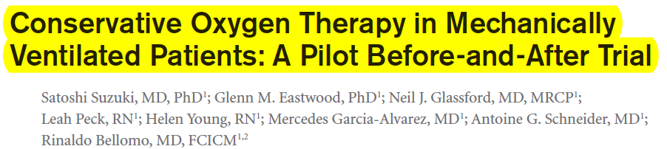
High FIO2 may:
- Impair innate immune system response
- Cause lung injury
- Induce interstitial fibrosis, atelectasis, tracheobronchitis, alveolar protein leakage and infiltration by neuts
Hyperoxemia can
- increase vascular resistance
- decrease cardiac output
- generate free radicals in various organs
Clinical adverse outcomes of hyperoxemia have been reported in patients with
- acute exacerbations of COPD
- after cardiac arrest
- after abdominal surgery
- in critical illness

Pilot before and after study – Before – conventional MV, After – targeting SPO2 level of 90-92% using the lowest possible FIO2 level

Primary outcome – change in PAO2/FIO2 in first 10 days.
Secondary outcomes – lab test results, lactate and creatinine changes, new non-respiratory organ failure while in ICU, prevalence of arrhythmias, infection, sever hypoxemia in the ICU, acquired RRT in the ICU, use of anti-delirium drugs, and pRBC transfusions in ICU, vent-free, hosp-free and ICU-free stays, hospital survival status t 28 days.

N=51 cases in conventional therapy group
N=54 cases in conservative therapy group

Conservative O2 therapy and Tx effect –
- significantly lower time-weighted SPO2, TWAmv-PaO2 and lower TWAmv-FIO2 compared with conventional treatment
- no differences in MV, PEEP, pH, PaCO2
- over the first 10 days – significantly lower levels of SPO2, PaO2 and FIO2 were observed
  - decreased total O2 delivered during MV by ~2/3
- the conventional group spent 59% in relative hyperoxemia (SPO2 >98%), PAO2 between 80-120, FIO2 30-40% or 40-50%. No time at room air.
- the conservative group spent 13% in relative hyperoxemia. Most of the time they were between 60-80 (63%) and at an FIO2 below 30%. 33% of time at 21%.

Discussion:
Pilot study to assess feasibility
Hypoxemia – negligible amount of time with PaO2 < 60. Trend towards decreased risk for new nonrespiratory organ failure in conservative therapy group
Greater relative decrease in lactate from baseline in the conservative group –
Lung is substantial source of lactate during ARDS/endotoxemia/in critically ill patients, production is assoc with lung injury score, suggesting that lactate production was not related to hypoxemia. Porposed mech: prolonged exposure to high FIO2 causes histo changes similar to those seen in ARDS and exacerbates VILI.
Ventilation of 50% has been reported to cause lung injury and changes in lung tissue
Ventilation with room air increases tissue volumes, myofibroblast differentiation and apoptosis in the sheep immature lung compared to nitrogen alone.
Conclusions: ventilating protocol targeting between 90-92% SPO2 is feasible, leads to marled decrease in oxygen exposure and can be safely implemented.
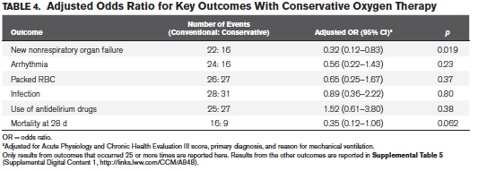

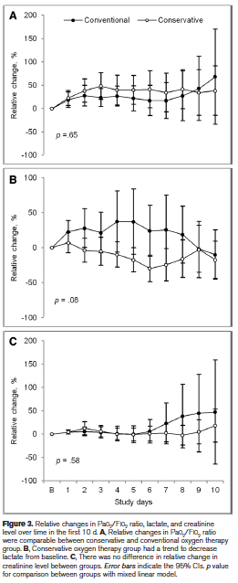
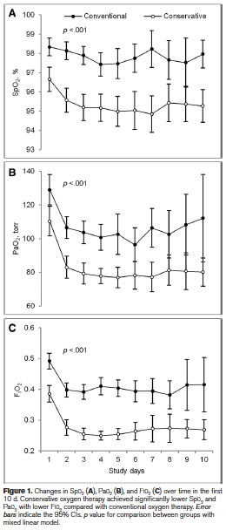

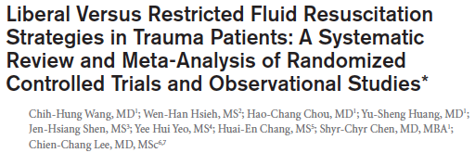

Meta-analysis comparing different fluid administration rates in trauma patients.
4 – randomized controlled trials (one excluded), 7 – observational studies (3-case control, 4 retrospective)

Conclusion: Initial liberal fluid resuscitation strategies may be associated with higher mortality in injured patients. Interpret with caution (high risk of selection bias and clinical heterogeneity).

RCT’s: NSD in overall mortality betn liberal and restricted fluid groups. Excluding one study which had some faults, there was a sign diff: RR 1.25 favoring restrictive fluid therapy with lower mortality than liberal.
Observational studies: liber assoc with higher mortality than restrictive OR 1.14.

Conclusions are not absolute, and were not identical in design and how the fluids were administered. The definitions between liberal and restrictive varied also and were not specified in the review.

