Berent AC, et al. Technical and clinical outcomes of ureteral stenting in cats with benign ureteral obstruction: 69 cases (2006-2010). JAVMA 2014; 244(5): 559-76.
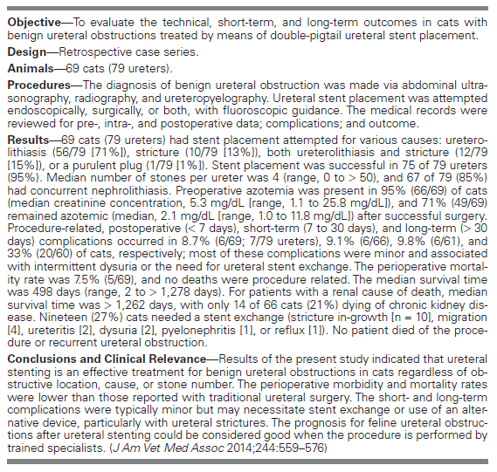
- Early intervention for ureteral obstruction recommended to avoid kidney injury, but improvements seen in creatinine of almost all cats, eve with long term obstruction
- Most likely all stents occlude overtime, but they also induce passive ureteral dilation
- Cats w/ strictures may benefit more from SUB placement as they have higher rate of needed stent exchange
- Few cats died of kidney disease, 96% of cats had stents placed successfully
- Most traumatic to go from bladder up ureter, prefer other direction.

