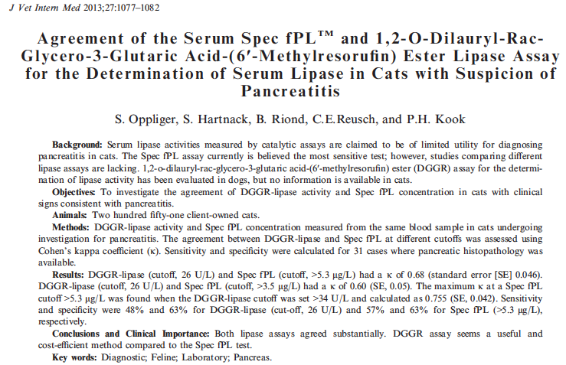
DGGR – cleaved by lipase, resulting in untable dicarbonic acid ester, which is spontaneously hydrolyzed under alkaline pH to yield glutaric acid and methylresorufin, a blue-purple (blurple) with peak absorption at 580 nm. Rate of formation is directly proportional to the lipase activity in the serum sample.

fPLI – radioimmunoassay using polyclonal antibodies. Evaluated in 18 cats – sensitivity 54% for mild, 100% for moderate-severe. Specificity 67-100%. Redesigned as a ELISA using monoclonal abs (Spec fPL) with sensitivity of 79% specificity of 82%. Generally regarded as most sensitive, but cons include limited availability, inability to produce immediate results, high cost.

AIM: Establish precision and linearity of DGGR-lipase in cats, and to evaluate the agreement between DGGR-lipase and Spec fPL

M&M:
Within-run precision – samples were divided into low, medium and high DGGR-lipase and pooled. 20 tests were performed consecutively.
Patient study – all cats with suspicion of pancreatitis had both DGGR-lipase and Spec fPL performed, in addition to creatinine. Samples run on the same blood sample
DGGR-lipase reference range 8-26 U/L (previously established)
Spec fPL – measured by IDEXX
Compared to histo when available
Creatinine – trying to assess if decreased GFR contributed to changes in values

Results:
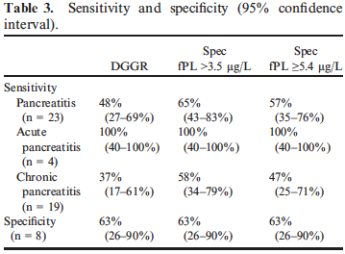

Conclusions:
DGGR-lipase as well as Spec fPL showed excellent sensitivity for acute pancreatitis
Sensitivity for chronic pancreatitis mediocre.
Both assays similarly affected by elevations in creatinine, but warrants further investigation.
DGGR-lipase should be considered reasonable alternative. Cheaper
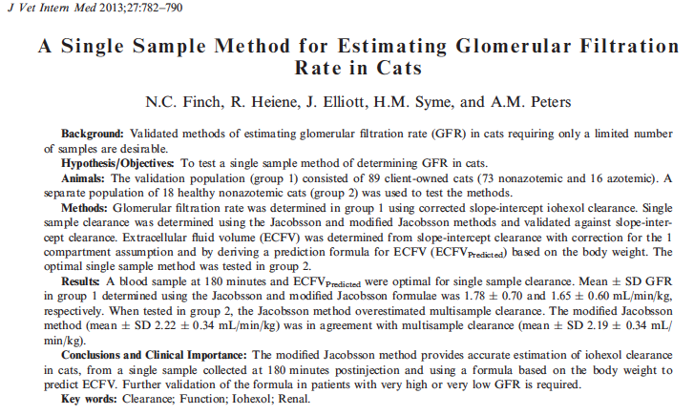
Traditional GFR measurements require iohexol administered intravenously and then collecting multiple blood samples over a variable time period and generating a plasma concentration vs time curve, with which one can determine a area under the curve (AUC). Clearance is calculated as the dose of the marker divided by the AUC.
Recently a corrected slope-intercept method has been validated in cats, requiring only 3 samples

For a single sample to be useful the following must be true: the marker must have a known volume of distribution, second the sample must be collected at a time when the distribution phase has reached completion.

Objective – to evaluate a single sample method for determining iohexol clearance in cats.

M/M: 89 cats, known plasma creatinine concentrations were recruited. Prospective study.
Bolusdose of 647mg/kg iohexol was administered IV
Blood samples collected at 120, 180 and 240 minutes. HPLC method performed to quantitate iohexol remaining. Calculations were completed.

Results: The original Jacobson formula for single sample showed excellent agreement with corrected-slope-intercept clearance in cats, however the modifiec Jacobson single sample formula showed better results in both populations

Discussion: In human medicine – single sample iohexol clearance shows stronger correlation and better agreement with the gold standard measurement of GFR, urinary clearance of inulin than slope-intercept iohexol clearance.
Conclusion:
Modified Jacobson method provides accurte estimation of iohexol clearance in cats, from a single sample collected 180 minutes post injection and using a formula to predict total ECFV. Further studies warranted.
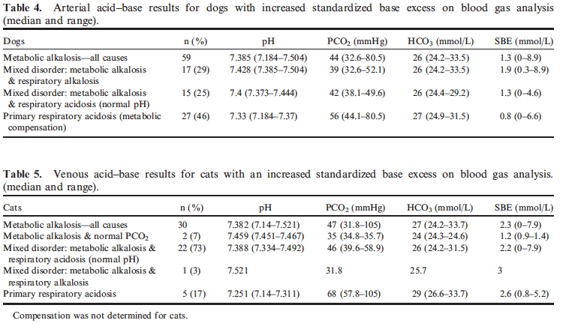
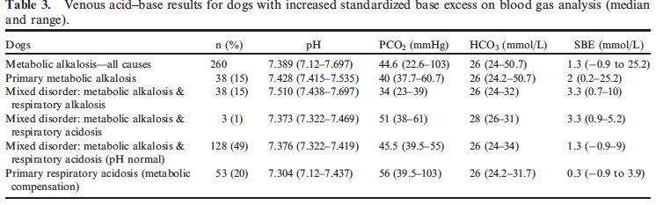
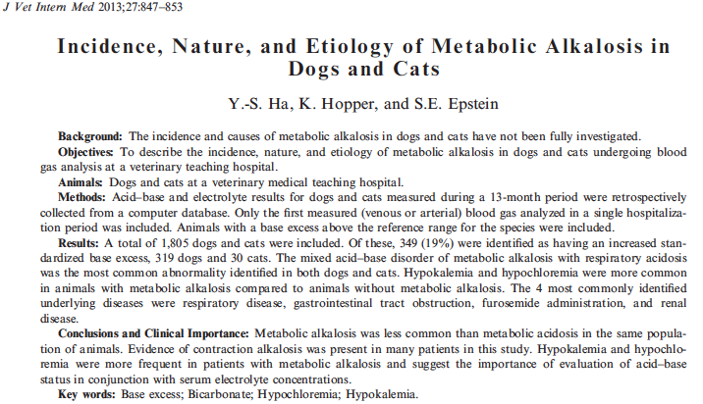

Increased SBE present in 19% of animals
Most common disorder – mixed metabolic alkalosis and respiratory acidosis
Hypochloremia (which resolved with correction) was more common in dogs vs true hypochloremia, however in cats the chloride corrected less frequently suggesting a free water deficit
Lasix administration common cause of metabolic alkalosis

Conclusion: metabolic alkalosis less common than metabolic acidosis. Evidence of contraction alkalosis was present in many patients.
Hypokalemia and hypochloremia were more frequent in this population.

