Hypernatremia NEJM Review

Summary:

Water homeostasis, which is mediated by thirst, arginine vasopressin, and the kidneys
Hypernatremia, defined as a rise in the serum sodium concentration to a value exceeding 145 mmol per liter
Because sodium is a functionally impermeable solute, it contributes to tonicity and induces the movement of water across cell membranes
Causes:
Hypernatremia represents a deficit of water in relation to the body’s sodium stores, which can result from a net water loss or a hypertonic sodium gain
Net water loss accounts for the majority of cases of hypernatremia
- It can occur in the absence of a sodium deficit (pure water loss) or in its presence (hypotonic fluid loss)
Hypertonic sodium gain usually results from clinical interventions or accidental sodium loading
Because sustained hypernatremia can occur only when thirst or access to water is impaired, the groups at highest risk are patients with altered mental status, intubated patients, infants, and elderly persons.
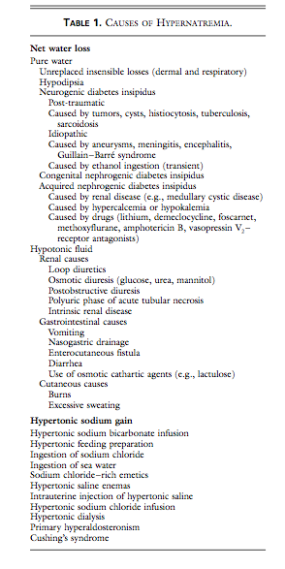

Clinical signs:
Signs and symptoms of hypernatremia largely reflect central nervous system dysfunction and are prominent when the increase in the serum sodium concentration is large or occurs rapidly
Clinical signs are variable
Brain shrinkage induced by hypernatremia can cause vascular rupture, with cerebral bleeding, subarachnoid hemorrhage, and permanent neurologic damage or death.
Brain shrinkage is countered by an adaptive response that is initiated promptly and consists of solute gain by the brain that tends to restore lost water. This response leads to the normalization of brain volume and accounts for the milder symptoms of hypernatremia that develops slowly
However normalization of brain volume does not correct hyperosmolality in the brain. In patients with prolonged hyperosmolality, aggressive treatment with hypotonic fluids may cause cerebral edema, which can lead to coma, convulsions, and death
Management:
Address underlying cause and correcting the prevailing hypertonicity.
Man- aging the underlying cause may mean stopping gastrointestinal fluid losses; controlling pyrexia, hyper- glycemia, and glucosuria; withholding lactulose and diuretics; treating hypercalcemia and hypokalemia; moderating lithium-induced polyuria; or correcting the feeding preparation
In patients with hypernatremia that has developed over a period of hours (e.g., those with accidental sodium loading) rapid correction improves the prognosis without increasing the risk of cerebral edema, because accumulated electrolytes are rapidly extruded from brain cells. In such patients, reducing the serum sodium concentration by 1 mmol per liter per hour is appropriate.
A slower pace of correction is prudent in patients with hypernatremia of longer or unknown duration, because the full dissipation of accumulated brain solutes occurs over a period of several days. In such patients, reducing the serum sodium concentration at a maximal rate of 0.5 mmol per liter per hour prevents cerebral edema and convulsions. Consequently, we recommend a targeted fall in the serum sodium concentration of 10 mmol per liter per day for all patients with hypernatremia except those in whom the disorder has developed over a period of hours.
The goal of treatment is to reduce the serum sodium concentration to 145 mmol per liter. Since ongoing losses of hypotonic fluids, whether obligatory or incidental, will aggravate the hypernatremia, allowance for these losses must also be made.
The preferred route for administering fluids is the oral route or a feeding tube; if neither is feasible, fluids should be given intravenously. Only hypotonic fluids are appropriate, including pure water, 5 percent dextrose, 0.2 percent sodium chloride (referred to as one-quarter isotonic saline), and 0.45 percent sodium chloride (one-half isotonic saline). The more hypotonic the infusate, the lower the infusion rate required. Because the risk of cerebral edema increases with the volume of the infusate, the volume should be restricted to that required to correct hypertonicity.

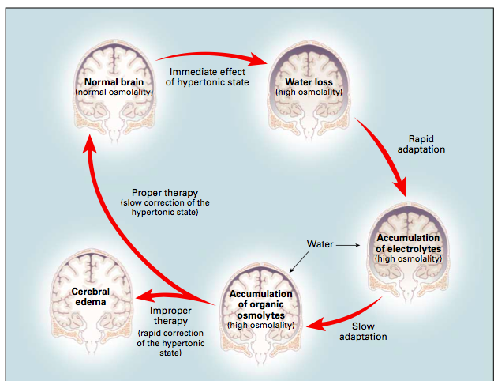

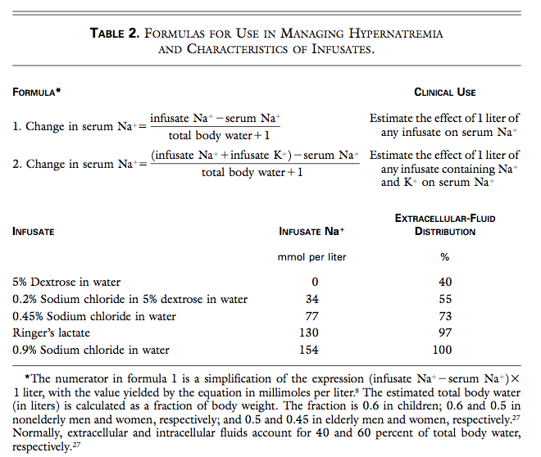
The estimated total body water (in liters) is calculated as a fraction of body weight. The fraction is 0.6 in children; 0.6 and 0.5 in nonelderly men and women, respectively; and 0.5 and 0.45 in elderly men and women, respectively. Normally, extracellular and intracellular fluids account for 40 and 60 percent of total body water, respectively

Questions:

A 40kg dog presents to your clinic for a 3 day history of vomiting and diarrhea. On presentation the patient has a stable cardiovascular status, however is markedly dehydrated. Other than being slightly dull and diarrhea on rectal, the remainder of the physical exam us unremarkable.

Point of care blood work reveals the following:

PCV 65%, TS 9.0g/dL, Azo 15-25, BG 136mg/dL, Na⁺ 170mmol/L,

Please answer the following questions below:

1. What type of fluid loss is occurring in this patient?
Answer: Hypotonic fluid loss due to vomiting and diarrhea

2. Estimate the total body water in this patient (as outlined in this review)
Answer: 0.6 x BW = 0.6 x 40 = 24L

3. Using the formula below, please estimate the effect on serum sodium that would result by administering 1L of D5W

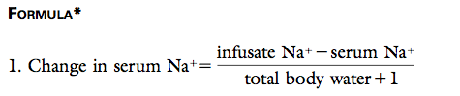

Answer:

Change in serum Na⁺ = 0mmol/L – 170mmol/L = - 6.8mmol/L
24L + 1
According to formula 1, the retention of 1 liter of 5 percent dextrose will reduce the serum sodium concentration by 6.8 mmol per liter

4. If the goal of treatment is to reduce the serum sodium concentration by approximately 10 mmol per liter over a period of 24 hours, how much of the solution (D5W) will be required? (ignoring ongoing water losses).
Answer:
Amount of infusate required = 10mmol/L = 1.5L
6.8mmol/L

5. Adding an additional 2.5L to account for average obligatory water losses over the next 24 hour period, what will be your hourly fluid rate?

Answer:

Fluid rate (ml/hr) = 1.5 +2.5 = 4L
= 4000ml/24hr = 166ml/hr

