Enteric Coccidiosis
- Coccidia are obligate intracellular parasites normally found in the intestinal tract
- Belong to the phylum Apicomplexa
- Coccidian genera that infect cats and dogs are Isospora, Hammondia, Besnoitia, Sarcocystis, Caryospora, Toxoplasma, Neospora, Cryptosporidium, and Cyclospora species

Isospora spp.
- Isospora spp., a coccidial protozoal parasite (phylum Apicomplexa)
- Transmitted by fecal-oral; ingestion of intermediate hosts
- Dogs and cats are the definitive host of different Isospora spp.
- The sexual phase of the organism is completed in the gastrointestinal tract, which culminates in the passage of oocysts in feces
- Most other vertebrates can serve as intermediate hosts; invertebrates can serve as transport hosts by carrying Isospora spp. oocysts.
- Found worldwide
- Most dogs and cats harbor subclinical infections
- Watery diarrhea that can contain blood occasionally occurs in puppies and kittens.
- Differential diagnoses include other enteropathogenic bacterial (e.g., Clostridium perfringens, Campylobacter) and protozoal infections (e.g., Giardia, Tritrichomonas foetus), as well as nematode infestations.
- Isospora spp. of dogs and cats do not infect humans
- Cats are the definitive hosts for Isospora felis and Isospora rivolta, and dogs are the definitive hosts for Isospora canis, Isospora ohioensis, Isospora neorivolta, and Isospora burrowsi
- Prevalence rates for Isospora spp. infection in dogs and cats vary from 3% to more than 30%
- Dogs experimentally infected with I. canis, the mean prepatent period was 9.8 days and the patent period was 8.9 days
- Clinical disease is most common in young, debilitated, and immunocompromised animals
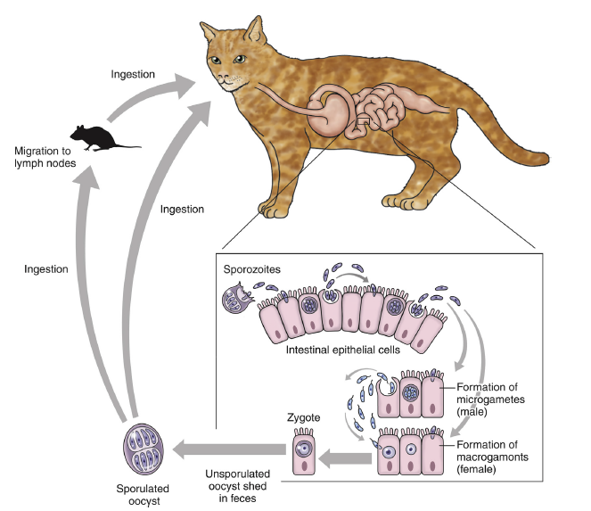
- Clinically ill puppies and kittens can exhibit vomiting, abdominal discomfort, inappetence, and watery diarrhea that sometimes contains blood
- Coccidiosis is generally self-limited, and clinical signs in most puppies and kittens resolve without therapy
- Treatment can speed resolution of clinical disease and may lessen environmental contamination
- The only approved treatment for coccidiosis in the United States is sulfadimethoxine
- Other drug regimens have been used including trimethoprim-sulfa (30 to 60 mg/kg of trimethoprim daily for 6 days in animals >4 kg; or 15 to 30 mg/kg trimethoprim daily for 6 days in animals <4 kg)
- Ponazuril 20 mg/kg twice, 1 to 7 days apart or 50 mg/kg once
- Ponazuril may be superior to other drugs for the treatment for coccidiosis
- Prognosis is considered good to excellent
- Isospora spp. oocysts are very resistant to environmental conditions and disinfectants
- The key to control is to provide good sanitation

Sarcocystosis

- Sarcocystosis is caused by Sarcocystis species, which are coccidian parasites that resemble Toxoplasma and Neospora
- Life cycle involves intermediate and definitive host species
- After ingestion of oocysts, organisms replicate in the intermediate host, forming schizonts, usually in endothelial cells
- Merozoites are released from the schizonts and ultimately encyst in tissues as a sarcocyst which contains bradyzoites
- On ingestion of tissues from the intermediate host by the definitive host, bradyzoites are released from sarcocysts and replicate in the small intestine, with formation of oocysts
- The oocysts are then excreted in feces
- Dogs are definitive hosts for numerous species of Sarcocystis, but the life cycles of these Sarcocystis species are incompletely understood
- Sarcocystis canis can cause hepatitis, encephalitis, dermatitis, and pneumonia in dogs, with most reports involving puppies
- Sarcocystis neurona is an unusual species with opossums as definitive hosts and several other animal species as intermediate or aberrant hosts, including dogs, cats, marine mammals, and horses
- Virtually all cattle and sheep are infected with Sarcocystis

Questions:

- True or False: Coccidia are obligate intracellular parasites normally found in the intestinal tract

- True or False Coccidiosis is not a self-limiting disease and requires antimicrobial treatment

- The only approved treatment for coccidiosis in the United States is:
  - Ponazuril
  - Sulfadimethoxine
  - Trimethoprim/Sulfamethoxazole
  - Metronidazole
  - Matt Damon

4) True or False: Isospora spp. oocysts are very susceptible to environmental conditions and disinfectants

5) The sexual phase of Isospora is completed in the _____________________________, which results in the passage of oocysts in ________________

6) The definitive host of Sarcocystis neurona is:
a. Cats
b. Dogs
c. Horse
d. Opossum

7) True or False: Virtually all cattle and sheep are infected with Sarcocystis

8) What must occur for the definitive hosts of Sarcocystis to become infected:

Questions and answers:

- True or False: Coccidia are obligate intracellular parasites normally found in the intestinal tract

- True or False Coccidiosis is not a self-limiting disease and requires antimicrobial treatment

- The only approved treatment for coccidiosis in the United States is:
  - Ponazuril
  - Sulfadimethoxine
  - Trimethoprim/Sulfamethoxazole
  - Metronidazole
  - Matt Damon

4) True or False: Isospora spp. oocysts are very susceptible to environmental conditions and disinfectants

5) The sexual phase of Isospora is completed in the gastrointestinal tract, which results in the passage of oocysts in feces

6) The definitive host of Sarcocystis neurona is:
a. Cats
b. Dogs
c. Horse
d. Opossum

7) True or False: Virtually all cattle and sheep are infected with Sarcocystis

8) What must occur for the definitive hosts of Sarcocystis to become infected:
- Ingestion of the intermediate host
- bradyzoites are released from sarcocysts and replicate in the small intestine, with formation of oocysts

