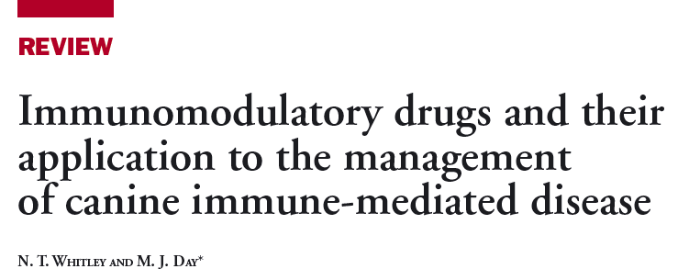

Immune System
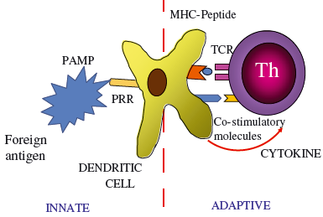
- Innate immune system traditionally thought of as a primitive and simplistic means of immune defence
- Relies on the non-specific and slow action of epithelial barriers, secreted antimicrobial substances and the phagocytic and NK cells
- Key cell is the dendritic antigen-presenting cell (APC
- Encounter with foreign antigen and mediated by various component molecules of the organism
- PAMPS (pathogen-associated molecular patterns) are recognised by APC receptors
- Initiates specific intracellular signaling pathways
- Integral to the activation of the T cell by the APC
T cells
- Regulation of the adaptive immune response is undertaken by numerous different T cell subsets
- T lymphocytes include CD4+ T helper (Th) cells, CD8+ T cytotoxic (Tc) cells and T “suppressor” cells
- Th1 and Th2 subsets develop from a common Th0 precursor cell
- Dependent on the signals delivered to that precursor by the APC
- Th1 cells are characterised by production of interferon and in inducing cell mediated immunity
- Th2 cells produce a panel of cytokines including IL-4, IL-5, IL-9 and IL-13
- Th2 activate B cells which transform into plasma cells and secrete antibody
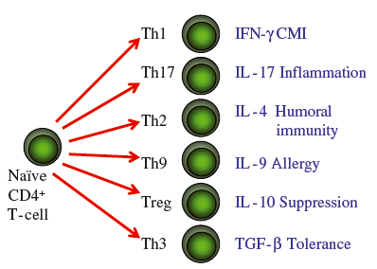
- Th17 cells play a role in the immune response to infectious agents and Th9 cells may be important in the allergic immune response
- There are other CD4+ T cell subsets that inhibit or suppress immune responses
- Regulatory T cells (Treg) originally described T suppressor cells
- Natural Treg continuously present within the immune system and have the effect of preventing the activation of potentially damaging autoreactive or allergen-reactive T cells

Glucocorticoids
- Act primarily by binding to a cytosolic glucocorticoid receptor which then translocates to the nucleus
- Binds specific DNA sequences and enhance or inhibit transcription of corresponding genes
- More rapid effects are mediated through GRs influencing intracellular signalling, non-specific interactions with cell membranes and specific interactions with membrane-bound receptors
- Anti-inflammatory effects of glucocorticoids relate to the stabilisation of cell membranes of granulocytes, mast cells and monocytes-macrophages and inhibition of phospholipase A2
- Prevent release of the pro-inflammatory cytokines IL-1 and IL-6
- Effects on complement and rapid downregulation of Fc receptor expression on macrophages, reducing phagocytosis of opsonised red blood cells and platelets
- This could explain early efficacy of glucocorticoids in treating immune-mediated haemolytic anaemia and immune-mediated thrombocytopenia
- Cause reduction in antigen processing and presentation by effects on macrophages and dendritic cells
- Cause direct suppression of T cell function (including T cell help for B cells) and reduced affinity of antibody to cell membrane epitopes
- Glucocorticoids have never been subjected to rigorous evaluation by randomised double-blinded placebo controlled trials for treating canine immune-mediated disease
Azathioprine
- Azathioprine (Imuran, Glaxo Smith Kline) is a cytotoxic synthetic imidazole derivative of 6-mercaptopurine (6MP)
- Thiopurines which interfere with purine synthesis and result in production of fraudulent nucleotides
- DNA and RNA syntheses are inhibited, and mitosis and cellular metabolism is disrupted
- Generally accepted that azathioprine has a “lead-in time” of 11-14 days before having clinical effect
- Main effects of this drug are thought to be on CMI with a reduction in lymphocyte number and T cell-dependent antibody synthesis
- Combined with glucocorticoid for sparing effect
- Unpredictable efficacy by itself
- Side effects include myelosuppression, acute pancreatitis, hepatopathy and gastrointestinal distress
Ciclosporin
- Blocks gene transcription for T cell activation, primarily those encoding a number of immunoregulatory cytokines including IL-2
- Specific for T-helper/T-cytotoxic (CD4+)
- Spares T-suppressor (CD8+)
- Binds cyclophilin which prevents the activation of calcineurin that would normally occur when T cell receptor engagement with antigen triggers an influx of calcium into the cell
- Reduces clonal proliferation of T and B cells
- Reduced production of IL-2, IL-3, IL-4, GSF, TNF-α
- Only licensed immunosuppressive veterinary drug
Cyclophosphamide
- Cytotoxic alkylating agent preventing DNA separation through cross-linking
- Suppresses cell mediated immunity and humoral immunity
- Toxic to resting and dividing cells, proliferating lymphocytes very sensitive to cyclophosphamide
Human intravenous immunoglobulin
- Inhibits the binding of canine IgG to monocytes by saturation of Fc receptors
- Binding to canine T (CD4 and CD8) and B cells in vitro and interferes with B and T cell activation
- Interence with complement
- Decreases immunoglobulin production
Vincristine
- Binds tubulin
- Disrupts assembly of mitotic spindle cell in mitosis
- Increases platelet counts by stimulating megakaryoctes and impairs phagocytosis of opsonised platelets by impairing microtubule assembly in macrophages
Danazol
- Synthetic androgen which is reported to down regulate macrophage Fc receptor expression
- Reduce antibody binding to erythrocytes
- Stabilise erythrocyte membranes
- Alter T cell homeostasis
- Hepatotoxic
Leflunomide
- Isoxazole immunomodulatory drug
- Primary metabolite inhibits pyrimidine synthesis
- High concentrations inhibit cytokine and growth factor receptor-associated tyrosine kinase activity
- Inhibits T and B cell proliferation
Mycophenolate mofetil
- Metabolized to mycophenolic acid (MPA)
- Reversibly inhibits inosine monophosphate dehydrogenase (IMPDH) and purine biosynthesis
- Inhibits T and B cell proliferation and differentiation
- MPA induces apoptosis of activated T cells and impairs dendritic cell maturation
Clodronate
- Bisphosphonate
- Liposomal encapasulated clodronate (LC)preferentially phagocytosed by macrophages and dendritic cells
- Undergo apoptosis
- In vitro decreased clearance of opsonized RBCs by splenic macrophages
Chlorambucil
- Metabolized to mycophenolic acid (MPA)
- Reversibly inhibits inosine monophosphate dehydrogenase (IMPDH) and purine biosynthesis
- Inhibits T and B cell proliferation and differentiation
- MPA induces apoptosis of activated T cells and impairs dendritic cell maturation
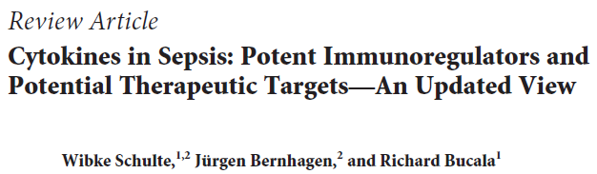
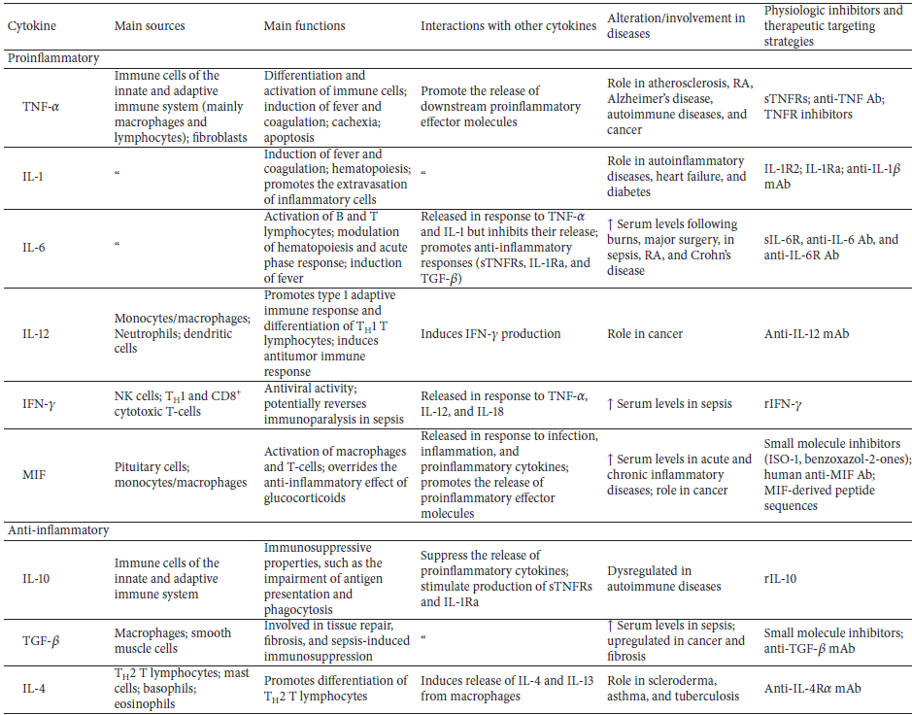

- The term cytokine describes a functional class of small protein mediators with low molecula rweights
- Produced in a regulated fashion to affect the activation and differentiation of the immune response
- Proinflammatory cytokines lead to an ensuing activation of the innate or the adaptive immune response,
- characterized by the further production of immunoregulatory or effector cytokines
- Release of specific cytokines is referred to as a “cytokine cascade”
- Pathophysiologic mechanisms underlying sepsis indicate that the profound proinflammatory response is counteracted by certain anti-inflammatory cytokines, including IL-10, transforming growth factor (TGF)-𝛽, and IL-4, which attempt to restore immunological equilibrium
- Cytokine storm is the release of mainly proinflammatory cytokines, such as tumor necrosis factor (TNF)-𝛼, interleukin (IL)-1, IL-6, IL-12, interferon (IFN)-𝛾, and macrophage migration inhibitory factor (MIF)

Questions:
- Which immunosuppressive therapy is unlikely to be effective in the first 2 weeks of treating IMHA?
- Glucocorticoids
- Azathioprine
- MMF
- IVIG

- In dogs with IMHA, administration of which immunosuppressive drug has been associated with a worse outcome in retrospective studies?
- Ciclosporin
- Leflunomide
- Cyclophosphamide
- MMF

- True or False: A side effect of Ciclosporin use is gingival hyperplasia

- True or False: Ciclosporin use has been associated with the secondary development of lymphoma

- Which drug is an anabolic steroid?
- Prednisone
- Ciclosporin
- Azathioprine
- Danazol

- What is the effect of inflammatory cytokines on platelets?
- They decrease platelet reactivity
- They accelerate platelet destruction
- They increase platelet count
- They decrease platelet count

- Inflammatory cytokines downregulate the protein C pathway by inhibiting
- Protein S
- Protease-activated receptors
- Thrombomodulin and endothelial cell protein C receptor
- Heparan sulfate

