Antimicrobials part 2 – Hyatt

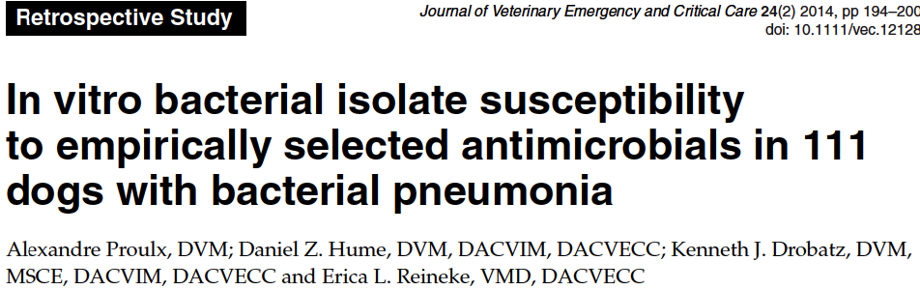
n=111 dogs with bacterial pneumonia
Community acquired: Bordetella (71%), E coli (17%), pseudomonas, staph, strep
Aspiration pneumina: Ecoli (21%, klebsiella, strep (21%), staph, enterobacter, enterococcus, pseudomonas
Other causes of pneumonia: Ecoli, Klebsiella, staph, strep, morganella

26% of dog had at least one bacterial isolate that was resistant to empirically prescribed antibiotics

Severe neutrophilic inflammation:
100% of community acquired
87% of aspiration pneumonia

For dogs previously treated with antimicrobials, and for which susceptibility was available: 57% had resistant organisms to previously rxed antibiotic.

Overall survival 87%. All nonsurvivors euthanized

Questions:

- According to Proulx et al (JVECC 2014, this paper), what were the three most common aspiration pneumonia isolates (in order)?
  - E. coli, Enterobacter, Enterococcus
  - E. coli, Klebsiella, strep/staph
  - E. coli, Strep/Staph, Klebsiella
  - E. coli, Klebsiella, enterococcus
- Which category was most likely to have a severe neutrophilic inflammation?
  - Community acquired
  - Aspiration pneumonia
  - Hematogenous pneumonia
  - Matt Damon
- What percent of cases had at least one bacterial isolate that was resistant to previously (empirically_ prescribed antibiotics?
  - 77%
  - 7%
  - 52%
  - 26%
- True or False – the presence of resistance (in vitro) was associated with increased mortality.
- Based on the findings of this paper, which of the following recommendations is most accurate?
  - Given the high survival rate, aggressive antibiotic therapy is unwarranted
  - The survival rate for the community acquired pneumonia was less than the aspiration pneumonia group, and therefore should be more aggressively treated.
  - Dogs who have recently received antibiotics should be treated with different/new antibiotics given the rate of resistance.
  - Add dogs that were nonsurvivors were euthanized so this paper is crap
  - Matt Damon and Josh Smith are BFFs and like to “hang”

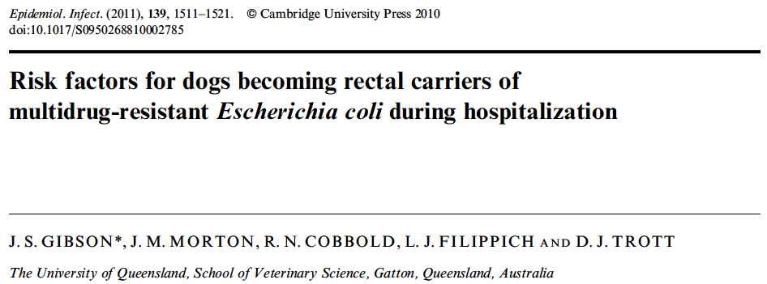
GI tract is most important reservoir for nosocomial gram-negative organisms such as MDR E coli and enterobacter spp. In humans intestinal carriage often preceeds clinical extraintestinal infection. Risk of infection increases with time spent in ICU, with disease, age, catheterization, and antimicrobial drug use.
Hospitalization for >6 days was risk factor for dogs becoming recta carriers of MDR e. coli.
Cephalosporines within 42 days of hospitalization and treatment with cephalosporins or metronidazole in hospital were risk factors for developing MDR E. coli.
Treatment with fluoroquinolones prior to hospitalization or gentamicin in hospitalization were risk factors.

Questions

- Which of the following was NOT found to be associated with intestinal colonization of MDR strains?
  - Duration of hospitalization
  - Treatment with cephalosporins and metronidazole during hospitalization
  - Treatment with cephalosporins prior to hospitalization
  - Treatment with penicillins during hospitalization
- True of False: Most cases of MDR colonization confirmed that MDR strains of E. coli were the same strain isolated from extraintestinal infections.
- True or False: Rectal swabbing was highly specific for identifying GI carriers of MDR strains.

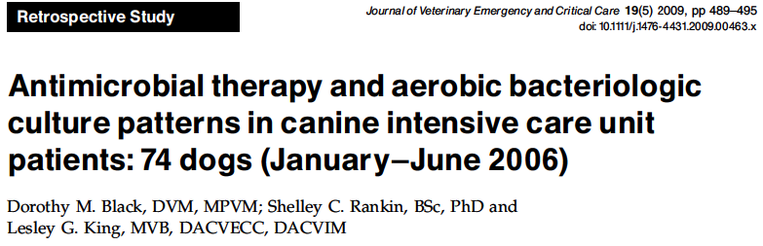

More than half the samples submitted >48 hours after admission were MDR.

Questions:

- The combination of enrofloxacin/ampicillin and clindamycin/cephalosporin was an appropriate choice in what percent of isolates of infections that developed after 48 hours of hospitalization? 70%
- Which antibiotics were ideal in this study for treating infections of gram-negative isolates in critically ill animals that have been hospitalized for >48 hours? Gentamicin, amikacin,imipenum
- Which antibiotics maintained efficacy against MRSA isolates in this study? Doxycycline, TMS

Questions:
- According to Proulx et al (JVECC 2014, this paper), what were the three most common aspiration pneumonia isolates (in order)?
  - E. coli, Enterobacter, Enterococcus
  - E. coli, Klebsiella, strep/staph
  - E. coli, Strep/Staph, Klebsiella
  - E. coli, Klebsiella, enterococcus
- Which category was most likely to have a severe neutrophilic inflammation?
  - Community acquired
  - Aspiration pneumonia
  - Hematogenous pneumonia
  - Matt Damon
- What percent of cases had at least one bacterial isolate that was resistant to previously (empirically_ prescribed antibiotics?
  - 77%
  - 7%
  - 52%
  - 26%
- True or False – the presence of resistance (in vitro) was associated with increased mortality.
- Based on the findings of this paper, which of the following recommendations is most accurate?
  - Given the high survival rate, aggressive antibiotic therapy is unwarranted
  - The survival rate for the community acquired pneumonia was less than the aspiration pneumonia group, and therefore should be more aggressively treated.
  - Dogs who have recently received antibiotics should be treated with different/new antibiotics given the rate of resistance.
  - Add dogs that were nonsurvivors were euthanized so this paper is crap
  - Matt Damon and Josh Smith are BFFs and like to “hang”

- Which of the following was NOT found to be associated with intestinal colonization of MDR strains?
  - Duration of hospitalization
  - Treatment with cephalosporins and metronidazole during hospitalization
  - Treatment with cephalosporins prior to hospitalization
  - Treatment with penicillins during hospitalization
- True of False: Most cases of MDR colonization confirmed that MDR strains of E. coli were the same strain isolated from extraintestinal infections.
- True or False: Rectal swabbing was highly specific for identifying GI carriers of MDR strains.

- The combination of enrofloxacin/ampicillin and clindamycin/cephalosporin was an appropriate choice in what percent of isolates of infections that developed after 48 hours of hospitalization?
- Which antibiotics were ideal in this study for treating infections of gram-negative isolates in critically ill animals that have been hospitalized for >48 hours?
- Which antibiotics maintained efficacy against MRSA isolates in this study?

