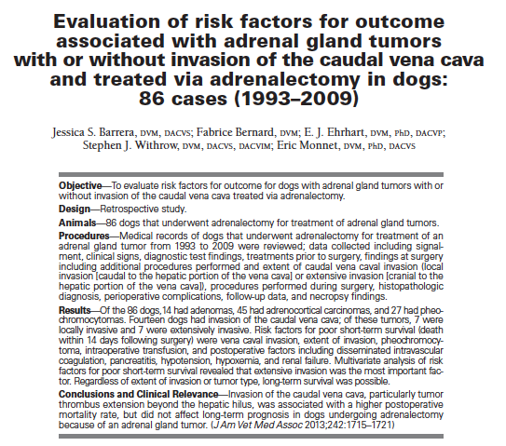

Caudal vena cava invasion by adrenal gland tumor occurs in 9-46% cases.
Purpose – evaluate risk factors assoc with short and long term outcome for adrenal gland tumors with or without invasion of the caudal vena cava and treated with adrenalectomy in dogs.
N= 86 dogs
14=adrenocortical adenoma
45= adrenocorticol adenocarcinoma
27= pheochromocytoma
14=caudal vena cava invasion
13=pheo
7=locally
7=extensive invasion
5=left sided
9=right sided
72=no caudal vena cava invasion

71/86=intraop complications
7=died in sx
6=pheo
5=invasive group
**SD** intraoperative death is significantly more frequent in dogs with invasion of the vena cava than for dogs without invasion of the vena cava
Cause of death: hemorrhage, cardiac arrest, lack of respectability (euth), and persistant refractory hypotension.
Intra-op complications: Hypotension, hemorrhage transfusion, arrhythmias, hypertension, hypoxia.
Pheo= 25/27 dogs; adrenocortical adenoCA=36/45
Post op complications: 34/79
15=died in post-op period
CPA, DIC, resp failure, peritonitis, euth d/t renal failure
3= adenoma; 12=pheo
post-op complications: 10=CVC invasion, 28 w/o CVC invasion
V/D, hypotension, hypoxemia, pancreatitis, renal insufficiency, peritonitis.
Short term survival: 52 survivors / 22 nonsurvivors / 11 lost to follow up
14d survival rates: 79% adenocarcinomas / 48% pheos
10/12 dogs that died had CVC invasion

Factors assoc with short term survival (death within 14 days of sx): pheochromocytoma tumor type, invasion of the caudal vena cava, extensive invasion of the CVC. Also pancreatitis, DIC, hypoxemia, renal failure, hypotension.
Pretreatment with phenoxybenzamine did NOT make a significant difference in short term survival.
Nephrectomy was significantly associated with development of renal failure
Median survival time was assoc with nephrectomy.
Pheos – more likely to develop DIC
Vena cava extension (and the extent of invasion) was associated with poor short term survival, tumor type was not (when invading CVC)

Long term survival: 52 dogs survived >14 days.
Pheos: MST was 48 months. 1 year: 88% / 2 year: 60%, 3 year: 60% for pheos
Adenocarcinomas: MST 23mo.

Conclusions:
Caudal vena cava invasion was associated w/ higher perioperative mortality rate, esp. if invasive.
Pheochromocytoma short term survival (correcting for invasion) was not different from carcinoma.
Long term survival was not affected by invasion into the CVC
NSD in MAP in pheochromocytomas
Intra op mortality 8%, <14 day mortality 25%
Phenoxybenzamine did not have protective effect in the present study – however there were inadequate numbers to further conclude.

Questions:
- According to this Barrera et al (JAVMA 2013), which of the following factors was associated with survival of <14 days following surgery?
  - Pre-operative use of phenoxybenzamine
  - Tumor type of adenocarcinoma
  - Use of heparin
  - Development of pancreatitis.
- True or False: Caudal vena cava invasion in pheochromocytoma was a significant association with death <14 days, whereas adenocarcinoma was not.
- True or False: the use of phenoxybenzamine was protective for pheochromocytomas and intra op mortality.
- Which of the follow was determined to be the most important risk factor for decreased survival time for adrenalectomy surgery according to Barrera et al (JAVMA 2013)?
  - Intraoperative hemorrhage requiring transfusions
  - Post-operative development of disseminated intravascular coagulation
  - Development of post-operative renal failure
  - Extensive tumor thrombus in the caudal vena cava
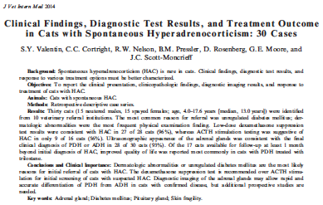

Objectives: Determine nature and frequency of clinical, clinicopathologic and diagnostic imaging abnormalities, determine the clinical performance of commonly used endocrine tests, and report outcome after treatments.
Hypothesis: ACTH stim test would have poor sensitivity and specificity for the diagnosis of HAC in cats, where as the DST would be more accurate. Imaging will differentiate the cause of HAC.

Results:
Clinical signs – derm lesions (thin skin, alopecia, lacerations, dull/scaling/seborrheic skin), muscle wasting, abdominal distension, weight loss, weight gain.
Concurrent illnesses – DM 90%, pancreatitis, CKD, bacterial infections, heart disease, pancreatic ACA. Only one cat had no concurrent disease.
Labs: Hi BG (in DM kitties), low Cl, hi triglycerides. TT4 normal in 84% cats, low in 16% cats
ACTH stim tests: 9/16 were consistent with HAC. Normal in all three cats with adrenal dept HAC.
Calc specificity 89% and 85% (30 min and 60 minutes). Sensitivity 56% in all sampling times, 46% if only 60 minute sampling time was evaluated.
Dex suppression test: 28 cats. 27 cats had inadequate suppression of serum cortisol concentration 8 hours after administration of dexamethasone, 1 equivocal. 21 cats had inadequate suppression at 4 hours. Dex suppression tests were consistent with HAC in 25 of 25 cats with PDH and consistent with HAC in 2 of 3 cats.
Differentiation of PDH from ADH: AUS, endogenous ACTH, advanced cranial imaging, histo. Final diagnosis made by histo in 15 cats, histo and cranial imaging in 6 cats, cranial imaging in 3 cats, AUS in 12 cats.
Endogenous ACTH tests – consistent with PDH in 7/8 cats.
Histopath-

Treatment:

