- Addisons Review parts I and II

- Clinical disease occurs when 85-90% of the adrenocortical tissue is destroyed.

- Anatomy and physiology
- Adrenal glands consist of outer cortex and inner medulla.
  - Adrenal cortex:
    - Zona glomerulosa – mineralocorticoid hormones, supplies precursors for the inner two layers - aldosterone
    - Zona fasciculate – glucocorticoid hormones - cortisol
    - Zona reticularis – adrenogen sex hormones
  - Aldosterone and cortisol
    - Synthesized from cholesterol
    - Not stored, can be rapidly synthesized from cholesterol

- Aldosterone
  - Na, K, water balance
  - Target organ is kidney, also affects intestinal mucosa, salivary glands, sweat glands
  - Aldosterone stimulates the insertion of theepithelial sodium channels (ENaCs) in the luminal surface of corticol collecting duct cells.
    - Increases number of open Na channels in the luminal membrane
    - Enhances K egress into renal tubular fluid
  - Net effects:
    - Reabsorption of Na Cl
    - Excretion of K and H
    - Water absorption and expansion of the extracellular fluid volume occurs secondary to Na retention
  - Regulation of aldosterone release
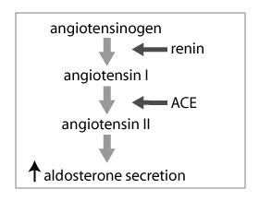
    - RAAS
      - Stimulated by reduced ECFV, systemic blood pressure, Na concentration in renal filtrate, increased K concentration in ECFV
      - Angiotensin II, final product of the RAS is main stimulation for aldosterone production.
      - ACTH from anterior pituitary exerts permissive effect for aldosterone release

- Cortisol
  - Actions:
    - Maintaining blood pressure, water balance, vascular volume.
    - Increases vascular sensitivity to catecholamines.
    - Preserves normoglycemia by increasing lipolysis and gluconeogenesis while decreasing peripheral glucose utilization
    - Suppresses inflammatory responses
    - Catabolic effects on connective tissue, muscle, bone,
    - Stimulates erythrocytosis
    - Counteracts stress
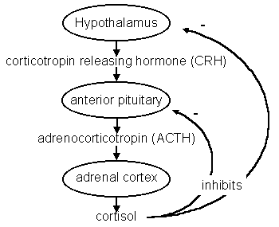
  - Regulation of Cortisol release
    - HPAA (hypothalamic-pituitary axis
    - Corticotrophin-releasing hormone (CRH)
      - ACTH from pituitary gland
        - Cortisol release by zona fasciculate cells
    - Cortisol exerts strong negative feedback on pituitary gland
    - Stimuli for CRH release: stress, ACTH, above normal baseline level secretions

- Etiology
  - Primary immune-mediated destruction of all three layers of the adrenal cortex
  - Rarely infectious diseases – Histoplasma, Blastomyces, Coccidoides, Cryptococcus, neopleasia, amyloidosis, coagulopathy
  - Autoimmune polyglandular syndrome (rare in dogs) - >1 endocrinopathy
  - Iatrogenic primary hypoadrenocorticism – drugs
    - Mitotaine – zona fasciculate and zona reticularis. Generally reversible, on occasion permanent. Causes necrosis of the zones.
    - Trilostane – reversibly and competitively inhibits 3B-hydroxysteroid dehydrogenase enzyme decrease in conversion of progesterone to cortisol, aldosterone and androstenodione, resulting in decreased mineralocorticoids and glucocorticoids. Less likely than mitotaine to cause problems
  - Iatrogenic secondary hypoaldosteronism – exogenous glucocorticoid supplementation. Caused by chronic administration of sterpods leading to feedback inhibition causing pituitary suppression. Leads to atrophy of the zonas faciculata and reticularis
  - Tertiary hypoadrenocorticism –
    - hypothalamic disorders disruption CRH secretion. Rare. Manifests as secondary Addisons.
    - Isolated aldosterone insufficiency is rarely recognized in humans (hyporeninemic hypoaldosteronism) – has been recognized on 1 dog.

- Signalment
  - Young to middle aged dogs most commonly. Avg age 4-5y at diagnosis, Nova Scotia Duck Tolling retrievers generally younger, 2.6 years
  - Female > Male
  - Male > female in bearded collies, Portuguese water dogs, SPOO
  - Autosomal recessive mode of inheritance in NCDTR, SPoo, PWD

- Clinical signs
  - Vague, nonspecific
  - Body systems affected: GI, renal, neuro
  - Episodic or progressive
  - Inappetance/anorexia
  - Lethargy
  - Vomiting/regurgitation
  - Weakness
  - Weight loss
  - Diarrhea
  - PU/PD
  - Shaking/shivering/tremors
  - Collapse
  - Paingul abdomen
  - Seizures/ataxia
  - Difficulty breathing
  - Hematemesis/hematochezia, melena
  - Muscle cramps

- PE findings
  - Dehydration
  - Potentially shock (primary >> secondary)
  - Lethargy
  - Thin
  - Weakness
  - Hypothermia
  - Bradycardia
  - Weak pulses
  - Melena/hematochezia
  - Abdominal pain

- Laboratory abnormalities
  - Hyperkalemia, hyponatremia, hypochloremia (primary, hyperkalemia less common in secondary)
    - Primary Addisons - Aldosterone deficiency – kidneys then fail to conserve sodium and secrete potassium.
    - Secondary Addisons – hyponatremia occurs secondary to GI losses and inappetance.
    - Hyperkalemia – decreases myocardial excitability, slows conduction and can lead to cardiac standstill
    - DDX hyponatremia and/or hyperkalemia: vomiting, diarrhea, severe GI disease, renal and urinary tract disease, severe liver failure, parasitism, CHF, pleural effusion, severe metabolic acidosis (DKA), severe respiratory acidosis, tissue crush injuries or reperfusion injury, pregnancy, artifact
  - Pre-renal azotemia
    - Decreased GFR and renal perfusion
    - Increased BUN from GI bleeding
    - Present in 66-95% of primary dogs
    - Hyperphosphatemia – decreaed GFR and renal excretion of Phos
    - Ideally urine sample should be collected. USG generally > 1.030
      - Dilute urine could indicate medullary washout from chronic hyponatremia, or could indicate kidney disease
  - Metabolic acidosis
    - Impaired renal excretion of H+ due to lack of aldosterone
  - Increased total serum calcium +/- ionized calcium
    - Incompletely understood, hemoconcentration, decreased GFR, decreased renal calcium excretion
    - Usually resolves with therapy
  - Hypoglycemia
    - Up to 22%
  - Hypoalbuminemia
    - 17-39%
    - impaired albumin synthesis, lack of nutrient intake from anorexia, impaired nutrient abdorption, decreased hepatic synthesis, GI or renal loss
    - lower in glucocorticoid def than mineralocorticoid def
  - increases in ALT, AST
    - 30-50% of cases
    - poor cardiac output, hypotension, tissue perfusion
    - concurrent hepatopathy – suspect if hypoglycemia, hypoalbuminemia and hypocholesterolemia present
  - Hypocholesterolemia
    - 17.5%
  - mild normocytic normochromic anemia
    - 21-25%
    - secondary to BM suppression, lack of glucocorticoids
    - secondary to GI bleeding in severe anemic cases
    - hemoconcentration may mask anemia
  - WBC count
    - Norma, varies
    - Eosinophil normal, hi or low. Eosinophilia exists in 10-20% of cases
    - Lymphocytosis 10-13%
    - Lack of stress leukogram

- Diagnostic imaging
  - Hypovolemia
  - Reversible megaesophagus – rare
  - +/- small liver
  - US – small adrenals

- Blood pressure
  - 90% hypotension – humans with primary, less with secondary

- ECG
  - Hyperkalemia –
    - >5.5 – tall t waves, bradycardia may be seen
    - >6.5 – prolonged P-R interval, prolonged QRS interval. R wave amplitude
    - decrease, S-T segment depression
    - >7 – progressive lengthening of QRS interval and P-R interval, decreased amplitude of P wave, duration of P wave increases
    - >8.5 – atrial standstill, severe bradycardia. P wave disappears due to lack of activation of the atrial myocardium
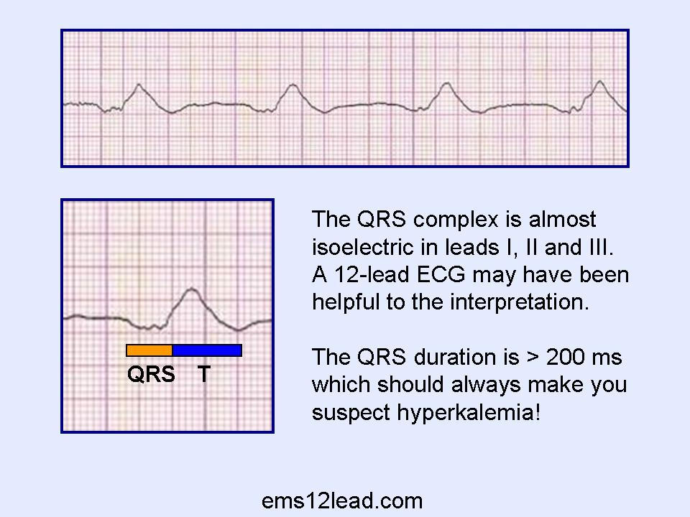
    - >10 – QRS widens, replaced by sine wave
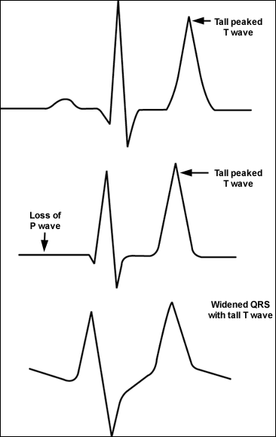
    - terminal phases – ventricular flutter, ventricular fibrillation, ventricular asystole

- Diagnosis
  - ACTH stimulation test is gold standard for diagnosing addisons
  - 5ug/kg cosyntropin IV
  - vial can be refrigerated for 21 days without loss of potency, can be frozed for up to 6 months
  - single cortisol
    - does not confirm diagnosis because cortisol levels fluctuate during day. Cheaper and easier to perform.
    - Baseline cortisol levels <27.59 (<2ish ug/dl) had 100% sensitivity and 98.2% specificity in detecting dogs with addisons. Cortisol levels </= 55.2 nmol/L (no clue what this is in American units) showed 100% sensisitivity but less specificity (78.2%)
    - Should confirm with full ACTH test

- Treatment
  - Correct hypovolemia
  - Correct hypoglycemia if present
  - Treat hyperkalemia
    - Calcium gluconate
    - Insulin/dextrose
    - IV fluids to correct perfusion/metabolic acidosis
  - Correct metabolic acidosis
    - Bicarb if necessary – deficit is 0.3 x kg body weight x (24-patients HCO3) – give ¼ to ½ and reassess.
  - Glucocorticoid supplementation
    - Dexamethasone sodium phosphate 0.5-4mg/kg IV – does not interfere with ACTH stimulation test
    - Prednisolone sodium succinate (Solu-Delta-Cortef) 15-20mg/kg IV
    - Hydrocortisone sodium succinate (Solu-Cortef) 0.3mg/kg/hr – replaces both glucocorticoid and mineralocorticoid
    - Hydrocortisone 5mg/kg IV over 5 minutes, then 1mg/kg q6hr
  - Mineralocorticoid supplementation
    - Hydrocortisone short term
    - Fludrocortisone
    - DOCP 2.2 mg/kg IM once monthly
  - Additional supportive care
    - Anti-emetics
    - Carafate
    - Etc as indicated
  - Monitoring as indicated

- Chronic treatment
  - Atypical addisonians will generally eventually need mineralocorticoid support as well as glucocorticoid
  - DOCP – 2.2mg IM or SQ q25d
    - Initially with rechecks to check electrolytes, CBC or PCV/TS. First recheck day 12 to help adjust the dose, then at day 25
  - Prednisone 0.22 mg/kg BID initially – adjusted to avoid PU/PD
    - Increase dose with stressful events, illness
  - Fludrocortisone – 0.02mg/kg PO divided BID – mineralocorticoid and glucocorticoid, so patients may not need additional glucocorticoid supplementation

- Prognosis
  - Good with proper monitoring and medications
  - MST 4.7years

- Questions for Addisons part I and II

- 1. A 3 year old female spayed standard poodle presents to your clinic in hypovolemic shock, with a history of vomiting, diarrhea, and collapse. POS labs reveal severe hyponatremia (138) and hypochloremia (100), and hyperkalemia (7.5). You successfully volume resuscitate her with crystalloids and manage the hyperkalemia. While diagnostics are pending you elect to begin a more definitive therapy. Which of the following treatments is most appropriate?
  - A: DOCP 2.2 mg IM injection
  - B: Hydrocortisone sodium succinate (Solu-Cortef) 0.3mg/kg/hr as a CRI
  - C: Fludrocortisone 0.02mg/kg PO divided BID
  - D: Prednisone 0.2mg/kg PO SID

- 2. The patient in the previous question is found to be hypoglycemic. What is the most likely mechanism of hypoglycemia?
  - A: Decreased intake due to vomiting
  - B: Concurrent liver disease
  - C: Decreased gluconeogenesis due to decreased cortisol production
  - D: Sepsis

- 3. True or False: A baseline cortisol level because a result of <2 ug/dL is diagnostic of Addison’s disease.

- 4. True or false: a dose of 5ug/kg of cosyntropin is as effective as the larger 250ug/kg dose in performing an ACTH stimulation test.

- Answers:
- 1. B
- 2. C
- 3. False
- 4. True

