Historical Background
In the early years of Cornell University, water was drawn from springs, wells, and Fall Creek and carried in buckets. In 1875, a reservoir was designed by Dean Fuertes from the civil engineering school and constructed on Observatory Hill. Savage and Newman Halls are located in that area today. The water was pumped from Fall Creek with no treatment whatsoever.
There was no fire protection as we know it today and there was a real fear of fire. A rope was provided at nearly every window for escape. There was occasional sickness or death from waterborne disease. In 1876-78 eleven students died out of a population of 500. A report of 1880 pointed to the suspected contamination of Fall Creek and several springs. The need for a safe drinking water supply at Cornell became urgent following the typhoid epidemic of 1903. Cornell's water did not become typhoid contaminated, but 291 of Cornell’s 3000 students who drank City of Ithaca water became ill with typhoid - 29 died.

The Carnegie Plant
News of the typhoid epidemic received worldwide attention. As a result, that same year Andrew Carnegie wrote a letter to the University asking if he might be allowed to furnish Cornell with a water plant. Gardner S. Williams, a professor of civil engineering at Cornell, designed a small filtration plant. The plant was in operation by 1905. Water was pumped from Beebe Lake (built in 1898) to two “rapid sand filters” located approximately where Emerson Hall stands today. Pumps underneath the filter pumped the water to the Fuertes reservoir. From the reservoir, the water flowed by gravity down to the original campus quadrangle.

The Present Water Filter Plant
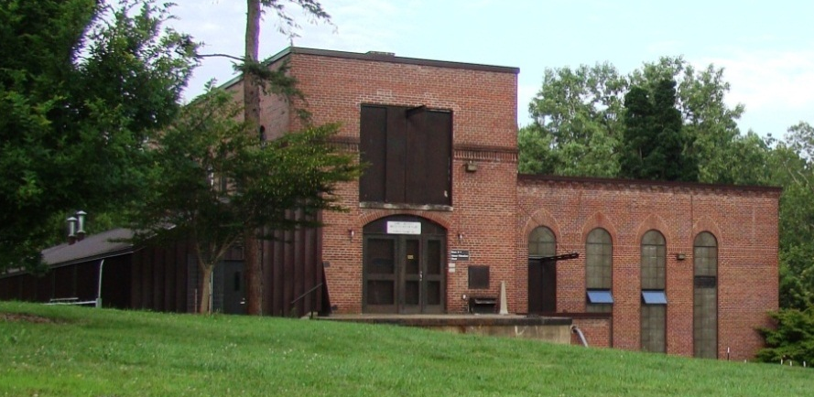
As the University grew, the Carnegie plant proved to be in an inconvenient location and too small to meet the growing demands. Cornell had to buy water from the City of Ithaca to meet the high pressure requirements of some buildings. The capacity of the Carnegie plant was finally surpassed in 1926. Cornell's present plant was built in 1927-28 with a 2.0 MGD capacity. Operation began in early 1929. A dam and intake were built on Fall Creek above the village of Forest Home (contamination from the village was a problem at the time). The source of supply is a 125 square mile watershed that originates at Lake Como. Water from Fall Creek flows to the plant via gravity through a ¾-mile, 16" cast iron main utilizing an 11 foot drop in elevation. There is also a pumping station directly across from the plant that can pump water to the plant if the gravity intake is out of service or demand is high. A one million gallon concrete reservoir for finished water storage was constructed uphill on Dryden Rd. (Rte. 366). That concrete tank is still in use today.
In 1948, it was updated with another filter and a laboratory, and a one million gallon steel storage tank was added next to the concrete tank. In 1956, the elevated tank was built to create another pressure zone to serve the newer high-rise State buildings. These tanks were replaced by a new elevated tank on Hungerford Hill in 2010.
Campus demand for potable water continued to grow, particularly for cooling buildings. In June of 1963, a water main break occurred in the 14' main from the plant to the back of the Vet College. At the time, this was the only outlet from the filter plant and the plant had to be shut down while it was repaired. Although the break was soon valved off, it took almost two days to make repairs. In less than 30 hours the university tanks went dry. The City of Ithaca came to Cornell's aid and pumped water from their East Avenue Main into the Cornell main in the vicinity of Baker Laboratory. This break prompted the trustees to provide funds for long sought after improvements.
- The chilled water system was put on line in 1963 to handle the campus cooling needs
- The main water filter plant was expanded in 1965, adding two filters, another sedimentation basin and a new 16-inch double main leaving the plant – bringing the plant capacity up to 3.6 MGD.
- In 1979, the intake area was upgraded by raising the dam, installing a weir, and building a new intake house.
- Lagoons were added in 1981-82 for disposal of backwash water and dewatering of the residuals removed from the water during the treatment process.
Today the plant has an average demand of 2.0 MGD and can reasonably produce 3.6 MGD. Current plant improvements aim to improve aesthetic water quality and meet the ever-changing drinking water regulations mandated by the U.S. Environmental Protection Agency through the Safe Drinking Water Act (SDWA).

The Plant Process
Water entering the plant's process is treated with polyaluminum chloride (PCH-1800) - a coagulating agent - and mixed in a rapid-mix basin (approximate capacity of 80,000 gallons). From the rapid-mix basin the water flows in channels to two, 400,000 gallon flocculation and sedimentation basins. Water is gently mixed with flocculator paddles in the front of the basins, then baffled through the sedimentation areas. As the flocculation of particles takes place, the heavier particles drop to the bottom of the sedimentation basin, allowing the clarified water to stay near the top and flow on to the filters. The retention time in the basins is about eight hours for an average flow.
The last stage of the treatment process is the filtration of water through "dual media rapid sand filters". The water passes through the filters at a rate of 2.3 gallons per square foot per minute. Each filter can process 600,000 gallons of water per day. After it passes through the filters, the water is stored in a 250,000 gallon “clear well”. Here, it receives a dose of chlorine for disinfection, and a corrosion inhibitor (zinc orthophosphate) is added to prevent corrosion of the distribution pipes. Pumps take the finished product to the storage tanks.
The Water Filtration Plant laboratory performs some of the basic chemical testing that applies directly to the operation of the plant daily, while other samples are sent to EPA certified laboratories for additional tests. Samples are taken from the plant and from points in the distribution system. All operating personnel are licensed by New York State.

Distribution system
The distribution system has more than 1050 valves and 200 hydrants. The pipe is cast iron or ductile iron in composition and ranges in diameter size from 4 to 16 inches. It is divided into three pressure zones. Zone 1 supplies about 65% of the total demand through 15 miles of water mains to the western, lower, portion of campus. Zone 2 makes up about 30% through 11 miles of water mains. Zone 3 supplies water to the areas south of Rt. 366. The new 1.5 MG tank on Hungerford Hill provides the elevation to pressurize both Zone 2 and Zone 3. The original 1928 concrete tank (1 MG) still serves Zone 1. There are a number of interconnections between the pressure zones and also between the Cornell, City of Ithaca, and Bolton Point systems.

