Authors: SLB, RB, VP

Pressure Vessel - Problem Specification

Problem Specification

Consider the following pressurized thick-walled hydraulic cylinder. The following figure shows a section through the mid-plane.

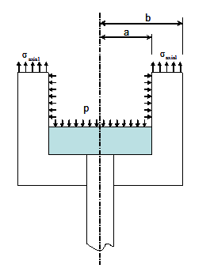

Stress directions in polar coordinates:
σ_{radial}
σ_{axial}

σ_{hoop}

σ_{hoop} is in the circumferential direction (out of the plane here)

a = inner radius = 1.5 in
b = outer radius = 2 in

Assume the cylinders are 18 inches long and the vessel is pressurized to 1000 psi. Here, we will be interested in finding the hoop, axial and radial stresses at the mid-length of the cylinders (@ 9 inches), to neglect the local effects of the end caps.

Compare the finite element results obtained from axisymmetric analysis to those calculated with the theoretical formulae for both thin-wall and thick-wall approximations.

Note: For this problem, the material choice will not affect the stresses; it will only affect the displacements and strains.

Learning Goals

The purpose of this tutorial is to showcase, in a relatively simple situation, where thin-wall pressure vessel theory is no longer as valid as it is in the limit of large radius-to-thickness ratios. The point is that inadequate theory should not be used for validation purposes in the limit that the physical assumptions on which the theory is based break down. In this problem, this happens gradually as the vessel walls become thicker. This tutorial is meant to highlight where it is relatively straightforward to apply axisymmetric FEA and resolve a solution correctly that disprove analytical treatment with simple formulae derived for thin-walled vessels.

Pressure Vessel – Pre-Analysis and Start-Up

Pre-Analysis

The equations for stresses in thin- and thick-wall cylinders can be found in many mechanics of materials references, and are summarized here, with a = inner radius, b = outer radius, r = radial position where stress is to be found, and t = wall thickness.

 | Thin-wall | Thick-wall
Hoop Stress
Axial Stress

Notice that in thick-wall theory, the hoop stress varies with the radial position, while the stress is assumed to be constant in thin-wall theory. Comparing the substitution of a and b for r in the hoop stress thick-wall equation will convince you that stress is greater on the inner surface. The hoop stress variation in thick-walled vessels can be depicted as follows (the view shown corresponds to looking from above the pressure vessel):
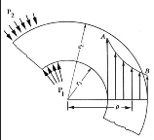
Hoop stress variation
σ_{radial}
σ_{hoop}

σ_{axial}

By using the parameters given in the problem statement and the above formulae for hoop stress, we find that the maximum hoop stresses using the thin-wall and thick-wall approximations yield 3000 psi and 3571 psi, respectively. This corresponds to a 16% difference which tells us that the thin wall theory might not be adequate for this geometry. Thin-wall theory actually gives good results when b/a ratio is less than 1.10, and that is not the case here.

Notice that the axial stresses are constant for both theories since they do not depend on radius. For this example, the thin-wall and thick-wall approximations yield 1500 psi and 1285 psi, respectively.

The radial stresses at the inner and outer surfaces can be deduced from the boundary conditions:
- The radial stress at the outer surface is 0 psi since the traction is zero at a free surface
- The radial stress at the inner surface is -1000 psi since it has to equal the applied normal traction (radial direction is also the normal direction here). The negative sign indicates that the applied traction is compressive.

The following table displays the results of these approximations:

 |  | FEA  Axisymmetric | Thin-Wall Equations | Thick-Wall Equations
HOOP STRESS  (psi) | Inner Surface | ? | 3000 | 3571
HOOP STRESS  (psi) | Outer Surface | ? | 3000 | 1125
AXIAL STRESS  (psi) | (Constant for both theories) | ? | 1500 | 1285

 |  | FEA  Axisymmetric | Boundary Conditions
RADIAL STRESS  (psi) | Inner Surface | ? | -1000
RADIAL STRESS  (psi) | Outer Surface | ? | 0

We will fill in the missing information by performing an axisymmetric analysis using ANSYS. We will then compare the numerical results from ANSYS to the analytical results.

Start-Up

Launch ANSYS Workbench and start a "Static Structural" analysis in the project page as shown in the video below.

SimCafe: Pressure Vessel in ANSYS, Start-up

Pressure Vessel – Geometry

For axisymmetric models, we use cylindrical polar coordinates (r, θ, z) with no variation in the θ direction. So we can just model a slice in the (r, z) plane as shown below.

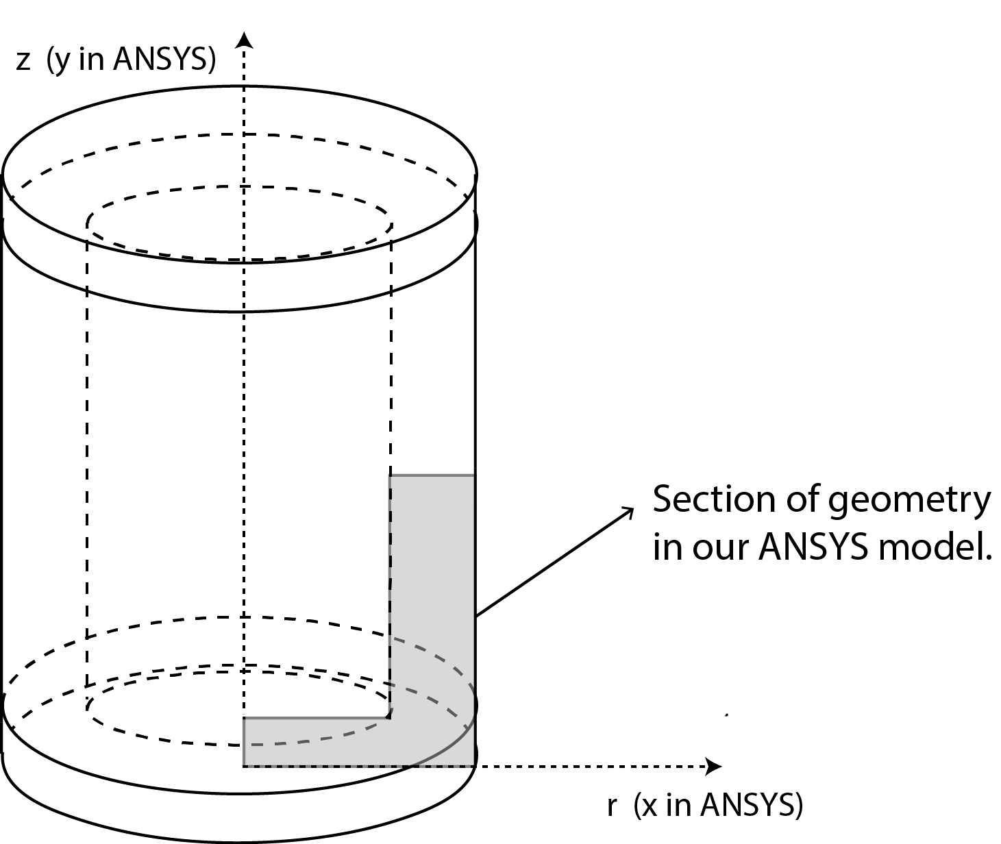

In ANSYS, the radial direction is x (rather than r) and the axial direction is y (rather than z). Confusing! We recommend that in an axisymmetric analysis, you think of the directions in ANSYS as radial & axial rather than “x” and “y”.

Note that for axisymmetric models in ANSYS, the y-axis is always the axis of symmetry. The corresponding 3D geometry can be generated by revolving the 2D section 360° about the y-axis (we’ll do this later in the Numerical Results step).

Below is the 2D geometry we need to model:

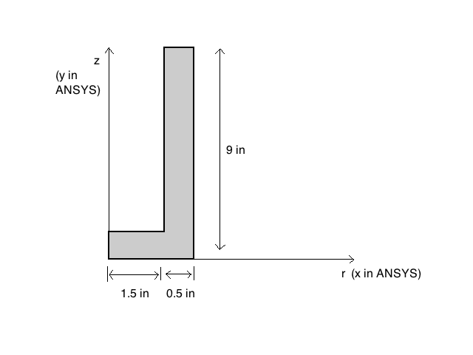

We use symmetry to model only half the total length of the cylinder.

We will first create a sketch and then a "surface body" from the sketch. The "surface body" is nothing but an area that we can mesh and apply boundary conditions to. The video below shows the steps to be followed to create the sketch and surface body.

SimCafe: Pressure Vessel in ANSYS, Geometry

Pressure Vessel – Mesh

The following video shows how to create a regular mesh for our rectangular slice using "Mapped face meshing".

SimCafe: Pressure Vessel in ANSYS, Mesh

Pressure Vessel – Physics Setup

Here are the boundary conditions we will impose on the model:

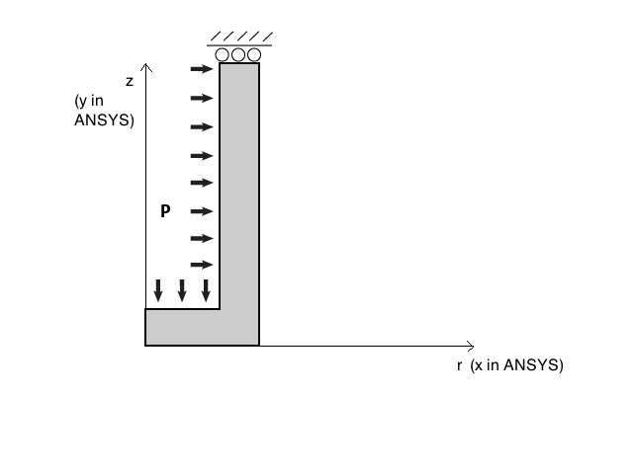
Symmetry boundary condition at the top edge implies zero displacement in the axial (y) direction. The top edge represents a plane of symmetry since it is located at the mid-length of the cylinder and we are modeling only half the length. In ANSYS, we impose this symmetry boundary condition using a “Frictionless support”.

In an axisymmetric model, no displacement constraints are necessary in the radial direction to prevent rigid body motion in that direction. This is because radial displacement represents expansion/contraction of the structure which is resisted structurally.

The following video shows how to specify the physics of the problem: axisymmetric analysis, material properties (Young's modulus and Poisson ratio) and boundary conditions. These settings get fed into the element formulation when obtaining the numerical solution later.

SimCafe: Pressure Vessel in ANSYS, Physics Setup

Note:
- We perform an axisymmetric analysis by clicking on Geometry, expanding Definition, and selecting Axisymmetric for the 2D behavior.

Pressure Vessel – Numerical Solution

*Take pictures of where to click.

Pressure Vessel – Numerical Results

The following video shows how to plot the deformed shape to check if our boundary conditions have been applied correctly.

SimCafe: Pressure Vessel in ANSYS, Results1

The hoop, axial and radial stresses can be found in a similar fashion.

SimCafe: Pressure Vessel in ANSYS, Results2

A really neat way to represent hoop stress graphically is by using the “path” tool in ANSYS. The following video shows how to display stress as a function of radius much like the figure below.

SimCafe: Pressure Vessel in ANSYS, Results3

The “path” tool can also be used to show the axial and radial stresses along the top edge. Try it!

The next video shows how to display the full 3d model by revolving the 2D section 360° about the y-axis.

SimCafe: Pressure Vessel in ANSYS, Results4

Pressure Vessel – Verification and Validation

"Verification and validation" can be thought of as a formal process for checking results. We previously performed some sanity checks on the deformed shape. A further basic check is how the results change on refining the mesh. The following video shows how to recalculate the results with a refined mesh.

SimCafe: Pressure Vessel in ANSYS, Mesh Refinement

Comparison with thin and thick-walled theory (table) from pre-analysis.

To save and exit when you are done, select "File > Save" and "File > Exit" in the project view (yellow icon in taskbar). When transferring the project to another location, you need to transfer the "2d_beam.wbpj" file as well as the "2d_beam_files" folder. The project cannot be read into ANSYS without both these entities.

