Torsional Stiffness Analysis
A monocoque chassis can be modeled the most simply as a cylinder with a cutout as shown below in Figure 1. The cutout mimics the cockpit of the racing car.
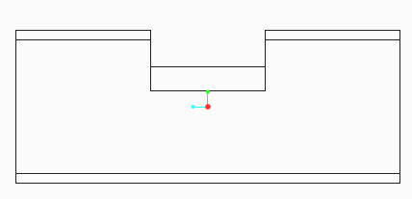

Figure 1: Cylinder with a cutout
A quick analysis in ANSYS Workbench reveals that the cut-out portion is the weakest part of the cylinder. If the cylinder is cantilevered with a torque applied at the other end as shown in Figure 2 below, the front end of the cylinder deflects very little compared to the cut-out section. This is because the front end is a closed section tube which performs very well in torsion. The cut-out section, however, is open and therefore deflects greatly. The cut-out section does not twist, but rather it skews. From a top view, the section tries to turn from a rectangle into a parallelogram (Figure 3). This means that when a torque is applied to the monocoque, the primary mode of deflection around the cockpit is not twisting but rather for the nose to deflect to one side or the other. The cockpit therefore undergoes a horizontal lozenging deformation mode.
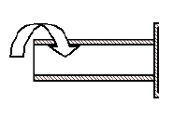

Figure 2: Cantilevered cylinder with applied torque
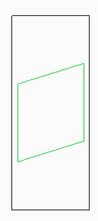
Figure 3: Top view of cylinder with skewed cut-out section after applied torque
Since the monocoque chassis is as stiff as its weakest section, it’s important to understand the mechanics of the cut-out section of the cylinder. A mathematical model to examine the torsional stiffness problem is developed below:
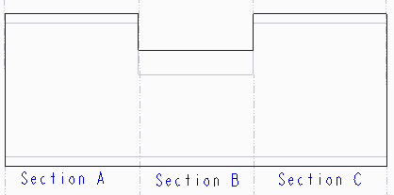

Figure 4: Cylinder divided into 3 sections of interest

The torsional stiffness of section A can be derived simply as:
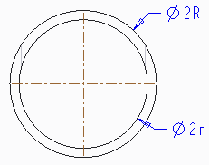

Figure 5: Cross-section of section A
$T_{A}$ = $\frac{GJ_{A}}{L_{A}}∅$ where$J_{A}=\frac{π(R^{4}-r^{4})}{2}$  G – Shear modulus  $J_{A}$ – Polar moment of inertia of cylinder section A  $L_{A}$ – Length of section A | (1)

The torsional stiffness of section A can be written as:

$$K_{T}^{A}=\frac{GJ_{A}}{L_{A}}$$ | (2)

The torsional stiffness of section B requires more subtle analysis. A cross-section of the cut-out section shows in a U-shape. Since this is not a circular cross-section, the twist induced by the externally applied torque is transformed into a horizontal lozenging deformation mode.[6] A quick analysis done in ANSYS Workbench reveals this is true.
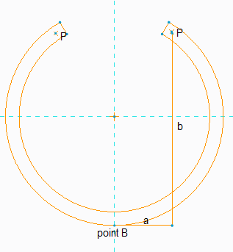

Figure 6: Cross-section of section B
From the Figure 6, it’s apparent that, we are twisting about point B. We can see that, there are 2 moment arms from the force (P) to the point B that causes the lozenging.
$$T_{B}+M_{B}=\frac{GJ_{B}}{L_{B}}∅-EIK$$  $T_{B}$=P$∙$b will result in torsion  $M_{B}$=P$∙$a will result in bending | (3)

To simplify the problem, we assume unconstrained lozenging and also assume that the effect of bending due to “P$∙$a” is so small, it can be neglected. [6] Another way to think about this is, bending is along the strong axis, therefore, it doesn’t control the design and as such we are designing to satisfy torsion.
$T_{B}=\frac{GJ_{B}}{L_{B}}∅$ where $J_{B}=\frac{L_{B}t^{3}}{3}$  G – Shear modulus  $J_{B}$ – Polar moment of inertia of cylinder section B  $L_{B}$ – Length of section B  t – Thickness of cylinder | (4)

The torsional stiffness of section B will be given as:

$$K_{T}^{B}=\frac{GJ_{B}}{L_{B}}$$ | (5)

Now that we understand the behavior of a cylinder (with a cut-out) under torsion, we can deduce the combined torsional stiffness. The stiffness of the entire system can be found from
$$\frac{1}{K_{T}^{Total}}=\frac{1}{K_{T}^{A}}+\frac{1}{K_{T}^{B}}+\frac{1}{K_{T}^{C}}$$ | (6)

Note that section A and C have the same polar moment of inertia values. The relation between T and $∅$ for both sections can be written as
$$T=\frac{π\left(R^{4}-r^{4}\right)G}{2L_{A}}∅$$  $$K_{T}^{A}=K_{T}^{C}=\frac{π\left(R^{4}-r^{4}\right)G}{2L_{A}}$$ | (7)

To find the stiffness of section B, we need to write P in terms of T. If we analyze the internal forces that result from the externally applied torque T, we find that, P is T/2R.
$$P∙b=\frac{L{(R-r)}^{3}G}{3L_{B}}∅$$  $$\frac{T}{2R}∙b=\frac{L_{B}{(R-r)}^{3}G}{3L_{B}}∅$$  $$T=\frac{2L_{B}{(R-r)}^{3}GR}{3L_{B}b}∅$$  $$K_{T}^{B}=\frac{2R{(R-r)}^{3}G}{3b}$$ | (8)

Depending on whether horizontal lozenging of section B is constrained or not, we can have a significant amount of longitudinal bending in addition to twist.

