Oliver Case Study #2
Handout 1

Scenario

In July 2012, public health departments around the nation started to report illness related to Salmonella serotype Typhimurium. By January of 2013, a total of 329 individuals had been identified, relating to this specific serovar. The state distribution of patients can be seen in Figure 1 below.

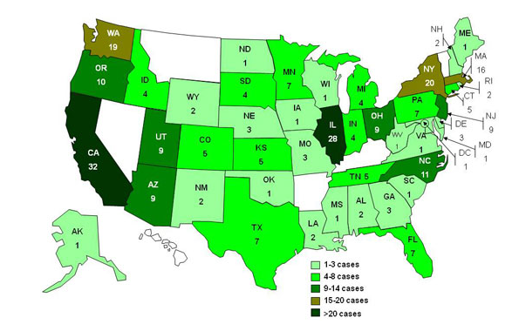
Figure 1. Persons infected with outbreak serovar Salmonella Typhimurium

Your Task #1: Identify if an outbreak is occurring
Determine if these cases are related?
Give a case definition?

Similar to steps taken in Case Study 1, the students should be asking for further information. Characteristics of patients, PFGE patterns should also be a main question. Talk through if this can be designated as an outbreak, given that it is not known if the strains are genetically identical and the food source is still not known.

Oliver Case Study #2
Handout 2

Overall, the breakdown of patients affected with Salmonellosis included:
- 53% male to 47% female in gender
- An even representation of patients throughout all ages was shown
- Samples from all 329 patients revealed one of two PFGE profiles
  - PFGE profiles only had one band in difference and were indistinguishable based on the traditional three band rule
- Along with the 329 identified patients, an additional 9 people were diagnosed with Salmonellosis during this same period
  - Salmonella Senftenberg was identified as the culprit related to the isolated 9 new patients

Your Task #2: What additional steps need to be taken, given the information above?

The students should be asking for information on the patients including dietary history, lifestyle, etc. Is it reasonable that all 329 patients had very similar if not exact PFGE patterns?
The appearance of an additional serotype hints at the fact that there is a multitude of Salmonellosis cases occurring simultaneously.

Oliver Case Study #2
Handout 3

With regards to dietary patterns, a drastic discrepancy occurred in all 329 patients. In total:

- 70 of the patients were vegetarian
- 109 of the patients were bachelors and showed a strong distaste for any sort of vegetable or fruit

Further investigation of eating patterns elucidated several similarities:

- 247 of the patients had eaten ready to eat deli products containing similar seasonings
- 20 of the vegetarian patients had the same pistachio products
- The remaining patients had no established similar eating history

Given the fact that the PFGE patterns were indistinguishable, whole genome sequencing was performed on randomly chosen clinical and food samples. Several different strains were identified from the sample taken, indicating multiple different sources. The results are as follows:

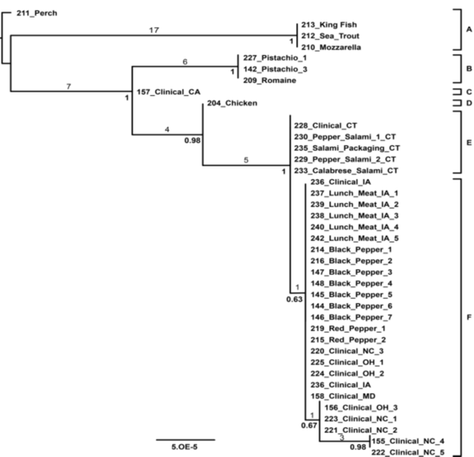

Note the area circled in red. This is the important information for the students to focus on. Mention to them how the dendrogram shows slight differences in a few of the isolates (e.g. group E and group F). Discuss the occurrence of events that could cause SNPs and slight molecular variations within the chromosome.

Oliver Case Study #2
Handout 4

In tandem, groups from the FSIS worked to investigate the source of contamination for the ready to eat deli products. It was identified that all products consumed by the persons involved came from Co-Man under the title “Mamma Does It Right” in Frankfurt, IN. With the first reported cases occurring in July of 2012, records were assessed from April 2012 to February 2013.

Information about the production site is listed below and available in Figure 1:

1) The production site was built in 1958 with an inadequate, at best, effort to keep up with renovations. Innovations in hygienic design for equipment and environment have not been implemented. Along the same lines, the slicers used for production are from the early 1990’s.

2) The production site runs 24 hours, 7 days a week. Sanitation is scheduled monthly in the processing area. Records and documentation show proper cleaning was performed during the time period of the outbreak. Having said this, detail was insufficient in the records and the support for the documents was hearsay from the sanitation crew.

3) Every May, the town of Frankfurt hosts a festival celebrating its most famous citizen, the author of the Myrtle the Turtle book series. A turtle petting zoo is the main attraction, led by the 2nd shift operations manager.

4) Although the processing environment is cleaned regularly, the storage area of the dry ingredients is cleaned on a bi-annual basis. Also, the air and traffic flow from the raw ingredient receiving rooms (dry and wet) interact with the final product.

5) In late May and early June, the air conditioning units, responsible for providing proper environmental temperatures, were under maintenance. Coincidentally, Indiana in the months of May and June had record high temperatures.

6) Insufficient records were kept for the Certificate of Analyses from the spice supplier from May and June 2012.

From the diagram located below, note the traffic flows designated by red and blue. The red is the raw ingredient/product flow and the blue is final product. The black circles indicate drains.

If students ask, the CofA’s from the spice supplier were located and had extremely high counts for coliforms. This should be a piece of information the students should be asking for.

Figure 1 – Layout of the plant design
Red arrows denote movement of raw ingredients and blue arrows denote movement of final product. Black ovals denote drain locations.

Receiving

Refrigerated
Warehouse

Dry
Warehouse

Employee Lounge and Restrooms
Shipping
Processing
Entrance and Main Offices

Your Task #2: Determine likely sources of contamination
Your team represents a group of experts at the US Food and Drug Administration (FDA), who have been asked to work with the company to identify the source of Salmonella and to mitigate any further issues from occurring. You are to plan your initial steps in this environmental assessment and will be provided with additional information you request to help your investigation.

Within your group, identify likely sources of contamination. Outside of the information provided above, request other information you need to determine additional likely sources of contamination.

Oliver Case Study #2
Handout 5

Your Task #3: Submit a sampling plan
Once you have determined likely sources of contamination, your group must now come up with a sampling plan.

You are required to take at least 50 samples.

Determine where you will take samples from after hypothesizing multiple likely sources of contamination?

It is feasible to investigate the raw ingredient suppliers as well given the discrepancy in validity of CofA documents.

Once you have designed a sampling plan, please submit your samples in the submission form provided:

Your results will be provided to your group for samples submitted by the following day.

A similar sampling plan will be supplied to that of Anna’s from the last case study. We should get the students thinking of the overall hygiene level of the production site and what a wholistic environmental sampling plan can tell a search agency.

As mentioned earlier, the results will show similarities between the different locations within the processing facility as well as those samples taken from the spice ingredient company. The difference between the samples will reflect SNPs causing events. The majority of the isolates taken from the spice production site will be more similar to the clinical isolates (genome sequence-wise) than that of the isolates from the drains and other harborage points within the deli meat processing facility.

Oliver Case Study #2
Handout 6

Your Task #4: Result interpretation

Given the results provided, what are the next steps you will take in this investigation?

Your Task #5: Outbreak source determination

Using all of your combined data, determine root cause of outbreak.

The source of the contamination will lead back to contaminated spices coming into the plant used in the majority of the products. Having said that, the current on hand stock of spice and dry ingredients will be negative for Salmonella spp. upon environmental/raw ingredient/product testing. However, the majority of the drains and select crevices in the processing area will test positive for Salmonella Typhimurium. This will be due to inadequate sanitation procedures.

The supplier of the spices should be investigated as well. Salmonella Typhimurium will be found at the spice production facility. As shown in the environmental testing results for both the deli meat plant, spice production site and clinical isolates, all had very similar genomic sequences with SNP’s present to show a slight alteration to the genomic.

Oliver Case Study #2
Handout 7

Your Task #6:

Knowing the source and location of contamination, what are some mitigation strategies (i.e. GMPs etc.) you could apply to implement control of this as well as other pathogens in the future?

