Oliver Case Study #2
Handout 1

Scenario

In July 2012, public health departments around the nation started to report illness related to Salmonella serotype Typhimurium. By January of 2013, a total of 329 individuals had been identified, relating to this specific serovar. The state distribution of patients can be seen in Figure 1 below.

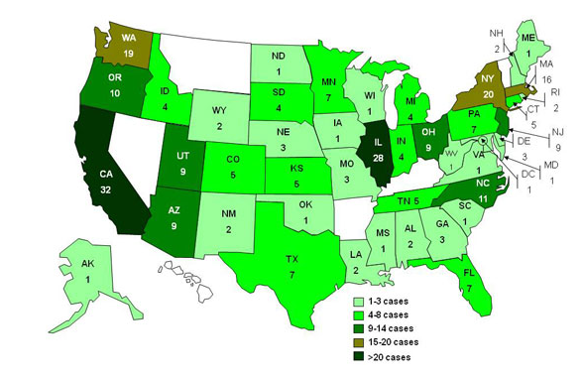
Figure 1. Persons infected with outbreak serovar Salmonella Typhimurium

Your Task #1: Identify if an outbreak is occurring
Determine if these cases are related?
Give a case definition?

