FS 6940
GASTROENTERITIS OUTBREAK From a retail food source
March 25 and April 1, 2013
Learning Objectives
After completing this case study, the student should be able to:
1) Recognize the difference between pathogen-specific outbreak investigations versus complaint/notification outbreak investigations.
2) Identify methods used to detect norovirus from environmental, food and stool samples.
3) Recognize the various transmission routes of norovirus.
4) Apply epidemiological and microbiological analyses to an outbreak scenario.
5) Evaluate a norovirus outbreak for possible sources of contamination and noncompliance issues.
6) Recommend prevention and control strategies.

Monday, March 25
Specific goals:
- Pre-assessment quiz
- Facilitators present the scenario and discussion questions. (Based on the assigned reading, students should be able to answer and discuss each question.)
- Identify appropriate methods for the epidemiologic investigation and laboratory analysis.
- Students should discuss and request the results they will need to determine the source of contamination and complete the subsequent assignment.
Monday, April 1
Specific goals:
- Students present an overview of the outbreak and their possible scenarios of the contamination source(s).
- Discuss appropriate control measures which could be applied during and after the outbreak.
- Discuss any limitations or pitfalls of the investigation.
- Post-assessment quiz
Outbreak SCENARIO
Event A: On March 14, 2012, the Worcester County Health Department (WCHD) was notified of complaints of gastrointestinal illness from six individuals who attended the Worcester Hurling Tournament on March 12. These individuals, ages ranging from 21 to 43, had become ill with vomiting and diarrhea (one individual reported fever) within 12 to 24 hours after the tournament. No hospitalizations were reported.
(The Worcester Hurling Tournament is an annual event hosted by the local Worcester Hurling Club in Boston, MA, and features catered food and beverages from a local Irish restaurant and pub (O’Malley’s). It is a popular event for all ages in the area.)
Event B: The following week (March 18-20), WCDH received 36 complaints of similar cases (vomiting, diarrhea, stomach cramps, 14 individuals reported fever) from patrons who had dined at an Irish restaurant and pub (same venue as Event A) over the weekend (March 15-17). Individuals ranged in ages from 4 to 82. No deaths were reported, and two hospitalizations were reported with matching symptoms and dehydration.
As a state epidemiologist, it is your responsibility to determine how widespread the outbreak has become, the source of infection, and means to control the outbreak. This involves interviewing foodborne illness victims, determining common exposures, determining transmission routes, interpreting laboratory results, identifying appropriate control measures to stop the outbreak, as well as the necessary actions to prevent future outbreaks.

Question 1: What actions should be taken by the Worcester County Health Department after receiving these reports?
Response: Prompt investigation of the outbreak is critical for identifying the cause of the outbreak and the primary way the infectious agent was spread. State and local health departments serve as the lead agencies in most investigations of outbreaks. The CDC will become involved in multi-state outbreak investigations, providing epidemiologic consultation and laboratory support.) For outbreaks associated with events or establishments, investigators follow five key activities:
1) Identify the etiologic agent
2) Identify persons at risk
3) Identify mode of transmission and vehicle
4) Identify source of contamination
5) Implement control measures

In order to address these activities, there are three types of analysis that epidemiologists from the health department should address:
1) Descriptive epidemiology: identifies time, place and person within an outbreak. This type of analysis can identify patterns among cases and in populations, allowing epidemiologists to develop hypotheses about the causes of these patterns and factors that increase the risk of illness.
2) Analytic epidemiology: tests the hypotheses generated in descriptive epidemiology. It is used to quantify the association between exposures and outcomes and to test hypotheses about causal relationships.
3) Laboratory analysis: The collection of stool samples, as well as food and environmental samples is helpful in identifying and confirming the cause of an outbreak.
Reporting: Currently, state and local health departments are not required to report individual cases of illnesses to a national surveillance system; however, they are encouraged to report all suspected and confirmed outbreaks of a suspected etiologic agent. In contrast to pathogen-specific surveillance, group illness or individual complaints does not require identification of a specific agent or contact with the health-care system to be reported to the CDC.
Additional note: Whereas reports of diseases caused by specific pathogens generally follow specific disease reporting rules, complaints of illnesses by consumers associated with specific events or establishments generally have been referred to the agency responsible for licensing the establishment, i.e., local or state health departments. These consumer complaints lead to the identification of most localized foodborne disease outbreaks and are the only method for detecting outbreaks caused by agents, such as norovirus, for which there is no pathogen-specific surveillance from clinical diagnostic (hospital) testing.

I. IDENTIFY THE ETIOLOGIC AGENT
Question 2: Based on what we know so far, what etiologic agents are consistent with the reported illnesses?
Reported symptoms include vomiting, diarrhea, stomach cramps, and some individuals reported fever.
- Infections versus Intoxications
  - Infection: consequence of growth of a microorganism in the body. The necessary growth of the microorganism (for damage to the tissues or production and release of toxins) takes time, thus the incubation periods for infection are relatively long – at least 12 hours and many times measured in terms of days. Common symptoms include diarrhea, nausea, vomiting and abdominal cramps. Fever is often times associated with infections.

  - Intoxication: consequence of ingestion of food already contaminated by toxin. Intoxications most often result from bacteria that release toxins during growth in the food; the preformed toxin is then ingested with the food. The incubation period is commonly measured in minutes or hours. Typical symptoms include vomiting and sometimes diarrhea; fever is rare.

- Brainstorm with students on possible etiologic agents: norovirus, Salmonella, Staphylococcus aureus, E. coli O157:H7, Clostridium perfringens, Bacillus cereus

Question 3: In order to confirm the etiologic agent, what type of samples should be collected, what etiologic agents would you test for, and what methods do you perform?
- Samples: Fecal samples (stool) from cases and restaurant staff who have reported or have had symptoms of gastroenteritis
- Etiologic agents: norovirus, Salmonella, Vibrio, S. aureus and other enteric pathogens (Answers may vary)
- Methods: Most county health departments use RT-PCR for testing fecal samples.

*Students may ask for the fecal testing results (Table 1).*

II. Identify persons at risk (Descriptive Epidemiology)
After learning of the initial outbreak (Event A) on March 14, WCHD launched an epidemiologic and environmental assessment. The investigation was extended to cover the subsequent outbreak (Event B), as both outbreaks consisted of cases who dined from foods originating from the local Irish pub. Studies included 1) descriptive analysis, 2) a retrospective cohort study, 3) a laboratory investigation and 4) an environmental assessment.
Question 4: How would you define a case in this investigation at this point?
- A case is defined as anyone reporting at least two gastrointestinal illness symptoms (nausea, vomiting, diarrhea) who (1) attended the Hurling tournament on March 12 and ate catered items from the Irish pub, or (2) who ate at the Irish pub during March 15-17 and became ill with vomiting and/or diarrhea within 10-50 hours after eating the food.

The majority of gastrointestinal illnesses can be spread by food, water, person-to-person contact and animal-to-person contact. Investigators will want to consider all possible sources of transmission as they begin investigating this outbreak.
Question 5: On the basis of the information provided so far, what specific information would you collect to identify persons at risk?
- Contact participants of the hurling tournament to determine if they became ill, date of illness onset, and if they consumed food or drinks.
- Contact patrons of the Irish pub and what menu items they consumed, if they became ill, and date of onset.
  - Obtain list of reservations for establishment, credit card receipts, receipts for take-out orders, or guests lists for events. Where possible, obtain information electronically.
- Contact food handlers from the Irish pub to determine if they became ill, date of illness onset and perform hypothesis-generating interviews.
- Characterize ill persons by place (occurrence of disease) person (age, gender), and time to provide clues on the likely source of the outbreak.

*Students may ask for the epidemic curve at this point (Figure 1).*
*Students may ask for the disease characteristics among cases (Table 1 and 2).*

III. IDENTIFY MODE OF TRANSMISSION (ANALYTIC EPIDEMIOLOGY)
Question 6: What type of information should be collected to help identify the mode of transmission?
- Catering event and restaurant menu
- Questionnaires intended to identify exposures to foods of persons who attended Event A and Event B
- Interviews with food workers to determine food-preparation responsibilities
- Samples of food which may align with an increased risk of contamination
- Environmental samples from food contact surfaces
Question 7: A retrospective cohort study was launched by the county health department. What is the purpose of the retrospective cohort study and, in this case, what advantages does this type of study provide? What other type of analytic study could be used?
- Because of the high number of cases that occurred in restaurant patrons and employee staff members, a retrospective cohort study was performed to assess risk factors associated with illness in these groups.

- A retrospective cohort studies both the exposure and the outcomes that have already occurred. The investigator calculates and compares rates of disease in the exposed and unexposed groups. Retrospective cohort studies are commonly used in investigations of disease in groups of easily identified people such as workers at a restaurant or attendees of a one-time event.

- A case-control study is another type of analytic analysis. In a case-control study, investigators compare groups of individuals with disease (cases) to those without disease (controls). Investigators compare previous exposures between the two groups. The control group provides an estimate of the baseline or expected amount of exposure in that population. If the amount of exposure among the case group is substantially higher than the amount you would expect based on the control group, then illness is said to be associated with that exposure.

Question 8: On what basis is the cohort study established and what can information can it potentially provide?
- The cohort is established by identifying a particular group and then determining whether or not they were exposed to a list of foods. In this case, we establish a cohort based on the attendees of the hurling tournament and restaurant patrons during the weekend of March 15-16th.
*Students may ask for the results of the retrospective cohort study (Table 5).*

IV. IDENTIFY SOURCE OF CONTAMINATION (FOOD AND ENVIRONMENTAL INVESTIGATION)

Question 9: What samples should be collected to determine the likely source of the outbreak? Discuss which pathogens you would test for and what method you would use.
- 1) Food samples – refer to menu; Samples of foods may be limited to non-perishable products by this time in the investigation. Sampling and holding of food products may take place early in the investigation in order to obtain suspected products.
- 2) Environmental samples – kitchen and food preparation areas

- Important to note: If a hypothesis on the source of the outbreak has not been generated from descriptive and analytic epidemiology results, testing of some (or most) food items might not be an effective use of resources.
Question 10: Give reasons why you would not test all available foods.
- Testing is time consuming and costly and should be based on the hypothesis generated from the analytic epidemiologic results.
- Unlike bacteria, which multiply very easily, viruses are very difficult to detect in foods. In many cases, virological study of stool samples and epidemiological analysis of patients are the only way of identifying the outbreak.
Question 11: What specific factors would you look for in an environmental assessment?
- Investigate the restaurant for possible sources of the outbreak, i.e., personnel practices and behavior, sanitation standard operating procedures, documentation, etc.
Question 12: In the absence of clinical laboratory diagnostics or in the case of delay in obtaining laboratory results, what clinical and epidemiologic criteria can be used to identify a norovirus outbreak?
- Kaplan Criteria
1) Vomiting in more than half of symptomatic cases
2) Mean (or median) incubation period of 24 to 48 hours
3) Mean (or median) duration of illness of 12 to 60 hours
4) No bacterial pathogen isolated in stool culture

*Students may ask for food and environmental laboratory results (Table 6.) and results from the environmental assessment.*
Question 13: Based on the data so far, we can see that there are multiple fecal specimens which all resulted in a positive GII norovirus strain. What conclusions can be made from these results?
- The contamination source is not conclusive. In order to link illnesses to a common source, strain identification and sequence analysis are needed.

Question 14: What should the health department do next? (The health department laboratory in Worcester County does not have the capability to further analyze the norovirus samples.)
- The WCDH should report the outbreak to the CDC’s norovirus surveillance system, CaliciNet, for sequence analysis among this specific outbreak and potential links with outbreaks ongoing at other geographical locations.

*Students may ask for the CDC CaliciNet sequencing analysis results (Figure 2).*

Take-Home Assignment, due Monday, April 1, 2013
1) At the beginning of the next class, your group will present an overview (5-10 minutes) of the case, including your analyses of possible scenarios for contamination source(s) and transmission routes of norovirus contamination.
- Students’ overview should include, but not limited to, the following:
  - Role of the food handlers
    - FH1 (asymptomatic carrier) is the index case initiating transmission at Event A
      - Only those consuming beer from Event A became sick
      - Transmission to other food handlers at the restaurant (person-to-person transmission)
      - Possible fomite contamination (possible significance of E. coli result and hygiene)
    - Transmission of norovirus from infected workers to food
      - Returned to work too soon
    - Associated with GII.4 Sydney

  - Oyster Contamination
    - Associated with the GI and GII genotype in clinical isolates and oyster samples
    - Sequence analysis indicated multiple genotypes in oysters
      - Analysis given to students may indicate a possible association with October, 2011 outbreak in Washington – students should have referred to MMWR 61(06);110 to generate this hypothesis

  - Environmental Assessment
    - Use of quaternary ammonium compounds as a sanitizer and its lack of effectiveness on norovirus

2) On October 19, 2012, Seattle & King County Public Health Department was notified of an acute gastroenteritis case after dining at a restaurant. Based on their epidemiological investigation, it was confirmed that three of the seven in the party had consumed raw oysters.
- Review CDC’s MMWR 61(06);110 for a summary of this investigation. Be prepared to discuss how this small outbreak might be of significance to the current investigation under study.
- Based on this information, what analyses should be performed?
- How would this information affect your suggested control measures?

3) Be prepared to discuss appropriate control measures to halt the outbreak.
O’Malley’s Menu
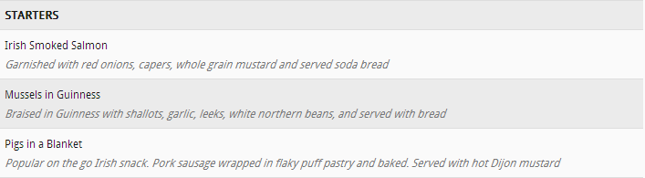

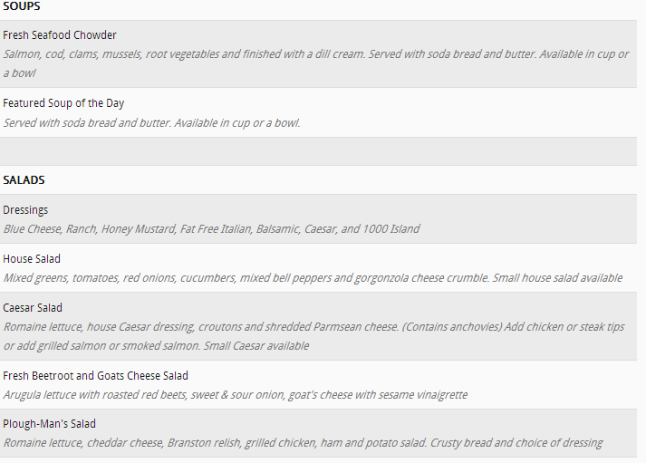

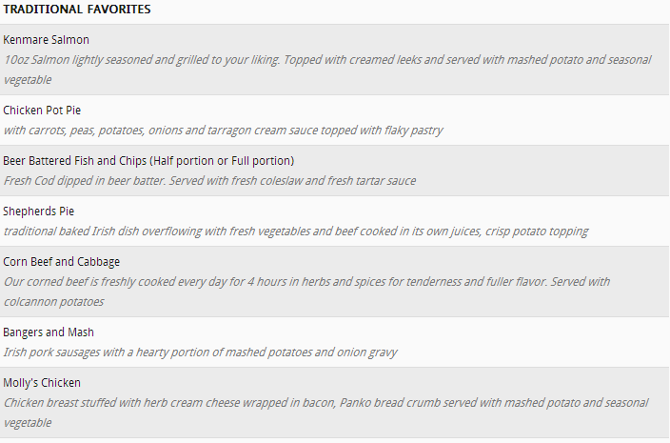

- St. Patrick’s Special 
Enjoy our 12th annual Leprechaun Oyster Festival – March 15-17

BBQ’D OYSTERS (Sold by the 1/2 Dozen)
RAW OYSTERS (Sold by the 1/2 Dozen)
STEAMED OYSTERS (Sold by the 1/2 Dozen)


Results
Table 1. Fecal Laboratory Analysis
 | Infectious Agent
Sample Type | E. coli | Salmonella | Shigella | E. coli O157:H7 | Toxins (C. perfringens, S. aureus, B. cereus) | Norovirus (GI/GII)
Fecal
03131A* | NA | - | - | - | - | GII
03132A | NA | - | - | - | - | -
03151B | NA | - | - | - | - | -
03152B | NA | - | - | - | - | GI, GII
03161B | NA | - | - | - | - | GI, GII
03162B | NA | - | - | - | - | GII
03163B | NA | - | - | - | - | GII
03164B | NA | - | - | - | - | -
03165B | NA | - | - | - | - | GII
03166B | NA | - | - | - | - | GII
03171B | NA | - | - | - | - | GI, GII
03172B | NA | - | - | - | - | GI, GII
03173B | NA | - | - | - | - | GII
03174B | NA | - | - | - | - | GII
03175B | NA | - | - | - | - | GII
03176B | NA | - | - | - | - | GII
03FH1** | NA | - | - | - | - | GII
03FH2 | NA |  |  |  |  | -
03FH3 | NA |  |  |  |  | -
03FH4 | NA | - | - | - | - | GII
03FH5 | NA | - | - | - | - | GII
*Letter A or B denotes event; **FH=Food Handler; ***Environmental samples included surface swabs, catering utensils and equipment included glassware, tables and cleaning equipment
Descriptive Epidemiology Results
A total of 625 persons were interviewed by WCDH for both outbreak events: 554 patrons and 21 employees. A total of 446 patrons of the 554 interviewed met the descriptive study case definition; 51 cases were connected with Event A; 395 cases were connected with Event B. (Of the cases with reported onset of symptoms, 78% reported onset of illness between 24 -48 hours after attending event A or B.)

Epidemic Curve
Restaurant staff
Event A &B Patrons
Cases
March
Onset of Illness

Figure 1. Onset of gastrointestinal illness among tournament participants and restaurant patrons and employees of a restaurant

Table 2. Selected characteristics of patrons (n=51) who became ill in a gastroenteritis outbreak
associated with Event A – Worcester County, MA, March 11-March 13
Characteristic | Measure
Median Age (yrs) (range) | 40 (21-52)
No. female (%) | 18 (35.3)
No. who reported diarrhea (%) | 44 (86.3)
No. who reported vomiting (%) | 35 (68.6)
Median incubation period (hrs) (range) | 27 (10-50)
Median duration of illness (hrs) (range) | 38 (2-172)
No. who sought medical attention (%) | 0 (0.00)

Table 3. Selected characteristics of patrons (n=407) who became ill in a gastroenteritis outbreak associated with Event B – Worcester County, MA, March 16-March 25
Characteristic | Measure
Median Age (yrs) (range) | 40 (2-89)
No. female (%) | 179 (44)
No. who reported diarrhea (%) | 368 (90.4)
No. who reported vomiting (%) | 302 (74.2)
Median incubation period (hrs) (range) | 32 (10-50)
Median duration of illness (hrs) (range) | 42 (2-172)
No. who sought medical attention (%) | 4 (0.98)

Results: Analytic Epidemiology (Retrospective Cohort)
Calculate the attack rates for the exposed and not exposed groups, followed by the relative risks of each exposure (food).

 | Exposed |  |  | Not Exposed
Exposure | Ill (n) | Not ill (n) | Attack Rate (%) | Ill (n) | Not ill (n) | Attack rate (%) | Relative Risk
Corned beef sandwich | 136 | 70 | 66 | 18 | 20 | 47 | 1.4
Cole Slaw | 22 | 33 | 40 | 26 | 18 | 59 | .7
Beer | 61 | 108 | 36 | 2 | 38 | 5 | 7.2
Lemonade | 21 | 26 | 45 | 30 | 22 | 58 | .8
Table 4. Attack rates and relative risks for specific foods from catered event “Event A”

Table 5. Attack rates and relative risks for specific foods from restaurant “Event B”
 | Exposed |  |  | Not Exposed
Exposure | Ill (n) | Not ill (n) | Attack Rate (%) | Ill (n) | Not ill (n) | Attack rate (%) | Relative Risk
Seafood Chowder | 93 | 151 | 38 | 70 | 67 | 51 | 0.7
House Salad | 68 | 77 | 47 | 18 | 92 | 16 | 2.9
Chicken Pot Pie | 80 | 96 | 45 | 101 | 119 | 46 | 1.0
Corn Beef and Cabbage | 53 | 50 | 51 | 67 | 39 | 63 | 0.8
Corned beef sandwich | 101 | 45 | 69 | 29 | 98 | 23 | 3.0
Molly's Chicken | 44 | 73 | 38 | 56 | 83 | 40 | 0.9
Raw Oysters | 156 | 48 | 76 | 26 | 94 | 22 | 3.5

Calculating the attack rate (risk) and risk ratio

 | Ill | Not ill | Total | Attack Rate
Exposed | a | b | a+b | a/(a+b)
Not Exposed | c | d | c+d | c/c+d

Risk Ratio (RR) = [a/(a+b)] ÷ [c/c+d)]
To interpret the risk ratio, we compare the value of the RR to 1. If risks in both groups are the same, the ratio of the risks with be 1, indicating that there is no association between the exposure being evaluated and the risk of disease.
If RR = 1, exposure has no association with disease
If RR > 1, exposure may be positively related to disease.

Results:
Table 6. Food and Environmental Laboratory Analysis
 | Infectious Agent
Sample Type | E. coli | Salmonella | Shigella | E. coli O157:H7 | Toxins (C. perfringens, S. aureus, B. cereus) | Norovirus (GI/GII)
Food
Oyster1 | - | - | - | - | - | GI
Oyster2 | - | - | - | - | - | GI, GII
Oyster3 | - | - | - | - | - | -
Oyster4 | + | - | - | - | - | GI
Oyster5 | + | - | - | - | - | -
Chowder | - | - | - | - | - | -
Chowder | - | - | - | - | - | -
BeefCabbage | - | - | - | - | - | -
BeefCabbage | - | - | - | - | - | -
ChickenPie | - | - | - | - | - | -
ChickenPie | - | - | - | - | - | -
Environmental*
Storage areas (n=8) | - | - | - | - | - | -
Prep areas  (n=12) | + (n=4) | - | - | - | - | -
Dining areas  (n=12) |  | - | - | - | - | -
Catering Utensils & Equip (n=12) | + (n=3) | - | - | - | - | GII  (n=1)
*Environmental samples included surface swabs, catering utensils and equipment included glassware, tables and cleaning equipment

Results: Environmental Assessment
Investigators reviewed the practices within the restaurant, along with their food safety management system and found no issues. Sanitation records indicated the use of quaternary ammonium compounds used throughout the kitchen.
Interviews of available restaurant employees were included within the assessment. Five employees were available at the time of the assessment and willing to participate in the investigation. Job duties of FH 2-5 include food preparation and clean-up at the end of their shift. Food handler 1 does not work directly with food, serving as the bartender at both the restaurant and catered events. He is also part of the “clean-up” crew during the night shift at both catered events and the restaurant. The food handlers were knowledgeable of best practices in food safety. Four of the five employees interviewed (FH 2-5) had symptoms of gastroenteritis during the week of March 10, 2013. Food handlers 2 and 3 were sick March 12-13 and did not work; they returned to work March 16. The onset of illness for food handlers 4 and 5 were March 16 and 17, respectively. Twenty-four hours after onset of illness, both employees returned to work, stating that their symptoms of vomiting and diarrhea had subsided. Food handler 1 did not report any gastrointestinal symptoms at any time.

Results: CDC CaliciNet Sequence Analysis
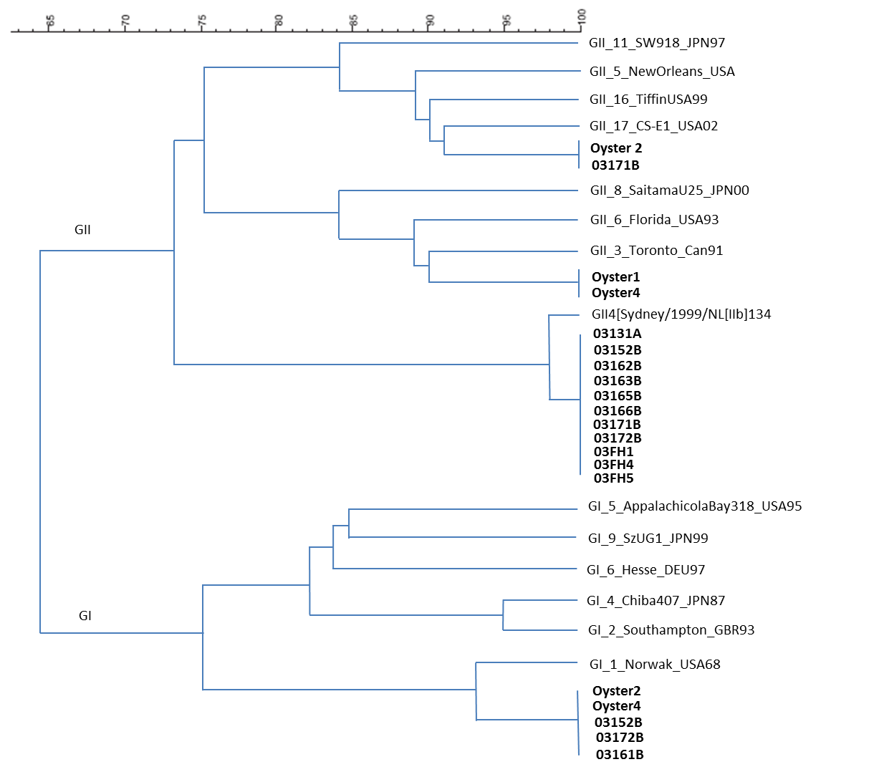
Figure 2. Region B sequence comparison of GI and GII strains detected from oysters and food handlers

