Nightingale Case Study #1
Handout 4

The Texas Public Health Laboratory determined patients had been infected with strains of E. coli non-O157 STECs. These patients were contacted and asked to fill out food survey questionnaires. Epidemiologists with the Texas State Department of Health determined the patients had consumed lettuce purchased from a local farmers market on 4/5/2012.

Information about the lettuce farm, which supplied the farmers market, is listed below and available in Figure 1:

1) There is a concentrated animal feeding operation (CAFO) that is located east of the farm in the immediate vicinity of the Medina River. Manure is composted and hauled away. Wastewater collects in three retention ponds.

2) A small dairy that is co-located with a small beef cattle feedlot shares a storm water retention pond with the beef operation. The dairy is located west of the farm. Wastewater from the facility is contained in evaporation ponds. Manure is not composted; it is stored in covered piles and trucked from the property.

3) The lettuce farmer reported feces observed along the sides of the fields.

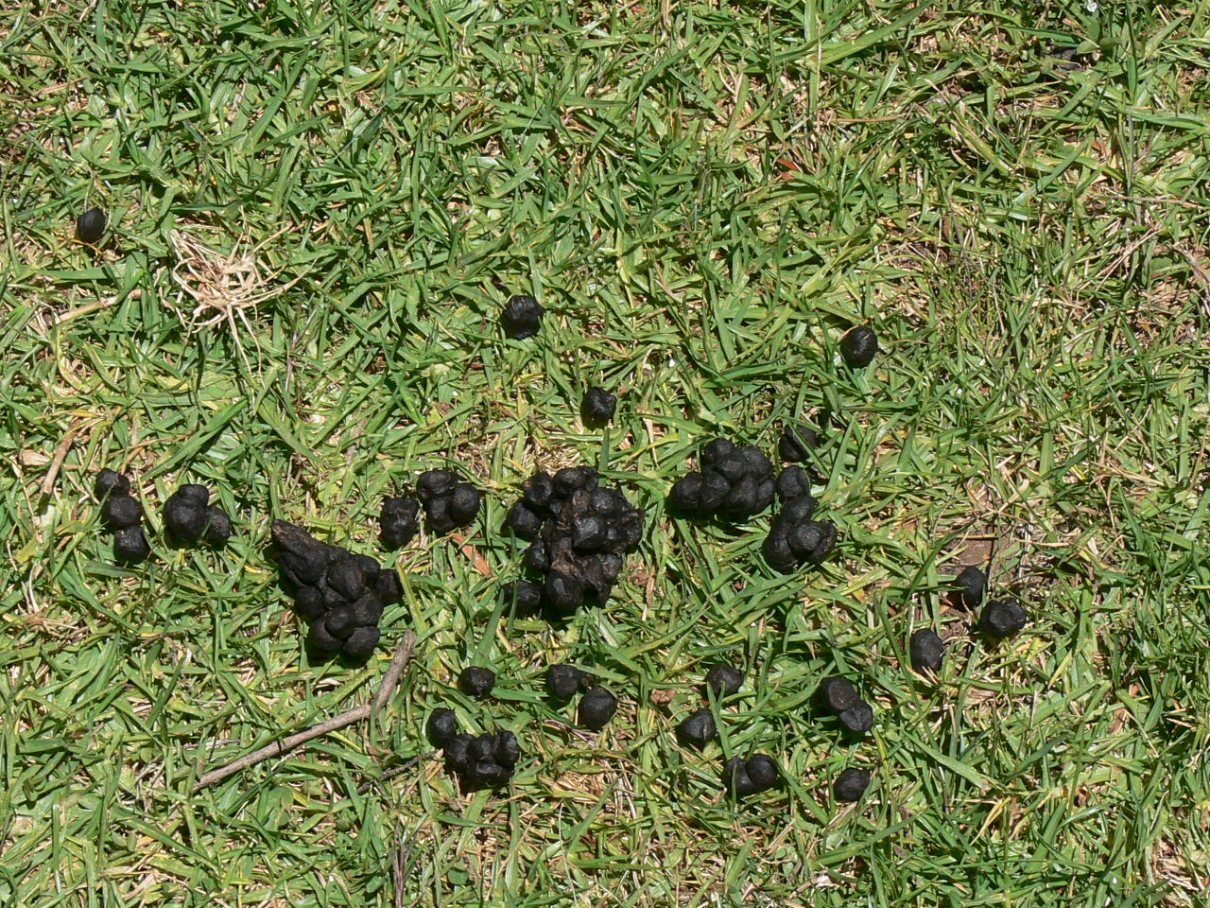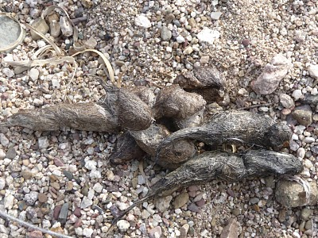

4) An R.V. park is located on a rise above the valley floor. A lateral irrigation canal is adjacent to the property. There is only one other farm in addition to the identified farm that is serviced by the section of lateral canal downstream of the R.V. park. Sewage from the R.V. park goes into an on-site subterranean septic tank leach system. Along one side of the property there are areas that drain directly into the lateral irrigation canal.

Figure 1 - Details on lettuce farm and surrounding areas

Your Task #2: Determine likely sources of contamination
Your team represents a group of experts at the US Food and Drug Administration (FDA), who have been asked to investigate these non-O157 STEC cases and determine if the lettuce grown on this farm is the culprit for this small regional outbreak. You are to plan your initial steps in this environmental assessment and will be provided with additional information you request to help your investigation.

Within your group, identify likely sources of contamination. Outside of the information provided above, request other information you need to determine additional likely sources of contamination.

