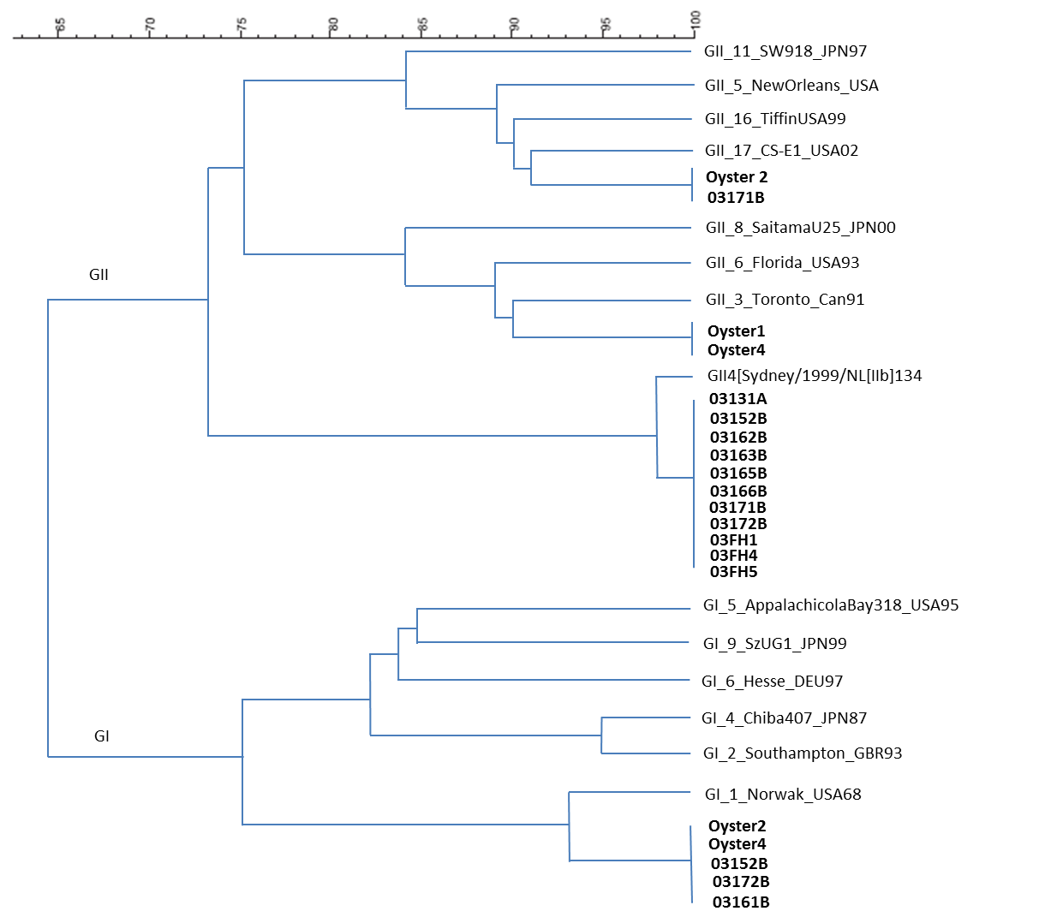

Figure 2. Region B sequence comparison of GI and GII strains detected from oysters and food handlers

