O’Malley’s Menu
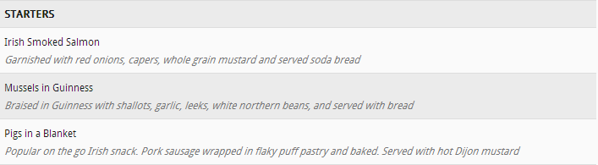

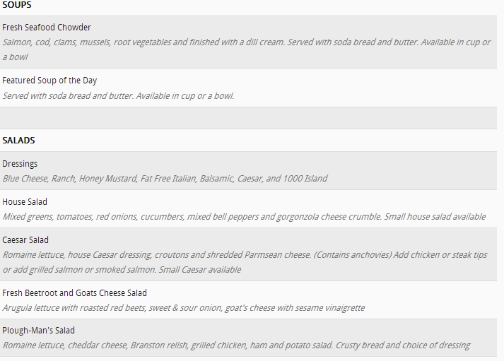

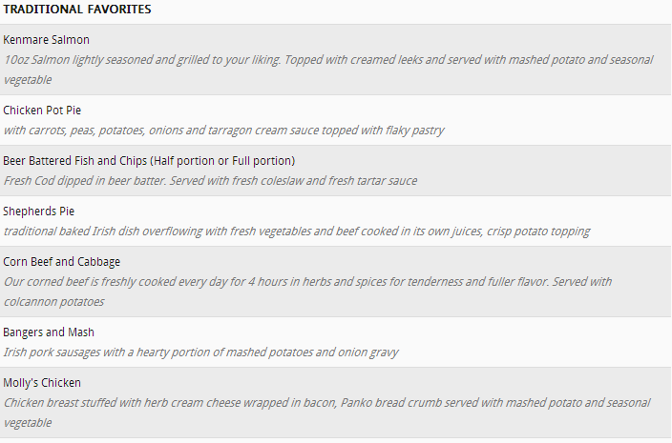

- St. Patrick’s Special 
Enjoy our 12th annual Leprechaun Oyster Festival – March 15-17

BBQ’D OYSTERS (Sold by the 1/2 Dozen)
RAW OYSTERS (Sold by the 1/2 Dozen)
STEAMED OYSTERS (Sold by the 1/2 Dozen)


