WebEx Instructions
- Turn on the microphone. The green light should be on.

- Turn on the 2 small speakers.

- The camera should be on top of the computer.

- Balance the camera on the top of the monitor and plug it in if necessary. The plug is under the microphone.

- Turn on the computer as usual and bring up your email client and display the email invitation from your host.

Topic: 2CUL TSI Steering Committee
Date: Every Monday, from Monday, November 4, 2013 to Monday, December 22, 2014
Time: 11:00 am, Eastern Standard Time (New York, GMT-05:00)
Meeting Number: 649 972 607
Meeting Password: (This meeting does not require a password.)
-------------------------------------------------------
To join the online meeting (Now from mobile devices!)
-------------------------------------------------------
1. Go to https://cornell.webex.com/cornell/j.php?ED=253256712&UID=1688687272&RT=MiMxMQ%3D%3D
2. If requested, enter your name and email address.
3. If a password is required, enter the meeting password: (This meeting does not require a password.)
4. Click "Join".

- Click on the GO TO link. A screen will come up with instructions for joining a meeting. Wait for it to show that Cornell has arrived. (We are never the host.) When the grey “join” button on the right hand side of the screen lights up, click on it.

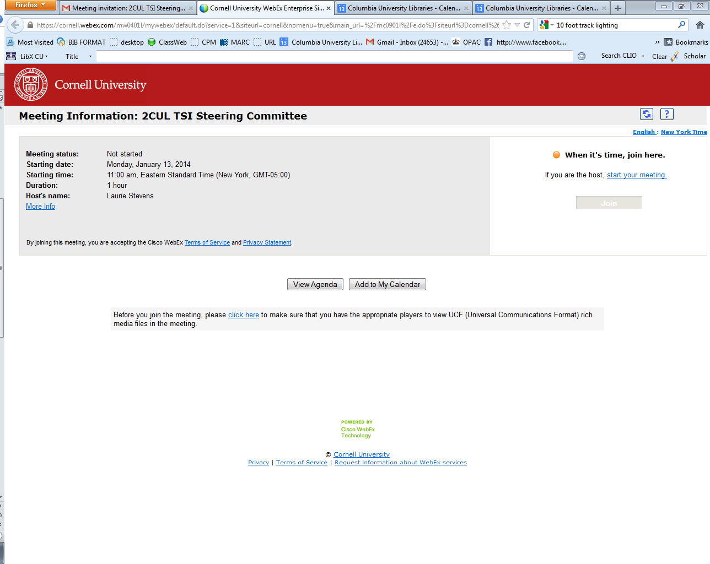

- Type in your name and email.

- Click on call using computer.

- It should say audio call connected.

- Click on the start my video icon. You should see video of yourself on the screen in a small window.

- Click on the silver people icon. This should bring up Cornell.

- To end, stop video and leave meeting.

- Turn off computer as usual.

