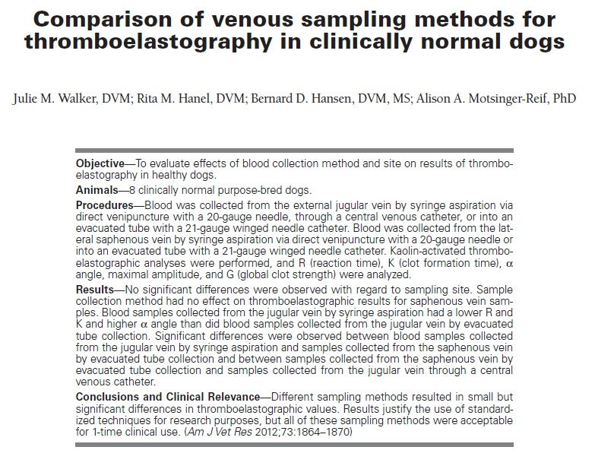
Key Points:
- Sample collection method had no effect on thromboelastographic results for saphenous vein samples
- Differences with significance were noted between collection from jugular vein by syringe aspiration and samples collected from the saphenous vein by evacuated tube collection and between samples collected from the saphenous vein by evacuated tube collection and samples collected from the jugular vein through a central venous catheter
- Ensure that you have a protocol in place for blood collection or TEG

