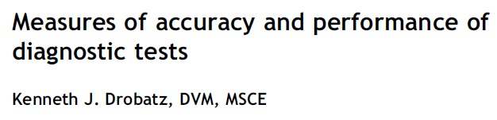
Sensitivity and specificity
- Most commonly utilized when the diagnostic results are dichotomous
- A 2 x 2 table is useful in determining sensitivity, specificity, PPV and NPV
- This table should always be set up in the same fashion: the two columns on thetop are the true disease (the gold standard results)and the two rows are always the test results
- Always put the positive gold standard diseased state in the first column and the positive diagnostic test result in the first row
- Each of the cells can alsobe described in terms of the results of the diagnostic test in relation to whether they truly have the disease; Example, cell A represents the numberof ‘‘true positives’’, B is ‘‘false positives’’, C is‘‘false negatives’’ and D is ‘‘true negatives’’
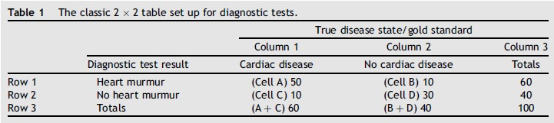
- Sensitivity can be derived from the data given in column 1 and is described as: Of all the cats that truly have disease what proportion test positive for the disease
- Specificity can be calculated from the data derived from column 2 and answers the question: Of the cats without heart disease what proportion will test negative
- Sensitivity represents the percentage of patients correctly classified in the diseased category and the specificity is the percentage of patients correctly classified inthe non-diseased category
- Sensitivity isused to help rule out a disease. As an extreme example to illustrate the point, if the sensitivity of a test is 100%, then all animals with disease test positive, therefore, if the test is negative, then the animal does not have the disease and can beruled out
- Specificity is used to rule in a disease, so, if the specificity is 100%, then all of the animals without disease test negative. Similarly, if the animal tests positive, it has the disease
- ‘‘SnNout’’ (in a test with high sensitivity, a negative rules a disease out) and ‘‘SpPin’’ (in a test with high specificity, a positive test rules a disease in)
Predictive values
- The Positive Predictive Value can be defined as the ratio of the number of true positives to the total number of positive tests
- The Negative Predictive Value is the ratio of the number of true negatives to thetotal number of negative tests

Prevalence
- Prevalence is the number of cases of a disease that are present in a particular population at a given time
Likelihood ratios
- Odds are defined as the ratio of the proportion of animals with disease to the proportion of animals without that disease
- The likelihood ratio is defined as: The probability of an animal with the disease having the test result divided by the probability of the animal without the disease having that same test result
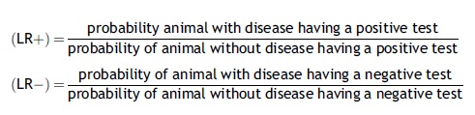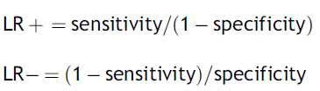
Continuous diagnostic test variables
- A continuous variable is a variable that can take on any value on the scale used to measure it
Receiver operating characteristic curve
- Receiver operating characteristic curve analysis isoften used to help determine the cut-off point to optimize sensitivity and specificity
Confidence intervals
- The p value the authors often cite when reportingtheir results gives a sense of how likely the results reported are due to chance
- Reporting a range of plausibleresults is known as confidence intervals
- Confidenceintervals are ameasure of how precise an estimate is
- The range or width of a confidence interval isprimarily determined by two parameters; the numberof observations in the study and how widely spreadthe data are
Adjusting for potential influential variables
- Test parameters mayvary with the characteristics of the population thatthey are applied to
- In these instances, multiple logistic regressions canbe used to adjust the sensitivity and specificity forvarious population parameters that might affect theestimates of the test
Study sample selection
- Diagnostic test has to be developedusing a representative sample of the animalsto which it will eventually be applied, and that thecharacteristics of the sample population areclearly and thoroughly described
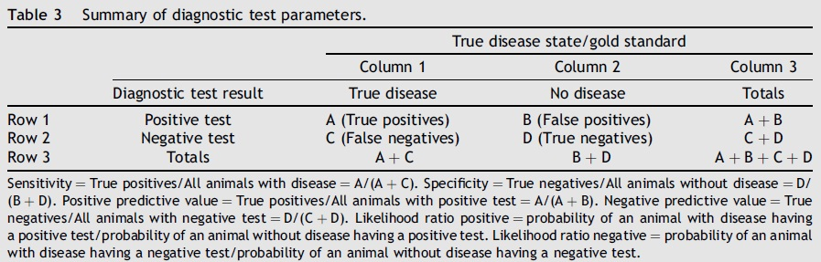

Questions:
- To evaluate the performance of a new diagnostic test, the developer checks it out on 100 known cases of the disease for which the test was designed, and on 200 controls known to be free of the disease. Ninety of the cases yield positive tests, as do 30 of the controls. Based on these data, the specificity and false positive error rates of the test are, respectively,
  - 75% and 10%
  - 85% and 10%
  - 85% and 15%
  - 85% and 25%
  - 90% and 15%
2X 2 | + disease | -disease | Totals
+ test | 90 | 30 | 120
- test | 10 | 170 | 180
Totals | 100 | 200 | 300
Sens = 90/100 = 90% Spec= 170/ 200 = 85% PPV= 90/ 120 = 75% NPV=170/180= 94% False positive rate= 30/120 =25% False negative rate= 10/100= 10%
- Your vet school colleague, Dr. Seamus S. Salar, contacts you on facebook for help. He is working as an aquaculture veterinarian near the Bay of Fundy in New Brunswick. He has been tasked with evaluating a new SNAP test for detecting Infectious Salmon Anemia. Seamus has all of his data and needs to evaluate some basic statistics. Unfortunately after being forced to take 3 semesters of epidemiology in vet school Seamus has developed severe PTSD and spends much of his time drinking and watching episodes of Honey Boo Boo and Swamp people. Given Seamus’ destiny to work with fish you agree to help him out, despite the fact that you did not care for him during vet school. Seamus sends you the following information:
We collected 987 fish. Gold standard testing was performed on all fish (Virus isolation and PCR) and showed 246 infected and 741 non-infected (assume that true infection status is determined by virus isolation and PCR). Of the infected fish the SNAP test picked up 180 of them. The SNAP test also was positive for 45 fish that were determined to be non-infected by gold standard methods. Complete the following 2 x 2 table and questions.

 | ISA + | ISA -
SNAP + | 180 | 45 | 225
SNAP - | 66 | 696 | 762
 | 246 | 741 | 987
List the apparent prevalence of ISA in this sample population:
apparent prevalence =225/987 = 0.23 = 23%

What is the sensitivity of this test? What is the specificity of this test?
sensitivity = 180/246 = 0.73 = 73% True pos/disease pos
specificity = 696/741 = 0.94 = 94%

What is the NPV? PPV?
positive predictive value =180/225 = 0.8 = 80%
negative predictive value =696/762 = 0.91 = 91%

