What I Learned at IVECCS 2013

Lymph and Lymphatics: The Forgotten Players in MODS Pathophysiology
Dr. Mellema

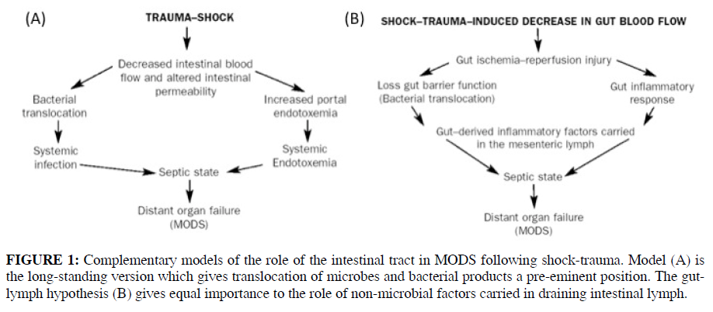
- Old paradigm was that bacteria translocate from the GIT resulting in MODS (figure A)
  - This was based on the following indirect evidence:
    - Association btwn gut barrier dysfunction and systemic infection, ARDS MODS
    - Bacteria can escape the gut and induce lethal/nonlethal syndromes
    - Increased bacterial numbers in proximal GIT result in increased translocation
      - Use of antacids in ICU!
    - Increased intestinal permeability in many dz states in ICU patients
    - Interventions that preserve gut barrier improve outcomes
    - Gastric tonotomy studies show gut ischemia was more predictive of ARDS and MODS than global oxygen delivery indicies
  - Data against this:
    - Only 2% of trauma patients had portal bacteriemia but 30% had MODS – this rate is lower than normal people following tooth brushing or defecation (Moore, J Tramua, 1991)
    - Selective GI decontamination does not improve survival
- New model (figure 2) expands on the old hypothesis, does not replace it
- Gut-lymph hypothesis
  - Uncertain if it is due to toxic lymph vs loss of protective lymph
  - The mesenteric lymph duct (MLD) can provide an alternate route to systemic circulation
    - In rat model bacteria and their products found in both portal and MLD fluid
    - Studies suggest that preferred route depends on severity of insult with MLD being preferred in all but worst insults
    - May explain why lung is usually the first remote organ to become dysfunctional after bowel ischemia (lung and R heart are first tissue beds exposed to lymph from thoracic duct)
    - Ligation of MLD reduces or prevents MODS and ARDS in several animal models – rodent, porcine, canine, and baboon models
      - Essentially prevents if done before shock
      - Protective when performed up to 1 wk before shock induction
      - Protective when performed up to 24 hours after shock (no tests beyond 24 hours)
        - Reduced severeity/frequency
    - Intestinal lymph from animals in shock can induce MODS
      - Neutrophil activation
      - Cardiomyocyte injury – can stop spontaneously beating cardiomyoctes in culture
      - Bone marrow suppression
      - Endothelial dysfunction and injury
      - Erythrocyte dysfunction and altered rheaology
      - **These lymph samples are sterile**
  - Are cytokines the toxic component found in mesenteric lymph
    - Gut becomes cytokine generating organ after shock/trauma/sepsis
    - Priming site for neutrophils as they pass through
    - Toxic component of lymph does not appear to be cytokine based
      - In protein component >100 kD mass (danger hypothesis)
        - The endothelial toxic component of mesenteric lymph is a modified form of albumin
          - Glycalated alb
        - ~ 60 proteins upregulated in mesenteric lymph of shock rats
          - Profilin
          - Pancreatic enzymes
          - Calmodulin
          - 14-3-3 zetaepislon
          - peroxiredoxins
      - In lipid fraction
        - Neutrophil priming component
        - Heparin administration can make this fraction more toxic
        - Hypertonic saline can abrogate neutrophil priming by mesenteric ln (J trauma, 2000, 486:45-8)
- Temporary MLD diversion or ligation may be beneficial in patients

Use of CT and u/s
- For diagnosis of ureteral obstruction
  - CT has 96% sensitivity for diagnosis
  - Use of contrast does NOT increase sensitivity
- Congenital PSS
  - CT w/ contrast – correctly identified insertion/origin in 15/16 dogs
  - U/s – correct origin 24/30, correct insertion 16/30 dogs
- Multiple acquired PSS
  - U/S – correct in 1/6 pts, sensitivity 68%
  - CT angion – correct in 4/5 pts, sensitivity 96%
- Trauma
  - CT superior
  - Can do triple contrast technique to look at GI tract, vascular, and urinary integrity
- Acute abdomen (19 dogs, 11 needed sx)
  - CT correctly identified surgical dz in all – 100%
  - u/s & radiographs – 89%
  - U/s most sensitive for identifying PF
- FB obstruction
  - u/s definitive in 97% of cases
  - rads 70%
- Splenic torsion
  - u/s identified absent doppler flow in splenic veins in 100% of cases
  - thrombi in splenic veins in 86% of dogs

