Retired racing greyhounds have higher incidences of post-gonadectomy bleeding compared to other breeds (26% vs 2%). Greyhounds with post-op bleeding issues have been shown to have lower levels of antiplasmin and antithrombin suggesting an abnormality in the clot maintenance or fibrinolytic system (enhanced fibrinolysis?) or endothelial dysfunction.
Epsilon aminocaproic acid (EACA) is a fibrinolytic inhibitor. Prevents the activation of plasminogen into plasmin on the fibrin surface.
Hypothesis: Aminocaproic acid would significantly decrease the prevalence of post-op bleeding in RRG and result in significant changes in TEG and fibrinolysis variables.
N=100
Randomized to receive aminocaproic acid (500mg PO TID) or placebo. Scoring of bruising was subjective according to modified bleeding score (recorded by 1 individual). Bloods drawn pre op, and 24, 48, and 72h post-op.
Statistics: Random effects linear regression model to test main effects and interactions. Bleeding prediction model was developed
Results:
30% of placebo group had bleeding compared to 10% in tested group. (P=0.012).
No significant differences pre-op on TEG values, however over time the R and K significantly decreased in the aminocaproic acid group but increased in the placebo group. Implies initial clot begins to form faster in the EACA group. The angle, MA and G increased in the EACA group and decreased in the placebo group over time. This implies stronger clot formation in the EACA group. Values suggest that EACA dogs became hypercoagulable.
Bottom line: Administration of EACA significantly decreased the prevalence of delayed post-op bleeding in RRG undergoing gonadectomy by amplifying strengthening of the fibrin clot.
Case report: Canine epidermoid cyst noted in dog, removed surgically. MRI findings include heterogeneously hypertense lesion on T2 weight series. Epidermoid cysts are histologically benign. Patient presented with seizures and decreased level of mentation. The mass was largely excised, however clinical signs returned 8 months post-op.
Comparing laparoscopic vs transvaginal laparoscopic OVH techniques – no significant differences in surgical time. Requires strict hygiene with vaginal approach. No complications noted. Recommend avoiding with patients that have any vaginal pathology.

Comparing bovine cross-linked collagen (BC) to polyethylene glycol-based hydrogel (PRG-CMC) injected into the urethral submucosa to treat urinary incontinence. BC typically used currently but can require retreatment. PEG-CMC is supposed to undergo little swelling or shrinking after placement (more permanent). Conclusions: PEG-CMC produced mucosal excoriations in some dogs, suggesting further studies are needed before stating that it can be used without formation of mucosal defect or negative clinical effects.

Indications: when better visibility is needed during thoracoscopy procedures.
Conclusion: do-able but bronchoscopy still useful
Questions:
Marin, et al. EACA for prevention of delayed post-op bleeding in retired racing greyhounds undergoing gonadectomy (VetSurg 41 (2012) 594-603
- Define and label the following (TEG variables):
  - R time – latency time, time to initial fibrin formation
  - K time – speed to a pre-determined specific level of clot strength
  - Alpha angle – measures speed of fibrin buildup and cross linking (clot strengthening)
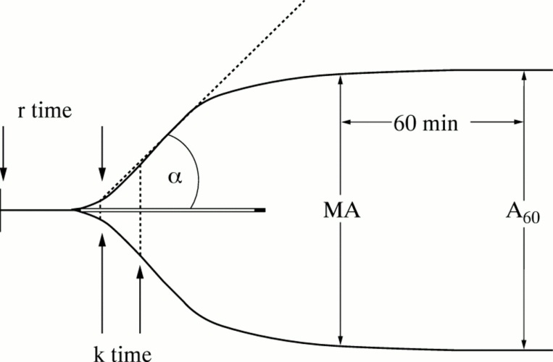
  - MA (maximal amplitude) – represents the clot strength

- The authors postulate that which of the following are causes for post-operative bleeding in retired racing greyhounds?
  - Enhanced fibrinolysis
  - Primary hemostatic disorders
  - Secondary hemostatic disorders
  - Thrombocytopenia

