Suture types:
Characteristics
- Absorbable vs non-absorbable
- Breaking strength: limit of tensile strength at which failure occurs
- Capillarity: extent to which absorbed fluid is transferred along the suture
- Elasticity: measure of the ability of material to regain original form and length
- Fluid absorption: ability to take up fluid after immersion
- Knot-pull tensile strength: breaking strength of knotted suture material
- Knot strength: amount of force necessary to cause a knot to slip
- Memory: inherent capability to return to or maintain original gross shape (related to elasticity plasticity, and diameter)
- Plasticity: ability to deform without breaking and maintain new form after relief of deforming force
- Pliability: ease of handling, ability to adjust knot tension and to secure knots (related to suture material, filament type, and diameter)
- Tensile strength: material’s or tissue’s ability to resist deformation and breakage
- Wound breaking strength: limit of tensile strength of a healing wound at which separation of the wound edges occurs
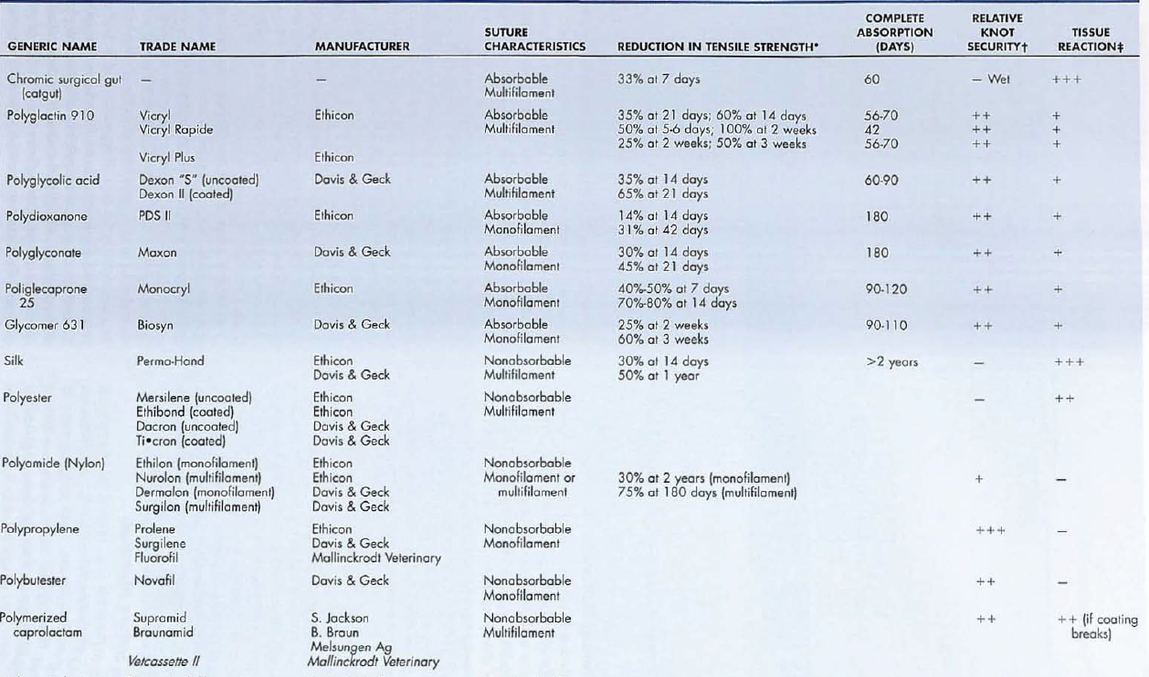
Suture selection for different tissue types
Abdominal closure
- Rectus fascia: interrupted or continuous pattern, monofilament + absorbable
- Subcutaneous sutures: absorbable suture required, used to eliminate dead space
  - PDS, Maxon, Monocryl
- Skin: monofilament, nonabsorbable to prevent wicking or capillary transport of bacteria
  - If absorbable sutures used, should be removed as they require exposure to body fluids to dissolve
Muscle
- Absorbable or non-absorbable
- Placed non-parallel to the muscle fibers
Tendon
- Strong, non-absorbable and minimally reactive suture on a taper or taper cut needle
Parenchymal organs
- Absorbable, monofilament
Hollow viscus organs
- Absorbable
Infected or contaminanted wounds
- Avoid sutures altogether
- Multifilament non-absorbable sutures should absolutely not be used
- Avoid surgical gut due to unpredictable absorption
- Consider synthetic monofilament nylon suture or polypropylene sutures
Suture patterns
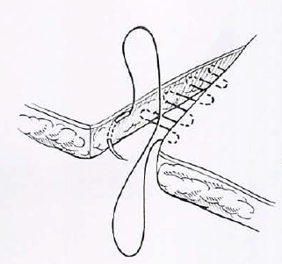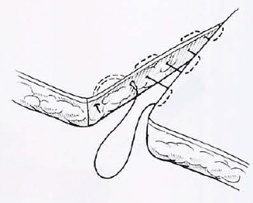
Subcutaneous -suture line not parallel to skin Subcuticular-suture line parallel to the skin
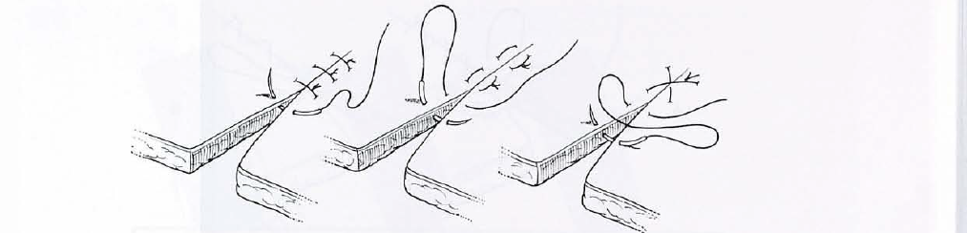
Simple interrupted Horizontal mattress Cruciate
- Horizontal mattress: used in areas of tension
  - Can cause tissue eversion
  - May cause tissue eversion
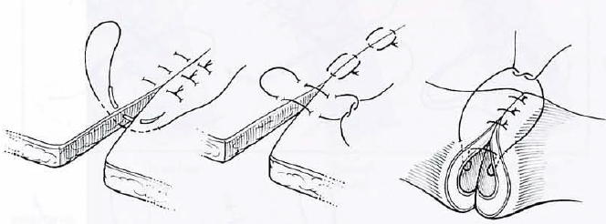

Vertical mattress Halsted Gambee
- Vertical mattress: used in areas of tension
  - Stronger than horizontal mattress
  - Eversion of skin margins less of a problem
  - If two vertical mattresses are placed in a vertical manner this is known as Halsted suture
- Gambee: used in intestinal surgery to reduce mucosal eversion/inversion
  - May also reduce wicking of material from the intestinal lumen to the exterior
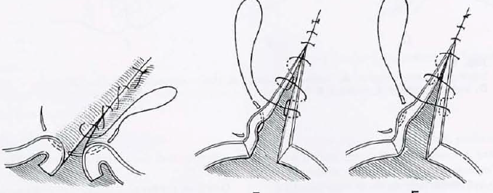
Lembert Connell Cushing
Inverting sutures
- Lembert: inverting pattern
  - Used to close hollow viscera
- Connell and Cushing:
  - Cause excessive tissue intervsion
  - Used infrequently
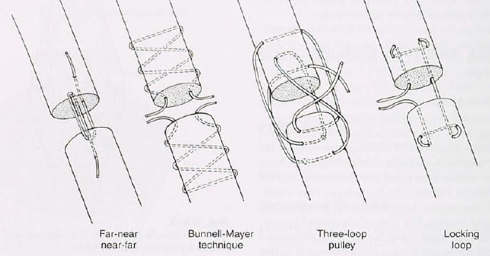
Tendon sutures:
- Three-loop pulley
  - Has good tensile load
- Bunnell suture
  - May damage tendon microcirculationischemia
  - Used for severed tendons
- Far-near-near-far: used in flat tendons
- Locking loop is preferred
Questions
- Increased capillarity indicates a suture has
  - Increased capillary damage
  - Increased fluid draw across the suture
  - Decreased size
  - Decreased tensile strength
- Why should braided sutures be avoided in skin wounds?

- The preferred suture type for contaminated wounds would be
  - Ethiband
  - Vicryl
  - Ethilon
  - Chromic gut

