Surgery of the stomach

Surgical anatomy:
- Stomach divided into cardia, fundus, body (middle 1/3), pyloric antrum, pyloric canal, pyloric osteum
- Gastric (lesser curvature) and gastroepiploic (greater curvature) arteries supply stomach and are derived from the celiac artery
- Short gastric arise from the splenic artery and supply the greater curvature
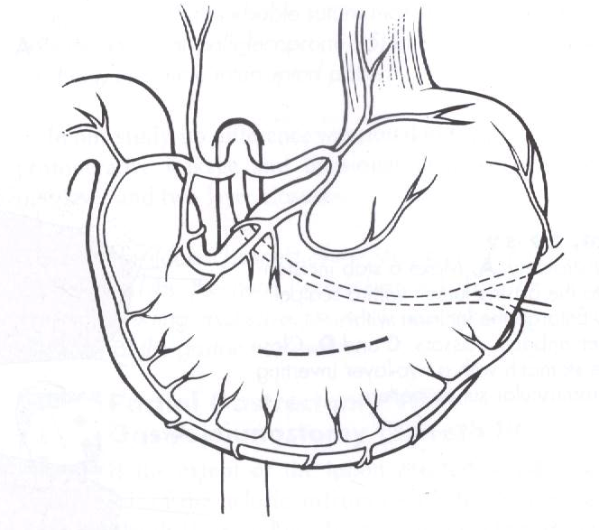
- Portion of the lesser omentum that passes from the stomach to the liver is the hepatogastric ligament
Emergency surgical diseases:
- Foreign body
- GDV
- Perforation

Gastrotomy:
- Place stay sutures to assist in manipulation of the stomach and help prevent spillage of gastric contents
- Make the gastric incision in a hypovascular area of the ventral aspect of the stomach, between the greater and lesser curvatures- make sure the incision is not near the pylorus
- Close with 2-0 or 3-0 absorbable suture material in a two layer inverting seromuscular pattern (include serosa, muscularis, and submucosa in the first layer using a simple continuous pattern or Cushing pattern; incorporate the serosa and muscularis in the second layer using a Cushing or Lembert pattern; as an alternative some people close the mucosa alone as a single layer)

GDV:
Generally, the stomach rotates in a clockwise direction when viewed from the surgeon’s perspective
The rotation may be 90-360 degrees, but usually is 220-270 degrees
The duode num and pylorus move ventrally and to the left of midline
Spleen is usually displaced to the right
The goals of surgery are threefold: 1) to inspect the stomach and spleen to identify and remove damaged or necrotic tissue; 2) to decompress the stomach and correct any malpositioning; 3) to adhere the stomach to the body wall to prevent subsequent malpositioning

- Upon entering the abdomen, the first structure noted is the greater omentum, which usually covers the dilated stomach
- Pass an orogastric tube or use a large-bore needle (14 or 16-guage) attached to suction to decompress prior to rotation
- For a clockwise rotation, once the stomach has been decompressed, rotate it counterclockwise by grasping the pylorus with the right hand and the greater curvature with the left
- Push the greater curvature, or fundus, of the stomach toward the table while simultaneously elevating the pylorus towards the incision
- Check to make sure that the spleen is normally positioned in the left abdominal quadrant- if there is splenic necrosis or significant infarction, perform a partial or complete splenectomy
- Remove or invaginate necrotic gastric tissue- if uncertain if it will remain viable-invaginate; sx here removes unless VERY focal area of necrosis d/t concern over ulceration
- Verify that the gastrosplenic ligament is not torsed prior to closure and also palpate the intraabdominal esophagus to ensure that the stomach is derotated
- Perform a permanent gastropexy

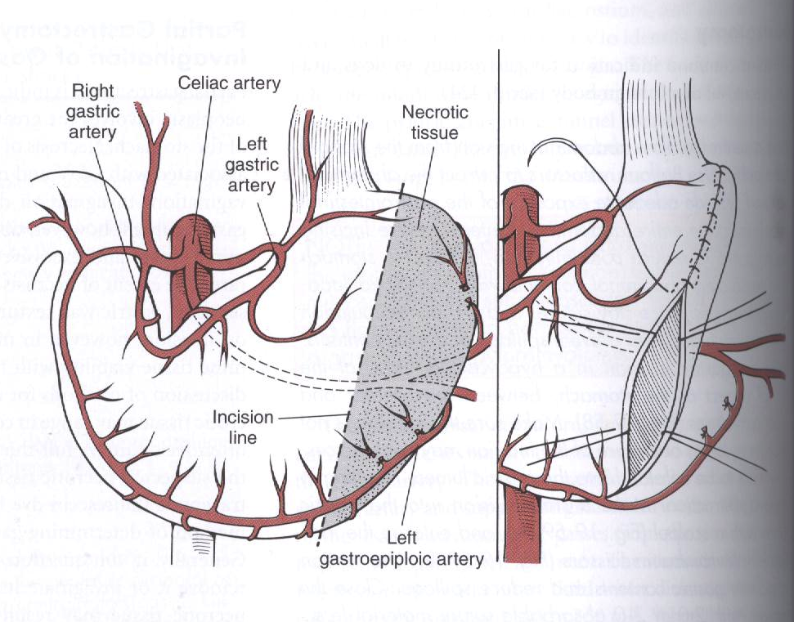
Partial gastrectomy and invagination of gastric tissue:

When assessing viability do not look at the mucosa as it often appears compromised, even when full thickness necrosis is not present- 80% of arterial flow to the mucosa; therefore, observation of mucosal color is not a reliable indicator of gastric wall viability
To remove the greater curvature of the stomach:
- Ligate branches of the left gastroepiploic vessels and short gastric vessels along the section of the stomach to be removed
- Excise the necrotic tissue, leaving a margin of normal actively bleeding tissue to suture
- Close the stomach in a two-layer inverting pattern using 2-0 or 3-0 absorbable suture- first layer submucosa, muscularis, serosa in a simple continuous pattern or Cushing pattern; second layer- serosa and muscularis using a Cushing or Lembert pattern); as an alternative can use TA stapling device to close
To invaginate necrotic tissue:
- Use a simple continuous suture pattern followed by an inverting pattern (Cushing or Lembert)- use 2-0 or 3-0 absorbable suture
- Place sutures in healthy gastric tissue on both sides of the tissue that is to be invaginated

Gastropexy techniques:
To create a permanent adhesion, the gastric muscularis layer must be in contact with the muscle of the body wall; intact serosa does not form permanent adhesions to the intact peritoneal surface
Muscular flap (Incisional) gastropexy recommended (avoids complications of tube gastropexy and is easier than circumcostal gastropexy):
- Make an incision in the seromuscular layer of the gastric antrum
- Then make an incision in the right ventrolateral abdominal wall by incising the peritoneum and internal fascia of the rectus abdominis or transverse abdominis muscles
- Suture the edge of the incision in a simple continuous pattern using 2-0 absorbable or non-absorbable suture (we use O or 1 non-absorbable or absorbable here)
- Make sure the muscularis layer of the stomach is in contact with the abdominal wall muscle
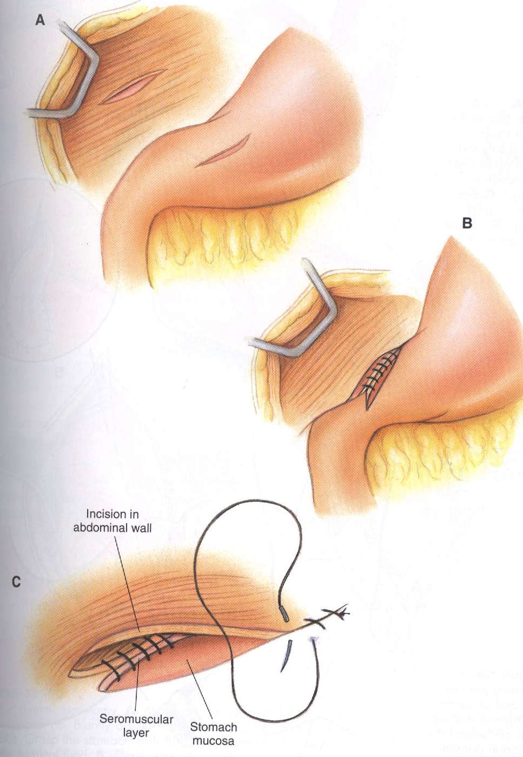
- Suture the cranial margin first, then the caudal margin

Tube gastropexy:
- Make a stab incision in to the right abdominal wall caudal to the last rib and 4-10cm lateral to the midline
- Place a Foley catheter (18-30Fr) through the stab incision
- Select a site in a hypovascular region of the seromuscular layer of the ventral surface of the pyloric antrum where the balloon of the cathter will not obstruct gastric outflow
- Place a purse-string suture of 2-0 absorbable suture at the site
- Make a stab incision through the purse-string suture, and insert the Foley catheter tip into the gastric lumen
- The catheter can be placed through the omentum before entry into the stomach so that the omentum is secured between the stomach and body wall, or the omentum can be wrapped around the site after the stomach has been secured to the body wall
- Inflate the bulb of the Foley catheter with sterile saline
- Secure the purse-string around the tube
- Preplace three or four absorbable sutures between the pyloric antrum and the body wall where the tube exists
- Draw the stomach to the body wall by placing traction on the catheter, and tie the preplaced sutures
- Secure the tube to the skin with a Chinese finger trap suture pattern
- Place a bandage around the site
- Leave in place for 7-10 days
- If would like to leave in for gastrostomy feedings, med administration, cut the tip off of the end of the Foley catheter
- Risk of leakage is minimal with this technique; however, improper placement can result in peritonitis
Circumcostal gastropexy:
Forms a stronger adhesion than most other techniques, but is technically more challenging
Possible complications include pneumothorax and rib fracture
- Make either a one- or two- layer hinged flap (approximately 5-6 cm long) by incising through the seromuscular layer of the pyloric antrum (don’t incise mucosa)
- Elevate the flap by dissecting under the muscularis
- If a one-hinged flap is made, place the hinge toward the lesser curvature
- Make a 5- to 6-cm incision over the eleventh or twelfth rib at the level of the costochondral junction
- Place stay sutures on the flap (if using a two-flap technique, place the sutures on the flap nearest the lesser curvature)
- Form a tunnel under the rib using a Carmalt
- Pass the gastric antral flap craniodorsal under the rib and suture it with 2-0 absorbable suture to the original gastric margin
Belt-loop gastropexy:
- Elevate a seromuscular flap in the gastric antrum
- Make two transverse incisions in the ventrolateral abdominal wall by incising the peritoneum and abdominal musculature (incisions should be 2.5-4cm apart and 3-5cm long
- Create a tunnel under the abdominal musculature with forceps
- Place stay sutures in the edge of the antral flap and use them to pass the flap from cranial to caudal under the muscular flap
- Suture the flap to its original gastric margin in a simple continuous pattern using 2-0 absorbable or nonabsorbable suture
- You can place additional sutures between the body wall and the stomach to reduce tension on the gastropexy

Billroth I: Removal of the pylorus (pylorectomy) and attachment of the stomach to the duodenum (gastroduodenostomy)
Indicated for neoplasia, outflow obstruction caused by pyloric muscular hypertrophy or ulceration/perforation of the gastric outflow tract
If neoplasia, at least 1-2cm margins of normal tissue should be removed with the abnormal tissue
If common bile duct damaged,a cholecystoduodenostomy or cholecystojejunostomy may be required
- Identify the common bile duct and pancreatic ducts, then place stay sutures in the proximal duodenum and pyloric antrum
- Ligate branches of the right gastric and right gastroepiploic artery and vein to the affected tissue and remove the omental and mesenteric attachments
- Using Doyen forceps or fingers to occlude the stomach and duodenum proximal and distal to the area to be resected
- Using Metzenbaums or a scalpel blade, excise the area of the pylorus to be removed and inspect to ensure that all abnormal tissue excised
- If the gastric and duodenal lumens are notably different sizes, incise the duodenum at an angle or partially close the antrum
- Perform a one-or two-layer end-to-end anastomosis of the pyloric antrum to the duodenum using 2-0 or 3-0 absorbable suture in a simple continuous, crushing or simple interrupted pattern (close far, dorsal aspect of the incision first, followed by the near, ventral aspect)
Billroth II: Attachment of the jejunum to the stomach (gastrojejunostomy) after a partial gastrectomy (including pylorectomy)
If the extent of the lesion precludes end-to-end anastomosis of the pyloric antrum to the duodenum, consider a Bilroth-II procedure
In most cases, a cholecystojejunostomy or cholecystoduodenostomy is required in addition to the gastrojejunostomy
EPI may occur if the pancreatic ducts are damaged
EPI + DM may occur if the pancreas is resected or severe damage to the blood supply occurs
Similar to a Billroth I, but the distal stomach and proximal duodenum are closed and the jejunum is attached with a side-to-side anastomosis of the stomach
- Resect the pylorus, antrum, and proximal duodenum as with a Bilroth I, ligating appropriate branches of the right and left gastric and gastroepiploic vessels
- Close the stumps in a two layer inverting pattern (first layer mucosa and submucosa in a simple interrupted or simple continuous pattern using 2-0 or 3-0 absorbable suture)
- Identify an avascular area between the gastric incision and the greater curvature.
- Bring a loop of proximal jejunum to the selected site, and attach it to the stomach with stay sutures
- Suture the seromuscular layers of the stomach and intestine together using a simple continuous pattern with 2-0 or 3-0 absorbable suture
- Make full-thickness, longitudinal incisions into the stomach and intestinal lumens near the suture line
- Suture the mucosa and submucosa of the stomach to the intestine in a continuous pattern using 3-0 or 4-0 absorbable suture
- Place a continuous pattern in the serosa and muscularis
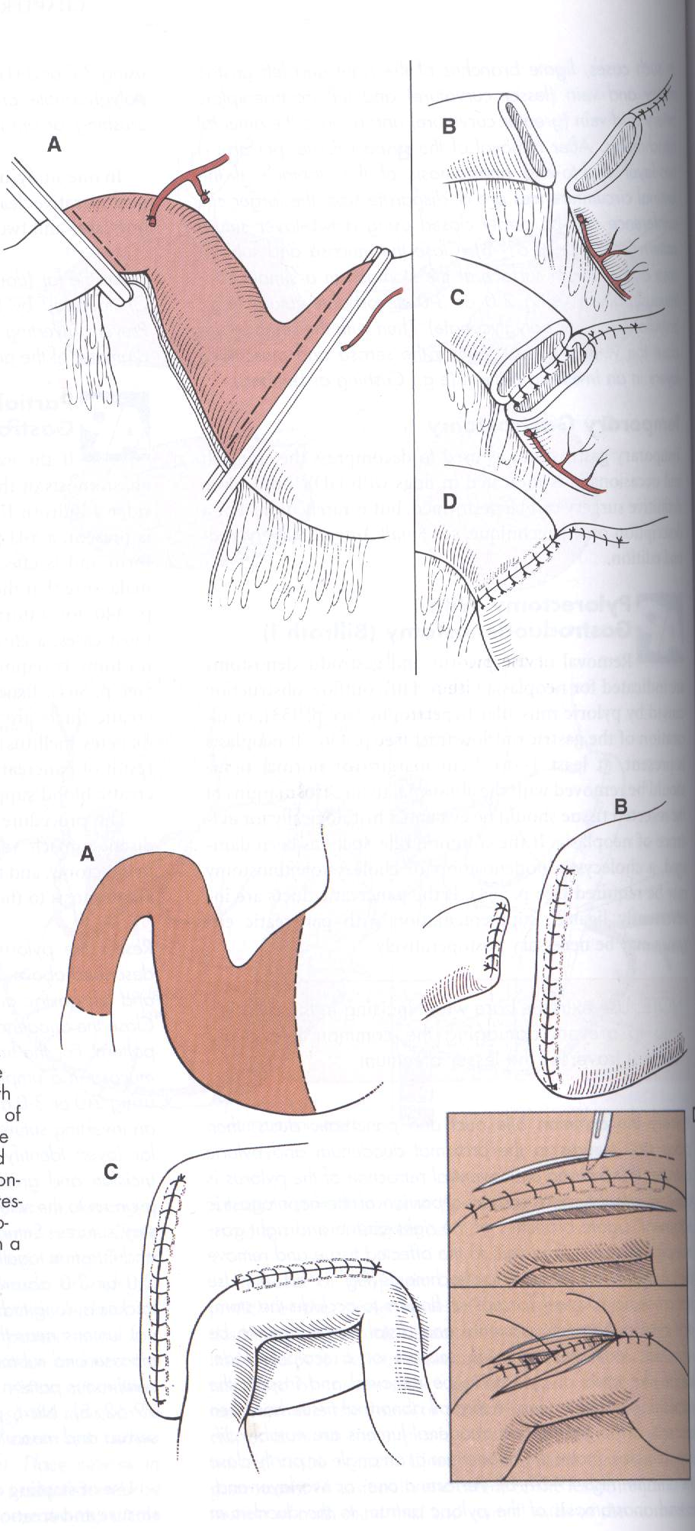

Literature:
GDV:
Evaluation of splenectomy as a risk factor for gastric dilatation-volvulus
Andrew M. Grange, bsc, bvetmed; William Clough, bs; Sue A. Casale, dvm, dacvs
Objective—To evaluate whether dogs undergoing splenectomy had an increased risk of gastric dilatation-volvulus (GDV), compared with a control group of dogs undergoing enterotomy.
Design— Retrospective case-control study.
Animals—219 dogs that underwent splenectomy for reasons other than splenic torsion (splenectomy group; n = 172) or enterotomy (control group; 47) without concurrent gastropexy.
Procedures—Medical records were reviewed for information on signalment, date of surgery, durations of surgery and anesthesia, reason for splenectomy, histopathologic findings (if applicable), whether gastropexy was performed, duration of follow-up, and date of death (if applicable). Follow-up information, including occurrence of GDV, was obtained via medical records review and a written client questionnaire.
Results—Reasons for splenectomy included splenic neoplasia, nonneoplastic masses, infarction, traumatic injury, and adhesions to a gossypiboma. Incidence of GDV following surgery was not significantly different between dogs of the splenectomy (14/172 [8.1%]) and control (3/47 [6.4%]) groups. Median time to GDV for the 17 affected dogs was 352 days (range, 12 to 2,368 days) after surgery. Among dogs that underwent splenectomy, sexually intact males had a significantly higher incidence of GDV (4/16) than did castrated males and sexually intact or spayed females (10/156). Incidence of GDV among sexually intact male dogs did not differ between groups.
Conclusions and Clinical Relevance—Results did not support a recommendation for routine use of prophylactic gastropexy in dogs at the time of splenectomy. Other patient- specific risk factors should be assessed prior to recommending this procedure. (J Am Vet Med Assoc 2012;241:461–466)

Evaluation of lidocaine treatment on frequency of cardiac arrhythmias, acute kidney injury, and hospitalization time in dogs with gastric dilatation volvulus
Yaron Bruchim, DVM; Srugo Itay, DVM; Ben-Halevy Shira, DVM; Efrat Kelmer, DVM, MS, DACVECC; Yudelecitch Sigal, DVM, DECVS; Aroch Itamar, DVM, DECVIM-CA and Segev Gilad, DVM, DECVIM-CA
AKI
Abstract
Objective – To assess the efficacy of IV lidocaine in decreasing complication rate and improving the outcome in dogs with gastric dilatation volvulus (GDV). Design – Prospective non-controlled study of 83 lidocaine-treated dogs with GDV compared to 47 untreated historical controls with GDV.
Setting – University veterinary teaching hospital.
Animals – One hundred and thirty client-owned dogs with naturally occurring GDV.
Interventions – Study group dogs were treated at presentation with lidocaine (2 mg/kg, IV bolus) followed by constant rate infusion (CRI) of 0.05 mg/kg/min for 24 h. Historical control dogs did not receive any lidocaine.
Measurements and Main Results – There were no group differences in age, body weight, time lag from onset of clinical signs to presentation, rectal temperature and pulse rate at presentation, and proportion of gastric wall necrosis. The proportions of cardiac arrhythmias and acute kidney injury (AKI) were significantly (P< 0.001 and P = 0.045, respectively) lower in the lidocaine group (10/83 [12%] versus 18/47 [38.3%] and 3/83 [3.6] versus 0/47). Median hospitalization time period was shorter (P = 0.05) in the lidocaine group compared to the controls (median 48 h; range 24–360 h versus median 72 h; range 24–144 h, respectively).
Conclusion and Clinical Relevance – Early treatment with IV lidocaine bolus, followed by CRI of lidocaine for 24 h post presentation decreased the occurrence of cardiac arrhythmias, AKI and hospitalization time period significantly in lidocaine-treated dogs with GDV compared to untreated historical controls. Due to the nonblinded, placebo-uncontrolled, nonrandomized nature of the current study, further evaluation of the efficacy of lidocaine in dogs with GDV is warranted.
(J Vet Emerg Crit Care 2012; 22(4): 419–427)

An Internet-based survey of risk factors for surgical gastric dilatation-volvulus in dogs
Marko Pipan, dvm, dacvecc; Dorothy Cimino Brown, dvm, msce, dacvs; Carmelo L. Battaglia, phd; Cynthia M. Otto, dvm, phd, dacvecc
Objective—To evaluate risk factors for gastric dilatation-volvulus (GDV) in a large number of privately owned dogs across a wide geographic area.
Design—Internet-based, cross-sectional study.
Animals—2,551 privately owned dogs.
Procedures—A questionnaire addressed dog-specific, management, environmental, and personality-associated risk factors for GDV in dogs. Respondents were recruited through the posting of the electronic link to the questionnaire on websites for dog owners; the information was also disseminated at meetings of dog owners and via newsletters, e-mail lists for dog owners and breeders, owner-oriented dog publications, and e-mails forwarded by participants. Descriptive statistics and logistic regression analysis were performed.
Results—Factors significantly associated with an increased risk of GDV were being fed dry kibble, anxiety, residence in the United Kingdom, being born in the 1990s, being a family pet, and spending at least 5 hours a day with the owner. Factors associated with a decreased risk of GDV were playing with other dogs and running the fence after meals, fish and egg dietary supplements, and spending equal time indoors and outdoors. A significant interaction between sex and neuter status was observed, with sexually intact females having the highest risk for GDV.
Conclusions and Clinical Relevance—In dogs with a high risk of GDV, regular moderate daily and postprandial activity appeared to be beneficial. Feeding only commercial dry dog food may not be the best choice for dogs at risk; however, supplements with fish or eggs may reduced this risk. The effect of neuter status on GDV risk requires further characterization. (J Am Vet Med Assoc 2012;240:1456–1462)

Evaluation of initial plasma lactate values as a predictor of gastric necrosis and initial and subsequent plasma lactate values as a predictor of survival in dogs with gastric dilatation-volvulus: 84 dogs (2003^2007)
Tiffany I. Green, DVM; Caroline C. Tonozzi, DVM, DACVECC; Rebecca Kirby, DVM, DACVIM, DACVECC and Elke Rudloff, DVM, DACVECC
Abstract
Objective – To test whether an initial plasma lactate >= 6.0 mmol/L is associated with the presence of macroscopic gastric wall necrosis and overall survival in dogs presenting with gastric dilatation-volvulus (GDV). Additionally, if no association was identified we sought to identify a different predictive initial plasma lactate concentration and to examine whether serial plasma lactate concentrations provide better prediction of survival.
Design – Retrospective study over a 5-year period (2003–2007).
Setting – Urban private referral small animal teaching hospital.
Animals – Eighty-four client-owned dogs with a diagnosis of GDV and plasma lactate measurements.
Interventions – None.
Measurements and Main Results – There was no statistically significant relationship found between survival and the presence of macroscopic gastric wall necrosis with the initial plasma lactate >=6 mmol/L. There was a significant relationship between the initial plasma lactate >2.9mmol/L for predicting necrosis and <4.1 mmol/L for predicting survival to discharge. Forty dogs that had an increased initial plasma lactate (>2.5 mmol/L) also had a subsequent plasma lactate measured within 12 hours of presentation, with 37/40 dogs surviving and 70% of these surviving dogs having the subsequent lactate decrease by >=50% within 12 hours. The 3/40 that died failed to decrease their plasma lactate by >=50% from the initial blood lactate.
Conclusion – The results of this study indicate that an initial presenting plasma lactate concentration >6.0 mmol/L is not predictive of macroscopic gastric wall necrosis or survival in dogs presenting with GDV. A decrease in plasma lactate concentrations 􏰃 50% within 12 hours may be a good indicator for survival. Limitations to the study include its retrospective nature, the small number of patients, and the number of dogs that were euthanized rather than allowed to progress to a natural outcome.
(J Vet Emerg Crit Care 2011; 21(1): 36–44) doi: 10.1111/j.1476-4431.2010.00599.x

Association between outcome and changes in plasma lactate concentration during presurgical treatment in dogs with gastric dilatation-volvulus: 64 cases (2002–2008)
Laurie A. Zacher, dvm, dacvs; John Berg, dvm, dacvs; Scott P. Shaw, dvm, dacvecc; Raymond K. Kudej, dvm, phd, dacvs
Objective—To determine whether changes in presurgical plasma lactate concentration (before and after initial fluid resuscitation and gastric decompression) were associated with short-term outcome for dogs with gastric dilatation-volvulus (GDV).
Design—Retrospective case series.
Animals—64 dogs.
Procedures—Medical records were reviewed, and signalment, history, resuscitative treatments, serial presurgical lactate concentrations, surgical findings, and short-term outcome were obtained for dogs with confirmed GDV.
Results—36 of 40 (90%) dogs with an initial lactate concentration ≤ 9.0 mmol/L survived, compared with only 13 of 24 (54%) dogs with a high initial lactate (HIL) concentration (> 9.0 mmol/L). Within HIL dogs, there was no difference in mean ± SD initial lactate concentration between survivors and nonsurvivors (10.6 ± 2.3 mmol/L vs 11.2 ± 2.3 mmol/L, respectively); however, there were significant differences in post-treatment lactate concentration, absolute change in lactate concentration, and percentage change in lactate concentration following resuscitative treatment. By use of optimal cutoff values within HIL dogs, survival rates for dogs with final lactate concentration > 6.4 mmol/L (23%), absolute change in lactate concentration ≤ 4 mmol/L (10%), or percentage change in lactate concentration ≤ 42.5% (15%) were significantly lower than survival rates for dogs with a final lactate concentration ≤ 6.4 mmol/L (91%), absolute change in lactate concentration > 4 mmol/L (86%), or percentage change in lactate concentration > 42.5% (100%).
Conclusions and Clinical Relevance—Calculating changes in plasma lactate concentration following initial treatment in dogs with GDV may assist in determining prognosis and identifying patients that require more aggressive treatment. (J Am Vet Med Assoc 2010;236:892–897)
Myoglobin as a prognostic indicator for outcome in dogs with gastric dilatation-volvulus
Katja N. Adamik, DrMedVet; Iwan A. Burgener, DrMedVet, DACVIM, DECVIM; Alan Kovacevic, DrMedVet, DECVIM; Sebastian P. Schulze, MRCVS and Barbara Kohn, DrMedVet, DECVIM
Abstract
Objective – To determine whether myoglobin (Mb) is a useful prognostic indicator for outcome and to investigate any relationship between Mb and mortality in dogs with gastric dilatation-volvulus (GDV).
Design – Prospective study.
Setting – Veterinary teaching hospital.
Animals – Seventy-two dogs with GDV.
Interventions – Blood sampling.
Measurements and Main Results – Mb levels were measured at the time of diagnosis (Mbt0), 24 hours (Mbt1), and 48 hours (Mbt2) after signs of GDV were recognized. Fifty-seven dogs survived (group I) and 15 dogs did not survive (group II). Mb t0 differed significantly between groups (P 5 0.04). Mbt0 in group I ranged from <30 to >700ng/mL (n=57, median 74ng/mL), and in group II from 34 to >700ng/mL (n=15, median 238ng/mL). Analysis of a receiver operating characteristic curve of Mbt0 suggested that the best single cutpoint would be 168 ng/mL (sensitivity 60.0%, specificity 84.2%). Fifty percent of dogs with Mbt0>168 ng/ mL were euthanized, while 88.9% with Mbt0<168ng/mL survived. Mbt1 and Mbt2 differed significantly between groups I and II. Mbt1 in group I ranged from 32 to >700 ng/mL (n =55, median 123 ng/mL), and Mbt1 in group II ranged from 131 to 643 ng/mL (n = 7, median 343 ng/mL) (P =0.006). Mbt2 in group I ranged from 30 to 597 ng/mL (n = 54, median 101 ng/mL), and in group II from 141 to >700 ng/mL (n 5 8, median 203 ng/mL) (P =0.02). Conclusions – In this study, Mbt0 is a moderately sensitive and specific prognostic indicator. Almost 90% of the dogs below the cutpoint survived to discharge, whereas 50% with Mbt0 above the cutpoint did not survive.
(J Vet Emerg Crit Care 2009; 19(3): 247–253) doi: 10.1111/j.1476-4431.2009.00421.x

