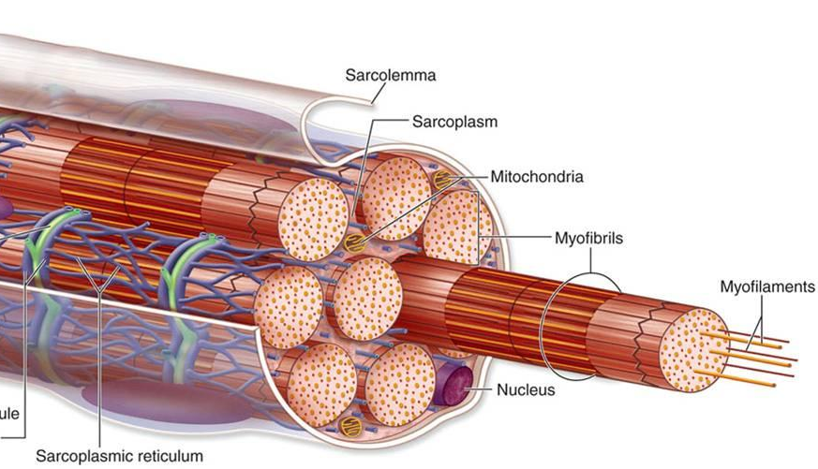
Contraction of Skeletal Muscle (part 1)
Physiologic anatomy of skeletal muscle
The skeletal muscle fiber
- Sarcolemma
  - Cell membrane of muscle fibre
  - Made of plasma membrane and outer polysaccharide coat
  - Fuses with the tendon fiber
- Myofibrils; actin and myosin filaments
  - Muscle fibers composed of myofibrils
  - Myofibrils composed of myosin filaments
  - Light bands-actin filaments, aka I bands
  - Dark bands-myosin and actin filaments, aka A bands
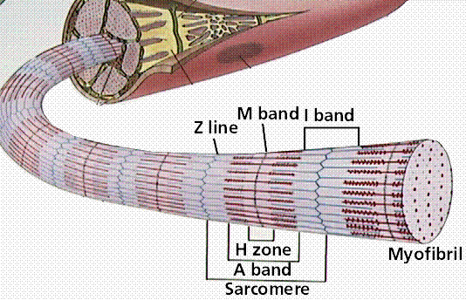
  - Z disc-attachment of adjacent actin filaments
    - Attaches myofibrils to one another
  - Sarcomere-portion of myofibril between adjacent Z discs
- Titin filamentous molecules-springy little filamentous molecules that line up the actin and myosin filaments
- Sarcoplasm
  - Cytoplasm of the muscle cell
  - Holds the myofibrins as well as cytoplasmic fluid and mitochondria
- Sarcoplasmic reticulum
  - Important somehow in causing rapid muscle contraction
General mechanism of muscle contraction
- Action potential moves on motor nerve to ending on muscle fibre
- Secretion of acetylcholine
- Acetylcholine opens multiple acetylcholine-gated channels through protein molecules floating in the membrane
- Opening of acetylcholine-gated channels allows large quantities of sodium to flow to interior of muscle fibre membraneaction potential
- Action potential travels along muscle fibre
- Depolarizes muscle membranesarcoplasmic reticulum to release large quantities of calcium
- Calcium initiates attractive forces between actin and myosin
- Calcium is pumped back into sarcoplasmic reticulum to participate in next contraction
- Removal of calcium causes muscle contraction to cease
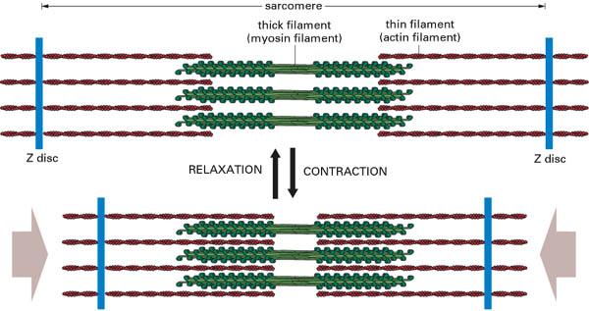
Molecular mechanism of muscle contraction
Sliding mechanism of contraction
- When relaxed-adjacent actin filaments barely overlap
- When contracted-adjacent actin filaments pulled inward among myosin filaments
- Sliding results from myosin/actin cross-bridge interactions
Molecular characteristics of the contractile filaments
- Myosin filament
  - Composed of a tail and two heads
  - Tails become intertwined to form the long filament
  - Heads protrude to form an “arm” that cross-bridges to adjacent actin filaments
  - Arm/head acts as a hinge
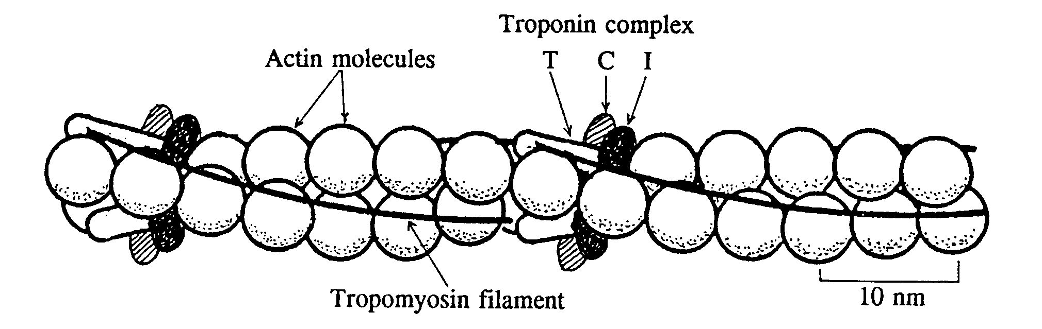
- Actin filament
  - Composed of three protein components: actin, tropomyosin, troponin
  - F-actin molecule acts as the backbone of the actin filament
  - Tropomyosin wraps spirally around sides of F-actin helix
    - When resting, tropomyosin lies on top of active sites of actin, preventing attraction with myosin
  - Troponin-3 subunits
    - Troponin I: strong affinity for actin
    - Troponin T: strong affinity for tropomyosin
    - Troponin C: strong affinity for calciuminitiates contraction
Interaction of myosin, actin, and calcium ions to cause contraction
- Inhibition of the actin filament by the troponin-tropomyosin complex; activation by calcium ions
  - Troponin-tropomyosin complex covers and actively inhibits actin
  - In presence of large amounts of calcium, inhibitory effect of troponin-tropomyosin is inhibited
    - Troponin C strongly binds up to 4 calcium ions
    - Results in conformational change to troponin complex
    - Pulls tropomyosin deeper into groove between actin strands
    - Uncovers active sites on actin allowing myosin attraction and contraction
- Interaction between the “activated” actin filament and the myosin cross-bridges
  - Heads of cross-bridges from myosin filaments attracted to active sites of the actin filament
  - Profound changes occur in the intramolecular forces between the head and actin
  - Allows for arm to drag actin filament along with it
  - Tilt of the head is called the “power stroke”
  - Heads of cross-bridges bend back and forth and step by step walk along an actin filament
- ATP as the source of energy for contraction-chemical eventsmotion of myosin heads
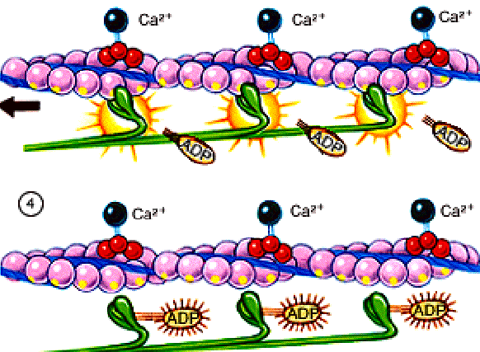
  - ATPase activity of the myosin head cleaves ATP to ADP and Pi, which stay bound to head
  - Calcium to exposure of actin site and myosin/actin interact
  - Bond between the head and actin siteconformational change in the head to tilt arm of cross-bridge
    - Called a power stroke
  - Tilting of the head allows release of ADP and Pi, allowing a new ATP molecule to bind
  - Binding of ATP allows for dissociation of head from the actin site
  - New molecule of ATP then cleavednext power stroke
Questions
- Contraction of the muscle is a result of the interaction between the myosin head and
  - Tropomyosin
  - Troponin
  - Actin binding site
  - ATP
- Which of the following prevents the attachment of ATP to myosin ATPase and the formation of a power stroke
  - ATP
  - Troponin C
  - Troponin I
  - Calcium
- Selective loss of the tropomyosin filament would lead to
  - Inability of actin to recognize calcium surge from sarcoplasmic reticulum
  - Loss of inhibition of myosin-actin interaction
  - Inability for myosin head ATPase to cleave ATP to ADP and Pi
  - Prevention of cross-bridge formation
- Fill in the blanks:

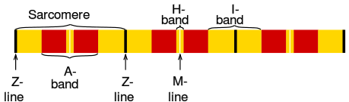
A. ___________________
B. ___________________
C. ______

D. _____________

