Ch 94: Principles of canine and feline blood collection, processing and storage
Donor considerations – CANINE

Maximum donation volume ~19ml/kg (based on estimated blood volume of 85ml/kg, and recommended collection volume of 15-22%.
Donors should be >23-27kg
PCV should be >/= to 40% at the time of donation
Routine health screens recommended (history, PE, labwork, infectious disease testing) annually
Babesia canis, gibsoni, Leishmania, E. canis and other Ehrlichia spp, Anaplasma, Neorickettsia, Brucella canis. If positive on donor should be excluded.
Others to potentially test for: Trypanosoma cruxi, Bartonella vinsonii and hemotrophic Mycoplasma
Remain current on vaccinations, heartworm, flea, and tick preventative
Donors should be excluded if they have ever received a transfusion
Donors need not necessarily be excluded for prior litters.

Donor considerations – Feline

Recommended maximum donation 11-15ml/kg based on blood volume of 40-60ml/kg.
Generally volumes collected range from 50-70ml (including anticoagulant)
Mild but transient decreases in MAP may be seen (perhaps a result of anesthesia protocol vs blood loss)
SQ fluids may be administered following transfusion.
Iron supplementation may be considered
Routine health screens recommended (history, PE, labwork, infectious disease testing) annually
FeLV, FIV, hemotrophic Mycoplasma spp. Cytauxzoon if endemic.
Donor PCV should be >30%
Donors should be housed inside exclusively

Blood collection principles
Collected as whole blood and separated into components by centrifugation or components are collected separately by apheresis.
Closed system of collecting blood: commercially available, sterile, airtight systems that allow for processing and storage without opening.
Open system: has one or more sites of entry. Not intended for storage. Intended for use within 24 hours (RBC) and 4 hours (plt)

Blood collection supplies

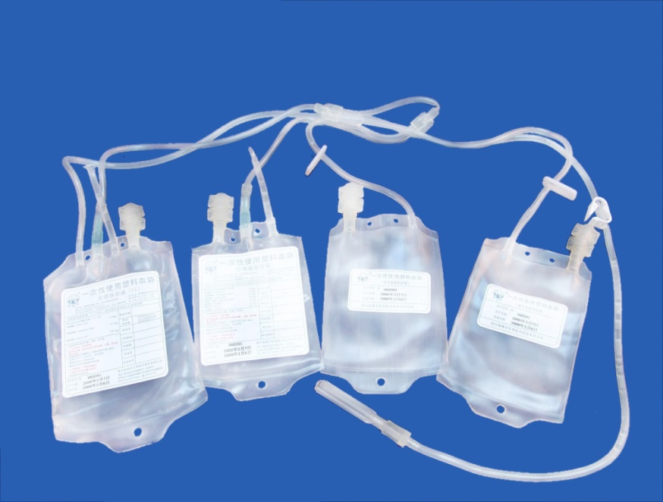
CANINE
Commercial 450ml collection bags used for human blood banking. Also avail in 150ml, 250ml, 350ml, 500ml. Contain anticoagulant-preservative solution (APS) and 16g needle attached to sterile collection line. Ideal APS:blood ratio is 1.4:10.
Primary collection bag and satellite bags for separation and/or housing of additives.
Additive solutions (AS)
Saline, adenine, dextrose +/- mannitol +/- citrate-citric acid.
Extends shelf life of stored cells to ~1mo.

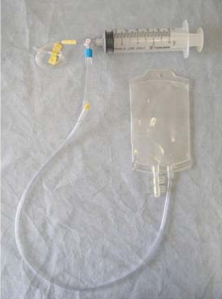
FELINE
Commercial closed collection systems not available, however one has been MacGuyvered (see pic).
Most collections systems are open (APS must be transferred into syringe from a multiuse container). (So technically shouldn’t be stored based on earlier comment)
Collection into syringe for immediate transfusion
Commercial 100 ml bags and collection tubing with attached butterfly needle
Attached three way stopcock, 60ml syringe and butterfly needle
Collection into syringe and gentle injection into transfer pack
Extra care to maintain sterility
Most common APS is citrate-phosphate-dextrose-adenine-1 (CPDA-1) at APS:blood ratio of 1:7

Blood components

Aphersis

Whole blood is fractionated and unwanted components returned.
May be performed as extension of whole blood transfusion, however use of automated processors preferred (improved efficacy and quality).

Preparation and collection of whole blood

Canine
Full unit is 450ml, acceptable variation is 405-495ml (426-521g). Minimum draw is 300mls (less than this and you have excessive anticoagulant).
Jugular vein, preferably lateral recumbency.
Venipuncture site is clipped and surgically prepared.
Collection systems commercially available contain the needle and tubing, and gravity and donor blood pressure can be used to collect. Bag can be placed on scale or rocker/scale during transfusion, allowing measurements of weight to ensure proper unit size. Donation takes about 5-15 minutes without suction (3-10 min with).
When the collection is competed, clamp the collection line, remove needle. Apply pressure to venipuncture site.
Strip the line into the bad using tube strippers, then refill a portion. Clamp or heat seal, creating several little straws of donor blood to be used in cross matching.
Monitor donor during procedure: MM color, pulse rate/quality, resp rate, attitude.

Feline
Sedation/anesthesia (book recommends ketamine-midazolam, sevoflurane, butorphanol as pre-med).
Position into lateraly recumbency.
Prepare the jugular vein as in the dog.
Blood collection typically complete in 3-5min
Gentle suction can be applied, avoid collapsing vein
Monitor patient carefully during transfusion (hypotension)
Consider SQ fluids after donation

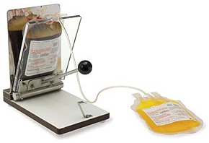
Separation of whole blood into components
Centrifugation in special centrifuge, 5000g for 5 minutes at 4C
Primary bag is placed in plasma extractor (squeezy thing picture to the right).
If using CPDA-1 - Leave ~2cm of plasma in the bag
If using CPD or CP2D, you can remove all the plasma.
Once plasma is removed, AS is added to pRBC’s
Label bags with pertinent information, including volume (weight of component divided by 1.026 for plasma and 1.056 for pRBC’s

Fresh plasma
Contains albumin, globulins, max quantities of coag factors. Considered FFP (fresh frozen plasma) if frozen with in 8 hrs of collection. Labeled FP (frozen plasma) if frozen >8 hours after collection.
Cryoprecipitate, cryosupernatent
After freezing, thaw to 1-6C (slushy consistency). Then centrifuge 5000g x 7 minutes. Transfer the supernatent (all but 10-15mls) into satellite bag. The supernatent is cryo-poor plasma, the slushy bits contain vWf, fibrinogen, fibrinectin, factors VIII, XIII. Uses: vWD, hemophilia A. Cryo-poor (aka cryosupernatent) contains all heat stabile factors.
Platelet rich plasma
Allow FWB to rest for 1 hour, resuspend platelets.
Centrifuge at 20C, isolating the platelets above the buffy coat. Stop squeezing the PRP out when plasma interface is 1 cm from top of bag (minimize leukocytes).
1 unit FWB = 1 unit PRP
Yield depends on the plt count, blood volume, centrifuge, protocol.
Most use 1000g x 4-6 minutes or 2000g-2500g for 2.5-3 minutes.
1000g protocol yields ~80% platelets = 6x10¹⁰ platelets/unit
Platelet concentrate
2000g x 10 minutes of PRP to pellet platelets.
Result is 35-70ml volume units

Feline blood products
Centrifuged at 3000g x 10 minutes at 4C to separate FWB into pRBC and FFP
pRBC’s may be stored without AS added

Storage
Red cell products – 1-6C for ~1mo. As RBCs age, they develop storage lesion
Plasma products – -18C or lower. FFP shelf life 1 year, then “becomes” FP and good for another 4 years.
Platelet products – 5-7d at room temp with continuous gentle agitation

Quality control
Do it…
Visually inspect pRBC prior to use. Dischard if discolored supernatent, clots, etc
Inspect plasma for leaks, discard if seen

Chapter 95: Red blood cell transfusion in the dog and cat

Indications
Anemia – hemorrhage, hemolysis, ineffective erythropoiesis.
Nearly all O2 is carried by hemoglobin, therefore RBC transfusions increase O2-carrying capacity.
CaO2 = [(1.34 x HCT x SaO2) = (0.003 x PaO2)
Transfusion threshold
Measurement of PCV or HCT AND clinical evaluation of patient.
Transfusion trigger has not been established in vet med
Humans – currently Hgb <7 (HCT 21), termed “restrictive” is the current recommendation made as a result of the TRICC trial (transfusion requirement in critical care – seminal article #67, 2012 list). They tested restrictive vs liberal (Hgb 10-12, HCT 30-36). Found mortality lower in the restrictive group.
Human review – Lancet 2007: Little need to transfuse at Hgb <10, risk of hypoxic organ damage low at Hgb 8-10, however at <6 there is substantial risk for hypoxic organ damage, especially of ongoing bleeding is possible
Vet me – transfusion trigger not established – HCT alone is insufficient for determining transfusion threshold. Must evaluate more thoroughly as cardiac output, and oxygen consumption play role in O2 delivery.
DO2 = CO x CaO2
Hypovolemic patients have falsely elevated PCV, chronic anemic patients cope better
Tachycardia, poor pulses, pallor, lethargy, weakness, decreased appetite

Whole blood vs packed RBC

Whole
FWB <8 hours after collection: functional platelets, coag factors, plasma proteins, oh yea, and RBC’s
Anemia and combined hemostatic defect
Anemia and thrombocytopenia or thrombopathia resulting in uncontrolled or life-threatening bleeding
Massive transfusion
Stored whole blood (SWB)
>8 hours from collection: plasma proteins, RBC’s not functional platelets or coag factors
Anemia and hypoproteinemia
pRBC’s
Anemia from any cause
More efficient to separate into components due to loss of functional coag factors and volume to be transfused

Fresh vs stored RBC’s
Storage lesion – reduces RBC viability after transfusion.
Decreased RBC deformability which can impeded microvascular blood flow
Depletion of 2-3 DPG which shifts oxyhemoglobin dissociation curve to the left and reduces O2 delivery
Reduction of RBC ATP concentration, which may result in decreased phosphorylation of other proteins or lipid kinases important in maintaining RBC integrity
Reduction of RBC-derived nitric oxide bioactivity – may impair the vasodilatory response to hypoxia
Accumulation of proinflammatory bioactive substances
Additive solutions – improve RBC viability post-transfusion
Dextrose, adenine, phosphate (substrates for RBC metabolism)
Collection in citrate-phosphate-dextrose and resuspended in Adsol (adenine, dextrose, saline, mannitol) – documented decrease in 2-3 DPG during storage, however this is reversible (at least in peeps) and by 72h can be completely reversed. (Not an issue with cats as their RBC’s contain low levels of 2-3 DPG’s, their Hgb does not require it for O2 release).
Oxygen release: certainly are differences in stored vs fresh RBC’s but there are no clinical signs to demonstrate changes in morbidity or mortality in vet med, although studies in human medicine have conflicting results: One suggested that “older blood” was associated with increased risk of post-op complications, and reduced short- and long-term survival. Another failed to show a connection with storage and adverse outcomes after cardiac surgery. Several retrospectives suggest detrimental effect to critically ill patients.

Additional benefits of RBC transfusions
Enhanced hemostasis
Correlation betn anemia and prolonged bleeding time reported in hums, corrects with resolution of anemia. Reduction of 10% in HCT can cause two fold increase in bleeding time. This is more than the effect of thrombocytopenia as well (tested by apheresing RBC or platelets, RBC produces more change in BT.
Potential mechanisms:
Decrease in RBC thromboxane B2 level at the template BT site
Dispersion of platelets from the center of the blood vessel wall toward the endothelial cells , facilitating plt-vessel adhesion
Shear stress-induced release of ADP from RBC’s
Scavenging of endothelial cell nitric oxide by oxidation and by nitric acid binding to Hgb.
It has been recommended in human med to transfuse to 35% prior to administering platelet transfusions in patients with nonsurgical bleeding diathesis
Iron – 1ml blood = 1mg iron (bioavailable). However repeated transfusions place patients at tisk for hemochromatosis (organ dysfunction secondary to iron-induced injury).

Administration
Canine pRBC’s stored in Adsol are ready to go. Others need to be diluted in 100ml of saline (10ml to cat units) – ((although I have never seen anyone do this)).
Refrigerated blood components do not need rewarming (warming may accelerate growth of contaminating microorganisms). For patients receiving large volumes, prewarming to 22-37C may prevent hypothermia (waterbaths, dry heat devices, warm water in sink).
Blood filters and infusion devices
Administer thru a filter to remove clots and particles potentially harmful to patients. Pore size ranging 170-260mcm in standard blood sets. A single filter can be used to administer 2-4 units or blood or for a maximum 4 hours.
Filters with pore size of 20-40mcm remove microaggregates. Pediatric version useful in small volumes.
Leukocyte reduction filters – used in human medicine to reduce transmission of cytomegalovirus, reduce transfusion reactions associated eith residual WBC (febrile nonhemolytic transfusion rxns, human lymphocyte antigen alloimmunization. Leukoreduced units contain less thatn 5x10⁶ donor WBC’s remaining.
Pump vs no pump – pump may induce hemolysis, require special filter/administration set. Check with manufacturer. Gravity administration sufficient generally.

Route, volume, rate
Route: IV or IO
Volume: dependent on degree of anemia, patients status, target PCV (generally >20%). General guideline: 2ml/kg WB or 1ml/kg pRBC will rates patients PCV by 1%. Alternatively 10ml/kg pRBC, 20ml/kg WB, then reassess. Cats: generally one unit of either WB or pRBC’s.
Rate: max to avoid circulatory overload in normovolemic patient is 10-20ml/kg/h. Hypovolemic patients will tolerate faster administration. With cardiac disease rate should not exceed 2-4 ml/kg/hr (preferably pRBC’s). Transfusion should be completed within 4 hours to prevent bacterial contamination.

Massive transfusion
“Transfusion of a volume of whole blood or blood components that is greater than the patient’s estimated blood volume within a 24-hour period or replacement of half the patient’s estimated blood volume in three hours”
Ionized hypocalcemia, hypomagnesemia, progressive thromobocytopenia, prolongation of PT and PTT.
Aim for 1:1 plasma:pRBC’s.

Patient monitoring
Early recognition of reactions requires careful eval of the patients condition, pay attention to any changes.
PCV/TS pre and post transfusion, also 24 hour post transfusion. Note changes in color of serum and urine.

