Development of a model based scoring system for diagnosis of canine disseminated intravascular coagulation with independent assessment of sensitivity and specificity. Wiinberg B, et al. The Veterinary Journal; 185 (2010): 292-298.
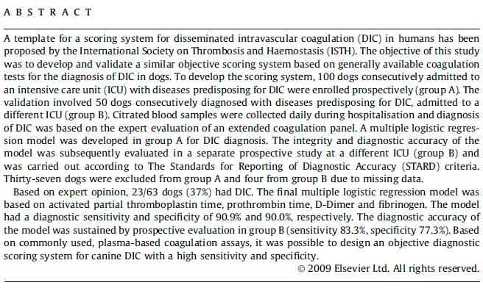
- DIC in vet med is traditionally diagnosed based on three or more abnormal hemostatic parameters: PTT, PT, fibrinogen, D-dimer, plt count, erythrocyte morphology, and the presence of a predisposing disease
  - Sensitive but unspecific
- Experts were asked to diagnose DIC based on evidence of procoagulant activation, inhibitor consumption and increased fibrinolytic activity (PTT, PT, fibrinogen, D-dimer, Protein C, Protein S, α2-antiplasmin, plasminogen, and plt count)
- Prospectively enrolled 100 dogs to develop scoring system, but only 63 had adequate data to use
  - 37% of dogs had DIC based on expert opinion, only 77% inter-rater agreement
  - Model equation:
    - Sens 90%, Spec 90%
x = 15.99 - 0.14(Fibrinogen) - 2.52(PT) - 2.13(aPTT) + 0.28(aPTT)(PT) + (5.41 when D-dimer is >.5 mg/L)

_e^{x} = P (P>0.401 considered positive for DIC)
1 + e^{x}
- Prospectively enrolled 50 dogs to validate system, but only 46 had adequate data to be used
  - 52% of dogs had DIC based on expert opinion, inter-rate agreement of 76%
  - only 11 (24%) had ISTH score ≥5 - sens 46%, Spec 100% (all dogs ≥5 had DIC)
    - When the decreased score cutoff to ≥4, sens 73%, Spec 76%
  - When new model was applied to these dogs diagnostic Sens 83%, Spec 77%
  - ROC area under curve = 0.817, PPV 80%, NPV 81%, but in a population with a high prevalence (54%)
    - Neither population shown here had that high of a prevalence
    - *Of the predisposing causes they used, many of those conditions likely do not have this high of a prevalence rate - severe infection, trauma, organ destruction, severe immunological and toxic reactions, and malignant disease
- 59% of dogs w/ DIC died vs 26% of dogs w/o DIC
- RR of death if P > 0.401 was 2.84 (CI 1.227-6.590)

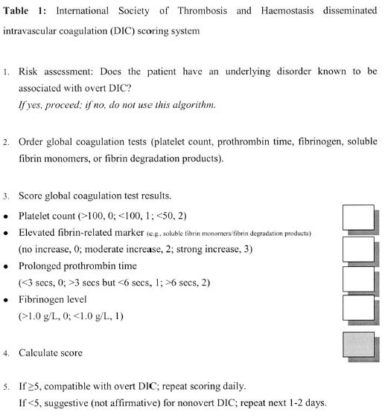
CCM 2004, Bakhtiari K, et al.
Humans - Sens 93%, Spec 98%

- Based on the study by Wiinberg et al, what was the mortality of dogs with DIC?
  - 25%
  - 25-46%
  - 59%
  - 82%
- Which of the following is NOT a parameter traditionally used to diagnose DIC?
  - fibrinogen
  - antithrombin
  - erythrocyte morphology
  - platelet count
- T or F: The human ISTH DIC scoring system, when applied to dogs using a cutoff value of ≥5, was very specific.
- Evidence based diagnosis of DIC should include which three characteristics:

