Guyton Chp 7 Skeletal muscle NM transmission and exciation-contraction coupling. Ab

- Large myelinated nerve fibers originate from large monotnuerons in the anterior horn of spinal cord
  - Nerve fiber forms branching nerve terminals that invaginate into surface of muscle fiber but is still outside of the sarcolemma = motor end plate
  - Covered by Schwann cell(s)
  - Most muscles only one motor end plate per muscle cell
  - Invagination of sarcolemma is the synaptic gutter and has many smaller folds which increase the surface area
  - Space between nerve and synaptic gutter = synaptic cleft
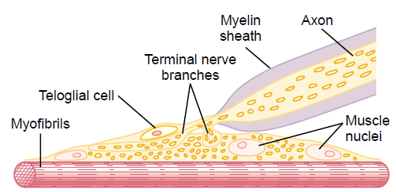
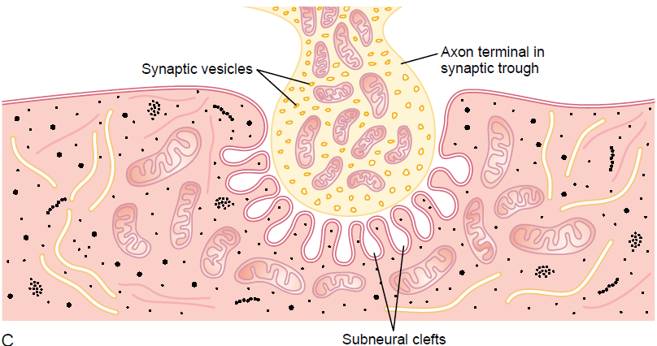
  - ACh is produced at the axon terminal and quickly taken up by synaptic vesicles for storage

- When nerve impulse reaches NMJ, voltage-gated Ca channels open and the influx of Ca attracts synaptic vesicles
  - Vesicles release ACh into cleft via exocytosis
- ACh-R are located at the mouths of the subneural cleft
  - ACh-R are acetylcholine gated ion channels
  - Two ACh bind to R causing conformational change
  - Positive ions, mainly Na, move into the sarcolemma
  - This local positive charge at the end plate results in an action potential spreading along the sarcolemma
  - ACh will continue to activate receptors until it is removed
    - Acetylcholinesterase rapidly destroys it
    - Small amount diffuses out of cleft
    - Rapid removal prevents re-excitation
  - NMJ has a high safety factor: each impulse causes about 3x the end plate potential needed
  - Fatigue of NMJ occurs when not enough ACh fails to transmit nerve impulse to muscle – rare under physiologic conditions
  - Nicotine, Methacholine, Carbachol have the same effect as ACh but cannot be degraded well by AChE resulting in tetany/spasm
  - Neostigmine, Physostigmine, Diisopropyl fluorophosphates inactivate AChE – tetany/spasm
  - Curariform drugs prevent passage of impulses from nerve ending into the muscle
- Transverse tubules (T tubules) allow the action potential to penetrate all the way through the muscle cell/fiber.
  - They run transverse to the muscle fibers and actually penetrate the sarcolemma from one side to the other.
  - They are actually internal extensions of the cell membrane – the inside of the T tubule is exposed to the extracellular environment.
  - Also branch among themselves – form a lace-like network among all the myofibrils
  - Action potential spreads across entire sarcolemma, including the T tubules so depolarization occurs throughout entire cell.
- Sarcoplasmic reticulum is made of the terminal cisternae and the longitudinal tubules
  - The terminal cisternae abutt the T tubules and the longitudinal tubules form a network between the terminal cisternae that surround all surfaces of the myofibrils
  - Within the SR is an excess of Ca ions.
  - Action potential flowing across T tubules causes current flow in the SR cisternae which causes rapid opening of large numbers of Ca channels in the cisternae and longitudinal tubules
  - This leads to muscle contraction – which continues as long as Ca is present
  - There are continually active Ca pumps in the walls of the SR which pump Ca back into the SR which rapidly removes Ca once released
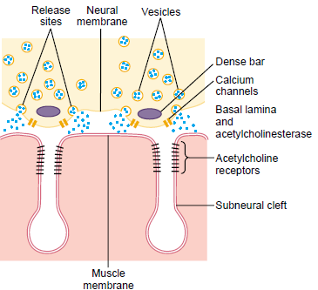
  - Calsequestrin inside the SR also helps to bind and store Ca in the SR

- Acetycholine is produced in the ___________________ and stored in ___________________ at the axon terminal. When a nerve impulse reaches the terminal axon, _____________-gated ion channels are opened which cause release of acetylcholine into the synaptic cleft via this process____________________.
When acetylcholine binds, a conformational change in the acetylcholine receptor allows influx of positive ions into the sarcolemma, primarily this cation:_____________________. This causes an action potential to spread along the sarcolemma. The action potential is carried to the interior of the cell via the __________________. The action potential is then spread to this part of the sarcoplasmic reticulum _____________________ which results in a release of a large amount of _______________ ions. This results in muscle contraction. The ions are taken back up into the sarcoplasmic reticulum by ___________________________________. This protein helps store the calcium in the sarcoplasmic reticulum _____________________.

