Board Review Jan 15 2012 – RJ bandage, splints
Bandages and splints – forms of external coaptation
Serve multiple functions – wound management, controlling edema, providing stability/support
Advantages:
- Minimal disruption of fracture site and further compromise of blood supply
- With no implants, the risk of infection is decreased
- Cost (sometimes)
Disadvantages:
- The need to immobilize the joint proximal and distal to the fracture site
- Prolonged immobilization may result in severe disuse atrophy and fracture disease
Selection of effective fracture management techniques involves patient and fracture assessment
- Patient:
- Young patients (< 1 year) heal fast, requiring limited coaptation time and are ideal candidates for external coaptation
- Breed ex. Small and toy breed dogs have an 83% of mal-union and non-union when external coaptation is used as the sole method of fixation for fractures of the antebrachium
- Patient conformation (ie may be difficult in chondrodystrophic or obese patients)
- Concurrent diseases, associated treatments (ie. Immune suppressive therapy may impede healing thus requiring a longer duration of external coaptation)
- Nature of the soft tissue injury associated with the fracture
- Temperament
- Multiple limbs affected (external coaptation may not be ideal)

- Fracture:
- Fracture type and location
- Degree of displacement
- Fracture environment (open vs closed)
- Multiple fractures
- Fracture forces present
- Bending
- Rotation
- Compression or shear
- Distraction
- External coaptation can effectively counteract bending and rotation, provided that the joints distal and proximal to the facture are effectively immobilized.
- If adjacent bones are intact (radius/ulna) they can act as anatomic functional splints and can reduce bending, shearing and rotational forces
Note: typically fractures subject to distraction, compression and/or shear forces require internal fixation
Basic guidelines for external coaptation as primary fracture management:
- Fracture reduction:
- Closed reduction with external coaptation is used as the primary method of fracute management
- appropriate reduction is required for healing. Generally minimally displaced non articular, stable fractures are suited for external coaptation
- 50% rule cortical positioning of fracture ends should have 50% contact to expect healing
- Perform rads before and after reduction
- If acceptable reduction cannot be maintained consider surgical fixation

- Fracture alignment:
- Proper rotational alignment between joints proximal and distal to the fracture is imperative to limb function
- If this is not appropriate rotational or angular malunion may result and may cause a functional gait abnormality or lameness secondary to development of osteoarthritis

- Standing position:
- Apply external coaptation at a neutral standing position this will encourgae weight bearing during and after coaptation

- Joints proximal and distal:
- Immobilize both
- Thus unsuitable for humerus and femur fractures (only applicable in some cases ie. Young patients with stable, non articular non displaced fracture of these bones). In these cases, uses a spica splint
Temporary splints:
For fractures distal to the elbow and stifle joints, temporary splints may improve patient comfort, reduce development of edema and minimize additional trauma when other forms of fixation are delayed. May also be beneficial for open fractures do decrease chances of infection and for wound management prior to repair.
Complications and post application care:
Result from improper selection, application or poor patient/owner compliance in most cases
Examples: Skin irritation, swelling, fracture disease, vascular compromise and necrosis
Robert Jones bandage and its modifications:
- Most commonly used bandages in orthopedic external coaptation
- These bandages are limited to injuries distal to the elbow or stifle
- Good for wounds, fractures, dislocations/luxations, strains/sprains
- Variations involve wound dressings, padding and rigidity
Robert Jones:
- A bulky bandage indicated as a temporary method of stabilization for fractures or dislocations present at or distal to the elbow or stifle joint until definitive repair is performed or after surgical intervention to address post operative swelling
- A properly applied RJ provides support and immobilization for traumatized soft and boney tissues , reduces and prevents edema, and limits effusion and hemarthosis before or after surgical intervention
- Its bulk and evenly applied mild compression achieve these objectives without compromise of the vascularity of the tissues
- NOTE: this bandage is NOT suitable for primary fracture fixation; the thick cotton padding loosens and can contribute to instability of the fracture site
- Compared with other padded bandages, the Robert-Jones bandage offers limb stability, tissue fluid absorption, and protection from trauma. Generally, most of the compression is lost after several hours to days as the cotton loosens. For definitive support of a fracture the bandage should never be on longer than a few days without reinforcement using rigid splint material
- Materials:
- 1 inch white adhesive tape
- 1-3 rolls of 1 pound 12 inch cotton
- 1-3 rolls of 3-4 inch roll gauze
- 1-2 roles of 3-4inch elastic adhesive tape or self adherent stretch tape a
- wound dressing if indicated
Instructions on how to apply a RJ bandage: Provided by UPENN http://cal.vet.upenn.edu/projects/orthopod/csfr/terms/robertjonesbandagecipage.htm
Step 1: Using white bandage tape, place stirrups on the distal 1/3rd of the limb overlapping the toes and extending approximately an equal length from the end of the leg. Be sure to tab the ends for easy separation later on. | 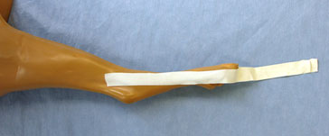
Step 2: Using roll cotton wrap the leg moving proximally from the toes (tearing the cotton in half down the middle may aid in application). Overlap the cotton 50% as you wrap being sure to leave some overlapping the toes. This layer is wrapped lightly with minimal compression creating a uniform thickness the entire length of the limb apply until 4-8cm thick.. Note - half to two pounds of cotton are typically used for the bandage depending on the size of the animal. | 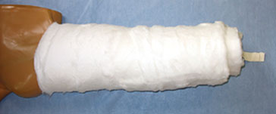
Step 3: Wrap the leg tightly with a conforming bandage starting at the toes and moving proximally. This is the step where you create compression. Overlap the bandage 50% as you wrap. When finished this step the bandage should appear markedly thinner then it did when you first applied the cotton wrap and the toes should still be visible. | 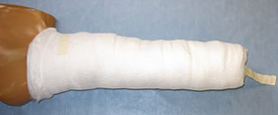
Step 4: Separate the tape stirrups, rotate them proximally, and secure them to the compression bandage thus creating a barrier and preventing the bandage from slipping down. | 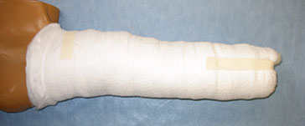
Step 5: Wrap the leg in vet wrap starting at the toes at an angle to cover the distal ends of the bandage and again moving proximally as you progress. Be sure to overlap 50% as you apply the material. When complete, the leg should make a sound when tapped with a finger mimicking a ripe watermelon all along the length of the limb. | 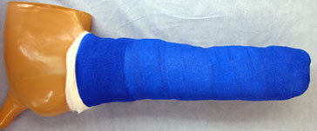

Modified RJ Bandage:
- Less padding is used
- Cast padding is used in place of cotton
- MRJ is indicated for light compression and partial immobilization if the limb distal to the elbow or stifle
- Good for use of further injury or swelling post operatively or post trauma, limb support foolwing surgical fixation or removal of orthopedic devices
- NOTE: this bandage is contraindicated if severe inflammation is expected
- Because it does NOT provide rigidity and complete immobilization of the limb, it is NOT appropriate for temporary support of fractures or dislocations
- This bandage is constructed in the same manner as an RJ, however padding is applied to a thickness of ½-2 cm

Reinforced RJ Bandage:
- Incorporates a rigid material to the modified RJ to enhance immobilization and support of the limb and joints
- This may be used in a temporary manner or as primary fixation for stable fractures in young animals
- The reinforcing material may consist of an aluminum rod, pre-formed metal or plastic splint, moldable materials.
- The reinforcing material is typically applied after cast padding and rolled guaze have been applied; an additional layer of rolled guaze is applied over the splint to help hold it in place

Splints:
Different splints can be added to a Modified Robert Jones compression bandage when additional support is needed. For each splint apply the splinting material after the compressive conforming bandage layer in all cases. In some cases, an additional conforming bandage layer can be applied over the splint to secure it in place. Vetwrap or elasticon is then applied as the final layer.
Orthoplast Splint: An orthoplast splint can be added by shaping with hot water and applying to the bandage. Apply it underneath an additional conforming bandage and finish off as you would the modified Robert Jones bandage. | 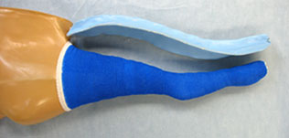
Lateral Splint: Veterinary fibercast casting tape can be added to the lateral aspect of the limb to create a lateral splint. Once wet, it will start the solidification process and harden within minutes. Fan it out laterally on the limb in multiple layers and then apply an additional conforming bandage on top to secure it to the limb. Finish off as you would a modified Robert Jones bandage. | 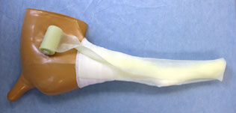
Full Leg Cast: Veterinary fibercast casting tape can also be added circumferentially to the limb creating a full leg cast. Once wet it will start the solidification process and harden within minutes. Apply an additional conforming bandage and finish off as you would a modified Robert Jones bandage. | 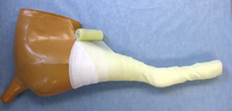
Bivalve: The veterinary fibercast casting tape can be cut on its medial and lateral sides with a cast-cutting saw to create a full bivalve cast. The two pieces can be separated during weekly splint removal allowing for treatment, cleaning, and monitoring of underlying soft tissue injuries. | 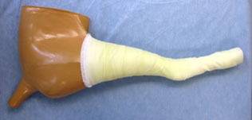
 | 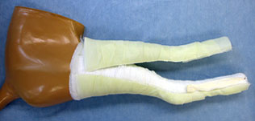
 | 