Opie Chapter 7 – Antihypertensives - Part Deux
Direct renin inhibitor
- Only new antihypertensive class introduced in more than a decade
- Lowers BP as well as other RAS blockers
- Production of excess potentially pathogenic renin
  - ACCELERATE was a small study in which hypertensive persons were given either aliskiren (150-300 mg) or amlodipine (5-10 mg) or the combination, with approximately equal BP reduction in both arms and a larger drop when combined
- The Aliskiren in the Evaluation of Proteinuria in Diabetes (AVOID) trial demonstrated that the combination of aliskiren with losartan (ACEi) resulted in a reduction in proteinuria compared with losartan alone in patients with type 2 diabetes
Aldosterone blockers
- Eplerenone and Spironolactone, Spironolactone primarily in vet med
- Spironolactone is a nonselective steroid receptor agonist/antagonist that has progestogenic and antiandrogenic effects in addition to its aldosterone receptor–blocking activity
- Spironolactone is finding wider use in hypertensive patients with congestive heart failure
- In one study, aldosterone blockers as first-line agents reduced sympathetic activity as measured by serum norepinephrine (NE) levels
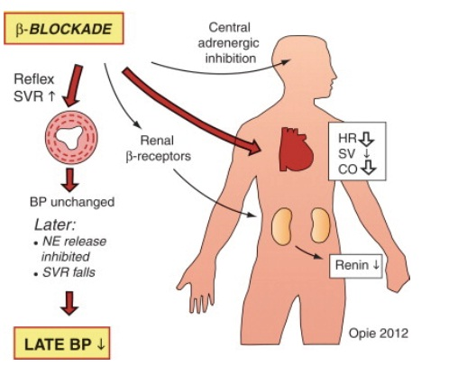
β-blockers for hypertension
- No longer recommended for primary prevention
- β-blockers do not protect against heart attack better than other classes and are associated with a 14% increase in the risk of stroke
- β-blockers differ from other standard antihypertensive agents in reducing aortic pressure less for a given fall in brachial pressure
- Dose adjustment is more likely to be required with more lipid-soluble (lipophilic) agents, which have a high“first-pass” liver metabolism that may result in active metabolites
- Ideal β-blocker for hypertension is long acting, cardioselective metabolically and usually effective in a standard dose
- Sometimes added vasodilation should be an advantage, as in olderadults or in black patients
- Once-a-day therapy is satisfactory with many β-blockers, but itis important to check early morning predrug BP to ensure 24-hour coverage
- Combinations of β-blockers with one or another agent from all other classes have been successful in the therapy of hypertension
α-adrenergic blockers
- At therapeutic doses, these agents block peripheral α-adrenergic receptors and result in arterial vasodilation
- Side effects: drowsiness, diarrhea, postural hypotension, and occasional tachycardia
- Tolerance, related to fluid retention, may develop during chronic therapy with α1-blockers, requiring increased doses or added diuretics
- α-blockers may still be chosen in the many men with benign prostatic hypertrophy in whom α-blockers provide symptomatic relief
- Phenoxybenzamine and phentolamine are combined α1 and α2-blockers used only for pheochromocytoma
Direct Vasodilators
- Hydralazine used to be a standard third-line drug
- Benefits enhanced and side effects lessened by concomitant use of a diuretic and an adrenergic inhibitor
- In addition to inciting intense renal sodium retention that requires large doses of loop diuretics to overcome, it often causes profuse hirsutism, so its use is usually limited to men with severe Renal Hypertension (RH) or renal insufficiency (it dilates renal arterioles)
- Hydralazine is recommended for the treatment of gestational hypertension
Central α-agonists
- Central α-agonists stimulate α2-receptors in the brain and result in decreased sympathetic nervous outflow and decreased peripheral arterial resistance
- Clonidine is the most commonly prescribed central α-agonist
- Methyldopa is a central α-agonist used almost exclusively in gestational hypertension and in the management of chronic hypertension in pregnancy

Combination Therapy
- In humans, guidelines suggest that therapy for mild hypertension (BP <160/100 mm Hg) should start with one drug, with combinations of drugs for more severe hypertension
- CCB–ACE inhibitor combination therapy had a resounding success in one study with decrease in CV events, all-cause mortality
- ACCOMPLISH trial showed that initial antihypertensive therapy with benazepril plus amlodipine was superior to benazepril plus HCTZ in reducing cardiovascular morbidity and mortality in high-risk hypertensive patients
- Events of renal progression in the benazepril-amlodipine group equaled 2% compared with 3.7% in the benazepril-HCTZ group
Patient Profiling
- Diabetic hypertensive patients - Based largely on expert opinion only, previous guidelines have recommended that antihypertensive therapy should be started in diabetics at a BP of more than 130/80 mm Hg and the goal of therapy is to lower systolic pressure to less than 130 mm Hg
- In the ACCORD trial, further BP reduction reduced strokes, but did not afford further protection against heart attack or other cardiovascular complications and caused more adverse drug reactions
- Diabetics with nephropathy - In type 1 diabetic nephropathy, ACE inhibitors have repeatedly been shown to reduce proteinuria andprotect against progressive glomerular sclerosis and loss of renal function
- In type 2 diabeticnephropathy, trials with ARBs have shown similar renal protection
- Evidence for specific renoprotection is stronger for ACE inhibitors for type I and ARBs for type 2 diabeticrenal disease
- Metabolic syndrome - Hypertension is present in 50% of type 1 diabetes, mostly secondary to renal damage; in type 2 diabetes, hypertension is present in 80%, often as a component of the metabolic syndrome
- Among treated hypertensive patients, diabetes developed over 25 years in 20.4%, related both to weight gain and use of β-blockers
- In the ADVANCE study the BP in high-risk diabetic patients already treated to mean BP levels of 140/77 mm Hg was further reduced by the addition of an ACEinhibitortogether with a diuretic
- All-cause mortality fell by 14%
Specific aims of antihypertensive therapy
- Regression of left ventricular hypertrophy - diagnosed by echocardiography, LVH is increasingly seen as animportant complication of hypertension
- Associated with abnormalities of diastolic function, which can result in overt LV failure
- Most effective agents in achieving LV regression are those that interrupt thegrowth pathways that make myocytes hypertrophy such as the ACE inhibitors, ARBs, or CCBs
- The hypertrophic response to catecholamines is mediated by α-adrenoreceptors, not β-adrenoreceptors
- Predisposes to LAE and then atrial fibrillation, also can result in ventricular arrhythmias
Acute severe hypertension
- Important to consider whether the patient is suffering from a hypertensive urgency (BP very high,must come down but not necessarily rapidly) or emergency (complicated by acute heart failure papilledemaor hypertensive encephalopathy) before choosing any drugs
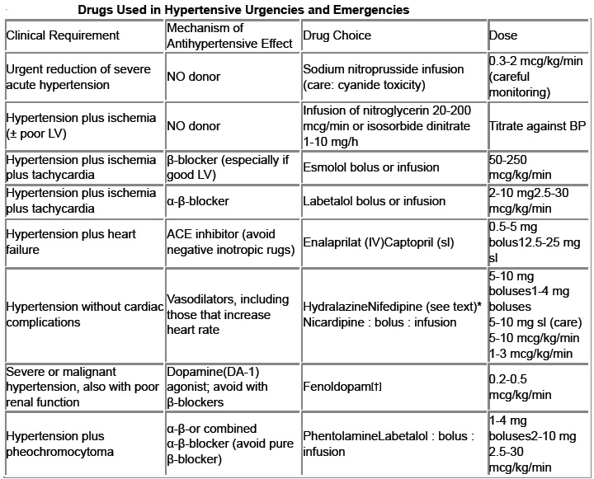
- Nitroprusside - still used extensively, but requires careful monitoring
- Reduces preload and afterload
- Warn against continuing a high-dose infusion for morethan 10 minutes if the BP dose not drop, because of the danger of cyanide toxicity
- Labetalol does not cause tachycardia and gives a smooth dose-related fall in BP; the side effects of
- β-blockade, such as bronchospasm, may be countered by the added α-blockade of labetalol
- Hydralazine and dihydralazine may cause tachycardia and are also best avoided, especially in angina, unless there isconcomitant therapy with a β-blocker
- Acute stroke with hypertension - In acute stroke with hypertension, the benefits of BP reduction remain conjectural, and most neurologistswould only reduce the BP if the diastolic level exceeds 120 mm Hg
Baroreflex activation therapy for hypertension
- Implantation of a carotid baroreceptor pacemaker is another device-based approach being investigated
- Prolonged baroreflex activation by sustained electrical stimulation of the carotid sinus nerves in dogslead to sustained reductions in arterial pressure, heart rate, and plasma NE concentrations

Questions:
- Which organs are most likely to sustain target organ damage (TOD) caused by systemic hypertension?
  - Eyes, kidneys, liver, central nervous system
  - Eyes, kidneys, central nervous system, heart
  - Heart, kidneys, pancreas, lungs
  - Kidney, central nervous system, liver, intestine
- When is treatment of systemic hypertension always indicated in dogs and cats?
  - Diastolic blood pressure ≥90 mm Hg
  - Diastolic blood pressure ≥100 mm Hg
  - Systolic blood pressure ≥160 mm Hg
  - Systolic blood pressure ≥180 mm Hg

- Which of the following drugs is the first drug of choice for treatment of hypertension in cats with chronic kidney disease (CKD)?
  - Amlodipine
  - Benazepril
  - Phenoxybenzamine
  - Carvedilol

- Which of the following drugs is the first drug of choice for treatment of hypertension in dogs with chronic kidney disease (CKD)?
  - Amlodipine
  - Benazepril
  - Phenoxybenzamine
  - Carvedilol

- Propranolol is a potent blocker of beta-adrenergic sympathetic activity. It has been found to be detrimental, however, in patients with:
  - Asthma
  - Hypertension
  - Hyperthyroidism
  - Ventricular arrhythmias

- Β-blockers produce most of its important effects by antagonizing the β-adrenergic effects of catecholamines. It therefore results in all of the following except:
  - Negative inotropic effect on the heart
  - Bronchoconstriction
  - Lowering plasma renin activity
  - Hyperglycemia

