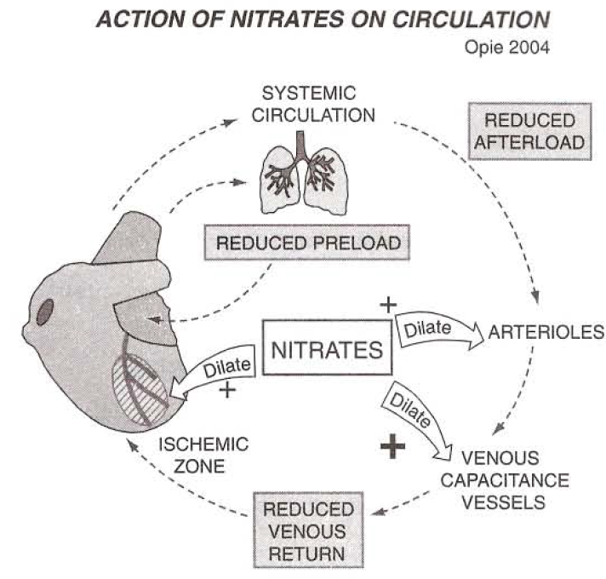
Nitrates
Mechanisms of nitrate actin
Vasodilatory effects: coronary and peripheral
- Provide exogenous source of nitric oxide (a vasodilator)
- Dilate large coronary arteries/arterioles > 100 um in diameter
  - Redistributes blood flow along collateral channels
  - Redistributes blood flow from epicardium to endocardium
  - Relieves coronary spasm and dynamic stenosis
  - Reduces the afterload and preload to the heart
Reduced oxygen demand
- Increased venous capacitancepooling of blood in peripheral veins
- Less preload leads to less mechanical stress on myocardial wall
- Low myocardial wall stressreduction in myocardial O2 demand
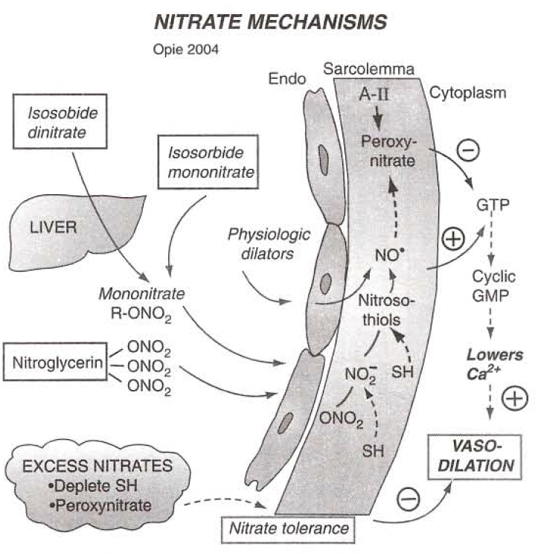
Endothelium and vascular mechanisms
- Formation of NOvasodilation (regardless of endothelial health)
  - NO stimulate guanylate cyclasecGMPreduced cytosolic Ca++
  - Sulfhydryl groups necessary for NO production and guanylate cyclase stimulation
  - Result in a reflex adrenergic mediated vasoconstriction
    - Results in better venodilation than arteriodilation
Antiplatelet effects
- Production of cGMPreduction in platelet aggregation
Pharmacokinetics and pharmacodynamics
Bioavailability and half-lives
- Absorbed across mucous membranes, skin and GI tract
- Nitroglycerin ½-life of a few minutes
- Isosorbide dinitrate has a ½-life of 4-6 hrs after hepatic activation
- Isosorbide mononitrate ½-life of 4-6 hrs with no activation needed
Pharmacodynamics and interactions
- Interactions with other drugs, such as B-blockers limit efficacy
- Severe hypotension can be seen with ACE inhibitors and PDE-5 inhibitors (sildenafil)
- Coadministration with hydralazine limits the development of tolerance
- Coadministration with heparin may increase heparin doses
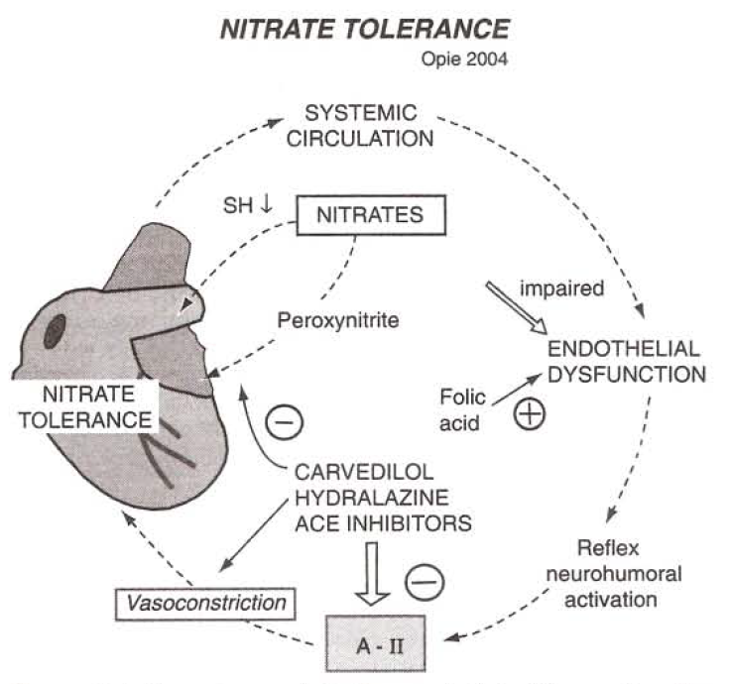
Side effects of nitrate therapy
Typical side effects
- Headaches and hypotension
Nitrate tolerance
- Theories:
  - Impaired bioconversion to active NO intracellularly
  - Free radical production via superoxide anion, particularly peroxynitrite
  - Vascular sulfhydryl depletion due to excess nitric oxide formation
  - Reflex adrenergic activationrenal vasoconstriction + RAAS activation
    - May be mitigated by the use of ACE inhibitors
Prevention of nitrate tolerance
- Interval dosing
- Cotherapy with hydralazine may overcome the impact of free radical formation
- Folic acid or L-arginine (improves activity of nitric oxide synthase) and vitamin C supplementation (free radical scavenging)
Therapeutic uses
Congestive heart failure
- Use as an afterload reducer
- Best suited for patients with raised PCWP and evidence of pulmonary congestion b/c of selective venous dilation
- Will eventually develop tolerance-should be coadministered ACE inhibitors, hydralazine or both
Acute pulmonary edema
- Rapid fall in LV filling pressure and increase in cardiac output seen with sublingual doses
Questions
- Nitroglycerin stimulates vasodilation via
  - Increased intracellular calcium levels
  - Production of cGMP
  - Production of free radical peroxinitrite
  - Reduction in adrenergic mediated vasoconstriction
- The reduction in oxygen demand seen with nitroglycerin is a consequence of which of the following?
  - Increased venous capacitance
  - Coronary arterial vasodilation
  - Reduction in systemic blood pressure
  - Redistribution of blood from epicardium to endocardium
- List three mechanisms of nitrate tolerance
  - Impaired bioconversion to active form
  - Free radical production
  - Vascular sulfhydryl depletion
  - Reflex adrenergic activationrenal vasoconstriction + RAAS activation

- Explain why nitroglycerin is a more potent venous dilator than arterial dilator

Nitroglycerin will cause powerful dilation resulting in a reflex adrenergic mediated vasoconstriction

- Which patient in congestive heart failure would be most likely to benefit from a nitrate
  - Maine coon cat with hypertrophic, obstructive cardiomyopathy
  - Maltese dog with mitral valve disease
  - Boxer dog with restrictive pericarditis
  - Newfoundland with subaortic stenosis
- Which of the following should not be co-administered with nitroglycerin
  - Sildenafil
  - Hydralazine
  - Dopamine
  - Pimobendan

