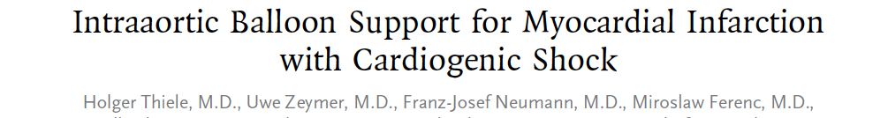
Background
In current international guidelines, intraaortic balloon counterpulsation is considered to be a class I treatment for cardiogenic shock complicating acute myocardial infarction. However, evidence is based mainly on registry data, and there is a paucity of randomized clinical trials.
Methods
In this randomized, prospective, open-label, multicenter trial, we randomly assigned 600 patients with cardiogenic shock complicating acute myocardial infarction to intraaortic balloon counterpulsation (IABP group, 301 patients) or no intraaortic balloon counterpulsation (control group, 299 patients). All patients were expected to undergo early revascularization (by means of percutaneous coronary intervention or bypass surgery) and to receive the best available medical therapy. The primary efficacy end point was 30-day all-cause mortality. Safety assessments included major bleeding, peripheral ischemic complications, sepsis, and stroke.
Results
A total of 300 patients in the IABP group and 298 in the control group were included in the analysis of the primary end point. At 30 days, 119 patients in the IABP group (39.7%) and 123 patients in the control group (41.3%) had died (relative risk with IABP, 0.96; 95% confidence interval, 0.79 to 1.17; P = 0.69). There were no significant differences in secondary end points or in process-of-care measures, including the time to hemodynamic stabilization, the length of stay in the intensive care unit, serum lactate levels, the dose and duration of catecholamine therapy, and renal function. The IABP group and the control group did not differ significantly with respect to the rates of major bleeding (3.3% and 4.4%, respectively; P = 0.51), peripheral ischemic complications (4.3% and 3.4%, P = 0.53), sepsis (15.7% and 20.5%, P = 0.15), and stroke (0.7% and 1.7%, P = 0.28).
Conclusions
The use of intraaortic balloon counterpulsation did not significantly reduce 30-day mortality in patients with cardiogenic shock complicating acute myocardial infarction for whom an early revascularization strategy was planned.
Key Points
- Use of the balloon did not reduce 30 day mortality nor infer benefit in subgroup analysis or secondary endpoint (except SAPS score on days 2 and 3)
- There was no increased stroke, bleeding, sepsis or peripheral ischemic complications in either group-considered safe
Questions
- The purported action of intraaortic balloon counterpulsation is
  - Improved preload
  - Improved contractility
  - Reduced afterload
  - Reduced myocardial oxygen demand
- T/F-the application of hypothermia has been shown to reduce 30 day mortality in patients with cardiogenic shock in myocardial infarction

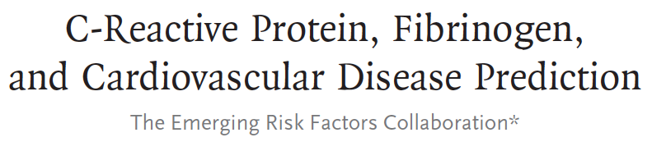
Background
There is debate about the value of assessing levels of C-reactive protein (CRP) and other biomarkers of inflammation for the prediction of first cardiovascular events.
Methods
We analyzed data from 52 prospective studies that included 246,669 participants without a history of cardiovascular disease to investigate the value of adding CRP or fibrinogen levels to conventional risk factors for the prediction of cardiovascular risk. We calculated measures of discrimination and reclassification during followup and modeled the clinical implications of initiation of statin therapy after the assessment of CRP or fibrinogen.
Results
The addition of information on high-density lipoprotein cholesterol to a prognostic model for cardiovascular disease that included age, sex, smoking status, blood pressure, history of diabetes, and total cholesterol level increased the C-index, a measure of risk discrimination, by 0.0050. The further addition to this model of information on CRP or fibrinogen increased the C-index by 0.0039 and 0.0027, respectively (P<0.001), and yielded a net reclassification improvement of 1.52% and 0.83%, respectively, for the predicted 10-year risk categories of “low” (<10%), “intermediate” (10% to <20%), and “high” (≥20%) (P<0.02 for both comparisons). We estimated that among 100,000 adults 40 years of age or older, 15,025 persons would initially be classified as being at intermediate risk for a cardiovascular event if conventional risk factors alone were used to calculate risk. Assuming that statin therapy would be initiated in accordance with Adult Treatment Panel III guidelines (i.e., for persons with a predicted risk of ≥20% and for those with certain other risk factors, such as diabetes, irrespective of their 10-year predicted risk), additional targeted assessment of CRP or fibrinogen levels in the 13,199 remaining participants at intermediate risk could help prevent approximately 30 additional cardiovascular events over the course of 10 years.
Conclusions
In a study of people without known cardiovascular disease, we estimated that under current treatment guidelines, assessment of the CRP or fibrinogen level in people at intermediate risk for a cardiovascular event could help prevent one additional event over a period of 10 years for every 400 to 500 people screened.
Key Points
- Targeted assessment of CRP and fibrinogen would reclassify individuals from low risk to intermediate risk and qualify them for statin therapy
- This would prevent 30 and 27 cardiac events, respectively over a period of 10 years
- Analysis of both does not provide benefit over measurement of each individually
Questions
- CRP and Fibrinogen are utilized as biomarkers of cardiac events because
  - They are easily measured
  - They are acute phase reactants
  - They are inexpensive to test
  - Results are available quickly
- The purported utility of biomarker measurement in the patients in this study was that
  - They would be reclassified into a higher risk group
  - They would have additional biomarker measurements performed
  - They would have cardiac ultrasound performed
  - They would have less frequent bloodwork performed

