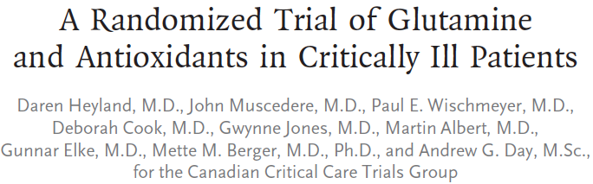

Abstract
Background
Critically ill patients have considerable oxidative stress. Glutamine and antioxidant supplementation may offer therapeutic benefit, although current data are conflicting.
Methods
In this blinded 2-by-2 factorial trial, we randomly assigned 1223 critically ill adults in 40 intensive care units (ICUs) in Canada, the United States, and Europe who had multiorgan failure and were receiving mechanical ventilation to receive supplements of glutamine, antioxidants, both, or placebo. Supplements were started within 24 hours after admission to the ICU and were provided both intravenously and enterally. The primary outcome was 28-day mortality. Because of the interim-analysis plan, a P value of less than 0.044 at the final analysis was considered to indicate statistical significance.
Results
There was a trend toward increased mortality at 28 days among patients who received glutamine as compared with those who did not receive glutamine (32.4% vs. 27.2%; adjusted odds ratio, 1.28; 95% confidence interval [CI], 1.00 to 1.64; P = 0.05). In-hospital mortality and mortality at 6 months were significantly higher among those who received glutamine than among those who did not. Glutamine had no effect on rates of organ failure or infectious complications. Antioxidants had no effect on 28-day mortality (30.8%, vs. 28.8% with no antioxidants; adjusted odds ratio, 1.09; 95% CI, 0.86 to 1.40; P = 0.48) or any other secondary end point. There were no differences among the groups with respect to serious adverse events (P = 0.83).
Conclusions
Early provision of glutamine or antioxidants did not improve clinical outcomes, and glutamine was associated with an increase in mortality among critically ill patients with multiorgan failure.
Key points
- No significant difference in 28 day mortality with the use of glutamine or antioxidants
- Significantly higher in hospital mortality, mortality at 6 months, median time to discharge alive from the ICU, and median time to discharge alive from hospital with the use of glutamine
Questions
- Based on this study
  - The use of glutamine is not indicated with patients with sepsis of any severity
  - The use of glutamine is indicated with severe sepsis
  - The use of glutamine is indicated in septic shock
  - The use of glutamine is not indicated with multiorgan dysfunction and mechanical ventilation
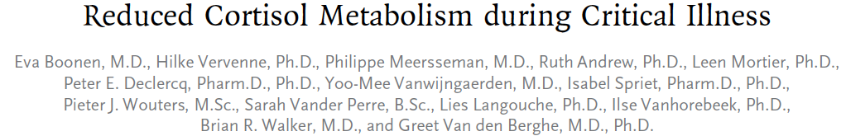
Abstract
Background
Critical illness is often accompanied by hypercortisolemia, which has been attributed to stress-induced activation of the hypothalamic–pituitary–adrenal axis. However, low corticotropin levels have also been reported in critically ill patients, which may be due to reduced cortisol metabolism.
Methods
In a total of 158 patients in the intensive care unit and 64 matched controls, we tested five aspects of cortisol metabolism: daily levels of corticotropin and cortisol; plasma cortisol clearance, metabolism, and production during infusion of deuteriumlabeled steroid hormones as tracers; plasma clearance of 100 mg of hydrocortisone; levels of urinary cortisol metabolites; and levels of messenger RNA and protein in liver and adipose tissue, to assess major cortisol-metabolizing enzymes.
Results
Total and free circulating cortisol levels were consistently higher in the patients than in controls, whereas corticotropin levels were lower (P<0.001 for both comparisons). Cortisol production was 83% higher in the patients (P = 0.02). There was a reduction of more than 50% in cortisol clearance during tracer infusion and after the administration of 100 mg of hydrocortisone in the patients (P≤0.03 for both comparisons). All these factors accounted for an increase by a factor of 3.5 in plasma cortisol levels in the patients, as compared with controls (P<0.001). Impaired cortisol clearance also correlated with a lower cortisol response to corticotropin stimulation. Reduced cortisol metabolism was associated with reduced inactivation of cortisol in the liver and kidney, as suggested by urinary steroid ratios, tracer kinetics, and assessment of liver-biopsy samples (P≤0.004 for all comparisons).
Conclusions
During critical illness, reduced cortisol breakdown, related to suppressed expression and activity of cortisol-metabolizing enzymes, contributed to hypercortisolemia and hence corticotropin suppression. The diagnostic and therapeutic implications for critically ill patients are unknown.
Key points
- Critically ill patients had significantly higher cortisol levels than controls with paradoxical significantly decreased corticotropin levels-suggesting a pituitary independent mechanism
- Seems as though reduced clearance of cortisol occurs with reduced levels of A-ring reductases and 11B-HSD2
Questions
- Cortisol metabolism occurs in which part of the body
  - Plasma-cortisol esterases
  - Liver-A-ring reductase
  - Kidney-Hydroxysteroid oxidase (not right b/c it is dehydrogenase type 2)
  - Lung-Hydroxysteroid esterase
- Presence of which of the following influences the activity of cortisol metabolizing enzymes in critical illness (according to this article)
  - Hypocalcemia
  - Inflammatory cytokines
  - Hypomagnesemia
  - Hyperbilirubinemia

